

ZTS-3001-TR-*-N01

Five Pin Soil Sensor

Product Manual

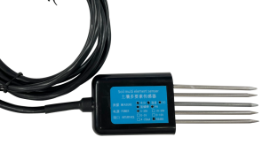

|  |  |
| --- | --- |
| 1 | **overview** |

The five-pin soil sensor has **stable performance, high sensitivity,** fast response, and stable output, and is suitable for various soil qualities . **It is an important tool for observing and studying the occurrence, evolution, improvement and water-salt dynamics of saline soil. By measuring the dielectric constant of soil, it can directly and stably reflect the real moisture content of various soils. It can measure the volume percentage of soil moisture, which is a soil moisture measurement method in line with current international standards.** Can be buried in the soil for a long time, resistant to long-term electrolysis, corrosion resistance, vacuum potting, completely waterproof .

|  |  |
| --- | --- |
| 2 | **features** |

(1) The sensor is compact in size .

(2) High measurement accuracy, fast response and good interchangeability .

(3) It has good sealing performance and can be directly buried in the soil for use without corrosion .

(4) The influence of soil quality is small, and the application area is wide .

(5) Accurate measurement, reliable performance, ensuring normal operation , and high data transmission efficiency .

|  |  |
| --- | --- |
| 3 | **scope of application** |

It is suitable for **temperature and humidity, electrical conductivity, and PH value testing in soil moisture monitoring, scientific experiments, water-saving irrigation, greenhouses, flowers and vegetables, grassland pastures, soil rapid testing, plant cultivation, sewage treatment, precision agriculture, etc.**

|  |  |
| --- | --- |
| 4 | **Product information** |

**4.1 Technical parameters**

Measurement parameters: soil electrical conductivity (EC value), temperature, moisture, PH value, nitrogen, phosphorus and potassium

Measuring range: 0~20000μS/cm, **-40~80℃, 0-100%, 3~9PH, 1-1999 mg/kg(mg/L)**

Measurement accuracy : ±2%, **±0.5°C, ±2% within 0-50%, ±3% within 50-100%,** ±0.3PH, ±2%FS

point identify Rate: 1μS/cm, **0.1℃, 0.1%, 0.1, 1 mg/kg(mg/L)**

Output signal: RS485 (ModBus-RTU protocol)

Power supply voltage: 4.5 ~ 30V DC

Working range: - 30°C ~ 70°C

Stabilization time: 1 second after power on

Response time: < 1 second

**4.2 Physical parameters**

Probe length: 55mm , φ3mm

Probe material: 316L stainless steel

Sealing material: ABS engineering plastics , epoxy resin, waterproof grade IP68

Cable specification: standard 2 meters (other cable lengths can be customized, up to 1200 meters)

Load capacity: voltage output: output resistance ≤ 250Ω; current output: ≤ 600Ω

**4.3 Product selection**

|  |  |  |  |  |  |
| --- | --- | --- | --- | --- | --- |
| ZTS- |  | | | | company code |
|  | 3001- |  | | |  |
|  | TR- |  | | Soil Testing Housing |
|  | TH NPK PH - |  | Temperature Moisture Nitrogen Phosphorus Potassium PH Transmitter |
| ECTHNPKPH- |  | Conductivity Temperature Moisture Nitrogen Phosphorus Potassium PH Transmitter |
| THPH- |  | Temperature Moisture pH Transmitter |
| ECTHPH- |  | Conductivity Temperature Moisture PH Value Transmitter |
|  | N01 | RS485 (Modbus-RTU protocol) |

|  |  |
| --- | --- |
| 5 | **form factor** |

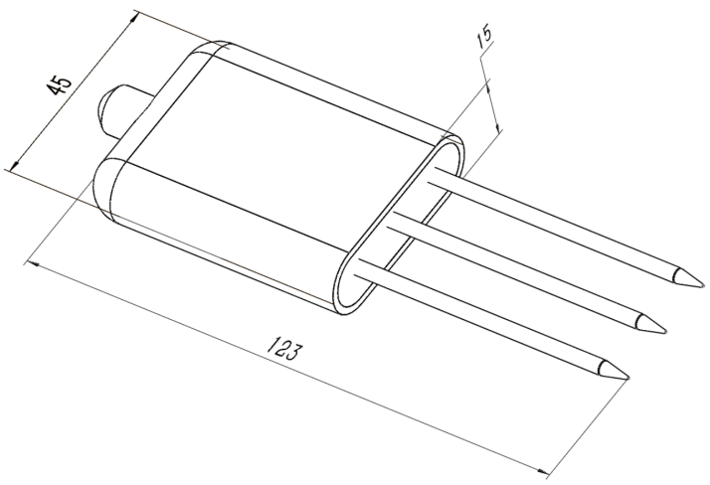

|  |  |
| --- | --- |
| 6 | **Instructions** |

The soil conductivity sensor can be connected to various data collectors with differential inputs, data acquisition cards, remote data acquisition modules and other equipment. The wiring instructions are as follows:

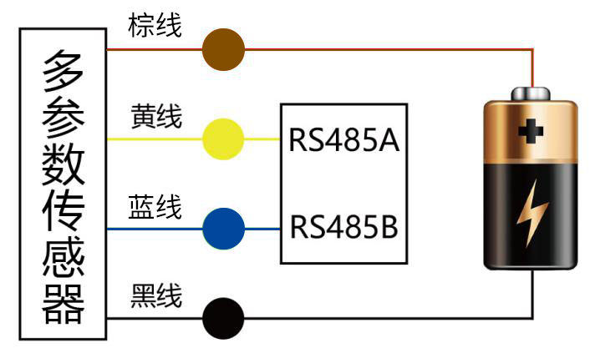

|  |  |
| --- | --- |
| 7 | **data conversion method** |

RS485 signal (default address 01):

Standard Modbus-RTU protocol, baud rate: 48 00; parity bit: none; data bit: 8 ; stop bit: 1

**7.1 Modify address**

For example: Change the address of the sensor with address 1 to 2, master→slave

|  |  |  |  |  |  |  |  |
| --- | --- | --- | --- | --- | --- | --- | --- |
| original address | function code | start register high | start register low | start address high | low starting address | CRC16 low | CRC16 high |
| 0 X 01 | 0 X 06 | 0X0 7 | 0X D 0 | 0X00 | 0X02 | 0 X08 | 0 X86 |

If the sensor is received correctly, the data will be returned in the same way .

Remarks: If you forget the original address of the sensor, you can use the broadcast address 0 XFF instead . When using 0 XFF , the master can only connect to one slave , and the return address is still the original address, which can be used as an address query method.

**7.2 Query data**

register address

|  |  |  |  |  |
| --- | --- | --- | --- | --- |
| register address | PLC or configuration address | content | operate | Definition |
| 0000H | 40001 (decimal) | moisture content | read only | Real-time value of moisture content (enlarged by 10 times) |
| 0001H | 40002 (decimal) | temperature value | read only | Temperature real-time value (enlarged by 10 times) |
| 0002H | 40003 (decimal) | Conductivity | read only | Conductivity real-time value |
| 0003H | 40004 (decimal) | PH value | read only | PH real-time value (enlarged ten times) |
| 0004H | 40005 (decimal) | nitrogen content | read only | Nitrogen content actual value |
| 0005H | 40006 (decimal) | Phosphorus content | read only | Phosphorus content actual value |
| 0006H | 40007(decimal) | potassium content | read only | Potassium content actual value |
| 07D0H | 42001 (decimal) | device address | read and write | 1~254 (factory default 1) |
| 07D1H | 42002 (decimal) | Device baud rate | read and write | 0 means 2400  1 for 4800  2 stands for 9600 |

Query the data of the conductivity temperature moisture PH value sensor (address 1), host → slave

|  |  |  |  |  |  |  |  |
| --- | --- | --- | --- | --- | --- | --- | --- |
| address | function code | Start register address high | Start Register Address Low | high register length | low register length | CRC16 low | CRC16 high |
| 0X01 | 0X03 | 0X00 | 0X00 | 0X00 | 0X04 | 0X44 | 0X09 |

If the sensor is received correctly, return the following data, slave → host

|  |  |  |  |  |  |  |  |  |
| --- | --- | --- | --- | --- | --- | --- | --- | --- |
| address code | function code | return valid  Bytes | Moisture value | temperature value | Conductivity value | PH value | check code  low byte | check code  high byte |
| 0x01 | 0x03 | 0x08 | 0x02 0x92 | 0xFF 0x9B | 0x03 0xE8 | 0x00 0x38 | 0x57 | 0xB6 |

Temperature calculation:

When the temperature is lower than 0 ℃, the temperature data is uploaded in the form of complementary code.

Temperature: FF9B H(Hex)= -101 => Temperature= -10.1℃

Moisture calculation:

Moisture: 292 H (hexadecimal) = 658 => humidity = 65.8%, that is, the soil volume moisture content is 65.8%.

Conductivity calculation:

Conductivity : 3E8 H (hexadecimal) = 1000 Conductivity = 1000 us/cm

PH value calculation:

PH value: 38H (hexadecimal) = 56 => PH value = 5.6

|  |  |
| --- | --- |
| 8 | **Precautions for use** |

police tell

圆圈斜杠符号Failure to follow the wiring sequence may cause damage to the device and the instrument connected to the device .

圆圈斜杠符号When the input power exceeds the maximum input power of the device, it will cause damage to the device .

Note meaning

* Please read this manual completely before use .
* Do not attempt to insert the probe into stones or hard clods as this may damage the probe .

jinggao Do not pull directly on the cable when moving the sensor out of the soil .

jinggao The sensor probe should be fully inserted into the soil / substrate to reduce operational errors and improve measurement accuracy .

|  |  |
| --- | --- |
| 9 | **product warranty** |

The warranty period of this product is one year. Counting from the date of delivery, within 12 months, the company is responsible for free repair or replacement of faults caused by sensor quality problems (non-human damage), and only the cost will be charged after the warranty period .