Integrated Smart POS Network & Infrastructure Report
1. Project Description

A smart POS network connecting multiple branches to a central server, analyzing sales, detecting suspicious transactions, and helping managers monitor operations securely.
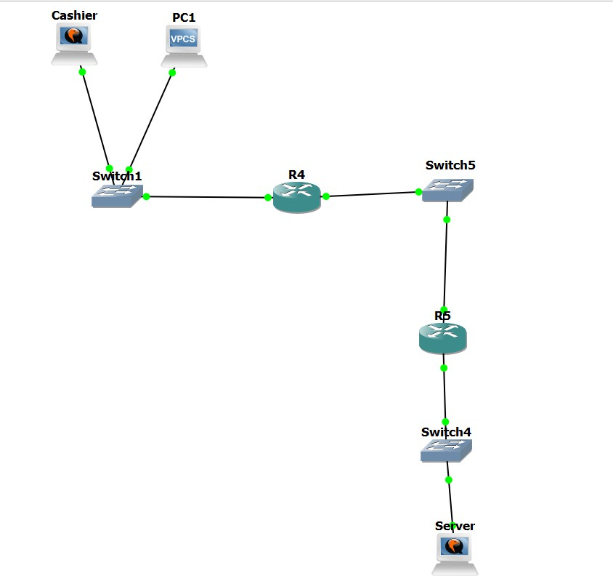
2. Network Topology & Addressing

Figure 1: GNS3 Network Topology for the Smart POS Project

Device | Interface | IP Address | Subnet Mask | Gateway
Router R4 | f0/0 (WAN) | 10.0.0.1 | 255.255.255.252 | -
Router R4 | f0/1 (LAN) | 192.168.1.1 | 255.255.255.0 | -
Router R5 | f0/0 (WAN) | 10.0.0.2 | 255.255.255.252 | -
Router R5 | f0/1 (LAN) | 192.168.10.1 | 255.255.255.0 | -
Cashier Desktop | eth0 | 192.168.1.12 | 255.255.255.0 | 192.168.1.1
Admin Server | eth0 | 192.168.10.10 | 255.255.255.0 | 192.168.10.1
3. Router Configurations

Router R4 (Branch Gateway)

enable
configure terminal interface f0/0
ip address 10.0.0.1 255.255.255.252
no shutdown exit
interface f0/1
ip address 192.168.1.1 255.255.255.0
no shutdown exit
ip route 192.168.10.0 255.255.255.0 10.0.0.2
end write
Router R5 (HQ/Admin Gateway)

enable
configure terminal interface f0/0
ip address 10.0.0.2 255.255.255.252
no shutdown exit
interface f0/1

ip address 192.168.10.1 255.255.255.0
no shutdown exit
ip route 192.168.1.0 255.255.255.0 10.0.0.1
end write
4. System Deployment (Ubuntu Admin Server)

sudo apt update && sudo apt upgrade
sudo apt install git python3 python3-pip python3-venv -y python3 -m venv venv
source venv/bin/activate
pip install uvicorn fastapi PyJWT
uvicorn main:app --host 0.0.0.0 --port 8000 --reload

Client Web Access: http://192.168.10.10:8000
5. (Bonus) Wireless Infrastructure & Hardware
Integration

Operating System Configuration (OS Environment)

Initially, the project utilized a standard OpenWrt Generic Image. However, we encountered significant technical bottlenecks when attempting to install the Tailscale package, including dependency conflicts and storage constraints.
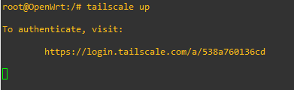
Technical Solution: We pivoted to a Custom Image Building approach using the OpenWrt Image Builder, pre-installing tailscale, tailscaled, and mt7601u drivers.

Figure 2: Successful Tailscale Activation

Physical Hardware Integration (USB Passthrough)

To transition to a realistic wireless setup, we integrated a MediaTek MT7601U USB Adapter with the GNS3 emulator via a multi-layer mapping process (VMware USB 2.0 Controller and Direct Passthrough).
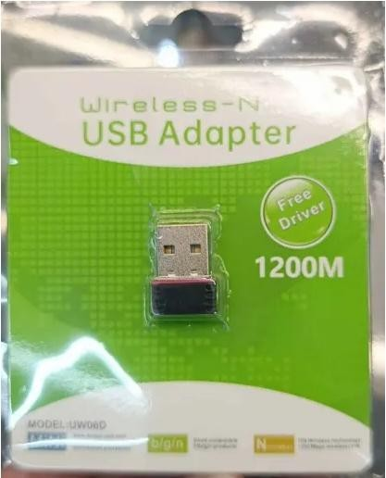

Figure 3: MediaTek MT7601U USB Adapter (Model UWDED)

Verification & Implementation Challenges

The system successfully returned the hardware signature: Bus 001 Device 002: ID 148f:7601 MediaTek 802.11n WLAN, confirming successful passthrough.
AP Mode Limitation: We encountered a limitation where the driver remained in "Managed Mode" (Receiver) and refused to switch to "Master Mode" (Broadcaster).

Engineering Decision: We adopted a Wired Solution to ensure maximum data reliability and zero latency for real-time processing requirements.

Smart POS Project Report | GNS3 Infrastructure Documentation | 2026

