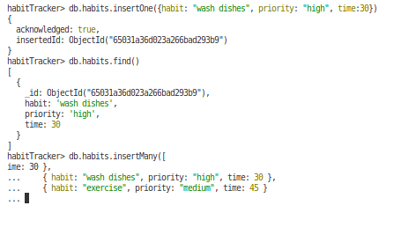
;

use {[]} to insert an array insertOne vs insertMany

doubles = numbers that contain decimals

to add date: new Date() - if don’t pass aguments it will pass currentt time otherwise do new Date(“2023-01-02”)

db.habits.find().sort({priority: 1})

