

FOOD GRADE DIATOMACEOUS EARTH

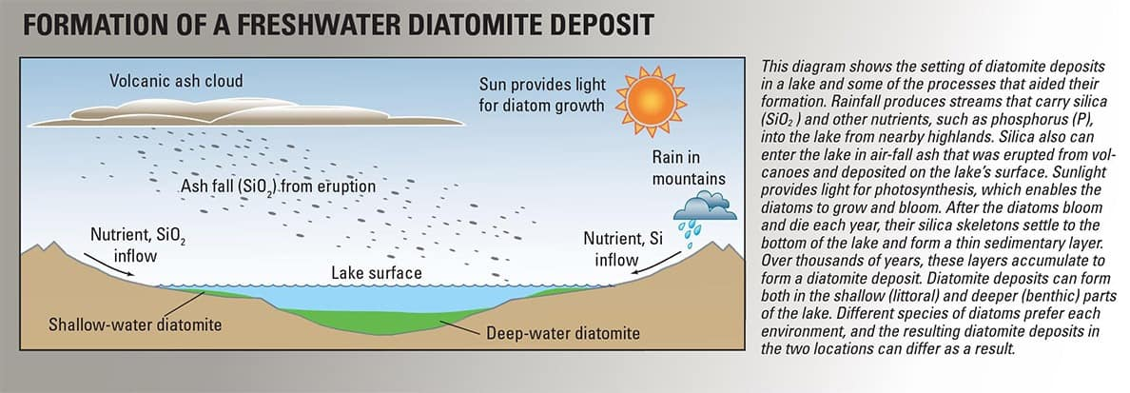

Our Food Grade Diatomaceous Earth comes from the Reno, NV region of the United States.

Food Grade Diatomaceous Earth is almost all silica at 89% and is pure white to off-white in color, showing its purity. There are other mines of Food Grade Diatomaceous Earth in the US as well as the world. You will find that those other mines have a product that is almost grey or red in color since it has a higher number of metals like iron or even clays that are not meant to be ingested. Food Grade Diatomaceous Earth is OMRI organic.

Food Grade Diatomaceous Earth is formed by diatoms absorbing the mineral content within a water body to form a shell around their cell membrane. These diatoms, in this particular case, absorbed a high amount of silica and low amount of metals within this particular body of water in the Reno, NV region of the U.S. Over thousands of years, these diatoms build up on top of each other forming a huge fossilized deposit.

The tubular shape of the diatom gives it more surface area than other shaped diatoms and this means it has greater absorptive capacity with the holes that open to the center. This allows the diatom to absorb unwanted fungus and bacteria within the gut! Food Grade Diatomaceous Earth does not swell in the stomach and has no physical or chemical capability to absorb nutrients, medicines, or herbs.

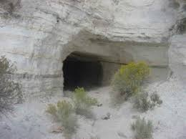

Here’s a picture of a fresh water diatomaceous earth mine

Fresh water deposits like ours have a consistent diatom presence.  Their fossilized shells have maintained their tubular structure.  This shape and strength of the fossil shell are critical to its effectiveness.  Our deposit has 89-92% amorphous silica content.  This deposit is also more consistent in its purity.  A fresh water deposit in the mountains, such as ours, formed when snow was pure and its run off provided the water source these diatoms lived in.  Salt water deposits contain a mix of types of diatoms of different shapes.  Their fossilized shells are fragile and break easily.  This renders them ineffective for our purposes and downright dangerous to ingest.  The salt water deposits are less predictable in their sediments due to their open environment.

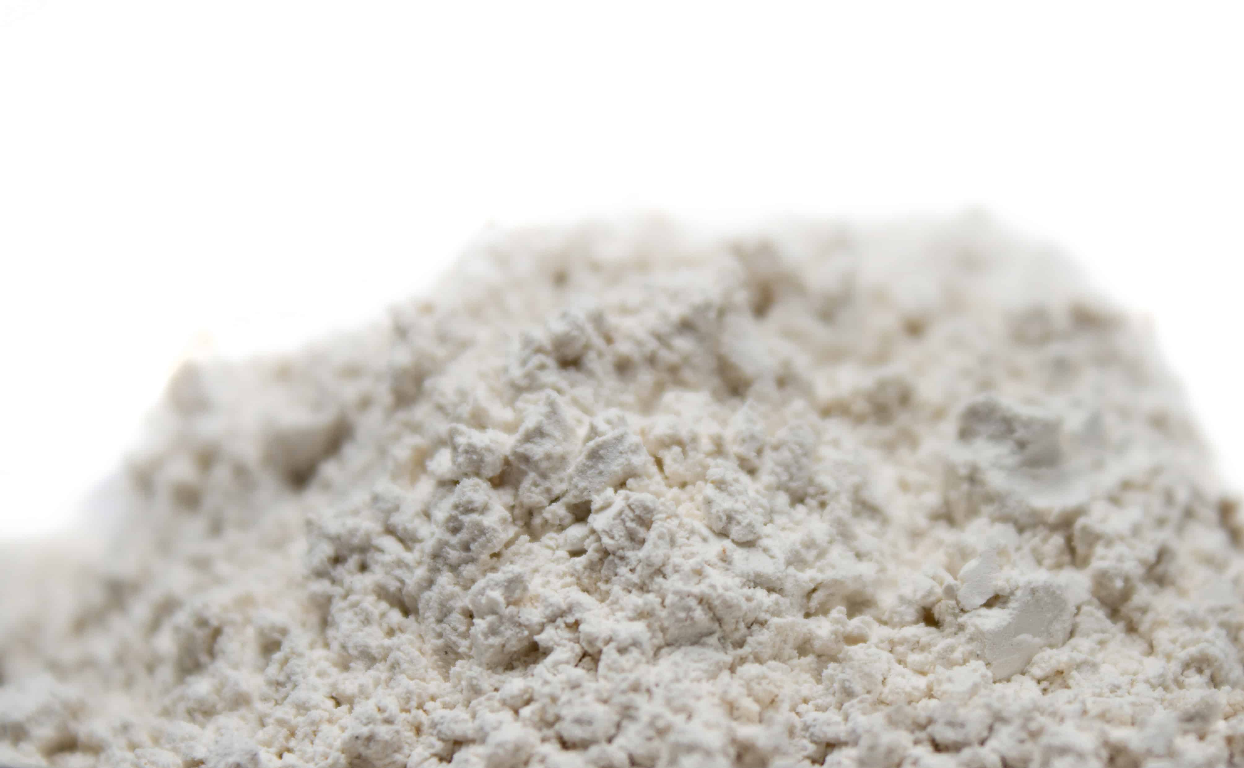

Amorphous silica is silica in its naturally occurring state. It is a trace mineral every mammal on the planet needs to live. Diatoms are found in all water sources and are the main food for aquatic life. Diatomaceous Earth becomes crystalline when it is exposed to extreme temperatures by manufacturing means and in minute amounts through naturally occurring extreme heat such as volcanic activity. The type of diatomaceous earth used in swimming pool and other filtration systems is crystalline silica that has been heated naturally or by man to make it crystalline. Crystalline silica is extremely dangerous when inhaled or ingested. IT IS NOT BIODEGRADABLE!!!

MORINGA SEED

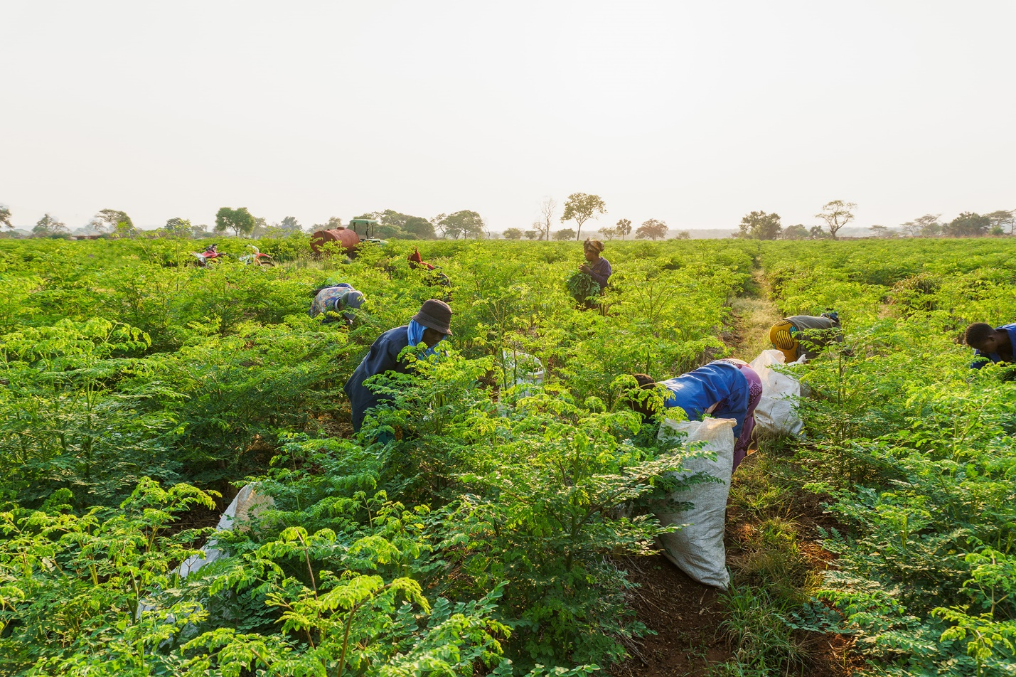

Our organic Moringa seeds come from a beautiful farm in Zambia which is located in South-Central Africa. When you support us, you are supporting a family business who employs over 150 farmers, of which 90% are female. We are committed to transparency, quality, nutritional education, sustainability, social upliftment, and environmental impact.

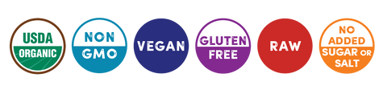

BAOBAB

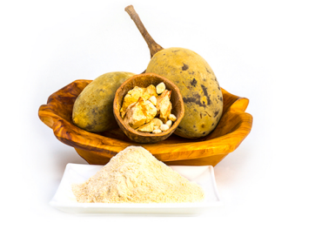

Our Baobab is sourced ethically from the region of Southern Africa

The Baobab tree (Adansonia digitata) is native to that beautiful region. As the fruit pod

dries on the branch it produces a naturally dehydrated fruit powder. Once harvested, the powder

is gently separated from the rest of the fruit by mechanical processing.

Our Certified Organic Baobab Fruit Powder is:

• GFSI, Organic (Ecocert), Kosher and Halal.

• 100% natural, organic and contains no preservatives or additives.

• Sustainably wild-harvested from existing tree populations.

• EU Novel Food and US FDA GRAS approved, intended for food and beverage applications.

• Exceptionally nutrient-dense, with one of the highest antioxidant profiles of any fruit on the

planet. It is a rich source of vitamin C, packed with calcium, iron, magnesium and potassium,

and contains 50% dietary fiber which research has shown to be prebiotic in nature.

• Demonstrated to lower the glycemic index (GI) of white bread when added to the baking

mix, lending itself to low GI bakery products and potential applications in weight loss and

control of diabetes.

• Highly alkalizing, against the PRAL (potential renal acid load) methodology of blood pH

regulating foods.



Mother Nature Does All Of The Work

No freeze drying, no heat extracting, no pasteurization

CACAO

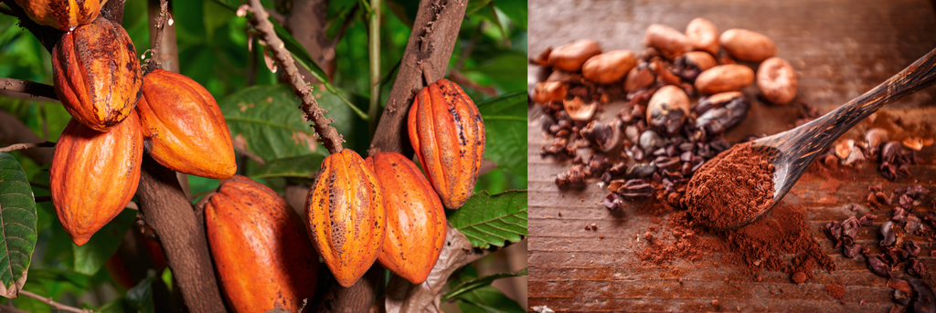

Our pure, raw, unsweetened, organic Cacao Powder is from the beautiful Peru region. This nutritious powder is made from deeply aromatic, Peruvian-grown heirloom cacao beans. They are sun-dried, fermented and stone-ground.



**Why We Love Cacao**

Cacao, 'the food of the gods' has been used for centuries to boost energy and enhance mood.*  
Cacao is also high in the mineral magnesium, essential for helping the heart to pump blood efficiently, building strong bones, and lowering blood pressure. Cacao is a good source of sulfur, generating healthy skin, nails, and hair. Cacao contains one of the highest levels of antioxidants on the planet, exceeding that of red wine, green tea, and many other exotic fruits and vegetables.

**Benefits**

* High in Antioxidants
* Excellent Source of Plant-based Iron
* Full of Calcium and Magnesium
* Natural Mood Elevator *

* These statements have not been evaluated by the FDA. This product is not intended to diagnose, treat, cure or prevent any disease.