***•Description***

 fake are those news stories that are false: the story itself is fabricated, with no verifiable facts, sources, or quotes.

When someone impersonates someone or a reliable source to false spread information, that can also be considered as fake news. In most cases, the people creating this false information have an agenda, that can be political, economical or to change the behavior or thought about a topic.

***•Experimental results***

Title :

-Fake news detection

Hypothesis

-computational techniques is natural language processing

- K-nearest neighbor , support vector machine , logistic regression, linear support vector machine, decision tree , and naïve bayes can solve this problem but with different accuracy .

-We used naïve bayes approach that give us 94% accuracy .

*Procedure*

-Upload data and separate it into two True and False containers

-Cleaning data by using NLP

-Classifying it with naïve bayes .

-Calculating accuracy and evaluating classification report

Results

After fit our model using naïve bayes , get 94% accuracy.

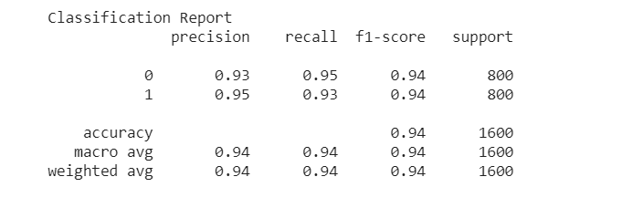

Conclusions

-Fake news detection is a famous NLP problem with many approaches to solve it , but stay that NLP is a major technique for this problem and classification can use many machine learning approaches for sure .