

GoPlan
AI-Powered Degree Planning System
Final Project Report
CSC 3326 Database Systems

Team Members:
Lalla Ibtihal Jerboui, Meryem Hosni, Ismail Tanji, Omar Taheri

Supervised by:
Prof. Nasser Assem

Al Akhawayn University in Ifrane
December 7, 2025

1. Executive Summary
GoPlan is an AI-powered degree planning system designed to revolutionize academic planning at Al Akhawayn University. The system leverages advanced database architecture combined with artificial intelligence to provide intelligent course scheduling, prerequisite validation, and graduation pathway optimization.
This report presents the comprehensive database implementation that serves as the foundation for the GoPlan application. The database schema consists of 17 interconnected tables, normalized to Third Normal Form (3NF), with advanced features including triggers, stored procedures, views, and scheduled events.

Key Achievements
- 17-table normalized schema adhering to Third Normal Form (3NF)
- Complete course catalog with 150+ courses across BBA, BACS, and BSCSC programs
- 12 database triggers for automated business logic enforcement
- 5 stored procedures for GPA calculation, prerequisite validation, and degree audit
- 7 database views for optimized data retrieval and reporting
- Secure authentication system with JWT refresh token management

2. Project Overview

2.1 Problem Statement
Academic planning at Al Akhawayn University presents significant challenges for students due to:
- Complex prerequisite chains that must be satisfied before enrollment, often with OR logic conditions
- Program requirements spanning multiple categories (core, concentrations, minors, general education)
- Course availability constraints based on semester offerings that change periodically
- Credit accumulation tracking toward degree completion with multiple requirement groups
- Advisor approval workflows that require manual coordination

2.2 Solution Approach
GoPlan provides a comprehensive database-driven solution that:
- Maintains accurate course catalogs with prerequisite relationships supporting both AND and OR logic
- Tracks student enrollment history, transcripts, and academic progress with automatic GPA calculation
- Models program requirements across major, minor, and concentration structures
- Supports academic plan creation with automatic prerequisite validation
- Facilitates semester-by-semester advisor approval workflows
- Enables AI-powered course recommendations based on structured data

2.3 Target Users
- Students: Creating and managing multi-semester academic plans with real-time validation
- Academic Advisors: Reviewing and approving student plans with streamlined workflows
- Registrar's Office: Managing course offerings and enrollment data across semesters
- Administrators: Configuring program requirements and system settings

3. System Architecture

3.1 Architecture Philosophy
GoPlan employs a database-centric architecture that prioritizes data integrity, normalization, and query efficiency. Business logic is enforced at the database level through constraints, triggers, stored procedures, and scheduled events. This approach ensures consistent data regardless of the application layer accessing the database.

3.2 Database Module Organization
The database schema is logically organized into six functional modules:

User Management Module
- users: Core user accounts with role-based access (ADMIN, ADVISOR, STUDENT)
- refresh_tokens: JWT token management for secure authentication

Academic Catalog Module
- courses: Complete course catalog with 150+ courses
- course_dependencies: Prerequisites and corequisites with OR logic support
- semesters: Academic calendar with active semester tracking

Program Structure Module
- programs: Majors, minors, and concentrations (BBA, BACS, BSCSC)
- program_requirement_groups: Hierarchical requirement categories
- requirement_group_courses: Course-to-requirement mappings with mandatory flags
- program_minor_rules: Minor compatibility rules (whitelist/blacklist)

Student Data Module
- student_profiles: Student-advisor relationships and enrollment info
- student_programs: Program declarations with primary major tracking
- student_transcript: Course history with grades and credit calculations

Planning Module
- student_plan_drafts: Multiple named plan versions per student
- student_plan: Planned courses with prerequisite validation
- student_plan_semesters: Semester metadata with locking capability
- recommended_sequence: Default course roadmaps by program

Approval Workflow Module
- semester_approvals: Advisor review and approval tracking

4. Database Schema Design

4.1 Complete Entity Catalog
Entity | Purpose | Key Attributes | Records
users | User accounts | username, email, role, password_hash | 4
semesters | Academic calendar | term, year, is_active, start/end_date | 14
courses | Course catalog | course_code, title, credits | 150+
course_dependencies | Prerequisites | dependency_type, logic_set_id | 100+
programs | Degree programs | code, type, total_credits_required | 18
program_requirement_groups | Requirement categories | credits_required, min_courses | 50+
requirement_group_courses | Course mappings | is_mandatory flag | 200+
student_profiles | Student info | advisor_id, enrollment_year | 1
student_programs | Declared programs | type, is_primary | 2
student_transcript | Course history | grade, status, credits_earned | 35
student_plan_drafts | Plan versions | name, is_default | 1
student_plan | Planned courses | semester_number, prereqs_met | varies
semester_approvals | Advisor approvals | approval_status, comments | 8
recommended_sequence | Default roadmaps | semester_number, recommended_order | 50+
refresh_tokens | Auth tokens | token_hash, expires_at, revoked | varies
program_minor_rules | Minor compatibility | rule_type (ALLOWED/FORBIDDEN) | varies
student_plan_semesters | Semester metadata | term, year, is_locked | varies

4.2 Normalization Analysis
The schema adheres to Third Normal Form (3NF):

First Normal Form (1NF)
- All attributes contain atomic values
- No repeating groups (course dependencies separated via logic_set_id)

Second Normal Form (2NF)
- No partial dependencies on composite keys
- All non-key attributes depend on entire primary key

Third Normal Form (3NF)
- No transitive dependencies
- Example: credits_earned in student_transcript calculated from grade via trigger, not stored redundantly

4.3 Key Design Decisions

OR Logic for Prerequisites
The course_dependencies table uses a logic_set_id to support OR conditions. Courses in the same logic set are ANDed together; different logic sets are ORed. For example, ACC 2301 can be satisfied by MTH 1305 OR MTH 1304 OR MTH 1311.

Hierarchical Requirement Groups
Program requirements use a parent-child hierarchy through parent_group_id. This allows General Education to contain sub-categories like First Year Experience, Arabic, English, etc., each with their own credit requirements.

Multiple Plan Drafts
Students can maintain multiple named plan drafts with one designated as default. This supports scenario planning ('Finish in 4 years' vs 'Graduate with minor').

5. Advanced Database Features

5.1 Triggers (12 Implemented)
Trigger Name | Purpose
trg_after_user_insert | Auto-creates student_profile when a STUDENT user is inserted
trg_after_student_profile_insert | Auto-creates default plan draft when profile is created
trg_before_plan_draft_insert | Ensures only one default plan per student
trg_before_plan_draft_update | Prevents multiple default plans during updates
trg_before_transcript_insert | Auto-calculates credits_earned based on grade
trg_before_transcript_update | Recalculates credits when grade changes
trg_before_student_profile_update | Validates advisor role assignment
trg_before_student_profile_insert_advisor | Prevents student from being their own advisor
trg_before_plan_update | Prevents modification of locked semesters
trg_before_plan_delete | Prevents deletion from locked semesters
trg_after_semester_update | Auto-locks past semesters when deactivated
trg_before_student_program_insert/update | Enforces single primary major per student

5.2 Stored Procedures (5 Implemented)
Procedure Name | Purpose
sp_update_prereqs_met | Updates prereqs_met flag for all courses in a plan based on transcript and earlier plan entries
sp_calculate_gpa | Calculates cumulative GPA with grade point mapping (A=4.0 through F=0.0)
sp_initialize_plan_from_template | Populates a student plan from recommended_sequence based on program and start semester
sp_check_course_eligibility | Validates prerequisites and standing requirements for course enrollment
sp_degree_audit | Returns completion status for each requirement group in a program

5.3 Views (7 Implemented)
View Name | Purpose
vw_student_transcript | Full transcript with grade points, semester info, and course details
vw_student_progress | GPA, credits earned, completion percentage, and academic standing
vw_current_enrollment | In-progress courses for current active semester
vw_student_plan_detail | Complete plan view with course info, lock status, and prereq flags
vw_advisor_students | Advisor dashboard showing all advisees with progress and pending approvals
vw_course_prerequisites | Complete prerequisite chain for each course with logic sets
vw_program_requirements | Program requirement summary with courses per group

5.4 Scheduled Events
evt_cleanup_expired_tokens: Weekly cleanup of expired and revoked refresh tokens to maintain database performance and security.

5.5 Performance Indexes
Strategic indexes created for common query patterns:
- idx_user_tokens: Optimizes token validation queries
- idx_student_plan: Accelerates plan retrieval by student and semester
- idx_transcript_student_status: Speeds up GPA and progress calculations
- idx_course_deps_course: Optimizes prerequisite lookups
- idx_req_group_courses: Accelerates degree audit queries

6. Sample Data & Case Study: Amina Berrada
To demonstrate the system's capabilities, we populated the database with a complete case study of Amina Berrada, a senior Computer Science student.

6.1 Student Profile
Name | Amina Berrada
Student ID | 23
Email | amina.cs@aui.ma
Major | Bachelor of Science in Computer Science (BSCSC)
Minor | Mathematics
Enrollment Year | 2021
Advisor | Fatima Alaoui (SSE Advisor)
Current Semester | Fall 2024 (Senior Year)

6.2 Academic Progress Summary
Query results from the implemented test suite:
- Total Credits Earned: 119 credits (completed courses)
- Credits In Progress: 17 credits (Fall 2024)
- Cumulative GPA: 3.879 (calculated via stored procedure)
- Academic Standing: Senior (based on credits > 90)

6.3 Current Semester Enrollment (Fall 2024)
Course Code | Title | Credits | Status
CSC 4307 | Agile Software Engineering and DevOps | 3 | IP
CSC 4308 | Cyber Security | 3 | IP
EGR 4402 | Capstone Design | 4 | IP
SLP 1101 | Service Learning Program | 1 | IP
SOC 1301 | Principles of Sociology | 3 | IP

6.4 Advisor Approval History
All previous semesters have been approved by advisor Fatima Alaoui. Fall 2024 is currently PENDING review.

PUML:
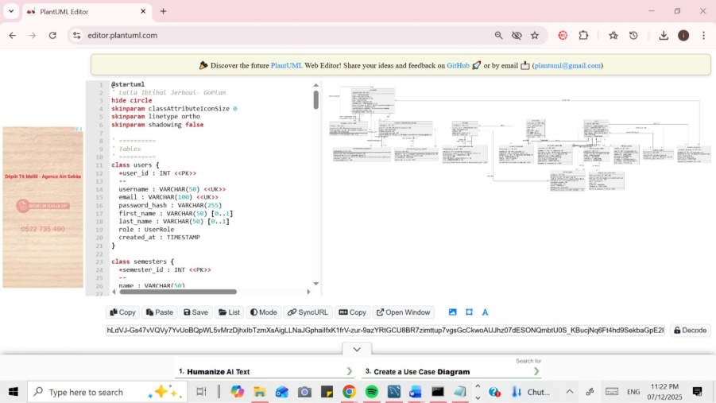
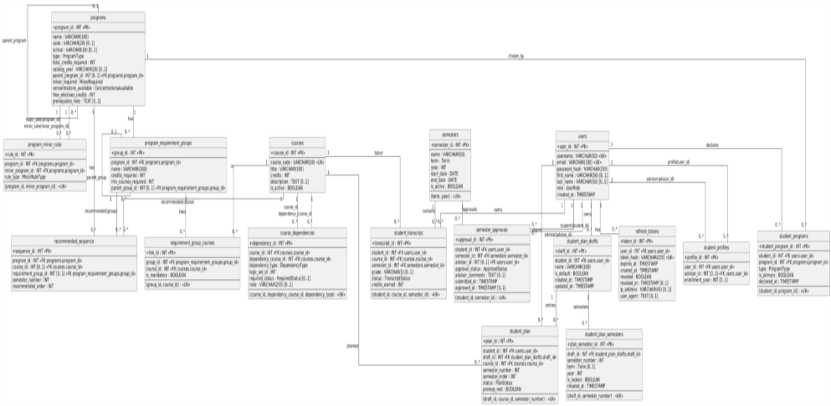
@startuml
hide circle
skinparam classAttributeIconSize 0
skinparam linetype ortho
skinparam shadowing false

' ==========
' Tables
' ==========
class users {
+user_id : INT <<PK>>
--
username : VARCHAR(50) <<UK>>
email : VARCHAR(100) <<UK>>
password_hash : VARCHAR(255)
first_name : VARCHAR(50) [0..1]
last_name : VARCHAR(50) [0..1]
role : UserRole
created_at : TIMESTAMP
}

class semesters {
+semester_id : INT <<PK>>
--
name : VARCHAR(50)
term : Term
year : INT
start_date : DATE
end_date : DATE
is_active : BOOLEAN
--
(term, year) : <<UK>>
}

class courses {
+course_id : INT <<PK>>
--
course_code : VARCHAR(10) <<UK>>
title : VARCHAR(100)
credits : INT
description : TEXT [0..1]
is_active : BOOLEAN
}

class course_dependencies {
+dependency_id : INT <<PK>>
--
course_id : INT <<FK courses.course_id>>
dependency_course_id : INT <<FK courses.course_id>>
dependency_type : DependencyType
logic_set_id : INT
required_status : RequiredStatus [0..1]
note : VARCHAR(255) [0..1]
--
(course_id, dependency_course_id, dependency_type) : <<UK>>
}

class programs {
+program_id : INT <<PK>>
--
name : VARCHAR(100)
code : VARCHAR(20) [0..1]
school : VARCHAR(10) [0..1]
type : ProgramType
total_credits_required : INT
catalog_year : VARCHAR(20) [0..1]
parent_program_id : INT [0..1] <<FK programs.program_id>>
minor_required : MinorRequired
concentrations_available : ConcentrationsAvailable
free_electives_credits : INT
prerequisite_note : TEXT [0..1]
}

class program_requirement_groups {
+group_id : INT <<PK>>
--
program_id : INT <<FK programs.program_id>>
name : VARCHAR(100)
credits_required : INT
min_courses_required : INT
parent_group_id : INT [0..1] <<FK program_requirement_groups.group_id>>
}

class requirement_group_courses {
+link_id : INT <<PK>>
--
group_id : INT <<FK program_requirement_groups.group_id>>
course_id : INT <<FK courses.course_id>>
is_mandatory : BOOLEAN
--
(group_id, course_id) : <<UK>>
}

class recommended_sequence {
+sequence_id : INT <<PK>>
--
program_id : INT <<FK programs.program_id>>
course_id : INT [0..1] <<FK courses.course_id>>
requirement_group_id : INT [0..1] <<FK program_requirement_groups.group_id>>
semester_number : INT
recommended_order : INT
}

class student_profiles {
+profile_id : INT <<PK>>
--
user_id : INT <<FK users.user_id>>
advisor_id : INT [0..1] <<FK users.user_id>>
enrollment_year : INT [0..1]
}

class student_programs {
+student_program_id : INT <<PK>>
--
student_id : INT <<FK users.user_id>>
program_id : INT <<FK programs.program_id>>
type : ProgramType
is_primary : BOOLEAN
declared_at : TIMESTAMP
--
(student_id, program_id) : <<UK>>
}

class student_transcript {
+transcript_id : INT <<PK>>
--
student_id : INT <<FK users.user_id>>
course_id : INT <<FK courses.course_id>>
semester_id : INT <<FK semesters.semester_id>>
grade : VARCHAR(5) [0..1]
status : TranscriptStatus
credits_earned : INT
--
(student_id, course_id, semester_id) : <<UK>>
}

class student_plan_drafts {
+draft_id : INT <<PK>>
--
student_id : INT <<FK users.user_id>>
name : VARCHAR(100)
is_default : BOOLEAN
created_at : TIMESTAMP
updated_at : TIMESTAMP
}

class student_plan {
+plan_id : INT <<PK>>
--
student_id : INT <<FK users.user_id>>
draft_id : INT <<FK student_plan_drafts.draft_id>>
course_id : INT <<FK courses.course_id>>
semester_number : INT
semester_order : INT
status : PlanStatus
prereqs_met : BOOLEAN
--
(draft_id, course_id, semester_number) : <<UK>>
}

class student_plan_semesters {
+plan_semester_id : INT <<PK>>
--
draft_id : INT <<FK student_plan_drafts.draft_id>>
semester_number : INT
term : Term [0..1]
year : INT
is_locked : BOOLEAN
created_at : TIMESTAMP
--
(draft_id, semester_number) : <<UK>>
}

class semester_approvals {
+approval_id : INT <<PK>>
--
student_id : INT <<FK users.user_id>>
semester_id : INT <<FK semesters.semester_id>>
advisor_id : INT [0..1] <<FK users.user_id>>
approval_status : ApprovalStatus
advisor_comments : TEXT [0..1]
submitted_at : TIMESTAMP
approved_at : TIMESTAMP [0..1]
--
(student_id, semester_id) : <<UK>>
}

class refresh_tokens {
+token_id : INT <<PK>>
--
user_id : INT <<FK users.user_id>>
token_hash : VARCHAR(255) <<UK>>
expires_at : TIMESTAMP
created_at : TIMESTAMP
revoked : BOOLEAN
revoked_at : TIMESTAMP [0..1]
ip_address : VARCHAR(45) [0..1]
user_agent : TEXT [0..1]
}

class program_minor_rules {
+rule_id : INT <<PK>>
--
program_id : INT <<FK programs.program_id>>
minor_program_id : INT <<FK programs.program_id>>
rule_type : MinorRuleType
--
(program_id, minor_program_id) : <<UK>>
}

' ==================
' Relationships
' ==================

' users
users "1" -- "0..*" refresh_tokens : has
users "1" -- "0..*" student_plan_drafts : owns
users "1" -- "0..*" student_plan : places
users "1" -- "0..*" student_programs : declares
users "1" -- "0..*" student_transcript : earns
users "1" -- "0..*" student_profiles : profile(user_id)
users "1" -- "0..*" student_profiles : advisor(advisor_id)

' semesters
semesters "1" -- "0..*" student_transcript : contains
semesters "1" -- "0..*" semester_approvals : approvals

' courses
courses "1" -- "0..*" student_transcript : taken
courses "1" -- "0..*" student_plan : planned
courses "1" -- "0..*" requirement_group_courses : in
courses "1" -- "0..*" recommended_sequence : recommended(course)
courses "1" -- "0..*" course_dependencies : course_id
courses "1" -- "0..*" course_dependencies : dependency_course_id

' programs
programs "1" -- "0..*" program_requirement_groups : has
programs "1" -- "0..*" recommended_sequence : has
programs "1" -- "0..*" student_programs : chosen_by
programs "0..1" -- "0..*" programs : parent_program

' requirement groups
program_requirement_groups "1" -- "0..*" requirement_group_courses : links
program_requirement_groups "0..1" -- "0..*" program_requirement_groups : parent_group
program_requirement_groups "1" -- "0..*" recommended_sequence : recommended(group)

' plans
student_plan_drafts "1" -- "0..*" student_plan : entries
student_plan_drafts "1" -- "0..*" student_plan_semesters : semesters

' approvals (advisor is a user too)
users "1" -- "0..*" semester_approvals : student(student_id)
users "1" -- "0..*" semester_approvals : advisor(advisor_id)

' minor rules (program-to-program)
programs "1" -- "0..*" program_minor_rules : major_side(program_id)
programs "1" -- "0..*" program_minor_rules : minor_side(minor_program_id)

@enduml

7. Testing & Validation

7.1 Query Test Suite
Six comprehensive SQL queries were developed to validate the schema functionality:

Query 1: Student Overview
Purpose: Retrieve complete student profile with programs
Returns student name, email, advisor, enrollment year, and all declared programs (major/minor) using JOINs across users, student_profiles, student_programs, and programs tables.

Query 2: Credits & GPA Summary
Purpose: Calculate academic standing metrics
Computes total credits earned, in-progress credits, and cumulative GPA using subqueries with grade point mapping. Validates the trigger-based credits_earned calculation.

Query 3: Current Semester Courses
Purpose: Display active semester enrollment
Filters transcript by is_active semester flag to show current in-progress courses with details.

Query 4: Advisor Approval History
Purpose: Track approval workflow status
Retrieves all semester approvals including status (PENDING, APPROVED, NEEDS_REVISION), submission dates, and advisor comments.

Query 5: Mandatory Course Status
Purpose: Degree audit for mandatory requirements
Identifies all mandatory courses for a program and shows completion status (COMPLETED, IN_PROGRESS, NOT_TAKEN) by cross-referencing with student transcript.

Query 6: Missing Prerequisites Check
Purpose: Validate current enrollment prerequisites
For all IN_PROGRESS courses, verifies that prerequisites are satisfied. Returns empty result set when all prerequisites are met (validated for Amina's enrollment).

7.2 Data Integrity Validation
Foreign Key Constraints: 25+ foreign key relationships enforce referential integrity across all tables.
Check Constraints: Validate data integrity for credits (1-12), years (1900-2100), roles (ADMIN/ADVISOR/STUDENT), and semester numbers (1-12).
Unique Constraints: Prevent duplicate usernames, emails, course codes, and student-semester-course combinations.
Trigger Validation: Credits earned automatically calculated, advisor role validated, single default plan enforced.

8. Future Roadmap

8.1 AI Integration Layer
- Course Recommendation Engine: LLM-powered suggestions based on requirements, preferences, and historical patterns
- Smart Schedule Generation: Conflict-free timetable creation using AI optimization
- Risk Detection: Early warning system for at-risk students based on progress patterns
- Natural Language Queries: "What courses do I need to graduate?" processed via LLM with database context

8.2 Application Development
- REST API: Full CRUD operations with JWT authentication
- Student Portal: Interactive degree planning interface with drag-and-drop
- Advisor Dashboard: Bulk approval workflows and advisee analytics
- Mobile App: Push notifications for approvals and deadlines

8.3 Data Enhancement
- Full AUI catalog import with all program requirements
- Historical enrollment data for analytics
- Faculty and section scheduling integration
- Waitlist management system

9. Conclusion

9.1 Project Status Summary
The GoPlan database system has been successfully implemented with a comprehensive 17-table schema that provides a solid foundation for AI-powered degree planning. The system demonstrates advanced database concepts including triggers for automated business logic, stored procedures for complex calculations, views for optimized data access, and scheduled events for maintenance.

Technical Achievements
- Normalized relational model adhering to 3NF principles
- Complex prerequisite logic with OR condition support
- Hierarchical program requirement modeling
- Secure authentication with refresh token management
- Comprehensive advisor approval workflow
- Validated query suite demonstrating real-world functionality

9.2 Team Reflection
This project represents a collaborative effort in translating complex academic planning requirements into a robust database solution. The team gained practical experience in schema design, SQL programming, trigger implementation, and creating comprehensive test suites that validate real-world use cases.

9.3 Commitment to Excellence
Our team remains dedicated to delivering a production-ready system that demonstrates mastery of relational database design, proficiency in advanced SQL features, and understanding of real-world academic planning complexity. The foundation established in this phase positions GoPlan for successful AI integration and application development.

