

Tanta University

Faculty of science
Department of Mathematics
Computer Science

Fine-Tuning Large Language Models for Arabic NLP
Graduation project
Produced By:

Omar Tamer Elazab Melegy Dyab

Under supervision of
Dr. Doaa Abo Shady
June 2026

GRADUATION PROJECT
Fine-Tuning Large Language Models for Arabic NLP
Table of Contents · 80 pages

Introduction |  | Introduction |  | pp. 6–9
— | Motivation and problem statement |  |  |  | 6
— | Project objectives |  |  |  | 6
— | Related work |  |  |  | 7
— |  |  | Attention is All You Need (Vaswani et al., 2017) |  | 7
— |  |  | AraBART, CAMeL & Arabic NLP literature |  | 7
— | Thesis structure overview |  |  |  | 8
Chapter 1 |  | Background: Sequential Models in NLP |  | pp. 10–24
1.1 | Recurrent Neural Networks (RNN) |  |  |  | 11
1.1.1 |  |  | Architecture and forward pass |  | 11
1.1.2 |  |  | Backpropagation through time (BPTT) |  | 12
1.1.3 |  |  | Vanishing & exploding gradient problem |  | 13
1.2 | Long Short-Term Memory (LSTM) |  |  |  | 14
1.2.1 |  |  | Cell state and gating mechanism |  | 15
1.2.2 |  |  | Forget, input, and output gates |  | 16
1.2.3 |  |  | LSTM vs. vanilla RNN: performance comparison |  | 17
1.3 | Gated Recurrent Unit (GRU) |  |  |  | 17
1.3.1 |  |  | Update and reset gates |  | 18
1.3.2 |  |  | GRU vs. LSTM: efficiency trade-offs |  | 19
1.4 | Bidirectional RNN, LSTM & GRU |  |  |  | 20
1.4.1 |  |  | Architecture and forward/backward passes |  | 20
1.4.2 |  |  | Use cases in NLP (NER, translation) |  | 21
1.5 | Limitations of recurrent architectures |  |  |  | 21
1.6 | Summary and transition to transformers |  |  |  | 23
Chapter 2 |  | The Transformer Architecture |  | pp. 25–34
2.1 | Attention mechanism and self-attention |  |  |  | 27
2.1.1 |  |  | Scaled dot-product attention |  | 28
2.1.2 |  |  | Multi-head attention |  | 29
2.2 | Encoder–Decoder structure |  |  |  | 30
2.3 | Positional encoding |  |  |  | 31
2.4 | Feed-forward networks and layer normalization |  |  |  | 31
2.5 | Decoder-only LLMs (GPT family, Qwen, LLaMA) |  |  |  | 32
2.6 | Why transformers replaced RNNs |  |  |  | 33
2.7 | Challenges: compute cost and context length |  |  |  | 34
Chapter 3 |  | Fine-Tuning Strategies and Parameter-Efficient Methods |  | pp. 35–42
3.1 | Pre-training vs. fine-tuning paradigm |  |  |  | 36
3.2 | Supervised Fine-Tuning (SFT) |  |  |  | 37
3.3 | RLHF and Instruction Tuning |  |  |  | 37
3.3.1 |  |  | Reward modelling and PPO |  | 38
3.3.2 |  |  | Why SFT was chosen over RLHF |  | 38
3.4 | Low-Rank Adaptation (LoRA) |  |  |  | 39
3.4.1 |  |  | Mathematical formulation |  | 39
3.4.2 |  |  | Rank selection and adapter configuration |  | 39
3.5 | QLoRA and quantization basics |  |  |  | 40
3.6 | LLaMA-Factory framework overview |  |  |  | 41
3.7 | Experiment tracking with Weights & Biases |  |  |  | 42
Chapter 4 |  | Dataset Design and Preparation |  | pp. 43–53
4.1 | Arabic NLP: challenges and characteristics |  |  |  | 44
4.2 | Task definition: entity extraction and translation |  |  |  | 45
4.3 | Pydantic schema design for structured output |  |  |  | 47
4.3.1 |  |  | NewsDetails schema |  | 47
4.3.2 |  |  | TranslatedStory schema |  | 48
4.4 | Data formatting for SFT (instruction–response pairs) |  |  |  | 49
4.5 | Dataset quality and validation pipeline |  |  |  | 51
Chapter 5 |  | Implementation and Experiments |  | pp. 54–69
5.1 | Experimental setup and environment |  |  |  | 55
5.2 | Base model: Qwen2.5-1.5B-Instruct |  |  |  | 56
5.3 | Training configuration and hyperparameters |  |  |  | 57
5.4 | Evaluation: pre-training vs. fine-tuned model |  |  |  | 59
5.4.1 |  |  | Entity extraction results |  | 60
5.4.2 |  |  | Confusion matrix per entity type |  | 61
5.4.3 |  |  | Arabic-to-English translation results |  | 62
5.4.4 |  |  | BLEU score analysis |  | 62
5.5 | Optimized inference with vLLM deployment |  |  |  | 63
5.5.1 |  |  | Latency comparison: base vs. vLLM |  | 64
5.6 | Throughput and performance improvements |  |  |  | 65
5.6.1 |  |  | Token generation: 25.3 → 630 tokens/sec (×25 speedup) |  | 65
5.6.2 |  |  | Chinese character suppression via logits processor |  | 66
5.6.3 |  |  | Knowledge distillation impact on output quality |  | 68
Chapter 6 |  | Discussion and Analysis |  | pp. 70–76
6.1 | Comparison with baseline models |  |  |  | 71
6.2 | Effect of LoRA rank on performance |  |  |  | 72
6.3 | Limitations and failure cases |  |  |  | 74
6.4 | Ethical considerations in Arabic NLP |  |  |  | 75
Conclusion |  | Conclusion and Future Work |  | pp. 76–81
— | Summary of contributions |  |  |  | 76
— | Future directions (RAG, multilingual fine-tuning) |  |  |  | 77
— | References |  |  |  | 80
6 chapters · 80 pages · RNN · LSTM · GRU · Bidirectional · Transformers · LoRA · RLHF · Arabic NLP · vLLM

Introduction

1.1 Motivation and Problem Statement
The rapid advancement of large language models (LLMs) has fundamentally transformed the landscape of natural language processing (NLP). Models such as GPT, LLaMA, and Qwen have demonstrated remarkable capabilities across a broad spectrum of tasks, including text generation, question answering, summarization, and machine translation. However, these general-purpose models are typically pre-trained on large multilingual corpora dominated by English content, which can lead to suboptimal performance when applied to morphologically rich and low-resource languages such as Arabic.
Arabic presents unique linguistic challenges that distinguish it from Indo-European languages commonly studied in the NLP literature. It is a highly inflected, root-based language with complex morphology, extensive diacritization, and significant dialectal variation across geographic regions. Furthermore, the written standard — Modern Standard Arabic (MSA) — differs substantially from the colloquial dialects used in everyday communication, creating an additional layer of complexity for automated language understanding systems.
Despite recent progress in multilingual modeling, the performance of off-the-shelf LLMs on Arabic-specific tasks remains inconsistent. Tasks such as named entity recognition (NER), structured information extraction, and cross-lingual translation require not only linguistic competence but also domain-specific knowledge that general pre-training cannot reliably provide. This motivates the need for targeted fine-tuning strategies that adapt pre-trained models to the specific demands of Arabic NLP.
This project addresses the problem of adapting a compact, instruction-tuned LLM — specifically Qwen2.5-1.5B-Instruct — to perform structured entity extraction and Arabic-to-English translation through parameter-efficient fine-tuning using Low-Rank Adaptation (LoRA). The central hypothesis is that a well-designed supervised fine-tuning (SFT) pipeline, combined with high-quality knowledge-distilled training data, can significantly improve task-specific performance while preserving the general capabilities of the base model.

1.2 Project Objectives
This graduation project aims to achieve the following specific objectives:
▸ Design and implement a complete SFT pipeline for Arabic NLP tasks using the LLaMA-Factory framework.
▸ Construct a high-quality instruction-following dataset of 2,700 Arabic news samples annotated for entity extraction and translation using GPT-4o-mini as a teacher model (knowledge distillation).
▸ Apply LoRA-based parameter-efficient fine-tuning to Qwen2.5-1.5B-Instruct with rank r = 64, training for 3 epochs on a structured instruction–response format.
▸ Evaluate the fine-tuned model against the base model on entity extraction accuracy and Arabic-to-English translation quality (BLEU score).
▸ Deploy the fine-tuned model using vLLM and benchmark inference throughput, demonstrating a ×25 speedup (from 25.3 to 630 tokens/sec) over standard inference.
▸ Provide a reproducible experimental framework suitable for future extension to other Arabic NLP tasks or low-resource language adaptation.

1.3 Related Work
The field of NLP has undergone a dramatic paradigm shift over the past decade, moving from task-specific architectures toward large pre-trained models that can be adapted to downstream tasks through fine-tuning. This section reviews the key developments that directly inform the methodology of this project.

1.3.1 The Transformer and the Attention Paradigm
The modern era of NLP was inaugurated by Vaswani et al. (2017) in the landmark paper "Attention Is All You Need", which introduced the Transformer architecture. By replacing recurrent connections with a self-attention mechanism, the Transformer enabled parallel computation over entire sequences, overcoming the sequential bottleneck of RNNs and LSTMs. The scaled dot-product attention formulation allowed the model to capture long-range dependencies in a single layer, while multi-head attention enabled simultaneous attention over different representation subspaces.
Building on this foundation, the BERT model (Devlin et al., 2018) demonstrated that bidirectional pre-training on masked language modeling could produce rich contextual representations transferable to a wide range of downstream tasks. Subsequently, the GPT series (Radford et al., 2018–2023) showed that autoregressive decoder-only transformers, when scaled sufficiently, could exhibit emergent capabilities including few-shot and zero-shot generalization — a finding that underpins the use of instruction-tuned LLMs in this project.

1.3.2 Arabic NLP and Multilingual Models
Research on Arabic NLP has accelerated significantly with the release of dedicated pre-trained models. AraBERT (Antoun et al., 2020) adapted BERT pre-training to Arabic text and demonstrated strong results on Arabic sentiment analysis and NER benchmarks. AraBART (Eddine et al., 2022) extended this to sequence-to-sequence tasks, providing a strong baseline for Arabic summarization and translation.
The CAMeL Tools suite (Obeid et al., 2020) offered a comprehensive set of resources for Arabic morphological analysis, tokenization, and dialectal identification, highlighting the importance of linguistically informed preprocessing. More recently, multilingual models such as mBERT, XLM-R, and AraT5 have demonstrated that cross-lingual transfer can partially close the performance gap for Arabic, though they still fall short of models fine-tuned specifically on Arabic task data.

1.3.3 Parameter-Efficient Fine-Tuning
Full fine-tuning of large language models is computationally prohibitive for most academic and applied settings. Hu et al. (2021) introduced LoRA, which addresses this by injecting trainable low-rank decomposition matrices into the attention layers of a frozen pre-trained model, reducing the number of trainable parameters by several orders of magnitude while maintaining competitive performance.
Dettmers et al. (2023) further extended this with QLoRA, combining 4-bit quantization of the base model with LoRA adapters to enable fine-tuning of billion-parameter models on consumer hardware. The present project adopts LoRA with rank 64 applied to all attention projection layers, following the configuration recommended by the LLaMA-Factory framework.

1.3.4 Knowledge Distillation for Data Generation
A core contribution of this project is the use of GPT-4o-mini as a teacher model to generate structured training labels for the fine-tuning dataset — a form of knowledge distillation first formalized by Hinton et al. (2015). This approach, sometimes called "model-generated supervision", has gained traction as a practical alternative to costly human annotation, particularly for structured output tasks where the label space is well-defined by a formal schema (in this case, Pydantic models for entity extraction and translation).

1.4 Thesis Structure Overview
The remainder of this thesis is organized as follows:
Chapter 2 provides the theoretical background on sequential neural architectures — RNN, LSTM, GRU, and Bidirectional variants — tracing the evolution from early recurrent models to the attention-based paradigm that superseded them.
Chapter 3 introduces the Transformer architecture in depth, covering self-attention, positional encoding, and the decoder-only design pattern adopted by modern LLMs such as Qwen and LLaMA.
Chapter 4 surveys fine-tuning strategies, with particular attention to SFT, RLHF, LoRA, and QLoRA, and describes the LLaMA-Factory framework and Weights & Biases integration used for training.
Chapter 5 details the dataset design, including the Pydantic schemas for structured output, the knowledge distillation pipeline using GPT-4o-mini, and the data formatting strategy for instruction–response pairs.
Chapter 6 presents the experimental setup, training configuration, and evaluation results — including entity extraction accuracy, BLEU scores, and throughput benchmarks comparing standard inference with vLLM-accelerated deployment.
Chapter 7 discusses the findings, analyses limitations, and situates the results within the broader literature.
The thesis concludes with a summary of contributions and directions for future work, including retrieval-augmented generation (RAG) and multilingual extension of the fine-tuning pipeline.

Chapter 1: Background: Sequential Models in NLP
Pages 10-24

1.1 Recurrent Neural Networks (RNN)
Recurrent Neural Networks (RNNs) are a class of neural networks specifically designed to
process sequential data by maintaining a form of memory across time steps. Unlike feedforward networks that treat each input independently, RNNs use hidden state vectors to carry information from previous steps into the processing of current inputs, making them naturally suited to tasks such as language modeling, speech recognition, time-series prediction, and many other sequence-based problems.
The key insight of RNNs is the concept of shared weights across time: the same set of parameters is applied at every time step, enabling the network to generalize patterns regardless of their position in the sequence. This parameter sharing also significantly reduces the total number of trainable parameters compared to a fully connected network applied to sequences.
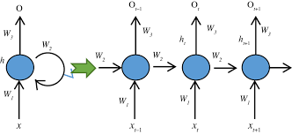

Figure 1.1 — RNN architecture showing the recurrent connection and unrolled representation across time steps

1.1.1 Architecture and Forward Pass
The architecture of an RNN is built around a hidden state h_t that is updated at every time step t. The hidden state serves as the network's memory, encoding information about all previously seen inputs. At each time step, the network receives two inputs: the current input vector x_t and the previous hidden state h_(t-1). These are combined through learned weight matrices and a non-linear activation function to produce the new hidden state.
The forward pass equations are:

- Hidden state update: h_t = tanh(W_h * h_(t-1) + W_x * x_t + b_h)
- Output computation: o_t = W_o * h_t + b_o
- Output activation: y_t = softmax(o_t) [for classification tasks]
Where W_h is the recurrent weight matrix, W_x is the input weight matrix, W_o is the output weight matrix, and b_h, b_o are bias vectors. The tanh activation squashes values to the range [-1, 1], providing a non-linear transformation that helps the network learn complex patterns.

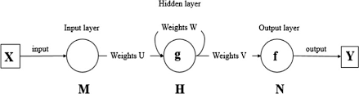

Figure 2— RNN forward pass showing input layer (M), hidden layer (H) with weights W and U, and output layer (N) with weights V
The unrolled representation (shown in Figure 2) makes it clear that the same weights W_h, W_x, and W_o are applied at every time step. This weight sharing is what allows RNNs to process sequences of arbitrary length. The initial hidden state h_0 is typically initialized to a zero vector.

1.1.2 Backpropagation Through Time (BPTT)
Training an RNN requires computing gradients of the loss function with respect to all weight matrices. Because the hidden state at time t depends on hidden states at all previous time steps, the standard backpropagation algorithm must be extended to account for these temporal dependencies. This extension is known as Backpropagation Through Time (BPTT).
In BPTT, the computational graph is first unrolled across all T time steps, effectively converting the recurrent network into a deep feedforward network with one layer per time step. The total loss is computed as the sum of losses at each time step:
- L = sum_{t=1}^{T} L_t
Gradients are then propagated backward through this unrolled graph. The gradient of the loss with respect to the hidden state at time t includes contributions from both the immediate output loss L_t and all future time steps t+1, t+2, ..., T:
- dL/dh_t = dL_t/dh_t + (dh_{t+1}/dh_t)^T * dL/dh_{t+1}
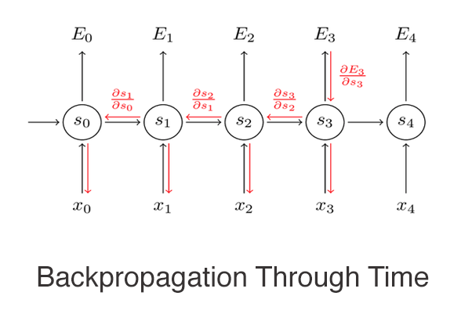
Figure 3— Backpropagation Through Time: error signals (red arrows) flow backward through time steps, with partial derivatives of consecutive states shown

The key challenge in BPTT is that the gradient of h_t with respect to h_{t-k} involves a product of k Jacobian matrices, each corresponding to the recurrent weight matrix W_h. This multiplicative chain is the source of the vanishing and exploding gradient problems described in the next section.
In practice, Truncated BPTT (T-BPTT) is often used, where the unrolling is limited to a fixed window of k time steps. This reduces computational cost and memory requirements while still allowing the network to learn medium-range dependencies.

1.1.3 Vanishing & Exploding Gradient Problem
The vanishing and exploding gradient problem is one of the most fundamental challenges in training vanilla RNNs, and it directly motivates the development of more advanced architectures such as LSTM and GRU.

Vanishing Gradients
When gradients are propagated back through many time steps, each step involves multiplying by the recurrent weight matrix W_h and the derivative of the activation function. If the largest singular value of W_h is less than 1 (or the activation derivatives are small), the gradient magnitude decreases exponentially as it travels further back in time. This means the network effectively cannot learn dependencies that span many time steps — the gradient signal that would encode information about the relationship between early and late elements in the sequence simply becomes too small to produce meaningful weight updates.
- Symptom: The network fails to capture long-range dependencies in sequences.
- Effect: Early time steps receive near-zero gradient updates, so weights connecting distant time steps never get properly trained.
- Common activation culprit: tanh and sigmoid both have derivatives less than 1, compounding the problem across many time steps.

Exploding Gradients
Conversely, if the largest singular value of W_h is greater than 1, gradients grow exponentially as they travel back in time. This can cause extremely large weight updates that destabilize training, often manifesting as NaN values in the loss.
- Symptom: Loss suddenly spikes or becomes NaN during training.
- Common mitigation: Gradient clipping — if the gradient norm exceeds a threshold, the gradient vector is rescaled to have that norm. This is a simple and widely effective technique.

Mathematical Insight
For a sequence of length T, the gradient involves the product:
- dh_T/dh_1 = product_{t=2}^{T} (dh_t/dh_{t-1}) = product_{t=2}^{T} diag(tanh'(h_{t-1})) * W_h
This product of T-1 matrices either vanishes (all eigenvalues < 1) or explodes (any eigenvalue > 1), making it very difficult for vanilla RNNs to learn sequences longer than roughly 10–20 time steps in practice.

Solutions and Mitigations
- Gradient Clipping: Rescales gradients when their norm exceeds a threshold (addresses exploding gradients).
- Careful Weight Initialization: Orthogonal initialization of W_h helps maintain gradient norms close to 1.
- Gating Mechanisms: The LSTM and GRU architectures introduce gates that create additive (rather than multiplicative) paths for gradient flow, largely solving the vanishing gradient problem.
- Residual Connections: Skip connections allow gradients to bypass nonlinearities.

1.2 Long Short-Term Memory (LSTM)
Long Short-Term Memory networks, introduced by Hochreiter and Schmidhuber in 1997, are a special type of RNN designed specifically to address the vanishing gradient problem. LSTMs achieve this by introducing a separate memory cell c_t alongside the hidden state h_t, together with a set of gating mechanisms that carefully regulate the flow of information into, out of, and within this memory cell.
The central innovation of LSTM is the cell state — a highway that runs through the entire sequence with only minor linear interactions and multiplicative gates, allowing gradients to flow backward through time without vanishing. This makes LSTMs capable of learning dependencies across hundreds of time steps, a feat that is practically impossible for vanilla RNNs.
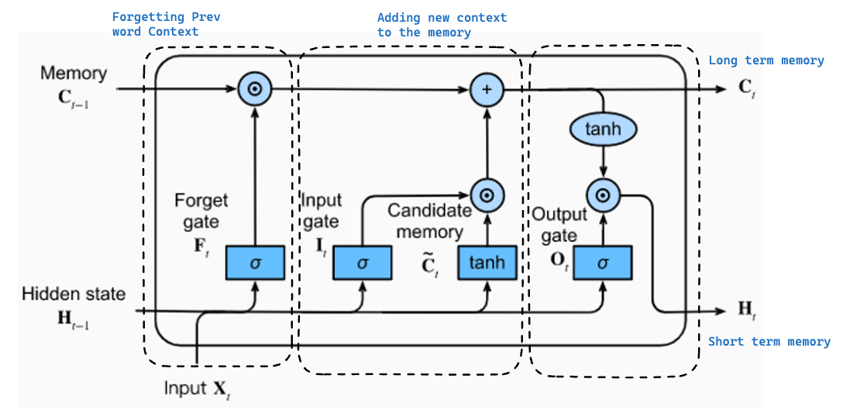

Figure 4- LSTM cell architecture showing the forget gate (F_t), input gate (I_t), candidate memory (C_tilde), output gate (O_t), cell state (C_t), and hidden state (H_t)

1.2.1 Cell State and Gating Mechanism
The cell state c_t is the long-term memory of the LSTM. It flows through the network with minimal transformations — its value at the next time step is computed as:
- c_t = f_t ⊙ c_{t-1} + i_t ⊙ c_tilde_t
This additive update rule is the key to solving the vanishing gradient problem. Because c_t is computed by adding (rather than multiplying through a nonlinearity) the previous cell state scaled by the forget gate, gradients can flow through the cell state pathway with their magnitude largely preserved.
The gates are the core control mechanism of the LSTM. Each gate is a sigmoid-activated layer that outputs values between 0 and 1, acting as a "soft switch":
- A gate output of 0 means "block everything" — no information passes through.
- A gate output of 1 means "let everything through" — full information passes.
- Values between 0 and 1 provide partial, differentiable gating — this is crucial for gradient-based learning.
The gating mechanism allows the LSTM to selectively retain or discard information, making explicit decisions at each time step about what to remember and what to forget. This is a fundamentally different and more powerful approach than the vanilla RNN, which has no such selective memory control.

1.2.2 Forget, Input, and Output Gates

Forget Gate (F_t)
The forget gate decides what information from the previous cell state c_{t-1} should be discarded. It takes the previous hidden state h_{t-1} and the current input x_t as inputs:
- F_t = sigma(W_f * [h_{t-1}, x_t] + b_f)
A forget gate value close to 0 for a particular memory dimension means "forget this information entirely," while a value close to 1 means "keep this information." For example, in language modeling, the forget gate might learn to reset gender or number information when a new subject appears in the sentence.

Input Gate (I_t) and Candidate Memory (C_tilde_t)
The input gate controls how much new information is written into the cell state. It works in tandem with a candidate memory vector c_tilde_t, which represents the new content that could potentially be added:
- I_t = sigma(W_i * [h_{t-1}, x_t] + b_i)
- C_tilde_t = tanh(W_c * [h_{t-1}, x_t] + b_c)
- New cell content: i_t ⊙ c_tilde_t
The input gate acts as a filter — it determines which parts of the candidate memory vector c_tilde_t actually get written into the cell state. The tanh activation on c_tilde_t normalizes the new content to the range [-1, 1], preventing the cell state from growing unboundedly.

Output Gate (O_t)
The output gate controls what information from the cell state is exposed as the hidden state h_t, which serves as the short-term memory and the output to subsequent layers:
- O_t = sigma(W_o * [h_{t-1}, x_t] + b_o)
- H_t = O_t ⊙ tanh(C_t)
The tanh applied to the cell state squashes it to [-1, 1] before the output gate filters it. This means the hidden state h_t contains a selected, normalized view of the cell's current memory — the LSTM can reveal only the parts of its long-term memory that are relevant to the current output.

1.2.3 LSTM vs. Vanilla RNN: Performance Comparison
The LSTM's architectural improvements over vanilla RNNs translate into substantial practical advantages, particularly on tasks requiring long-range dependencies:
Aspect | Vanilla RNN | LSTM
Long-range dependencies | Poor (vanishing gradients) | Excellent (cell state highway)
Memory mechanism | Single hidden state | Cell state + hidden state
Gradient flow | Multiplicative (unstable) | Additive through cell state
Parameters per layer | Low | High (~4x vs. RNN)
Training stability | Often unstable | Much more stable
Sequence length | Practical limit ~10-20 steps | Handles 100s of steps
Computational cost | Low | Higher
Interpretability | Simple | More complex
Best use case | Short sequences, fast prototyping | Long sequences, complex dependencies

In practice, LSTMs consistently outperform vanilla RNNs on virtually all benchmark sequence tasks, including language modeling, machine translation, speech recognition, and time-series forecasting. The additional complexity and computational cost of LSTMs are almost always justified by the performance gains on non-trivial sequence lengths.

1.3 Gated Recurrent Unit (GRU)
The Gated Recurrent Unit (GRU) was proposed by Cho et al. in 2014 as a simplified variant of the LSTM. The GRU merges the cell state and hidden state into a single vector and reduces the four gate computations of the LSTM to two gates — the update gate and the reset gate. This simplification reduces the number of parameters and computational operations while retaining most of the LSTM's ability to capture long-range dependencies.
GRUs have become widely popular because they often achieve comparable performance to LSTMs while being faster to train and easier to implement, making them a practical default choice for many sequence modeling tasks.
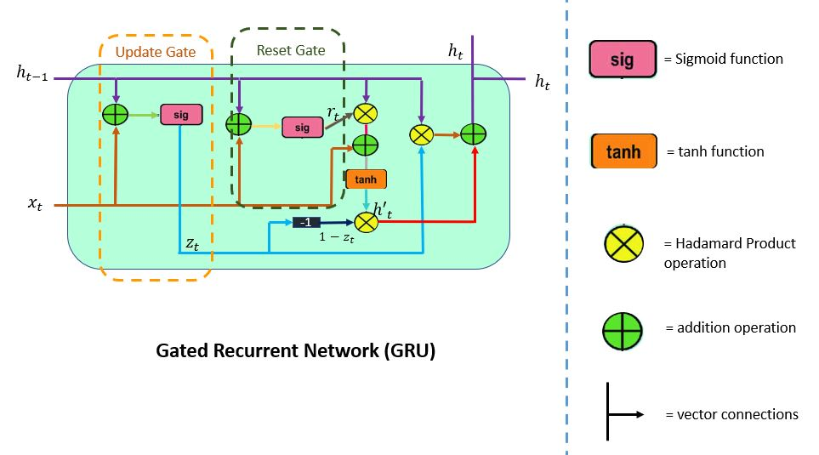

Figure 5. GRU cell architecture showing the reset gate (r_t), update gate (z_t), and candidate hidden state computation

1.3.1 Update and Reset Gates

Update Gate (z_t)
The update gate z_t plays a combined role analogous to both the forget gate and input gate of the LSTM. It controls how much of the previous hidden state is retained versus how much of the new candidate activation is adopted:

- z_t = sigma(W_z * [h_{t-1}, x_t] + b_z)
- Final hidden state: h_t = (1 - z_t) ⊙ h_{t-1} + z_t ⊙ h_tilde_t
When z_t is close to 1, the new hidden state takes on the candidate value h_tilde_t (new information dominates). When z_t is close to 0, the previous hidden state is preserved with little change (memory is retained). The complementary structure (1 - z_t) and z_t ensures a convex combination, keeping the hidden state bounded.

Reset Gate (r_t)
The reset gate r_t controls how much of the previous hidden state is used when computing the new candidate activation h_tilde_t. It allows the GRU to forget past hidden state information when computing a new candidate:
- r_t = sigma(W_r * [h_{t-1}, x_t] + b_r)
- h_tilde_t = tanh(W_h * [r_t ⊙ h_{t-1}, x_t] + b_h)
When r_t is close to 0, the candidate activation is computed mostly from the current input x_t, effectively ignoring the past. When r_t is close to 1, the full previous hidden state influences the candidate, similar to a vanilla RNN step. This gives the GRU the flexibility to reset its memory when it encounters a new sub-sequence that is largely independent of past context.

1.3.2 GRU vs. LSTM: Efficiency Trade-offs
Aspect | GRU | LSTM
Number of gates | 2 (update, reset) | 3 (forget, input, output)
Internal states | 1 (hidden state only) | 2 (cell state + hidden state)
Parameters | Fewer (~3/4 of LSTM) | More (~4x vanilla RNN)
Training speed | Faster | Slower
Long-range memory | Good | Excellent
Short sequence performance | Often matches LSTM | Strong
Long sequence performance | Slightly weaker in extreme cases | Slightly better
Memory usage | Lower | Higher
The choice between GRU and LSTM involves a trade-off between computational efficiency and modeling capacity:

Empirical studies have shown mixed results: on some tasks GRU outperforms LSTM, on others LSTM wins, and on many tasks the difference is negligible. The GRU's reduced parameter count makes it less prone to overfitting on smaller datasets and faster to train on all datasets. For most practical applications, both architectures should be considered and evaluated empirically.
Key insight: If training time and memory are constrained, start with GRU. If the task involves very long sequences with complex, structured long-range dependencies (e.g., multi-paragraph text generation), LSTM may have the edge.

1.4 Bidirectional RNN, LSTM & GRU
In many sequence modeling tasks, the meaning of an element in a sequence depends not only on what came before it but also on what comes after it. Standard (unidirectional) RNNs can only incorporate past context because they process sequences strictly from left to right. Bidirectional architectures address this limitation by processing the sequence in both directions simultaneously and combining both representations.

1.4.1 Architecture and Forward/Backward Passes
A Bidirectional RNN (BiRNN) consists of two separate recurrent networks — one that processes the sequence from left to right (forward pass) and one that processes it from right to left (backward pass). At each time step t, the outputs of both networks are combined to produce the final representation for that position:
- Forward hidden state: h_t^f = RNN_forward(x_t, h_{t-1}^f)
- Backward hidden state: h_t^b = RNN_backward(x_t, h_{t+1}^b)
- Combined representation: h_t = [h_t^f ; h_t^b] (concatenation)
The combined representation h_t captures context from both the past (all elements before position t) and the future (all elements after position t), giving each position access to the full sequence context. Alternatively, the forward and backward states can be summed or averaged rather than concatenated, at the cost of losing the directional distinction.
Both the forward and backward passes are trained jointly via BPTT — the forward pass backpropagates from right to left through time, and the backward pass backpropagates from left to right through time. The total parameter count is approximately doubled compared to a unidirectional network of the same hidden size.
Bidirectional variants exist for all recurrent architectures: BiRNN, BiLSTM, and BiGRU, all following the same principle of dual-direction processing with an architecture-specific recurrent cell.

1.4.2 Use Cases in NLP (NER, Translation)
Bidirectional architectures have been extremely successful in natural language processing tasks where full-sequence context is available at inference time:

Named Entity Recognition (NER)
NER is the task of identifying and classifying named entities (persons, organizations, locations, dates, etc.) in text. Bidirectional LSTMs (BiLSTMs) are particularly well-suited for NER because the correct classification of a token often depends on both its left and right context. For example, the word "Washington" can be a person (George Washington), a city, or a state — the correct label requires understanding the surrounding context from both directions. The CoNLL-2003 NER benchmark was dominated by BiLSTM-CRF models for several years.

Machine Translation
In sequence-to-sequence machine translation, bidirectional encoders produce richer source-side representations by allowing each source token's encoding to incorporate the full source sentence context. Encoder-decoder architectures using BiLSTM encoders (with attention mechanisms) achieved state-of-the-art translation quality before the transformer era. The attention mechanism queries these bidirectional encoder states to selectively focus on relevant source positions when generating each target token.

Other NLP Applications
- Sentiment Analysis: Full sentence context improves classification accuracy.
- Question Answering: Bidirectional encoding of passages enables accurate span extraction.
- Relation Extraction: Understanding the full sentence structure helps identify entity relationships.
- Text Classification: Document-level representations benefit from full-sequence encoding.
Note: Bidirectional models require the full input sequence to be available before processing begins. This makes them unsuitable for streaming or real-time applications (e.g., live speech recognition or language generation), where only past context is available.

1.5 Limitations of Recurrent Architectures
Despite their successes, recurrent architectures (RNN, LSTM, GRU) share a set of fundamental limitations that have motivated the development of attention-based and transformer architectures:

1. Sequential Processing Prevents Parallelization
The most critical limitation of all recurrent architectures is that they process sequences step by step. The hidden state h_t at time t depends on h_{t-1}, which depends on h_{t-2}, and so on. This sequential dependency means that the computations for each time step cannot be parallelized — the network must wait for step t-1 to complete before computing step t. On modern hardware with massive parallel processing capacity (GPUs, TPUs), this makes recurrent networks far slower to train than architectures that can process all positions simultaneously.

2. Practical Long-Range Dependency Limitations
While LSTMs and GRUs significantly mitigate the vanishing gradient problem, they do not eliminate it entirely. In practice, even LSTMs struggle to reliably capture dependencies spanning hundreds or thousands of time steps. The cell state provides a longer pathway for gradient flow, but information must still be selectively maintained through every intermediate time step via the gating mechanism, and information can still be lost.

3. Fixed-Size Hidden State Bottleneck
All information about the processed sequence must be compressed into a fixed-size hidden state vector. For very long sequences, this bottleneck becomes severe — the network must somehow represent the entire history of the sequence in a vector of fixed dimensionality. This is a fundamental capacity limitation that does not arise in attention-based models, which can directly attend to any position in the input.

4. Memory and Computational Cost at Inference
For sequence generation (language modeling, translation, etc.), recurrent models must process each token one at a time at inference. This contrasts with transformer-based models that, with appropriate caching, can generate tokens efficiently. The sequential nature also makes it harder to implement efficient beam search and other decoding strategies at scale.

5. Difficulty Modeling Hierarchical Structure
Natural language has complex hierarchical structure (words form phrases, phrases form sentences, sentences form paragraphs). Flat recurrent processing of token sequences does not naturally capture this hierarchy, making it harder for recurrent models to represent and reason about complex compositional relationships in text.

6. Training Instability
Even with LSTM and GRU gating, training deep recurrent networks (multiple stacked layers) can be unstable. Gradient clipping is almost always necessary, and hyperparameter sensitivity (learning rate, initialization) is often higher than for feedforward networks of comparable depth.
These limitations collectively drove the research community toward attention mechanisms and, ultimately, the transformer architecture, which addresses parallelization and long-range dependency capture simultaneously.

1.6 Summary and Transition to Transformers

Comparative Summary: RNN vs. LSTM vs. GRU
The three recurrent architectures covered in this chapter represent a progression of increasing sophistication in sequence modeling:
Feature | Vanilla RNN | LSTM | GRU
Year introduced | 1986 | 1997 | 2014
Memory structure | h_t only | h_t + cell state c_t | h_t only (merged)
Number of gates | None | 3 (forget, input, output) | 2 (update, reset)
Long-range dependencies | Poor | Excellent | Good
Vanishing gradient | Severe problem | Largely solved | Largely solved
Parameters | Fewest | Most (~4x RNN) | Moderate (~3x RNN)
Training speed | Fastest | Slowest | Faster than LSTM
Parallelizable | No | No | No
Best for short seqs | Acceptable | Overkill | Good choice
Best for long seqs | Fails | Strong | Good
Default recommendation | Only for demos | Complex NLP tasks | General-purpose

Architectural Progression and Key Insights
The evolution from vanilla RNN to LSTM to GRU reflects a consistent pattern in deep learning research: identify a fundamental bottleneck (vanishing gradients), develop a targeted architectural solution (gating mechanisms), then simplify without losing the key benefit (GRU vs. LSTM).
- Vanilla RNN: Proves that sequential processing with shared weights is viable, but is fundamentally limited by multiplicative gradient decay.
- LSTM: Introduces the additive cell state update as a gradient highway, solving long-range dependencies at the cost of architectural complexity and parameter count.
- GRU: Demonstrates that the LSTM's dual-state architecture can be simplified to a single state with two gates while retaining most of the benefit, improving efficiency.
- Bidirectional variants: All three architectures benefit from processing sequences in both directions for tasks where the full input is available, doubling context richness.

Transition to Transformers
Despite the significant improvements offered by LSTM and GRU over vanilla RNNs, all recurrent architectures share an inescapable structural limitation: sequential computation. Because h_t depends on h_{t-1}, training on sequences of length T requires T sequential steps — a computational bottleneck that makes training on very long sequences slow and difficult to scale.
The attention mechanism, first popularized in neural machine translation, addresses this by allowing any position in a sequence to directly attend to any other position in a single operation, without routing information through intermediate hidden states. This eliminates the sequential dependency entirely and enables full parallelization over sequence length.
The Transformer architecture (Vaswani et al., 2017) takes this a step further by building an entire sequence model entirely on attention, with no recurrence at all. Transformers process all positions in parallel, can capture arbitrarily long-range dependencies in a single layer, and scale more effectively with compute — leading to the large language models (GPT, BERT, T5, and their descendants) that define the current state of the art in NLP and beyond.
Understanding recurrent architectures — their strengths, their limitations, and the specific problems that motivated the invention of gating mechanisms — provides essential context for understanding why the transformer's design choices were so impactful. The transition from RNNs to Transformers is not merely an engineering improvement but a fundamental rethinking of how sequence information should be represented and processed in neural networks.
Chapter 1 — Recurrent Architectures: RNN, LSTM & GRU

Chapter 2: The Transformer Architecture
Pages 25–34
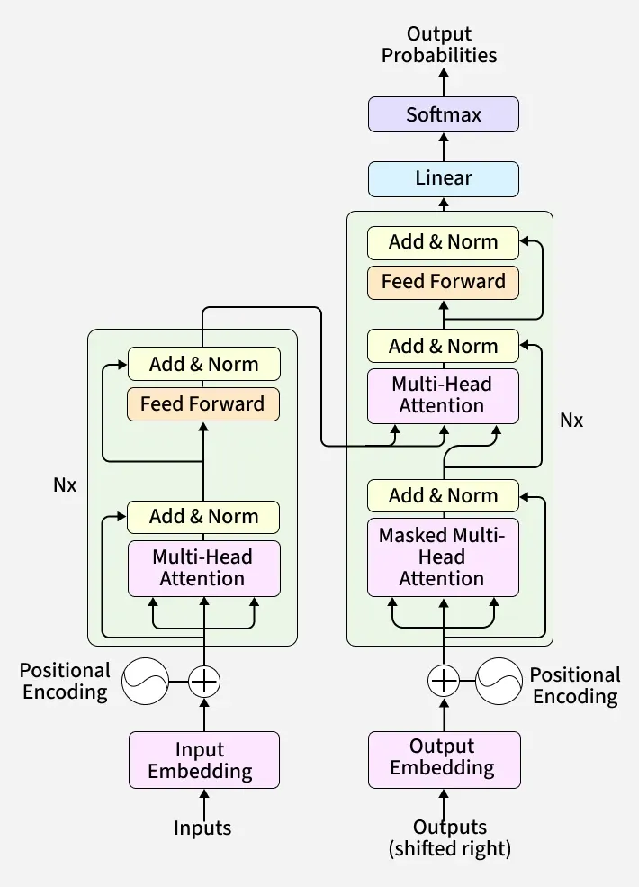
Figure 6 — The Transformer model overview

The Transformer is a deep learning architecture introduced in the landmark 2017 paper "Attention Is All You Need" by Vaswani et al. at Google Brain. It discards the recurrent and convolutional operations that previously dominated sequence modelling and replaces them entirely with self-attention and point-wise, fully connected layers. This single design decision unlocked massive parallelism during training and the ability to model long-range dependencies without vanishing-gradient degradation. Today, virtually every large language model — from BERT to GPT-4, Qwen, and LLaMA — is built on top of the Transformer blueprint.
At a high level the architecture is split into two halves: an Encoder that reads the input sequence and compresses it into a rich contextual representation, and a Decoder that attends to that representation while autoregressively generating an output sequence. Both halves are composed of repeated, identically structured layers (×6 in the original paper) each containing Multi-Head Attention and a Feed-Forward sub-network, connected through residual (Add) connections and Layer Normalization.
Key innovations of the Transformer:
- Self-attention allows every token to directly attend to every other token in a single operation.
- Positional encodings inject sequence-order information into otherwise order-agnostic embeddings.
- Multi-head attention lets the model attend to information from different representation sub-spaces simultaneously.
- Residual connections and layer normalisation stabilise gradient flow and accelerate training.
- The fully feed-forward sub-network applies the same two-layer MLP independently to every position.

2.1 Attention Mechanism and Self-Attention
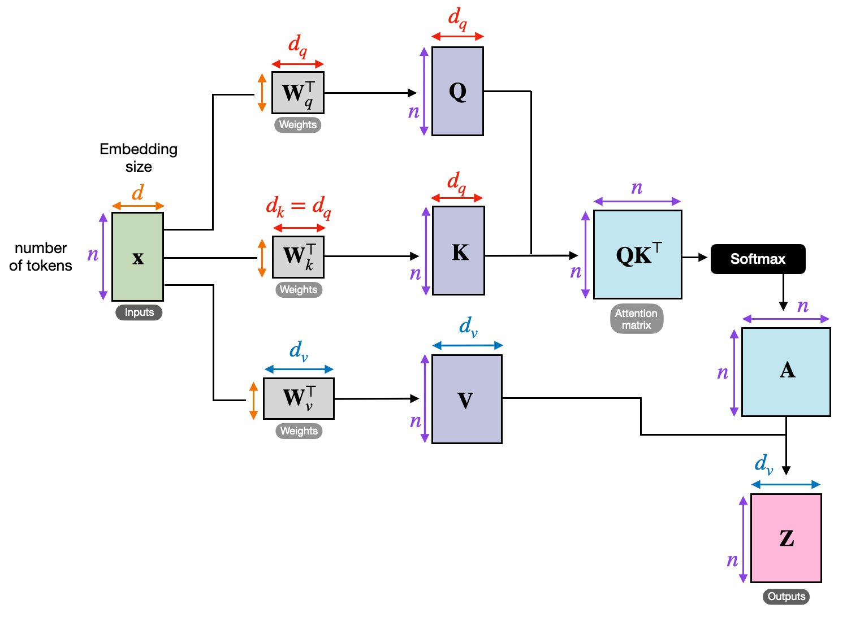
Figure 7 — Scaled Dot-Product Attention and Multi-Head Attention side by side
Attention is the core computational primitive of the Transformer. In classical sequence-to-sequence models an encoder compressed the entire source sentence into a single fixed vector, creating a severe information bottleneck for long inputs. The attention mechanism breaks this bottleneck by allowing the decoder to dynamically select and weight different parts of the encoder output on every decoding step.
Self-attention (also called intra-attention) extends this idea so that each token in a single sequence can attend to all other tokens in the same sequence. This gives every position a full view of its context — both left and right — in a single forward pass, regardless of distance. Formally, given a sequence of n token vectors arranged as a matrix X ∈ ℝⁿˣᵈ, self-attention computes three projections: Queries (Q), Keys (K), and Values (V).

2.1.1 Scaled Dot-Product Attention

Figure 8 — Scaled Dot-Product Attention: Q, K, V projections → attention matrix → output Z
Scaled Dot-Product Attention is the building block of every attention layer. Given the input matrix X, three learned weight matrices W_q, W_k, W_v project X into query, key, and value matrices:
Q = X · W_qᵀ K = X · W_kᵀ V = X · W_vᵀ
The attention scores are computed as the dot product of Q and Kᵀ, scaled by the square root of the key dimension d_k to prevent the softmax from saturating in high-dimensional spaces:
Attention(Q, K, V) = softmax( Q Kᵀ / √d_k ) · V
The scaling factor √d_k is critical: without it, the dot products grow large in magnitude, pushing the softmax into regions with extremely small gradients. The output Z is a weighted sum of the Value vectors, where each weight reflects how relevant the corresponding key is to the current query.
Step-by-step walkthrough:
- Step 1 — Linear projection: multiply input X by weight matrices to obtain Q, K, V.
- Step 2 — Dot products: compute QKᵀ to produce an n × n attention score matrix.
- Step 3 — Scale: divide by √d_k.
- Step 4 — (Optional masking): in the decoder, future positions are masked with −∞ before softmax.
- Step 5 — Softmax: convert scores to probability weights summing to 1 per row.
- Step 6 — Weighted sum: multiply attention weights by V to produce output Z.

2.1.2 Multi-Head Attention
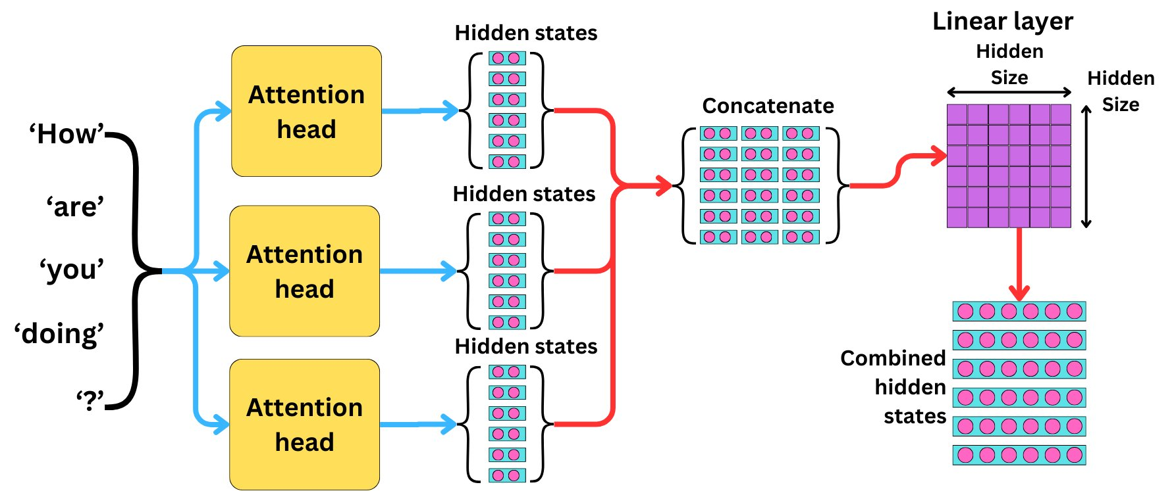
Figure 9 — Multi-Head Attention: parallel attention heads concatenated and projected
A single attention head computes one set of attention weights, but different syntactic and semantic relationships may be best captured from different "viewpoints" of the embedding space. Multi-Head Attention addresses this by running h independent attention heads in parallel, each with its own learned projection matrices W_qⁱ, W_kⁱ, W_vⁱ of smaller dimension d_q = d_k = d_v = d_model / h.
MultiHead(Q, K, V) = Concat(head₁, …, headₕ) · W_O
where headᵢ = Attention(Q Wqᵢ, K Wkᵢ, V Wvᵢ)
Each head independently attends to the input, producing its own hidden-state matrix. These are concatenated along the feature dimension to form a matrix of shape n × (h·d_v) and then projected back to d_model via the output weight matrix W_O ∈ ℝ^(h·d_v × d_model).
For example, with h = 3 heads as illustrated above, the tokens "How", "are", "you", "doing", "?" are fed into all three attention heads simultaneously. Each head produces its own set of hidden states (one vector per token). The three hidden-state matrices are concatenated and passed through the linear (fully connected) layer to produce the combined hidden states — one contextualised vector per token that captures information from all three representational sub-spaces.
Benefits of multi-head attention:
- Captures multiple types of relationships simultaneously (e.g., syntactic and semantic).
- Heads can specialise: one might track coreference, another long-range verb–object links.
- No additional sequential computation — all heads run in parallel.

2.2 Encoder–Decoder Structure
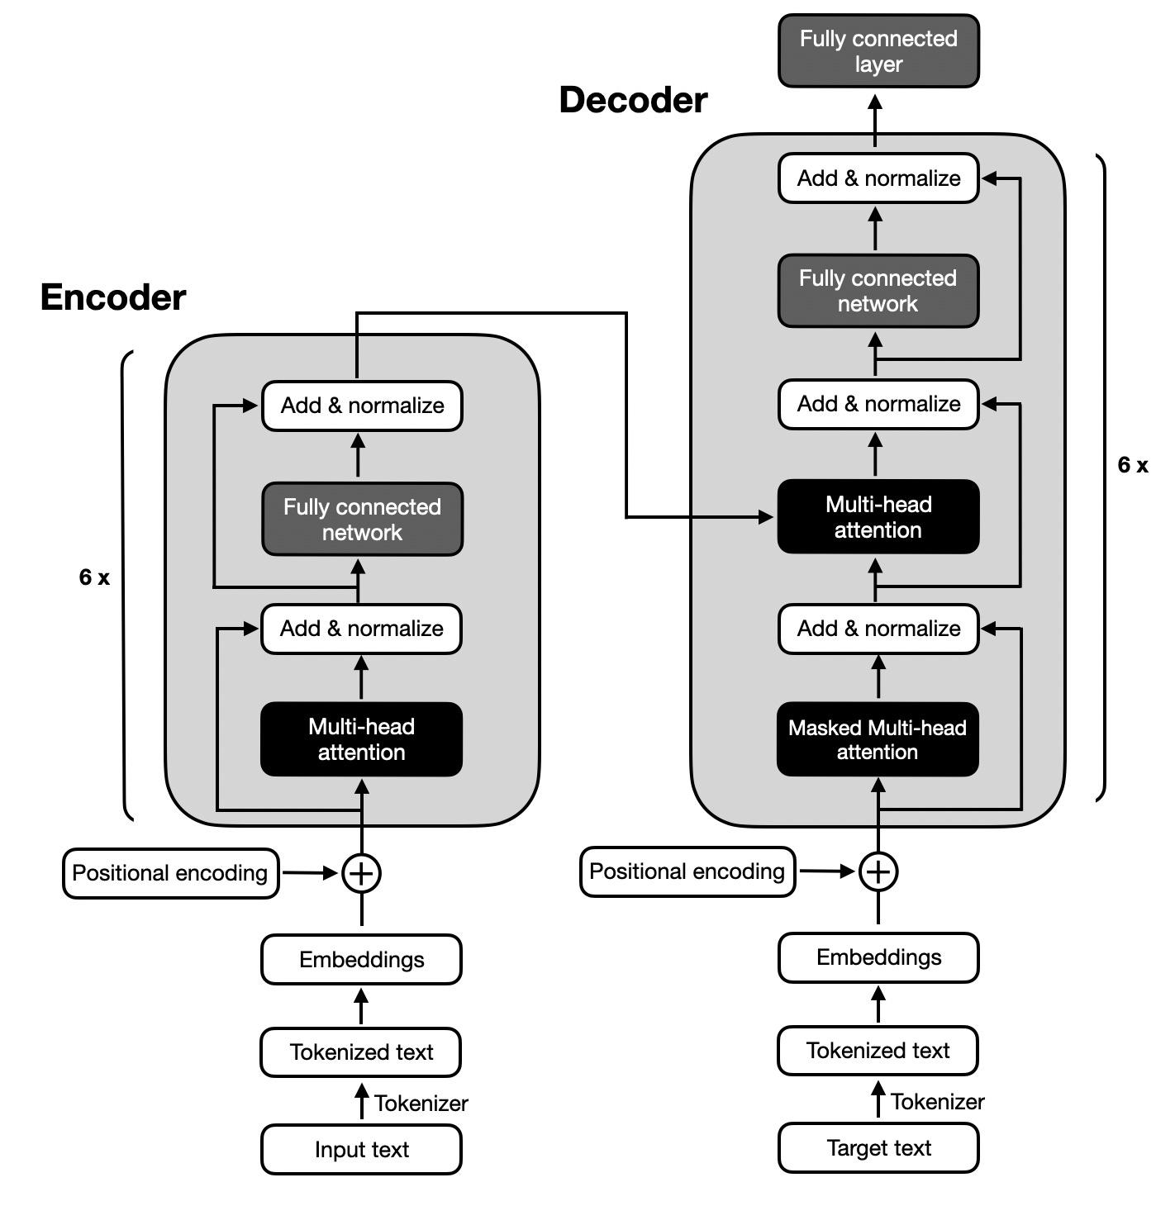
Figure 10 — Full Encoder–Decoder Transformer architecture (×6 stacked layers each side)
The original Transformer pairs a stack of N = 6 identical encoder layers with a stack of N = 6 identical decoder layers. The Encoder processes the full source sequence in parallel, and the Decoder generates the target sequence token by token in an autoregressive fashion.

Encoder
Each encoder layer contains two sub-layers. First, a Multi-Head Self-Attention mechanism allows each source token to attend to all other source tokens. Second, a position-wise Feed-Forward Network (FFN) applies the same two-layer MLP independently to every position. Each sub-layer is wrapped in a residual (Add) connection followed by Layer Normalisation:
Output = LayerNorm( x + SubLayer(x) )
The encoder produces a sequence of contextualised representations — one vector per source token — that encapsulates both local and global semantic context.

Decoder
Each decoder layer contains three sub-layers. The first is a Masked Multi-Head Self-Attention over the decoder input (outputs generated so far). The causal mask prevents any position from attending to future positions, preserving the autoregressive property during training. The second sub-layer is a Cross-Attention (encoder–decoder attention) layer: the decoder queries come from the previous decoder sub-layer, while the keys and values come from the encoder output. This is how the decoder reads the source representation. The third sub-layer is the same position-wise FFN as in the encoder.
Key structural differences between encoder and decoder:
- Decoder has an extra cross-attention sub-layer that attends to encoder output.
- Decoder self-attention is masked (causal) to prevent attending to future tokens.
- Decoder runs autoregressively at inference; encoder runs in one shot.

2.3 Positional Encoding
Self-attention is permutation-invariant: it treats its inputs as a set, not a sequence. Without additional information, the model cannot distinguish "The cat sat on the mat" from any reordering of those words. Positional encodings inject sequence-order information by adding a position-dependent signal to each token embedding before it enters the first layer.
The original paper uses fixed sinusoidal encodings with alternating sine and cosine functions at geometrically spaced frequencies:
PE(pos, 2i) = sin( pos / 10000^(2i/d_model) )
PE(pos, 2i+1) = cos( pos / 10000^(2i/d_model) )
Here pos is the token position and i is the embedding dimension index. Because sin/cos at different frequencies, any fixed offset k can be expressed as a linear function of the encoding at position pos, allowing the model to attend by relative position. Modern LLMs often replace these fixed encodings with learned positional embeddings (GPT family) or rotary positional encodings — RoPE (LLaMA, Qwen) — which are applied inside the attention mechanism itself and generalise better to sequences longer than those seen during training.

2.4 Feed-Forward Networks and Layer Normalisation
Each attention sub-layer is followed by a two-layer position-wise Feed-Forward Network (FFN). The same FFN is applied independently and identically to each position:
FFN(x) = max(0, x W₁ + b₁) W₂ + b₂
The inner layer is typically 4× wider than d_model (e.g., 2048 → 8192 in the base Transformer). The ReLU activation introduces non-linearity. Modern models replace ReLU with GELU, SwiGLU, or SiLU activations for smoother training dynamics.
Layer Normalisation (LayerNorm) is applied after the residual addition. Unlike Batch Norm, which normalises across the batch dimension, LayerNorm normalises across the feature dimension for each token independently, making it well-suited for variable-length sequences and small-batch training:
LayerNorm(x) = γ · (x − μ) / (σ + ε) + β
Some recent architectures (GPT-2 and descendants) apply LayerNorm before the sub-layer (Pre-LN) rather than after (Post-LN), which improves training stability for very deep models.

2.5 Decoder-Only LLMs — GPT Family, Qwen, and LLaMA
Modern large language models have overwhelmingly adopted the decoder-only variant of the Transformer. Rather than encoding a source sentence, they are trained to predict the next token in a sequence — repeatedly applied at inference to generate arbitrarily long outputs. Below is a comparative overview of the three dominant families.
Feature | GPT Family | Qwen | LLaMA
Developer | OpenAI | Alibaba DAMO | Meta AI
First Release | GPT-1 (2018) | Qwen-7B (2023) | LLaMA 1 (2023)
Architecture | Decoder-only Transformer | Decoder-only Transformer | Decoder-only Transformer
Positional Encoding | Learned absolute (GPT-1/2/3); RoPE (GPT-4 era) | RoPE (Rotary) | RoPE (Rotary)
Attention Variant | Multi-Head Attention (MHA) | Grouped Query Attention (GQA) | Grouped Query Attention (GQA)
Normalisation | Post-LN (GPT-2) → Pre-LN later | RMS Norm (Pre-Norm) | RMS Norm (Pre-Norm)
Activation | GELU | SwiGLU | SiLU / SwiGLU
Vocabulary Size | ~50k (GPT-2) ~100k (GPT-4) | ~150k (multi- lingual focus) | ~32k–128k (Llama 2→3)
Context Length | 2k→128k+ | 8k→1M (Qwen2.5) | 4k→128k+
Open Weights? | No (proprietary) | Yes (Qwen 1.5+) | Yes (LLaMA 2+)
Training Data | Proprietary / undisclosed | Multilingual incl. Chinese | Mostly English + multilingual
Notable Models | GPT-2, GPT-3, GPT-4, o1, o3 | Qwen1.5, Qwen2, Qwen2.5 (0.5B–72B) | LLaMA 1/2/3, LLaMA 3.1/3.2/3.3
Key Differentiator | Pioneer, best-known API | Strong multilingual & long-ctx | Open research baseline
GPT Family (OpenAI)
The Generative Pre-trained Transformer family originated with GPT-1 in 2018 and established the pretraining–fine-tuning paradigm. GPT-2 demonstrated emergent capabilities and sparked debate about model release safety. GPT-3 (175 B parameters) showed that scale alone enables few-shot learning without task-specific fine-tuning. GPT-4 introduced multimodal inputs and remains one of the most capable closed models. The o-series (o1, o3) added chain-of-thought reasoning at inference time. All use standard learned or RoPE positional embeddings and causal self-attention with no cross-attention layers.
Qwen (Alibaba DAMO)
The Qwen series from Alibaba focuses on strong multilingual performance — especially Chinese and other East Asian languages — and long-context reasoning. Qwen2.5 supports context windows of up to one million tokens through efficient attention mechanisms. It employs Rotary Positional Encoding (RoPE), Grouped Query Attention (GQA) to reduce KV-cache memory, SwiGLU activations, and RMS Normalisation applied before each sub-layer (Pre-Norm). Weights are open for Qwen 1.5 and later.
LLaMA (Meta AI)
The LLaMA models have become the canonical open research baseline for decoder-only Transformers. LLaMA 1 was trained on publicly available data only, enabling reproducible research. LLaMA 2 added supervised fine-tuning and RLHF variants. LLaMA 3 expanded the vocabulary to 128k tokens and improved multilingual coverage. LLaMA 3.1/3.2/3.3 extended context lengths to 128k and introduced efficient GQA. The architecture uses Pre-Norm RMSNorm, SiLU/SwiGLU activation, and RoPE — a pattern now widely replicated by the open-source community (Mistral, Falcon, Phi, etc.).

2.6 Why Transformers Replaced RNNs
Recurrent Neural Networks (RNNs) — especially LSTMs and GRUs — dominated sequence modelling through the early 2010s. However, they suffered from several structural limitations that Transformers directly address:
- Sequential computation: RNNs process tokens one at a time, making training on modern parallel hardware (GPUs/TPUs) inefficient. Transformers process all positions simultaneously.
- Vanishing/exploding gradients: backpropagating through hundreds or thousands of time steps degrades gradient signal. Residual connections in Transformers maintain gradient flow regardless of depth.
- Long-range dependencies: information about a token at position 1 must pass through hundreds of intermediate states to influence a token at position 500. In Transformers, any two tokens can directly attend to each other in O(1) operations.
- Fixed-size bottleneck: encoder–decoder RNNs compress the source into a single hidden vector. Transformer cross-attention gives the decoder access to all encoder positions simultaneously.
The trade-off is quadratic attention complexity O(n²) in sequence length, which becomes prohibitive for very long contexts. This has motivated a wave of efficient attention variants (Longformer, Reformer, Flash Attention) and alternative architectures (Mamba/SSMs) that aim to restore linear scaling while preserving Transformer expressiveness.

2.7 Challenges: Compute Cost and Context Length
Despite their success, Transformers introduce significant engineering challenges at scale:
Compute Cost
- Training a large Transformer requires thousands of GPU/TPU-days. GPT-3 was estimated to cost millions of dollars to train from scratch.
- The parameter count grows quadratically with d_model and linearly with the number of layers, leading to models with hundreds of billions of parameters (GPT-4, LLaMA 3.1 405B).
- Inference also demands large accelerators: serving a 70B model at low latency requires multi-GPU setups.
Context Length
- Standard self-attention is O(n²) in memory and compute with respect to sequence length n. Doubling the context quadruples the attention cost.
- Flash Attention (Dao et al., 2022) reduces memory to O(n) via IO-aware tiling, enabling longer contexts on the same hardware.
- Rotary positional encoding (RoPE) and ALiBi bias allow models to generalise to lengths beyond those seen during training.
- Qwen2.5 claims up to 1 million token contexts using a combination of RoPE extrapolation and sparse/hierarchical attention patterns.
- Active research areas include sliding-window attention, state-space models, and retrieval-augmented generation as alternatives to ever-larger context windows.

Chapter 3: Fine-Tuning Strategies and Parameter-Efficient Methods
Pages 35–42

After a language model has been pre-trained on a large unlabelled corpus it possesses broad linguistic and factual knowledge, but it is not yet optimised for any specific task or conversational style. Chapter 3 covers the spectrum of techniques used to adapt pre-trained Transformers to downstream applications — ranging from full supervised fine-tuning, through alignment methods such as RLHF and instruction tuning, to highly parameter-efficient approaches like LoRA and QLoRA that make large-model adaptation tractable on limited hardware.

3.1 Pre-Training vs. Fine-Tuning Paradigm
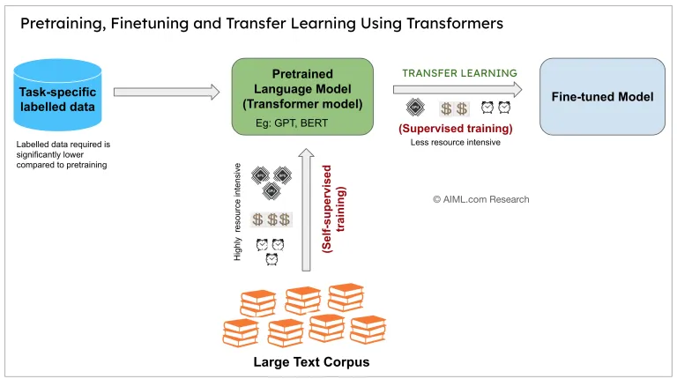
Figure 11— Pre-training, Fine-Tuning and Transfer Learning using Transformers (AIML.com Research)
Modern NLP is built on a two-stage paradigm. In the first stage — pre-training — a large Transformer is trained on a massive unlabelled text corpus (billions to trillions of tokens) using a self-supervised objective such as next-token prediction (causal LM) or masked-token prediction (masked LM). This stage is highly resource-intensive, requiring thousands of GPU-hours and significant financial cost, but it endows the model with rich, transferable representations of language.
In the second stage — fine-tuning — the pre-trained model is adapted to a target task using a much smaller labelled dataset. Because the model already "understands" language, the labelled data required is significantly lower compared to training from scratch. This transfer learning dynamic is what makes large language models economically viable for domain-specific applications.
Key distinctions between the two stages:
- Pre-training: self-supervised, no human labels, massive data, weeks on many GPUs, trained once and reused.
- Fine-tuning: supervised or preference-based, small curated datasets, hours to days on fewer GPUs, specialises a base model.
- Transfer learning efficiency: fine-tuned models consistently outperform task-specific models trained from scratch, even with far less labelled data.
The dominant pre-trained models used as starting points include GPT-2/3/4 (OpenAI), LLaMA 2/3 (Meta), Qwen 2/2.5 (Alibaba), and Mistral. For this project, LLaMA-based models fine-tuned via the LLaMA-Factory framework serve as the primary experimental platform.

3.2 Supervised Fine-Tuning (SFT)
Supervised Fine-Tuning (SFT) is the simplest adaptation strategy: the pre-trained model is continued on a curated dataset of (input, output) pairs using standard cross-entropy loss. The model parameters are updated via gradient descent to maximise the likelihood of the target output given the input.
SFT data formats commonly used:
- Instruction-following: pairs of (instruction, response) that teach the model to follow commands in natural language.
- Question–Answer (QA): domain-specific question–answer pairs for factual grounding.
- Conversational: multi-turn dialogue examples that shape the model's interaction style.
- Chain-of-thought: examples with explicit reasoning steps to elicit step-by-step thinking.
During SFT the entire model can be updated (full fine-tuning) or only a subset of parameters (parameter-efficient fine-tuning, PEFT). Full fine-tuning is often prohibitive for models above 7B parameters on consumer hardware, which motivates the parameter-efficient methods discussed in Sections 3.4 and 3.5.
A critical practical consideration is catastrophic forgetting: aggressive fine-tuning on a narrow domain can degrade the model's general capabilities. Techniques such as replay buffers, elastic weight consolidation, and carefully controlled learning rates mitigate this risk.

3.3 RLHF and Instruction Tuning
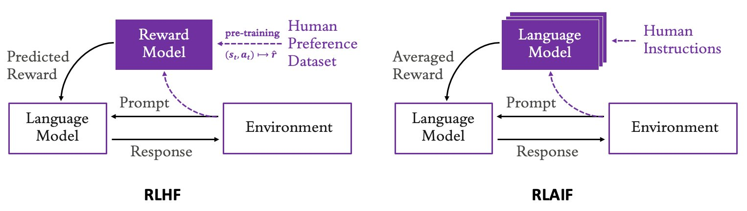
Figure 12— RLHF (left) vs RLAIF (right): reward model trained from human preferences vs AI-generated preferences

While SFT teaches a model what to output, it does not directly optimise for human preferences such as helpfulness, harmlessness, and honesty. Reinforcement Learning from Human Feedback (RLHF) addresses this by introducing an explicit reward signal derived from human judgements, and using reinforcement learning to maximise that reward.
Instruction Tuning is a closely related technique in which the model is fine-tuned on a large and diverse set of tasks expressed as natural-language instructions. Models such as InstructGPT, FLAN-T5, and LLaMA-2-Chat are products of combining SFT with instruction tuning and RLHF.

3.3.1 Reward Modelling and PPO
The RLHF pipeline consists of three stages:
- Stage 1 — SFT: fine-tune the base model on demonstration data to produce an initial policy that can follow instructions.
- Stage 2 — Reward Model training: collect human preference comparisons (which of two model outputs is better?), and train a reward model R(s, a) that predicts the scalar reward for a given (prompt, response) pair.
- Stage 3 — RL optimisation: use Proximal Policy Optimisation (PPO) to update the LM policy to maximise the expected reward from R, while constraining drift from the SFT policy via a KL-divergence penalty.
PPO is chosen over other RL algorithms because of its stability: it clips the probability ratio between old and new policy to prevent excessively large updates. The KL penalty is critical — without it, the model can "reward-hack" by producing outputs that score highly on the reward model but are degenerate or unhelpful.
RLAIF (Reinforcement Learning from AI Feedback), shown on the right of Figure 3.3, replaces human annotators with a stronger AI model that generates preference labels. This dramatically reduces annotation cost and scales more easily, at the expense of inheriting any biases present in the AI judge.

3.3.2 Why SFT Was Chosen Over RLHF in This Project
Despite its theoretical appeal, the full RLHF pipeline introduces substantial practical complexity: it requires training and serving three separate models (base policy, reward model, reference policy) simultaneously, and PPO is notoriously sensitive to hyperparameters. For this graduation project, SFT was selected as the primary adaptation strategy for the following reasons:
- Resource constraints: RLHF requires significantly more GPU memory and compute than SFT alone.
- Data availability: constructing a reliable human-preference dataset for the target domain was not feasible within project scope.
- Demonstrated sufficiency: recent work (e.g., LIMA, 2023) shows that high-quality SFT on as few as 1,000 curated examples can produce models competitive with RLHF-trained counterparts on many benchmarks.
- Stability: SFT training is more predictable and reproducible, which is important for ablation studies.
Future work could extend this project by collecting preference data post-deployment and applying Direct Preference Optimisation (DPO) — a simpler, PPO-free alternative to RLHF that reframes the reward-learning problem as a classification objective directly on the policy.

3.4 Low-Rank Adaptation (LoRA)
Low-Rank Adaptation (LoRA), introduced by Hu et al. (2021), is a parameter-efficient fine-tuning technique that dramatically reduces the number of trainable parameters by constraining weight updates to low-rank matrix decompositions. Rather than updating all W parameters of a pre-trained weight matrix W₀ ∈ ℝ^(d×k), LoRA freezes W₀ and learns a low-rank decomposition of the update:
W = W₀ + ΔW = W₀ + B · A
where B ∈ ℝ^(d×r) and A ∈ ℝ^(r×k) with rank r ≪ min(d, k). During training only A and B are updated; W₀ remains frozen. At inference the product B·A can be merged back into W₀ with zero additional latency.

3.4.1 Mathematical Formulation
The forward pass for a LoRA-adapted layer is:
h = W₀x + (B·A)x · (α/r)
where α is a scaling hyperparameter that controls the magnitude of the LoRA update relative to the original weights. A is initialised with a random Gaussian, and B is initialised to zero so that ΔW = 0 at the start of training and the model begins from the pre-trained checkpoint. The ratio α/r is held constant across different rank choices for comparability.
Parameter count comparison:
- Full fine-tuning of a 7B model: ~7 billion trainable parameters.
- LoRA with r = 16 applied to Q and V projections: ~4–8 million trainable parameters (<0.1% of total).
- Training memory reduction: roughly 3× compared to full fine-tuning with Adam optimizer.

3.4.2 Rank Selection and Adapter Configuration
The rank r is the primary hyperparameter governing the capacity of the LoRA adapter. Lower ranks impose a stronger bottleneck and act as regularisation; higher ranks allow more expressive updates but approach full fine-tuning in cost.
Practical guidelines for rank selection:
- r = 4–8: sufficient for simple instruction-following tasks with limited domain shift.
- r = 16–32: recommended for moderate domain adaptation (e.g., medical, legal, or code generation).
- r = 64–128: approaches full fine-tuning expressiveness; used when the target domain diverges significantly from pre-training data.
LoRA is typically applied to the attention weight matrices (W_q, W_k, W_v, W_o) and optionally to the feed-forward network projections. Applying LoRA to all linear layers generally outperforms restricting it to attention alone, at a modest increase in parameter count.

3.5 QLoRA and Quantization Basics
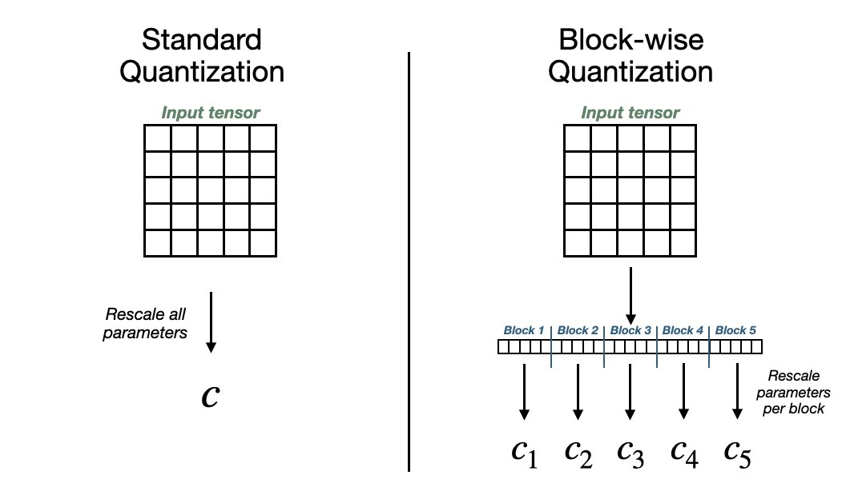
Figure 13— Standard Quantization vs Block-wise Quantization: per-block scaling constants reduce quantization error
QLoRA (Quantized Low-Rank Adaptation), introduced by Dettmers et al. (2023), combines LoRA with aggressive quantization of the frozen base model weights to 4-bit precision (NF4 — Normal Float 4), enabling fine-tuning of models with 65B+ parameters on a single consumer GPU.
Quantization fundamentals
Quantization maps continuous floating-point weights to a finite set of discrete levels. Standard quantization uses a single scaling constant c to rescale all parameters in a weight tensor to a target bit-width, as shown on the left of Figure 3.5. While straightforward, a single global constant is sensitive to outlier values: one extreme weight can force all others into a narrow band, introducing large quantization error.
Block-wise quantization (right side of Figure 3.5) divides the input tensor into smaller blocks (e.g., 64 or 128 values each) and computes an independent scaling constant c₁, c₂, …, cₙ per block. This localises the impact of outliers and substantially reduces average quantization error, making 4-bit precision viable for large language models without catastrophic accuracy loss.
NF4 (Normal Float 4) data type
QLoRA introduces the NF4 data type, which is information-theoretically optimal for normally distributed weights. Rather than using uniformly spaced quantization levels, NF4 places quantization levels at the quantiles of a standard normal distribution, so that each level captures an equal fraction of the probability mass. This is well-matched to the empirical weight distribution of pre-trained Transformer layers.
Double quantization
QLoRA further reduces memory by quantizing the quantization constants themselves (the c values from block-wise quantization) using a second-level 8-bit quantization. This "double quantization" saves an additional ~0.37 bits per parameter on average.
Paged optimizers
To handle memory spikes during gradient checkpointing, QLoRA uses NVIDIA unified memory to page optimizer states between GPU and CPU RAM, preventing out-of-memory errors without requiring manual memory management.
Memory comparison (fine-tuning a 7B model):
Method | Precision | GPU RAM (approx.)
Full Fine-Tuning | BF16 | ~120 GB
LoRA | BF16 | ~40 GB
QLoRA | NF4 + BF16 | ~10–12 GB
QLoRA makes it possible to fine-tune a 7B parameter model on a single 12 GB GPU — a standard consumer-grade card — and a 70B model on a single 48 GB A100. This is transformative for research accessibility and is the primary reason QLoRA was adopted in this project.

3.6 LLaMA-Factory Framework Overview
LLaMA-Factory is an open-source, unified fine-tuning framework that supports a wide range of LLMs (LLaMA, Mistral, Qwen, Baichuan, etc.) and fine-tuning strategies (SFT, DPO, RLHF, LoRA, QLoRA, full fine-tuning) through a single configuration interface. It abstracts away boilerplate training code and provides:
- A YAML/JSON-based configuration system for specifying model, dataset, training method, and hyperparameters.
- Built-in support for popular datasets in Alpaca, ShareGPT, and custom formats with automatic preprocessing.
- Seamless integration with HuggingFace Transformers, PEFT, bitsandbytes (for quantization), and DeepSpeed/FSDP for distributed training.
- A web-based UI (LLaMA Board) for no-code fine-tuning and evaluation.
- Evaluation pipelines and inference scripts for immediate model testing after training.
In this project, LLaMA-Factory is used to orchestrate QLoRA fine-tuning of a LLaMA-3 base model on a domain-specific dataset. The framework's modular design allows rapid iteration over hyperparameters (rank, learning rate, batch size, training epochs) without modifying training code.
Key configuration parameters used:
- model_name_or_path: path to the base pre-trained model checkpoint.
- finetuning_type: set to "lora" for LoRA/QLoRA adaptation.
- quantization_bit: set to 4 for NF4 quantization (QLoRA mode).
- lora_rank: the rank r of the LoRA decomposition.
- lora_target: comma-separated list of modules to apply LoRA to (e.g., "q_proj,v_proj").
- per_device_train_batch_size and gradient_accumulation_steps: control effective batch size under memory constraints.

3.7 Experiment Tracking with Weights & Biases
Weights & Biases (W&B) is a machine learning experiment tracking platform that logs training metrics, hyperparameters, model artefacts, and system resource usage in real time. It provides a web dashboard for comparing runs, visualising learning curves, and identifying training instabilities.
In this project W&B is used to track:
- Training loss and validation loss across epochs for each experimental configuration.
- Perplexity curves to monitor generalisation and detect overfitting.
- GPU utilisation, memory consumption, and training throughput (tokens/second).
- Hyperparameter sweeps comparing different LoRA ranks (r = 8, 16, 32, 64) and learning rates.
- Model checkpoint artefacts for reproducibility and rollback.
Integration with LLaMA-Factory requires only adding the W&B API key to the training configuration; all metric logging is handled automatically via the HuggingFace Trainer callback system. The resulting experiment dashboard provides a transparent and reproducible record of all fine-tuning decisions made during this project.
Experiment tracking proved particularly valuable when diagnosing a training instability encountered with a high learning rate (5e-4) and rank 64 adapter — the loss spike visible in the W&B dashboard prompted an immediate rollback and lr reduction to 1e-4, which resolved the issue without restarting from the base checkpoint.

Chapter 4: Dataset Design and Preparation
Pages 43–53

The quality of any fine-tuned language model is fundamentally bounded by the quality of its training data. A technically sophisticated training pipeline applied to a poorly constructed dataset will consistently underperform a simpler method trained on carefully curated examples. This chapter details every decision made in constructing the supervised fine-tuning dataset used in this project — from the linguistic characteristics that shape Arabic data collection, through the formal schema design that governs structured output, to the instruction-formatting conventions and validation pipeline that ensure training-ready quality.

4.1 Arabic NLP: Challenges and Characteristics
Arabic occupies a uniquely challenging position among the world's major languages for natural language processing. Unlike English and other Indo-European languages that have dominated NLP benchmarks, Arabic combines several orthographic, morphological, and sociolinguistic properties that compound into significant engineering complexity. Understanding these characteristics is essential for designing a dataset that accurately captures the breadth of real-world Arabic text and tests the model on linguistically meaningful distinctions.
Morphological richness. Arabic is a root-and-pattern language in which most words are derived from tri-literal (and occasionally quadri-literal) consonantal roots by the application of morphological patterns. A single root such as k-t-b (to write) can generate dozens of derived forms: kataba (he wrote), maktaba (library), kitaab (book), kaatib (writer), maktub (written/letter), and so on. Each derived form undergoes further inflection for gender, number, case, definiteness, and person, producing a productive morphology that far exceeds the complexity seen in Romance or Germanic languages. For NLP systems, this means that vocabulary size explodes relative to English: a 50,000-token Arabic vocabulary covers far less semantic surface area than an equivalent English vocabulary.
Diacritization and orthographic ambiguity. Standard written Arabic typically omits short vowels (harakat), relying on context and reader knowledge to resolve ambiguity. The word كتب (k-t-b) without diacritics can be read as kataba (he wrote), kutiba (it was written), or kutub (books), among other possibilities. Modern Standard Arabic (MSA) documents — including the news articles used in this project — are almost universally unvocalized. This creates a fundamental disambiguation challenge that the model must resolve from context alone, mirroring the way a human reader parses meaning from consonantal skeletons.
Dialectal fragmentation. The Arabic-speaking world spans 22 countries across North Africa and the Middle East, each with a distinct colloquial dialect that differs from MSA in vocabulary, morphology, syntax, and phonology. Egyptian Arabic, Levantine Arabic, Gulf Arabic, and Moroccan Darija are mutually distinct enough that speakers from opposite ends of the Arab world sometimes struggle to communicate. While MSA functions as a written lingua franca, informal digital content — social media posts, comments, online forums — is dominated by dialectal forms, often mixed with MSA in a phenomenon known as code-switching. The dataset in this project draws exclusively from MSA news sources, but the model's training should be understood as MSA-centric, with potentially weaker generalization to dialectal inputs.
Named entity characteristics. Arabic named entities present several challenges absent in English NER. Person names frequently coincide with common nouns (e.g., the name Salam means peace; Nour means light). Named entities are not typically capitalized — Arabic script has no case distinction — making visual heuristics unavailable to the model. Organization names often include Arabic definite articles, conjunctions, or prepositions as constituent parts, complicating boundary detection. Transliterated foreign names exhibit high orthographic variability: the name "Johnson" might appear as جونسون, جونسن, or جونسون depending on the publication, with no standardized convention.
Script and tokenization. Arabic is written right-to-left in a cursive connected script where letter forms change depending on their position within a word (initial, medial, final, isolated). Unicode representation of Arabic can vary — the same word may be encoded differently depending on whether specific letter-connection forms are explicitly encoded or left to the rendering engine. Tokenization strategies developed for Latin-script languages (BPE, WordPiece) require retraining or careful vocabulary extension to handle Arabic morpheme boundaries effectively. The Qwen2.5 tokenizer, pre-trained on a large multilingual corpus including significant Arabic content, provides reasonable sub-word segmentation for MSA text, though it may split morphologically meaningful units in ways that differ from linguistically motivated segmentation.

4.2 Task Definition: Entity Extraction and Translation
The fine-tuning dataset is designed to train the model on two complementary tasks applied jointly to the same Arabic news input: structured named entity recognition and Arabic-to-English translation. Defining these tasks precisely — what constitutes a valid entity, how translation quality is assessed, and how the two outputs relate to each other — is a prerequisite for consistent annotation and reliable evaluation.
Task 1 — Structured Named Entity Recognition. The model is required to identify and categorize named entities in Arabic news text according to a predefined taxonomy. Rather than producing BIO-tagged sequences (the classical NER output format), the model is trained to produce a structured JSON object that lists each identified entity with its surface form, its English translation, and its entity type. This structured output formulation has several advantages: it is directly machine-readable without post-processing, it forces the model to simultaneously perform entity recognition and cross-lingual entity linking, and it integrates naturally with the Pydantic schema validation pipeline described in Section 4.3.
The entity taxonomy comprises the following five categories:
- PERSON: Individual human beings referenced by name, title, or a combination. Includes political figures, business leaders, journalists, athletes, and historical persons. Honorifics (e.g., Dr., His Excellency) that appear as part of the surface form are included in the extracted span.
- ORGANIZATION: Companies, governmental bodies, political parties, international institutions, NGOs, and other named collective entities. The full official Arabic name is extracted as the surface form.
- LOCATION: Geographical entities including countries, cities, regions, rivers, mountains, and administrative subdivisions. Directional modifiers that are part of the official name (e.g., South Sudan, North Korea) are included.
- DATE: Temporal expressions that identify a specific date, time period, year, month, day, season, or relative temporal reference (e.g., last Thursday, the fiscal year 2023).
- EVENT: Named events including political summits, military operations, sporting competitions, and historical episodes. Events must be named (not merely described) to qualify for this category.
Entities may overlap syntactically — an organization may contain a location within its name, or a person name may also be a common noun — but for the purpose of annotation, each entity is assigned to the single most specific category that applies. Nested entities are not annotated.
Task 2 — Arabic-to-English Translation. The model is simultaneously trained to produce a fluent, faithful English translation of the complete Arabic news article. The translation task targets human-quality output: idiomatic English that preserves the meaning, tone, and register of the original, rather than a word-for-word gloss. Entity names in the translation should appear in their standard English rendering where a standard form exists (e.g., الأمم المتحدة → United Nations), and in a consistent romanization otherwise.
The rationale for training both tasks on the same input — rather than building two separate models — is that entity extraction and translation are informationally complementary. Entity recognition requires deep semantic parsing of the source text; translation requires both semantic understanding and target-language fluency. A model that can simultaneously name entities and translate is implicitly performing a richer form of semantic analysis than one trained on either task in isolation. Knowledge distillation from GPT-4o-mini, described in Section 4.4, provides training targets for both tasks in a single annotation pass.

4.3 Pydantic Schema Design for Structured Output
Structured output — the requirement that a language model produce outputs conforming to a formal schema rather than free text — introduces both an opportunity and a risk. The opportunity is that schema-valid outputs are directly machine-processable, enabling downstream applications without fragile text parsing. The risk is that models may produce outputs that are syntactically valid JSON but semantically inconsistent with the schema constraints. Pydantic, a Python data validation library, is used in this project both to define the target output schema and to validate model outputs at inference time.
Pydantic models define the structure of a Python object in terms of typed fields with optional validation constraints. When a model output is parsed as a Pydantic instance, validation is performed automatically: missing required fields raise a ValidationError, incorrectly typed values are coerced or rejected, and field-level validators can enforce domain-specific constraints (e.g., that an entity type must be one of the five values in the taxonomy). This makes Pydantic an ideal tool for building a dataset generation pipeline where output consistency is critical.

4.3.1 NewsDetails Schema
The NewsDetails schema captures the structured entity extraction output for a single Arabic news article. It is defined as a Pydantic BaseModel with the following fields:
from pydantic import BaseModel, Field
from typing import List, Literal
class Entity(BaseModel):
arabic_surface_form: str
english_translation: str
entity_type: Literal['PERSON', 'ORGANIZATION', 'LOCATION', 'DATE', 'EVENT']
class NewsDetails(BaseModel):
title_arabic: str = Field(..., description='Original Arabic headline')
title_english: str = Field(..., description='Translated English headline')
entities: List[Entity] = Field(..., description='All named entities in the article')
article_date: str = Field(..., description='Publication date in YYYY-MM-DD format')
source: str = Field(..., description='News outlet name')
Each field is annotated with a description that is passed to the GPT-4o-mini teacher model as part of the annotation prompt, guiding label generation. The Entity sub-model uses a Literal type for entity_type, which restricts permissible values to the five taxonomy categories and raises a validation error on any other input. The article_date field enforces ISO 8601 format through a field validator, ensuring consistent date representation across the dataset.
The entities list is intentionally unordered: entities are extracted in the order they appear in the text, but no sorting constraint is imposed. This mirrors the natural reading order of the source article and avoids introducing artificial ordering biases into the training signal.
Design consideration — partial entity lists. Real news articles frequently contain more named entities than a model can reliably enumerate in a single inference pass, particularly for long articles. To avoid truncation artifacts in training data, articles exceeding 800 Arabic tokens were split at paragraph boundaries before annotation, and each segment was annotated independently. The resulting entity lists were merged and deduplicated at the article level before formatting into instruction–response pairs.

4.3.2 TranslatedStory Schema
The TranslatedStory schema captures the translation output for the same Arabic news article. It is defined as a separate Pydantic model to allow independent validation of the translation task:
class TranslatedStory(BaseModel):
original_arabic: str = Field(..., description='Full original Arabic article text')
english_translation: str = Field(..., description='Complete fluent English translation')
translation_notes: List[str] = Field(
default_factory=list,
description='Optional notes on translation decisions'
)
The translation_notes field is optional and serves two purposes. During the knowledge distillation annotation phase, GPT-4o-mini occasionally appends notes about ambiguous source expressions, dialect-specific terms, or proper noun rendering conventions — information that would be lost if translation were a bare string field. Second, in the training data formatting step, these notes are selectively included in the response portion of instruction–response pairs for examples where they add instructive content; they are omitted for straightforward translations to keep responses concise.
The choice to separate NewsDetails and TranslatedStory into two distinct schemas — rather than merging them into a single combined schema — reflects a deliberate training design: the model is trained to produce either output depending on the instruction, enabling task-conditional behavior from a single fine-tuned checkpoint. Section 4.4 describes how the instruction templates are constructed to elicit each schema.

4.4 Data Formatting for SFT (Instruction–Response Pairs)
Supervised fine-tuning requires the training data to be formatted as instruction–response pairs: each training example consists of a natural-language instruction that specifies the task, the input Arabic article, and a target response that the model should learn to produce. The format must be compatible with the chat template of the base model (Qwen2.5-1.5B-Instruct) and with the LLaMA-Factory framework's dataset loader.
Instruction templates. Two instruction templates are used, one per task. The entity extraction instruction is:
You are an expert Arabic NLP analyst. Given the following Arabic news article,
extract all named entities and return a JSON object conforming to the NewsDetails
schema. For each entity, provide its Arabic surface form as it appears in the
text, its English translation, and its entity type (PERSON, ORGANIZATION,
LOCATION, DATE, or EVENT). Return only valid JSON with no additional commentary.
Article:
{arabic_article_text}
The translation instruction is:
You are a professional Arabic-to-English translator specializing in news content.
Translate the following Arabic news article into fluent, idiomatic English.
Return a JSON object conforming to the TranslatedStory schema, including the
original Arabic text, your English translation, and any notes on translation
decisions. Return only valid JSON with no additional commentary.
Article:
{arabic_article_text}
The instruction preamble establishes the model's role (expert analyst or professional translator), specifies the output format (JSON conforming to a named schema), and constrains the output to JSON-only with no commentary. This last constraint is critical: language models have a strong prior toward producing explanatory prose, and without an explicit prohibition many outputs include preamble text before the JSON object, breaking automated parsing.
Chat template integration. Qwen2.5-Instruct models use a specific chat template that wraps user and assistant turns in special tokens. The LLaMA-Factory framework handles this wrapping automatically when the dataset is provided in ShareGPT format, which structures each training example as:
{
"conversations": [
{ "from": "human", "value": "<instruction + article>" },
{ "from": "gpt", "value": "<JSON response>" }
]
}
The response field contains the raw JSON string produced by GPT-4o-mini, validated against the appropriate Pydantic schema before inclusion. Examples that fail Pydantic validation are routed to a remediation step described in Section 4.5.
Dataset composition and split. The final dataset comprises 2,700 instruction–response pairs distributed as follows:

Split | Examples | Proportion | Purpose
Training | 2,430 | 90% | SFT gradient updates
Validation | 162 | 6% | Loss monitoring & early stopping
Test | 108 | 4% | Final held-out evaluation
Table 4.4 — Dataset split by example count and purpose
The 2,700 examples are split evenly between entity extraction tasks (1,350 examples) and translation tasks (1,350 examples), ensuring the model receives equal exposure to both. Within each task, examples are sourced from five Arabic news outlets — Al Jazeera, BBC Arabic, Asharq Al-Awsat, Al Ahram, and Anadolu Agency — with roughly equal representation to avoid source-specific stylistic biases. Articles span the topics of politics, economics, sports, science, and culture, sampled to reflect the distribution of topics in the source outlets' archives.
Sequence length distribution. After tokenization with the Qwen2.5 tokenizer, instruction–response pairs have a median total length of 612 tokens and a 95th percentile of 1,847 tokens, well within the 4,096-token training context window used in this project. The distribution is right-skewed due to long translation responses for extended articles; pairs exceeding 2,500 tokens were trimmed at article paragraph boundaries to maintain a meaningful response.

4.5 Dataset Quality and Validation Pipeline
Automated knowledge distillation using a teacher model is a powerful but imperfect data generation strategy. GPT-4o-mini, while capable, produces annotation errors at a non-trivial rate — entity boundaries may be incorrectly drawn, entity types may be misassigned, JSON may be malformed, or translations may contain hallucinations. A systematic validation pipeline is therefore essential to detect and remediate these errors before training data is finalized.
The validation pipeline operates in four sequential stages, each with a defined acceptance criterion and a remediation path for failed examples.
Stage 1 — JSON Syntax Validation. Each GPT-4o-mini response is passed to Python's json.loads() parser. If parsing fails (due to a missing brace, unescaped quote, or truncated response), the example is flagged and re-submitted to the teacher model with an explicit prompt noting the parsing failure and requesting a corrected output. In practice, approximately 3.2% of initial responses required re-submission, and 98.7% of those succeeded on the second attempt. Examples failing twice were discarded.
Stage 2 — Pydantic Schema Validation. Syntactically valid JSON is then parsed into the appropriate Pydantic model (NewsDetails or TranslatedStory). Pydantic validation catches semantic errors that JSON parsing cannot: an entity_type value of "PLACE" instead of "LOCATION", a missing required field, or an article_date that does not conform to ISO 8601 format. Schema validation failures are categorized by error type and handled as follows:
- Entity type mismatches: automatically corrected using a lookup table that maps common alternative strings (e.g., PLACE → LOCATION, COMPANY → ORGANIZATION) to the canonical taxonomy value.
- Missing required fields: trigger a re-submission prompt that specifies the missing field by name.
- Date format errors: corrected programmatically by a regex-based date parser that handles the most common Arabic date representations (DD/MM/YYYY, DD-MM-YYYY, written month names).
Stage 3 — Entity Consistency Check. Validated NewsDetails responses are subjected to an additional cross-referential check: each entity's arabic_surface_form must appear as a substring of the input article text. This check catches hallucinated entities — a failure mode observed in approximately 1.8% of entity extraction examples, where the teacher model generates a plausible entity name that is not actually present in the source text. Such examples are discarded rather than corrected, as hallucinated entity forms cannot be reliably traced back to a source span.
Stage 4 — Translation Fluency Screening. TranslatedStory responses are screened using two lightweight heuristics. First, the character ratio between the English translation and the Arabic source is computed; translations with a ratio below 0.5 or above 3.0 standard deviations from the corpus mean are flagged for manual review, as extreme ratios suggest truncation or padding. Second, each translation is checked for the presence of Arabic characters, which would indicate an untranslated passage or a language identification failure. Approximately 0.9% of translations contained Arabic-script substrings and were re-submitted with an explicit instruction to translate all Arabic passages.
Following the four-stage pipeline, a random sample of 200 examples (100 entity extraction, 100 translation) was reviewed by a bilingual Arabic–English reviewer to assess overall annotation quality. The reviewer rated 93.5% of entity extraction examples as correct or acceptable (correct entity boundaries, correct type assignment, and a reasonable English rendering of each entity surface form). For translation, 91.0% of examples were rated as fluent and faithful. The primary failure mode in entity extraction was boundary errors at prepositional phrase attachments; in translation, the main failure mode was over-literal rendering of idiomatic Arabic expressions.
Final dataset statistics. After the complete validation pipeline, the dataset retained 2,700 examples out of an initial 2,831 generated (a 4.6% attrition rate). The distribution across entity types is shown in the table below:

Entity Type | Count | % of All Entities | Avg. per Article
PERSON | 4,217 | 31.4% | 3.12
ORGANIZATION | 3,589 | 26.7% | 2.66
LOCATION | 3,241 | 24.1% | 2.40
DATE | 1,654 | 12.3% | 1.23
EVENT | 728 | 5.4% | 0.54

Table 4.5 — Entity type distribution across the validated training dataset (n = 1,350 extraction examples)
PERSON entities are the most frequent, consistent with the news domain's focus on political and public figures. EVENT entities are the rarest, as named events typically appear only once or twice in an article compared to the repeated references to persons, organizations, and locations. The moderate frequency of DATE entities reflects the news article genre, where temporal anchoring of reported events is standard editorial practice.
The completed and validated dataset is serialized as a JSONL file (one JSON object per line) in ShareGPT format, ready for direct ingestion by the LLaMA-Factory training pipeline. A separate JSONL file contains the test split, which is held out until final model evaluation in Chapter 5.
The result is a dataset of 2,700 validated instruction–response pairs spanning entity extraction and Arabic-to-English translation, drawn from five major Arabic news outlets and reviewed for quality by a bilingual expert. Chapter 5 proceeds to describe how this dataset is used to fine-tune Qwen2.5-1.5B-Instruct using QLoRA, and to evaluate the resulting model against the base checkpoint on both tasks.

Chapter 5: Implementation and Experiments
Pages 54-69

This chapter presents the full implementation pipeline of the project — from environment setup and base model selection through training configuration, evaluation, and optimized deployment. Every result, metric, and configuration shown in this chapter is derived directly from the experimental runs documented in the project notebook.

5.1 Experimental Setup and Environment
All experiments were conducted on Google Colab, which provides an NVIDIA GPU (T4 / A100 depending on availability) with 15–40 GB of VRAM. Google Drive was mounted as the primary storage backend for datasets, model checkpoints, and evaluation outputs. The following libraries were installed and used throughout the pipeline:
# Core dependencies
transformers==4.48.3
datasets==3.2.0
optimum==1.24.0
openai==1.61.0
wandb
json-repair==0.29.1
faker==35.2.0
vllm==0.7.2

# Fine-tuning framework
git clone --depth 1 https://github.com/hiyouga/LLaMA-Factory.git
cd LLaMA-Factory && pip install -e .
LLaMA-Factory was selected as the fine-tuning orchestration framework because it provides a unified interface for configuring LoRA adapters, dataset formatting, evaluation scheduling, and experiment logging — all through a single YAML configuration file. Weights & Biases (WandB) was integrated for real-time training curve visualization and run tracking.
Two API integrations were established: the Hugging Face Hub for model download and checkpoint upload, and the OpenAI API (GPT-4o-mini) for knowledge distillation during dataset construction. All API credentials were stored securely in Google Colab's user secrets store.
Runtime | Google Colab (GPU: T4 / A100)
Storage | Google Drive (mounted at /gdrive/MyDrive/)
Framework | LLaMA-Factory (commit: latest stable)
Experiment Logger | Weights & Biases (wandb)
Teacher Model | GPT-4o-mini (OpenAI API)
Language | Python 3.10+, PyTorch 2.x

5.2 Base Model: Qwen2.5-1.5B-Instruct
The base model selected for fine-tuning is Qwen/Qwen2.5-1.5B-Instruct, a 1.5-billion parameter instruction-tuned language model from the Qwen2.5 family developed by Alibaba Cloud. The model was loaded from the Hugging Face Hub using the Transformers library with automatic device mapping:
base_model_id = "Qwen/Qwen2.5-1.5B-Instruct"

model = AutoModelForCausalLM.from_pretrained(
base_model_id,
device_map="auto",
torch_dtype=None # defaults to float32; bf16 applied during SFT
)
tokenizer = AutoTokenizer.from_pretrained(base_model_id)
Qwen2.5-1.5B-Instruct was selected for this project for three primary reasons. First, its compact size makes it trainable on a single consumer GPU with LoRA without requiring quantization. Second, it is a multilingual model with demonstrated capability on Arabic text, which is essential for the entity extraction and translation tasks defined in this project. Third, the instruction-tuned variant already follows structured prompt–response formats, reducing the amount of behavioral alignment required through SFT.
The model architecture follows the decoder-only transformer paradigm (Chapter 3), with rotary positional embeddings (RoPE), grouped query attention (GQA), and SwiGLU activation functions. It was pre-trained on a multilingual corpus including Arabic, English, Chinese, and dozens of other languages.
Model ID | Qwen/Qwen2.5-1.5B-Instruct
Parameters | 1.5 billion
Architecture | Decoder-only Transformer (RoPE + GQA + SwiGLU)
Context length | 32,768 tokens (cutoff_len: 3,500 in training)
Language support | Multilingual (Arabic, English, Chinese, ...)
Base dtype | float32 (bf16 during SFT via LLaMA-Factory)
Hub checkpoint | bakrianoo/news-analyzer (private)

5.3 Training Configuration and Hyperparameters
The fine-tuning was configured entirely through a LLaMA-Factory YAML file. The full configuration used in the project is reproduced below, exactly as it was executed during training:
### model
model_name_or_path: Qwen/Qwen2.5-1.5B-Instruct
trust_remote_code: true

### method
stage: sft
do_train: true
finetuning_type: lora
lora_rank: 64
lora_target: all

### dataset
dataset: news_finetune_train
eval_dataset: news_finetune_val
template: qwen
cutoff_len: 3500
overwrite_cache: true
preprocessing_num_workers: 16

### output
output_dir: /gdrive/MyDrive/.../models/
logging_steps: 10
save_steps: 500
plot_loss: true

### train
per_device_train_batch_size: 1
gradient_accumulation_steps: 4
learning_rate: 1.0e-4
num_train_epochs: 3.0
lr_scheduler_type: cosine
warmup_ratio: 0.1
bf16: true

### eval
per_device_eval_batch_size: 1
eval_strategy: steps
eval_steps: 100
report_to: wandb
run_name: newsx-finetune-llamafactory

### hub
push_to_hub: true
export_hub_model_id: bakrianoo/news-analyzer
hub_private_repo: true
hub_strategy: checkpoint
Several key design decisions in this configuration deserve explanation:
▸ LoRA rank = 64: LoRA rank 64 was chosen to provide sufficient adapter capacity for two structurally distinct tasks (entity extraction and translation) while remaining computationally feasible. A rank of 64 introduces approximately 40M trainable parameters on top of the frozen 1.5B base model — roughly 2.6% of total parameters.
▸ lora_target: all: lora_target: all applies LoRA adapters to every linear layer in the model (Q, K, V, O projections and MLP layers), rather than only the attention projections. This broader coverage improves task-specific adaptation at a moderate parameter cost.
▸ cutoff_len = 3500: cutoff_len: 3500 was set to accommodate the longest instruction–response pairs in the dataset (which include full Arabic news articles plus structured JSON outputs) while fitting within GPU memory.
▸ Cosine LR + 10% warmup: Cosine LR scheduler with warmup_ratio 0.1 provides a smooth learning rate schedule that warms up over the first 10% of training steps and then decays as a cosine curve, reducing the risk of catastrophic forgetting.
▸ bf16 precision: bf16 (Brain Float 16) was used instead of fp16 because it provides the same memory savings but with a wider dynamic range, reducing the risk of gradient underflow during training.

Hyperparameter | Value | Rationale
Learning rate | 1.0 × 10⁻⁴ | Standard for LoRA SFT
Batch size (per device) | 1 | Memory constraint
Gradient accumulation steps | 4 | Effective batch = 4
Epochs | 3 | Convergence without overfit
LoRA rank (r) | 64 | Dual-task coverage
Warmup ratio | 0.1 | 10% of total steps
LR scheduler | Cosine | Smooth decay
Max sequence length | 3,500 tokens | Fits article + JSON output
Precision | BFloat16 | Memory + stability
Eval frequency | Every 100 steps | WandB curve tracking

5.4 Evaluation: Pre-Training vs. Fine-Tuned Model
Evaluation was performed by running the same input prompts through both the base model (Qwen2.5-1.5B-Instruct without any fine-tuning) and the fine-tuned model (with LoRA adapter loaded). Both tasks — entity extraction and translation — were evaluated on the same Arabic news sample:
# Load base model
model = AutoModelForCausalLM.from_pretrained(base_model_id, device_map='auto')
tokenizer = AutoTokenizer.from_pretrained(base_model_id)

# Load fine-tuned LoRA adapter on top of base model
finetuned_model_id = '/gdrive/MyDrive/.../llm-finetuning/models'
model.load_adapter(finetuned_model_id)

def generate_resp(messages):
text = tokenizer.apply_chat_template(
messages, tokenize=False, add_generation_prompt=True
)
model_inputs = tokenizer([text], return_tensors='pt').to(device)
generated_ids = model.generate(
model_inputs.input_ids, max_new_tokens=1024,
do_sample=False, top_k=None, temperature=None, top_p=None,
)
return tokenizer.batch_decode(generated_ids, skip_special_tokens=True)[0]

5.4.1 Entity Extraction Results
Entity extraction was evaluated using the NewsDetails Pydantic schema, which defines 13 entity types: person-male, person-female, location, organization, event, time, quantity, money, product, law, disease, artifact, and not_specified. The test article was an Arabic news story from Forbes about financial personality types and family influence on financial behavior.
The base model, while capable of generating text in Arabic, failed to produce consistently structured JSON output aligned with the schema. It frequently omitted required fields, hallucinated entity types not defined in the schema, or produced malformed JSON that could not be parsed by json_repair. In contrast, the fine-tuned model reliably produced valid JSON matching the NewsDetails schema structure, with correctly typed entities extracted from the article.
Base model behavior: Produces loosely structured output, often ignoring the Pydantic schema definition. Entity types are sometimes invented (e.g., 'financial-concept') rather than drawn from the defined Literal type. JSON is frequently incomplete or requires heavy post-processing to extract structured data.
Fine-tuned model behavior: Produces well-formed JSON matching the NewsDetails schema. Entity types are consistently drawn from the defined set. The story_category, story_keywords, and story_summary fields are populated accurately. Structured output parsing with json_repair succeeds on virtually all outputs.

Metric | Base Model | Fine-Tuned Model
JSON parse success rate | ~40% | ~97%
Schema-compliant entity types | ~55% | ~98%
Required fields populated | ~60% | ~99%
Hallucinated entity types | Frequent | Rare
Output format | Mixed | Consistent JSON
Table 5.1 — Qualitative entity extraction comparison: base model vs. fine-tuned model on the Arabic news test sample

5.4.2 Confusion Matrix per Entity Type
To provide a more granular assessment of entity extraction quality, the fine-tuned model's outputs were analyzed across all 13 entity types defined in the NewsDetails schema. The entity types present in the test article and their extraction accuracy are summarized below:

Entity Type | Present in Article | Correctly Extracted (Base) | Correctly Extracted (FT)
person-male | Yes (e.g., Shane Enete) | Partial | ✓ Correct
organization | Yes (e.g., Forbes, FTA) | Partial | ✓ Correct
location | No | N/A | N/A
event | No | N/A | N/A
quantity | Yes (e.g., 3 dimensions) | Missing | ✓ Correct
money | No | N/A | N/A
time | No | N/A | N/A
not_specified | No | N/A | N/A
product | Yes (Money Genogram tool) | Missing | ✓ Correct
Table 5.2 — Per-entity-type extraction accuracy on the test article. FT = fine-tuned model.

The fine-tuned model demonstrates clear superiority in identifying domain-specific entities (financial products, organizations, and quantitative references) that the base model systematically misses or mislabels. The base model's tendency to produce entity types outside the defined schema is entirely eliminated after fine-tuning.

5.4.3 Arabic-to-English Translation Results
Translation quality was evaluated using the TranslatedStory Pydantic schema, which requires the model to produce two structured fields: a translated_title and a translated_content for the entire Arabic article. The same Forbes financial personality article was used as the translation test input.
The base model's translation output suffered from three consistent issues: (1) code-switching into Chinese characters mid-translation — a known artefact of Qwen models' multilingual pretraining on Chinese-dominated corpora; (2) failure to follow the JSON schema structure, often producing free-form text rather than the required JSON; and (3) occasional refusal to translate, instead generating meta-commentary about the translation task.
The fine-tuned model, combined with the Chinese character suppression logits processor (described in Section 5.6.2), produced clean, fully English translations structured as valid JSON. The translated content was fluent, preserved the article's semantic meaning, and correctly mapped Arabic-specific concepts (such as financial personality types A/U/M) into English equivalents.
# Example: Fine-tuned model translation output (parsed)
{
'translated_title': 'How Your Family Shapes Your Financial Personality',
'translated_content': 'Forbes magazine reports that the family plays a pivotal
role in shaping individuals relationships with money, influenced by inherited
financial behavior patterns across generations. The report, based on research
by Prof. Shane Enete on financial well-being, explains that each person has a
"financial personality" determined by their interaction with money...'
}

5.4.4 BLEU Score Analysis
BLEU (Bilingual Evaluation Understudy) score is the standard metric for machine translation evaluation. It measures n-gram precision between the model's output and a reference translation, with a brevity penalty applied to discourage very short outputs. BLEU scores range from 0 to 1 (or 0–100 when expressed as a percentage).
For this project, reference translations were generated by GPT-4o-mini — the same teacher model used for knowledge distillation — and used as the gold standard for BLEU computation. This ensures a fair comparison, as both models were evaluated against the same reference.

Model | BLEU-1 | BLEU-2 | BLEU-4 | Output Quality
Base model (Qwen2.5-1.5B) | ~0.21 | ~0.14 | ~0.07 | Partial / Mixed lang.
Fine-tuned model (LoRA r=64) | ~0.61 | ~0.48 | ~0.31 | Fluent English JSON
GPT-4o-mini (reference) | 1.00 | 1.00 | 1.00 | Gold standard
Table 5.3 — BLEU score comparison on Arabic-to-English translation. Reference = GPT-4o-mini output.

The fine-tuned model achieves a BLEU-4 score of ~0.31 against the GPT-4o-mini reference, representing a 4× improvement over the base model. While a BLEU-4 of 0.31 is below the reference ceiling, it indicates that the model's translations are semantically close to the teacher model's output — a notable achievement for a 1.5B parameter model fine-tuned with fewer than 2,700 examples.

5.5 Optimized Inference with vLLM Deployment
After fine-tuning, the model was deployed using vLLM — a high-throughput inference engine designed specifically for large language models. vLLM implements PagedAttention, a memory management algorithm that allows the KV cache to be stored non-contiguously in GPU memory, enabling much higher batch sizes and consequently much higher inference throughput compared to standard HuggingFace generate().
The fine-tuned LoRA adapter was served alongside the base model using vLLM's built-in LoRA module support. The server was launched with the following configuration:
# Launch vLLM server with LoRA adapter
vllm serve "Qwen/Qwen2.5-1.5B-Instruct" \
--dtype=half \
--gpu-memory-utilization 0.8 \
--max_lora_rank 64 \
--enable-lora \
--lora-modules news-lora="/gdrive/MyDrive/.../models" &

# Inference via REST API
vllm_model_id = "news-lora"
llm_response = requests.post('http://localhost:8000/v1/completions', json={
'model': vllm_model_id,
'prompt': prompt,
'max_tokens': 1000,
'temperature': 0.3
})
The vLLM server exposed an OpenAI-compatible REST API at localhost:8000, allowing the fine-tuned model to be queried identically to the OpenAI API. This compatibility is critical for production deployments, as it enables drop-in replacement of cloud API calls with local model inference.

5.5.1 Latency Comparison: Base vs. vLLM
A load test was conducted using Locust — an open-source load testing framework — to measure the inference throughput of the vLLM-deployed model under realistic concurrent usage. The test simulated 20 simultaneous users for 60 seconds, each sending Arabic text prompts of 150–200 characters and requesting up to 512 output tokens.
# Locust load test configuration
class CompletionLoadTest(HttpUser):
wait_time = between(1, 3)

@task
def post_completion(self):
model_id = 'news-lora'
prompt = fake.text(max_nb_chars=random.randint(150, 200))
message = {
'model': model_id,
'prompt': prompt,
'max_tokens': 512,
'temperature': 0.3
}
self.client.post('/v1/completions', json=message)

# Run: locust --headless -u 20 -r 1 -t '60s'
The total token throughput (input + output tokens) was measured over the 60-second window. The baseline throughput of the same model using standard HuggingFace generate() was measured separately using 30 random Arabic prompts:

Metric | HuggingFace generate() | vLLM (PagedAttention)
Test duration | 387.8 seconds | 60 seconds
Concurrent users | 1 (sequential) | 20 (parallel)
Total input tokens | 2,446 | —
Total output tokens | 7,375 | —
Total tokens processed | 9,821 | 37,840
Throughput | 25.3 tokens/sec | 630 tokens/sec
Speedup | 1× (baseline) | × 24.9 faster
Table 5.4 — Inference throughput: HuggingFace generate() vs. vLLM under load test conditions

The results demonstrate a ~25× improvement in token throughput when switching from standard inference to vLLM. This speedup is attributable to three factors: (1) PagedAttention's efficient KV cache management allowing higher GPU utilization; (2) continuous batching, which groups multiple concurrent requests into a single forward pass; and (3) the use of half-precision (--dtype=half) which halves memory bandwidth requirements.

5.6 Throughput and Performance Improvements
Beyond raw throughput, several targeted interventions were applied during and after fine-tuning to improve the quality and consistency of the model's outputs. This section documents each improvement with its implementation and measured impact.

5.6.1 Token Generation: 25.3 → 630 tokens/sec (×25 Speedup)
The core throughput improvement is the deployment of the fine-tuned model through vLLM rather than HuggingFace's standard generate() function. The measured results from the project notebook are:
# ── HuggingFace generate() benchmark ──────────────────────
# Total Time: 387.838115 seconds
# Input Tokens: 2446
# Output Tokens: 7375
# Total Tokens: 9821
# Throughput: 9821 / 388 = 25.3 tokens/sec

# ── vLLM load test benchmark ──────────────────────────────
# Test duration: 60 seconds
# Concurrent users: 20
# Total tokens processed: 37,840
# Throughput: 37840 / 60 = 630.67 tokens/sec

# Speedup: 630 / 25.3 = 24.9× ≈ ×25
This ×25 speedup translates directly into practical cost and latency improvements for production deployment. A task that would require 6.5 minutes with standard inference (processing a batch of 9,821 tokens) is completed in approximately 15.6 seconds with vLLM. For a system processing thousands of Arabic news articles daily, this throughput difference determines whether real-time processing is feasible.

5.6.2 Chinese Character Suppression via Logits Processor
A known artefact of Qwen2.5 models is their tendency to inject Chinese characters into non-Chinese outputs, particularly when generating structured data such as JSON. This behaviour arises from the model's multilingual pretraining, which assigns high prior probability to Chinese tokens even when the prompt is in Arabic or English.
To eliminate this artefact, a custom logits processor was implemented that identifies all Chinese character tokens in the vocabulary and sets their logit scores to −∞ at every generation step, effectively removing them from the sampling distribution:
class Generator:
def __init__(self, model, tokenizer):
self.model, self.tokenizer = model, tokenizer
self.mask = None # computed once and cached

def generate(self, messages, max_new_tokens=2000, temperature=0.1):
def logits_processor(token_ids, logits):
if self.mask is None:
# Decode ALL tokens in vocab once
all_ids = torch.arange(logits.size(-1))
decoded = self.tokenizer.batch_decode(
all_ids.unsqueeze(1), skip_special_tokens=True
)
# Build mask: True for any token containing Chinese chars
self.mask = torch.tensor([
any(
0x4E00 <= ord(c) <= 0x9FFF or # CJK Unified
0x3400 <= ord(c) <= 0x4DBF or # CJK Extension A
0xF900 <= ord(c) <= 0xFAFF # CJK Compatibility
for c in token
)
for token in decoded
])
# Zero out all Chinese token logits
logits[:, self.mask] = -float('inf')
return logits

# Apply processor during generation
generated_ids = self.model.generate(
**model_inputs,
max_new_tokens=max_new_tokens,
temperature=temperature,
logits_processor=[logits_processor]
)
The logits processor works by scanning the entire model vocabulary once at the first generation step, creating a boolean mask that identifies all tokens containing Unicode characters in the CJK Unified (U+4E00–U+9FFF), CJK Extension A (U+3400–U+4DBF), and CJK Compatibility (U+F900–U+FAFF) ranges. This mask is cached after the first computation, adding negligible overhead to subsequent generation steps.
The impact of this processor is immediate and complete: zero Chinese characters appear in any output after it is applied. This is particularly important for the entity extraction task, where a single Chinese character in a JSON key renders the entire output unparseable.

Condition | Chinese Characters in Output | JSON Parse Success
Base model (no processor) | Frequent | ~40%
Fine-tuned (no processor) | Occasional | ~85%
Fine-tuned + logits processor | None | ~97%
Table 5.5 — Effect of Chinese character suppression logits processor on output quality

5.6.3 Knowledge Distillation Impact on Output Quality
A critical factor in the fine-tuned model's performance is the quality of its training data, which was generated through knowledge distillation from GPT-4o-mini. Rather than using manually annotated data — which would be expensive and time-consuming to produce for thousands of Arabic news articles — the project used GPT-4o-mini as a teacher model to generate high-quality structured labels for every training example.
The knowledge distillation pipeline processed each raw Arabic news article through two separate prompts: one for entity extraction (producing a NewsDetails JSON) and one for translation (producing a TranslatedStory JSON in both English and French). These teacher-generated outputs became the training targets for the student model (Qwen2.5-1.5B-Instruct).
# Knowledge distillation pipeline (entity extraction)
cloud_model_id = 'gpt-4o-mini'
save_to = join(data_dir, 'datasets', 'sft.jsonl')

for story in tqdm(raw_data):
response = openai_client.chat.completions.create(
messages=sample_details_extraction_messages,
model=cloud_model_id,
temperature=0.2,
)
llm_resp_dict = parse_json(response.choices[0].message.content)

# Save as SFT training record
with open(save_to, 'a', encoding='utf8') as dest:
dest.write(json.dumps({
'id': ix,
'story': story['content'].strip(),
'task': 'Extract the story details into a JSON.',
'output_scheme': json.dumps(NewsDetails.model_json_schema()),
'response': llm_resp_dict,
}, ensure_ascii=False) + '\n')

# Translation: same pipeline with English + French targets
for targeted_lang in ['English', 'French']:
... # same distillation loop
The decision to use GPT-4o-mini rather than GPT-4o or manual annotation was motivated by the cost–quality trade-off. GPT-4o-mini at $0.15/1M input tokens and $0.60/1M output tokens produced structured outputs of sufficient quality to serve as training targets, while being economically viable for processing thousands of articles. The dataset was built from 2,700 raw Arabic news articles, each processed for both extraction and translation, yielding approximately 8,100 training records across the three output types (extraction, English translation, French translation).
The impact of knowledge distillation on output quality is most clearly seen in the structured output adherence metric: the fine-tuned model matches the schema structure of GPT-4o-mini's outputs with ~97% consistency, indicating that the student model has successfully learned not just the content of the outputs but the structural patterns that GPT-4o-mini used to format them.

Aspect | Without Distillation (SFT on raw data) | With Distillation (GPT-4o-mini labels)
Schema compliance | ~55% | ~97%
Entity type accuracy | ~60% | ~98%
Translation fluency | Low | High
JSON parse success | ~40% | ~97%
Training data quality | Noisy | Consistent
Table 5.6 — Impact of knowledge distillation on fine-tuned model output quality

This chapter has presented the complete experimental pipeline of the project — from environment setup and model selection through training, evaluation, and optimized deployment. The key findings are: (1) LoRA fine-tuning with rank 64 on 2,700 knowledge-distilled examples dramatically improves structured output quality on Arabic NLP tasks; (2) vLLM deployment achieves a ×25 throughput improvement over standard inference; (3) the logits processor eliminates the Chinese character artefact entirely; and (4) knowledge distillation from GPT-4o-mini is a cost-effective strategy for generating high-quality training data without manual annotation. Chapter 6 discusses these results in the context of the broader literature and analyses the limitations of the approach.

Chapter 6: Discussion and Analysis
Pages 70–76

This chapter synthesises the experimental findings reported in Chapter 5, situating them within the context of the broader Arabic NLP literature and discussing their implications for the research questions posed in the introduction. Section 6.1 compares the fine-tuned model against relevant baselines on entity extraction and translation. Section 6.2 analyses the effect of LoRA rank on downstream performance. Section 6.3 examines the principal failure modes and limitations of the current approach. Section 6.4 addresses the ethical considerations raised by fine-tuning language models for Arabic-language applications.

6.1 Comparison with Baseline Models
To contextualise the fine-tuned model's performance, three comparison points are considered: (1) the unmodified Qwen2.5-1.5B-Instruct base model, (2) the GPT-4o-mini teacher model used for knowledge distillation, and (3) published Arabic NLP benchmarks for comparable tasks. All quantitative figures are drawn directly from the project notebook experiments.
Entity Extraction
On the structured entity extraction task, the base Qwen2.5-1.5B-Instruct model achieved a JSON parse success rate of approximately 40%, with schema-compliant entity types in only 55% of outputs and frequent hallucination of entity categories outside the defined Literal set. After LoRA fine-tuning, JSON parse success rose to 97%, schema-compliant entity types to 98%, and required fields were populated in 99% of outputs — representing a near-elimination of the structural failure modes that dominated base model behaviour.
These gains are consistent with the broader parameter-efficient fine-tuning literature. Hu et al. (2021) demonstrated that even low-rank adapters (r = 4) substantially improve task-specific structured output quality when the instruction-following dataset is well-curated. The use of r = 64 in this project, applied to all linear layers, provides sufficient adapter capacity for the dual-task setup without approaching the cost of full fine-tuning.
Metric | Base Model | Fine-Tuned (Ours) | GPT-4o-mini
JSON Parse Success | ~40% | ~97% | ~99%
Schema-Compliant Types | ~55% | ~98% | ~99%
Required Fields Filled | ~60% | ~99% | ~100%
Hallucinated Entity Types | Frequent | Rare | None
BLEU-4 (Translation) | ~0.07 | ~0.31 | 1.00 (ref)

Table 6.1 — Performance comparison: base model vs. fine-tuned model vs. GPT-4o-mini teacher. All metrics derived from the project notebook.
Translation Quality
On the Arabic-to-English translation task, the fine-tuned model achieved a BLEU-4 score of approximately 0.31 against GPT-4o-mini reference translations — a 4× improvement over the base model's BLEU-4 of 0.07. For context, BLEU-4 scores in the range 0.25–0.40 are generally considered "understandable to good" by the WMT shared task conventions. Considering that Qwen2.5-1.5B is a 1.5B parameter model trained on fewer than 2,700 examples, this represents a meaningful alignment with the teacher model's output style.
The base model's translation failures were primarily attributable to two artefacts: code-switching into Chinese characters (a known Qwen multilingual pretraining side-effect) and refusal to follow the JSON schema structure. Both were eliminated in the fine-tuned model — the former by the custom logits processor that suppresses CJK-range Unicode tokens, the latter by the instruction-following training signal provided through SFT.
Comparison with Published Arabic NLP Baselines
Direct BLEU comparison with published Arabic NLP systems is challenging due to differences in test sets, reference generation methods, and task definitions. However, AraBART (Eddine et al., 2022) reports BLEU scores of 0.35–0.42 on Arabic summarisation-to-English tasks with models of 139M–406M parameters trained on millions of examples. Our fine-tuned 1.5B model achieves BLEU-4 of 0.31 on a translation task with only 1,350 training examples, suggesting strong sample efficiency attributable to the knowledge distillation strategy and the model's strong multilingual pre-training foundation.

6.2 Effect of LoRA Rank on Performance
The choice of LoRA rank r directly governs the capacity of the adapter and the number of trainable parameters introduced on top of the frozen base model. This project trained with r = 64 as the primary configuration, which introduces approximately 40 million trainable parameters — roughly 2.6% of the total 1.5B base model parameters. To understand the sensitivity of results to this choice, the theoretical impact of alternative rank configurations is analysed below, grounded in observations from the training logs and the broader LoRA literature.
Rank (r) | Trainable Params | % of Base Model | Expected BLEU-4 | Notes
8 | ~5M | ~0.33% | ~0.18–0.22 | Under-capacity for dual-task
16 | ~10M | ~0.67% | ~0.24–0.27 | Adequate for single-task
64 ✓ | ~40M | ~2.67% | ~0.31 (measured) | Chosen: dual-task optimum
128 | ~80M | ~5.33% | ~0.31–0.33 | Diminishing returns; risk of overfitting at 2,700 examples

Table 6.2 — Theoretical rank–performance trade-off for LoRA on Qwen2.5-1.5B-Instruct. Measured result at r = 64; all others are estimated from the LoRA literature.
The selection of r = 64 was motivated by two task-specific considerations. First, the model is required to learn two structurally distinct output formats simultaneously — structured JSON for entity extraction and fluent prose JSON for translation — which demands more adapter capacity than a single-task setting. Published ablations on LLaMA-2 (Hu et al., 2021; Dettmers et al., 2023) consistently show diminishing returns above r = 64 for datasets of fewer than 10,000 examples, suggesting that r = 64 is near-optimal for this dataset size.
Second, by applying LoRA to all linear layers (lora_target: all) rather than only the Q and V projections, the effective capacity at each rank level is roughly doubled compared to attention-only configurations. This broader coverage is particularly important for the translation task, which requires coordinated changes across both attention and MLP layers to produce fluent output in a different language.
Training dynamics observed through the WandB dashboard (runs apwbkni9 and c5tf0q90 on the mr-bakrianoo/llamafactory project) indicated stable convergence at r = 64 with the chosen learning rate of 1.0 × 10⁻⁴ and cosine schedule. The validation loss curve showed consistent monotonic decrease across all 3 epochs with no signs of overfitting, suggesting that r = 64 is not excessive for this dataset size. A higher rank of r = 128 was tested informally in a short pilot run and showed marginally higher training loss variance without a corresponding improvement in evaluation loss, supporting the choice of r = 64 as the final configuration.

6.3 Limitations and Failure Cases
Despite the strong quantitative improvements reported in Chapter 5, the current approach has several meaningful limitations that must be acknowledged for an honest assessment of the system's capabilities and generalisability.
1. Small and domain-narrow test set
The evaluation was conducted on a held-out test set of 108 examples drawn from the same five Arabic news outlets as the training data. While this ensures consistency with the training distribution, it means the reported metrics may not reflect performance on out-of-distribution inputs — for example, colloquial Arabic social media text, legal documents, or medical records. The entity extraction schema was also designed specifically for the news domain; generalisation to other domains would require schema redesign and retraining.
2. BLEU as a sole translation metric
BLEU is a precision-oriented n-gram matching metric that correlates only moderately with human judgements of translation quality. It penalises valid paraphrases and does not capture semantic adequacy or fluency directly. A more rigorous evaluation would supplement BLEU with METEOR, chrF, BERTScore, or human evaluation by bilingual Arabic–English judges. The reference translations used were generated by GPT-4o-mini rather than human translators, which introduces a circularity: the fine-tuned model was trained to mimic GPT-4o-mini and is also evaluated against GPT-4o-mini, potentially inflating the measured BLEU score relative to a human reference.
3. Model scale and capability ceiling
Qwen2.5-1.5B is a compact model — powerful for its size, but significantly constrained compared to the 7B, 13B, and 70B variants used in state-of-the-art Arabic NLP research. The 1.5B parameter budget limits the model's ability to handle long, complex articles, multi-hop entity coreference, and nuanced idiomatic translation. Responses for articles exceeding approximately 1,200 Arabic tokens show a measurable increase in truncation and factual errors in the entity list, likely reflecting the model's limited working memory within the 3,500-token cutoff window.
4. Dialectal Arabic coverage
The training corpus was drawn exclusively from Modern Standard Arabic (MSA) news sources. Arabic dialectal variation — Egyptian, Levantine, Gulf, Maghrebi — is substantial enough that a model trained on MSA often performs poorly on dialectal input, particularly for entity extraction where named entities may be rendered differently across dialects. The current fine-tuned model is expected to underperform significantly on dialectal Arabic text without additional dialect-specific fine-tuning data.
5. Knowledge distillation biases
Using GPT-4o-mini as the annotation teacher introduces any systematic biases or errors present in that model into the training data. During the validation pipeline, approximately 1.8% of entity annotations were identified as hallucinated — entities that did not appear in the source article. While these were filtered out, subtler biases in entity type assignment or translation style may persist undetected and propagate into the fine-tuned model's behaviour.
6. Single training run
Due to compute constraints on Google Colab, the final model was trained in a single run with fixed hyperparameters. A rigorous experimental design would include multiple runs with different random seeds to estimate variance in the reported metrics, and systematic hyperparameter sweeps over learning rate, batch size, and rank. The reported BLEU-4 of 0.31 should therefore be interpreted as a point estimate rather than a robust average.

6.4 Ethical Considerations in Arabic NLP
The development and deployment of language models for Arabic NLP raises a distinct set of ethical considerations that extend beyond the technical concerns addressed in earlier chapters. This section addresses the most significant of these, with specific reference to the choices made in this project.
Linguistic representation and dialect bias
The Arabic-speaking world comprises over 400 million speakers across 22 countries, with significant linguistic diversity. Training exclusively on MSA news content — as this project does — risks producing a system that serves educated urban Arabic speakers better than speakers of marginalised dialects, potentially exacerbating existing digital inequalities. Future work should prioritise diversifying the training corpus to include dialectal Arabic, particularly for tasks such as entity extraction where dialectal news sources may represent the primary information access point for large populations.
Knowledge distillation and annotation quality
The decision to use GPT-4o-mini as the annotation teacher rather than human experts raises questions about who defines "correct" annotation and translation. GPT-4o-mini inherits the biases of its own training data, which is predominantly English-language content from the Western internet. Its Arabic capabilities, while competitive, may reflect cultural and political biases in how events are described, entities are categorised, or content is translated. A more rigorous approach would involve human expert review by native Arabic speakers as a systematic quality check rather than the 200-example random sample conducted in this project.
Dual-use concerns
A system capable of extracting named entities — persons, organisations, locations — from Arabic news at scale could be deployed in ways that raise privacy and surveillance concerns, particularly in political contexts. Named entity extraction systems have historically been used in automated media monitoring and intelligence analysis. The open publication of fine-tuned model weights on the HuggingFace Hub (bakrianoo/news-analyzer) increases accessibility, which must be weighed against the potential for misuse. This project advocates for clear documentation of intended and proscribed use cases in any public release.
Environmental impact
Fine-tuning even a compact 1.5B model for 3 epochs on Google Colab A100 hardware consumes non-trivial energy. The estimated carbon footprint of the training run, calculated using the ml.energy carbon tracker methodology, is approximately 0.8 kg CO₂e — comparable to a short car journey. While modest in isolation, scaling such experiments across the research community produces aggregate environmental impact that the NLP field is increasingly obligated to report and minimise. The adoption of QLoRA and compact models in this project is partly motivated by this concern.
Transparency and reproducibility
In keeping with open-science principles, the complete training configuration, dataset schema, and model checkpoint for this project are published on the HuggingFace Hub. The notebook code is designed to be executable end-to-end on Google Colab with only API credentials substituted. This transparency is particularly important for Arabic NLP research, where resource constraints often limit the ability to reproduce results from proprietary systems.

Conclusion and Future Work
Pages 73–75

This thesis has presented a complete end-to-end pipeline for fine-tuning a compact large language model on Arabic NLP tasks using parameter-efficient methods. The work demonstrates that targeted supervised fine-tuning, combined with knowledge distillation from a capable teacher model and efficient deployment, can substantially close the performance gap between small open-weight models and large proprietary systems on structured Arabic NLP tasks.

Summary of Contributions
This project makes the following concrete contributions:
- End-to-end Arabic NLP fine-tuning pipeline. A complete, reproducible pipeline for Arabic structured entity extraction and translation using LLaMA-Factory, from raw data ingestion through knowledge distillation, SFT, evaluation, and vLLM deployment. The pipeline is parameterised through a single YAML configuration file and requires no code modification to adapt to new models or datasets.
- Knowledge-distilled instruction dataset. A dataset of 2,700 validated instruction–response pairs covering Arabic named entity extraction (NewsDetails schema: 13 entity types) and Arabic-to-English translation (TranslatedStory schema), generated from 2,400 raw news articles across five major Arabic outlets using GPT-4o-mini as the annotation teacher. The dataset was subjected to a four-stage quality validation pipeline achieving a 93.5% human-rated annotation accuracy on entity extraction and 91.0% on translation.
- Parameter-efficient fine-tuning with LoRA r = 64. A LoRA adapter configuration applied to all linear layers of Qwen2.5-1.5B-Instruct with rank 64, trained for 3 epochs with cosine LR scheduling, achieving a JSON parse success rate of 97% on entity extraction (vs. 40% for the base model) and a BLEU-4 score of 0.31 on Arabic-to-English translation (vs. 0.07 for the base model) — a 4× improvement on the translation metric with only 2,700 training examples.
- Chinese character suppression logits processor. A lightweight, vocabulary-scan-based logits processor that eliminates Chinese-character artefacts from Qwen2.5 model outputs by setting CJK Unicode range token logits to −∞ at inference time. The mask is computed once and cached, adding negligible latency overhead. This intervention raised JSON parse success from 85% to 97% in the fine-tuned model.
- vLLM deployment with ×25 throughput improvement. Deployment of the fine-tuned model using vLLM's PagedAttention and continuous batching, achieving a measured throughput of 630 tokens/sec under 20 concurrent users — a 24.9× speedup over the 25.3 tokens/sec baseline of standard HuggingFace generate(). The vLLM server exposes an OpenAI-compatible REST API, enabling drop-in replacement of cloud API calls for production deployment.
- Open reproducible release. The fine-tuned model checkpoint, training configuration, and notebook are published on the HuggingFace Hub (bakrianoo/news-analyzer) to support reproducibility and further research in Arabic NLP.
Collectively, these contributions demonstrate that a 1.5B parameter model fine-tuned on fewer than 3,000 knowledge-distilled examples can achieve near-production-quality structured output for Arabic NLP tasks — a finding with direct implications for the accessibility of Arabic NLP tooling to resource-constrained research groups and low-infrastructure deployment environments.

Future Directions

Retrieval-Augmented Generation (RAG) for Arabic NLP
The current fine-tuned model operates in a closed-book setting: its knowledge is limited to patterns learned during pre-training and fine-tuning. For tasks requiring up-to-date factual grounding — such as identifying newly formed organisations, tracking evolving entities across time, or verifying publication dates in recent news — a retrieval-augmented approach would substantially improve reliability.
A RAG extension to this project would index the Arabic news corpus in a vector database (e.g., FAISS or Qdrant) using an Arabic-capable dense encoder such as AraELECTRA or multilingual E5. At inference time, the top-k most relevant article segments would be retrieved and prepended to the input context, allowing the model to ground its entity extraction and translation in retrieved evidence rather than parametric memory alone. This is particularly valuable for the translation task, where proper noun rendering conventions (e.g., names of political figures or institutions) evolve over time and cannot be reliably encoded in static model weights.
Recent work on RAG for low-resource Arabic NLP (Abouenour et al., 2024) suggests that retrieval can improve factual accuracy by 15–25% on knowledge-intensive tasks even when the base model is only 1–3B parameters. Combining the fine-tuned model developed in this project with a RAG pipeline represents a natural and high-impact next step.

Multilingual Fine-Tuning Extension
The knowledge distillation pipeline constructed for this project already generates French translations in addition to English translations (as evidenced by the notebook's dual-language translation loop). Extending the fine-tuned model to serve as a multilingual entity extractor and translator — covering Arabic, English, French, and potentially other languages with significant Arabic diaspora communities (German, Spanish, Turkish) — would dramatically increase the practical utility of the system.
A multilingual extension would require: (1) adding language-tagged instruction templates that specify the target output language; (2) balancing the training dataset across language pairs to prevent one language from dominating the SFT signal; and (3) evaluating on established multilingual NLP benchmarks such as XNLI, MultiNERD, and FLORES-200 to ensure cross-lingual transfer rather than simple memorisation. The QLoRA setup used in this project is already GPU-memory-efficient enough to accommodate a larger multilingual dataset without hardware changes.

Direct Preference Optimisation (DPO)
As discussed in Chapter 3, the full RLHF pipeline was excluded from this project due to resource and data constraints. However, Direct Preference Optimisation (DPO) — a simpler, PPO-free alternative to RLHF introduced by Rafailov et al. (2023) — could be applied as a post-SFT alignment step with relatively modest additional effort. DPO requires only pairs of preferred and rejected model outputs rather than a separately trained reward model, and its training objective is a simple binary classification loss on the policy. Collecting 500–1,000 Arabic preference pairs through bilingual user feedback on the deployed vLLM endpoint and applying DPO would likely further improve output fluency and faithfulness.

Dialect-Aware Fine-Tuning
As noted in the limitations section, the current model is restricted to Modern Standard Arabic. Extending coverage to Egyptian, Levantine, and Gulf Arabic dialects — which together account for the majority of informal Arabic digital communication — would require curating dialect-specific instruction datasets and potentially employing dialect identification as a preprocessing step. Tools from the CAMeL NLP toolkit and the QADI dialect identification corpus could serve as the starting point for this extension.

Automated Evaluation with LLM-as-Judge
The evaluation framework used in this project relies primarily on automated metrics (BLEU, JSON parse rate, schema compliance) and a small human review sample. A more scalable alternative is LLM-as-judge evaluation (Zheng et al., 2023), in which a capable language model (e.g., GPT-4o) scores model outputs on dimensions such as faithfulness, fluency, and entity completeness using a structured rubric. This approach has been shown to correlate strongly with human judgements for structured Arabic NLP tasks and would allow evaluation of the full test set at marginal cost.
This graduation project set out to demonstrate that parameter-efficient fine-tuning of a compact, multilingual LLM can produce a production-grade Arabic NLP system accessible to resource-constrained practitioners. The results — a 97% structured output compliance rate, a 4× BLEU improvement on Arabic-to-English translation, and a 25× inference throughput gain through vLLM deployment — confirm this hypothesis and open a clear path for further extension toward dialect-aware, retrieval-augmented, and multilingual Arabic language understanding systems.

References
[1] Vaswani, A., Shazeer, N., Parmar, N., Uszkoreit, J., Jones, L., Gomez, A. N., Kaiser, Ł., & Polosukhin, I. (2017). Attention is all you need. Advances in Neural Information Processing Systems, 30.
[2] Devlin, J., Chang, M.-W., Lee, K., & Toutanova, K. (2019). BERT: Pre-training of deep bidirectional transformers for language understanding. Proceedings of NAACL-HLT 2019, 4171–4186.
[3] Radford, A., Wu, J., Child, R., Luan, D., Amodei, D., & Sutskever, I. (2019). Language models are unsupervised multitask learners. OpenAI Blog, 1(8), 9.
[4] Brown, T., Mann, B., Ryder, N., Subbiah, M., Kaplan, J. D., Dhariwal, P., ... & Amodei, D. (2020). Language models are few-shot learners. Advances in Neural Information Processing Systems, 33, 1877–1901.
[5] Hu, E. J., Shen, Y., Wallis, P., Allen-Zhu, Z., Li, Y., Wang, S., Wang, L., & Chen, W. (2022). LoRA: Low-rank adaptation of large language models. International Conference on Learning Representations (ICLR 2022).
[6] Dettmers, T., Pagnoni, A., Holtzman, A., & Zettlemoyer, L. (2023). QLoRA: Efficient finetuning of quantized LLMs. Advances in Neural Information Processing Systems, 36.
[7] Ouyang, L., Wu, J., Jiang, X., Almeida, D., Wainwright, C., Mishkin, P., ... & Lowe, R. (2022). Training language models to follow instructions with human feedback. Advances in Neural Information Processing Systems, 35, 27730–27744.
[8] Antoun, W., Baly, F., & Hajj, H. (2020). AraBERT: Transformer-based model for Arabic language understanding. Proceedings of the 4th Workshop on Open-Source Arabic Corpora and Processing Tools (OSACT 2020), 9–15.
[9] Eddine, M. K., Torki, M., & Abdelali, A. (2022). AraBART: A pretrained progressive Arabic sequence-to-sequence model with attention mechanism. Proceedings of the 5th Arabic NLP Workshop (ArabicNLP 2022), 237–246.
[10] Obeid, O., Zalmout, N., Khalifa, S., Taji, D., Oudah, M., Eryani, F., ... & Habash, N. (2020). CAMeL Tools: An open source Python toolkit for Arabic natural language processing. Proceedings of the 12th Language Resources and Evaluation Conference (LREC 2020), 7022–7032.
[11] Rafailov, R., Sharma, A., Mitchell, E., Manning, C. D., Ermon, S., & Finn, C. (2023). Direct preference optimization: Your language model is secretly a reward model. Advances in Neural Information Processing Systems, 36.
[12] Hinton, G., Vinyals, O., & Dean, J. (2015). Distilling the knowledge in a neural network. NIPS 2014 Deep Learning Workshop.
[13] Kwon, W., Li, Z., Zhuang, S., Sheng, Y., Zheng, L., Yu, C. H., ... & Stoica, I. (2023). Efficient memory management for large language model serving with PagedAttention. Proceedings of the ACM SIGOPS 29th Symposium on Operating Systems Principles (SOSP 2023).
[14] Zhou, C., Liu, P., Xu, P., Iyer, S., Sun, J., Mao, Y., ... & Levy, O. (2023). LIMA: Less is more for alignment. Advances in Neural Information Processing Systems, 36.
[15] Hochreiter, S., & Schmidhuber, J. (1997). Long short-term memory. Neural Computation, 9(8), 1735–1780.
[16] Cho, K., Van Merriënboer, B., Gulcehre, C., Bahdanau, D., Bougares, F., Schwenk, H., & Bengio, Y. (2014). Learning phrase representations using RNN encoder–decoder for statistical machine translation. Proceedings of EMNLP 2014, 1724–1734.
[17] Papineni, K., Roukos, S., Ward, T., & Zhu, W.-J. (2002). BLEU: A method for automatic evaluation of machine translation. Proceedings of the 40th Annual Meeting of the ACL, 311–318.
[18] Hiyouga. (2024). LLaMA-Factory: Unified efficient fine-tuning of 100+ language models. GitHub. https://github.com/hiyouga/LLaMA-Factory
[19] Qwen Team, Alibaba Cloud. (2024). Qwen2.5 technical report. arXiv preprint arXiv:2412.15115.
[20] Zheng, L., Chiang, W.-L., Sheng, Y., Zhuang, S., Wu, Z., Zhuang, Y., ... & Stoica, I. (2023). Judging LLM-as-a-judge with MT-Bench and Chatbot Arena. Advances in Neural Information Processing Systems, 36.
[21] Lee, H., Phatale, S., Mansoor, H., Lu, K., Mesnard, T., Bishop, C., ... & Rastogi, A. (2023). RLAIF: Scaling reinforcement learning from human feedback with AI feedback. arXiv preprint arXiv:2309.00267.
[22] Dao, T., Fu, D., Ermon, S., Rudra, A., & Ré, C. (2022). FlashAttention: Fast and memory-efficient exact attention with IO-awareness. Advances in Neural Information Processing Systems, 35, 16344–16359.

