Construct flow project management
Team Members:
1- Omar sharaf 24-101236
2- omar shafiy 23-201356
3- eiad essam 23-101108
4- youssef elsayed 23-101227

Deliverable #1

1. English Requirements (Business Rules)

Overview of the Business Scenario
The ConstructFlow system is a database designed to support a comprehensive web based platform for managing construction projects. The target business domain is small to medium sized construction companies that struggle with coordinating between a central office and multiple distributed job sites. Currently, these companies rely on a fragmented and inefficient mix of phone calls, WhatsApp messages, Excel spreadsheets, and physical paper forms. This manual workflow leads to significant operational problems, including delayed progress updates, version confusion from using outdated blueprints, inefficient resource allocation, and a lack of real-time visibility for project managers.
The ConstructFlow database will serve as the "single source of truth" by centralizing all project-related information. It will provide the backend persistence for a full stack application that enables project planning, real-time task tracking, resource management, and streamlined communication, ultimately aiming to reduce costs, minimize delays, and improve project profitability.

Functional Requirements
The database must support the following core functionalities:
- Project Management: Create, read, update, and delete projects. Each project will serve as a container for all related data.
- Task Management: Define tasks within a project, assign them to personnel, set deadlines, and track their status through a defined lifecycle (Pending -> In Progress -> Completed).
- Resource Management: Maintain a catalog of all company resources (materials, equipment, labor), track their costs, and manage their allocation to specific tasks.
- Progress Tracking: Allow field staff to submit Daily_Logs against tasks and enable managers to create high-level Daily_Reports for projects.
- Document Control: Provide a repository for all project-related documents (e.g., blueprints, contracts), including basic versioning.
- Stakeholder Management: Keep a record of all internal and external stakeholders associated with each project.
- Reporting & Analytics: Generate high-level reports for executive oversight, including budget vs. actual cost analysis and project completion metrics.
- Communication: Facilitate team-wide communication through a system of global Announcements with discussion threads.

System Requirements:
- R1 Project & Entity Integrity:
  - A Task cannot exist without being associated with exactly one Project. Deleting a Project must cascade to delete all its associated Tasks.
  - A Resource must be assigned to a Project. It cannot exist as a global, unassigned entity.
  - Every Project must be associated with exactly one Client.
- R2 Task Constraints:
  - A Task's priority level must be one of the following four values: 'Low', 'Medium', 'High', or 'Critical'.
  - A Task's status can only transition through a specific lifecycle (e.g., a 'Completed' task cannot revert to 'Pending').
- R3 Financial Constraints:
  - The actual_cost of a Project is a calculated value derived from the sum of actual_cost of all its completed Tasks. It cannot be set directly.
  - A resource allocation_percentage cannot exceed 100% for any given resource across all active tasks. The system should prevent over-allocation.
  - Example: If "Excavator CAT 320" is 80% allocated to Task A, it can only be allocated a maximum of 20% to Task B for the same time period.
- R4 Data Immutability and Auditing:
  - Once a Project's status is set to 'Completed' or 'Archived', all its associated records (Tasks, Daily_Logs, Documents) must become immutable (read-only) to serve as a legal and historical record. No further updates or deletions are permitted.
  - Example: A user attempting to delete a Daily_Log from a 'Completed' project should be blocked by the system.
- R5 Time Tracking Rules:
  - The hours_worked field in Daily_Logs and Work_Logs must be a positive value and shall not exceed 16 hours for a single entry to prevent data entry errors.
  - Example: An attempt to log 25 hours for a single day's work on a task must be rejected by the system with a validation error.

2. Entity–Relationship Diagram (ERD)
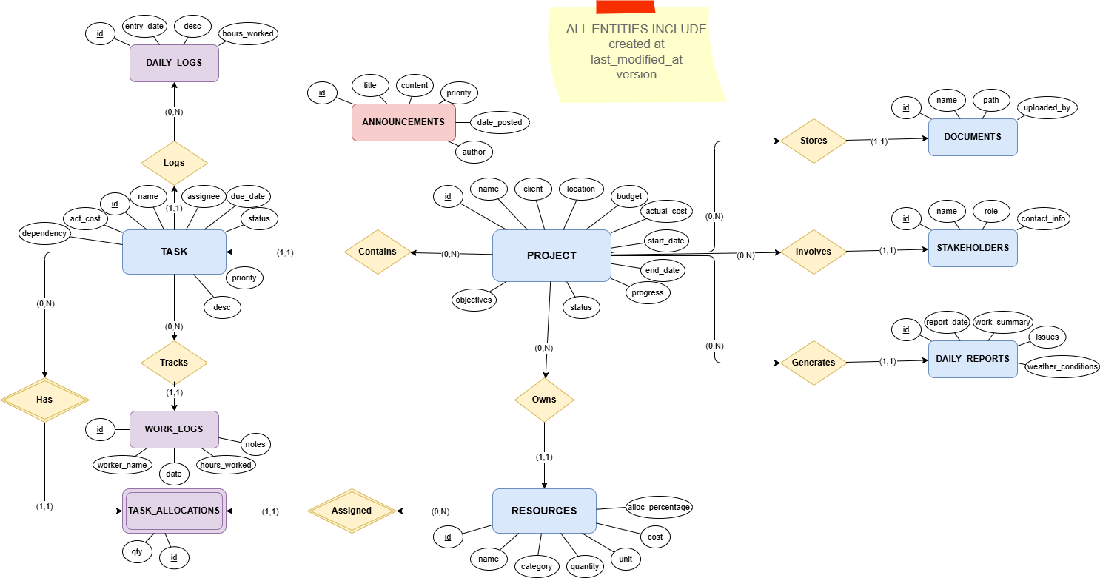

3. Relational Schema
This schema is a direct translation of the tables defined in the project documentation.
- Primary Keys (PK) are underlined
- Foreign Keys (FK) are italicized

Core Tables
Projects
(id, name, client, location, budget, actual_cost, start_date, end_date, progress, status, objectives, created_at, last_modified_at, version)
Tasks
(id, project_id, name, assignee, due_date, status, priority, description, actual_cost, dependencies, created_at, last_modified_at, version)
Resources
(id, project_id, name, category, quantity, unit, allocation_percentage, cost, created_at, last_modified_at, version)
daily_reports
(id, project_id, report_date, work_summary, issues, weather_conditions, created_at, last_modified_at, version)
daily_logs
(id, task_id, entry_date, description, hours_worked, created_at, last_modified_at, version)
work_logs
(id, task_id, worker_name, date, hours_worked, notes, created_at, last_modified_at, version)
stakeholders
(id, project_id, name, role, contact_info, created_at, last_modified_at, version)
documents
(id, project_id, name, file_path, uploaded_by, created_at, last_modified_at, version)
announcements
(id, title, content, priority, date_posted, author, created_at, last_modified_at, version)

Associative Table
task_allocations
(id, task_id, resource_id, quantity, created_at, last_modified_at, version)

Foreign Key Relationships
- tasks.project_id → projects.id
- resources.project_id → projects.id
- daily_reports.project_id → projects.id
- daily_logs.task_id → tasks.id
- work_logs.task_id → tasks.id
- stakeholders.project_id → projects.id
- documents.project_id → projects.id
- task_allocations.task_id → tasks.id
- task_allocations.resource_id → resources.id

4. list of all queries (not the ad hoc ones)

Aggregate queries
Query: Get the Total Budget vs. Total Actual Cost for All Projects Explanation: This is a high-level financial aggregate query, essential for an executive dashboard. It uses the SUM() aggregate function to provide a company-wide overview of planned spending versus actual spending.
SELECT SUM(budget) AS TotalPlannedBudget, SUM(actual_cost) AS TotalActualCost
FROM projects;
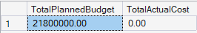
Query: Count the Number of Tasks per Priority Level for a Single Project Explanation: This helps a Project Manager understand the risk and effort distribution within their project. It uses the COUNT() function with GROUP BY to categorize tasks and provide a summary of workload priorities.
SELECT priority, COUNT(id) AS NumberOfTasks
FROM tasks
WHERE project_id = 'PROJECT_UUID_HERE'
GROUP BY priority
ORDER BY NumberOfTasks DESC;
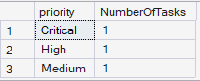

Use of sub-queries

Query: Find All Projects with a Budget Higher Than the Company-Wide Average
Explanation: This query is used for business intelligence to identify high-value or high-risk projects. It uses a subquery in the WHERE clause to first calculate the average budget of all projects and then filters the list to show only those that exceed this average.
SELECT name, budget, client
FROM projects
WHERE budget > (SELECT AVG(budget) FROM projects);
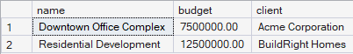

Query: Find All Tasks That Are More Expensive Than the Average Task Cost
Explanation: This helps in financial auditing to pinpoint tasks that are consuming a disproportionate amount of the budget. It uses a subquery to find the average actual_cost across all tasks and then identifies the outliers.
SELECT name, actual_cost, project_id
FROM tasks
WHERE actual_cost > (SELECT AVG(actual_cost) FROM tasks);
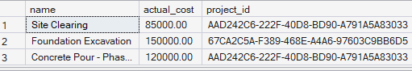

Joining more than two relations

Query: Find All Resources Currently in Use on Active Projects
Explanation: This is a crucial query for a Senior Operations Manager to get a high-level view of resource allocation across the entire company. It joins four tables (resources, task_allocations, tasks, projects) to find which resources are actively committed to tasks within projects that are currently in progress.
SELECT DISTINCT r.name, r.category, p.name AS project_name
FROM resources r
JOIN task_allocations ta ON r.id = ta.resource_id
JOIN tasks t ON ta.task_id = t.id
JOIN projects p ON t.project_id = p.id
WHERE p.status = 'Active';
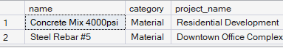

Query: Find All Detailed Daily Logs for a Specific Project Location
Explanation: This query allows a manager to audit all granular work being done at a specific job site. It joins three tables (daily_logs, tasks, projects) to retrieve detailed log descriptions based on the physical location of the parent project.
SELECT dl.entry_date, dl.description, dl.hours_worked, t.name AS 'task_name'
FROM daily_logs dl
JOIN tasks t ON dl.task_id = t.id
JOIN projects p ON t.project_id = p.id
WHERE p.location = '123 Main St, Downtown';
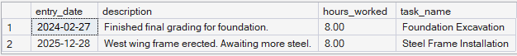

Extra query that uses aggregate + joins
Query: Get All Projects Along with a Count of Their Associated Tasks
Explanation: This query is used to generate a global report for management. It uses a LEFT JOIN and GROUP BY to provide a summary list of all projects and how many tasks each one contains, which is useful for assessing project complexity.
SELECT p.name, p.status, COUNT(t.id) AS task_count
FROM projects p
LEFT JOIN tasks t ON p.id = t.project_id
GROUP BY p.id, p.name, p.status
ORDER BY task_count DESC;
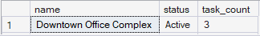

5. The GUI sceenshots that performs at least:

- 2 Insert Statements on 2 different tables.
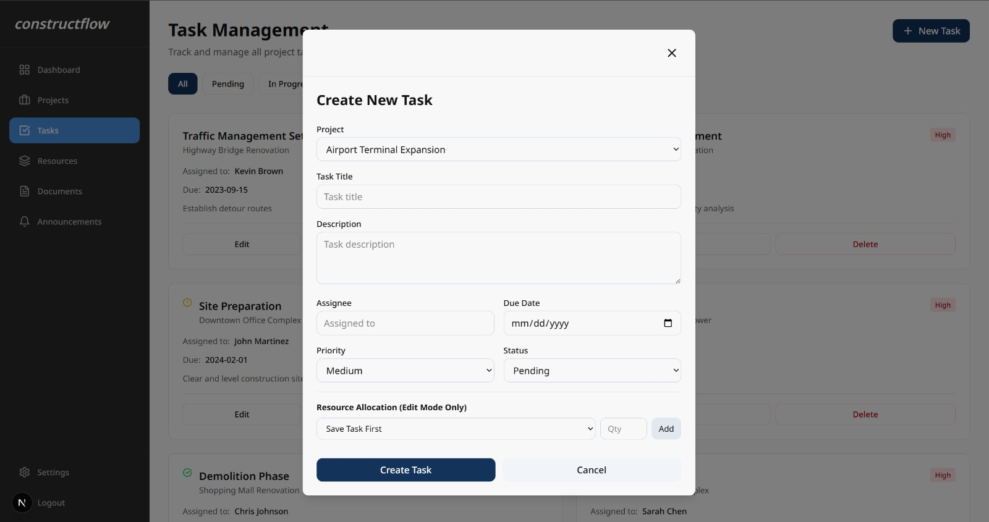
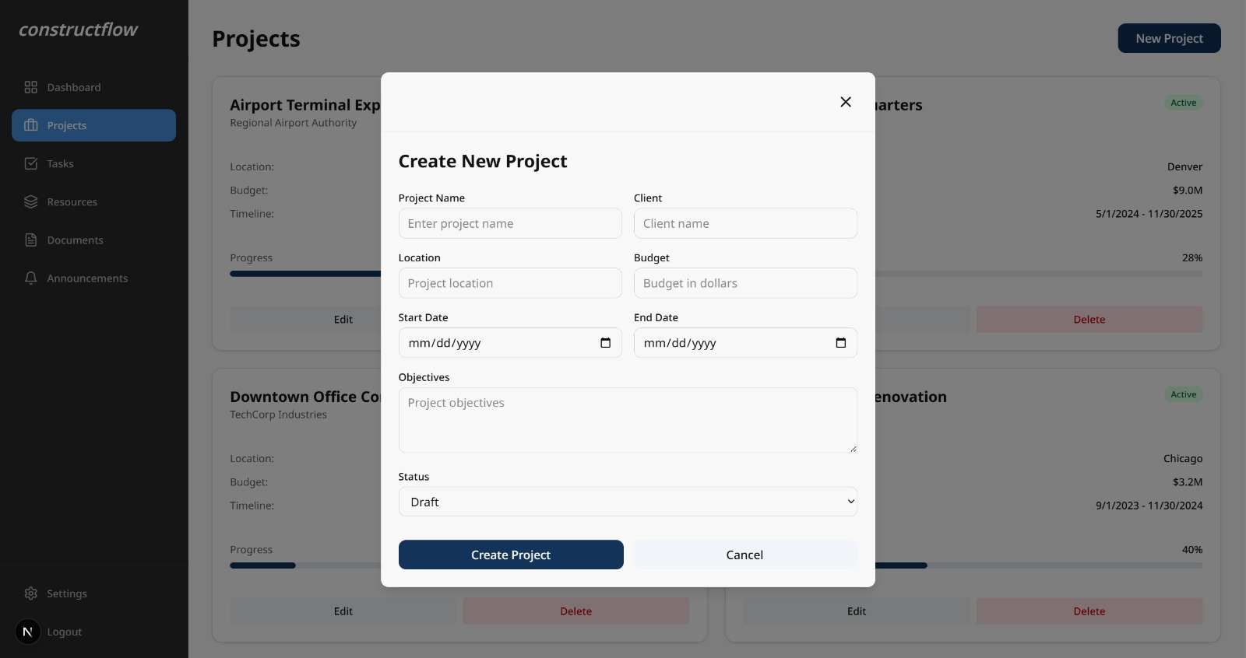

- 2 Delete Statements on 2 different tables (with conditions).
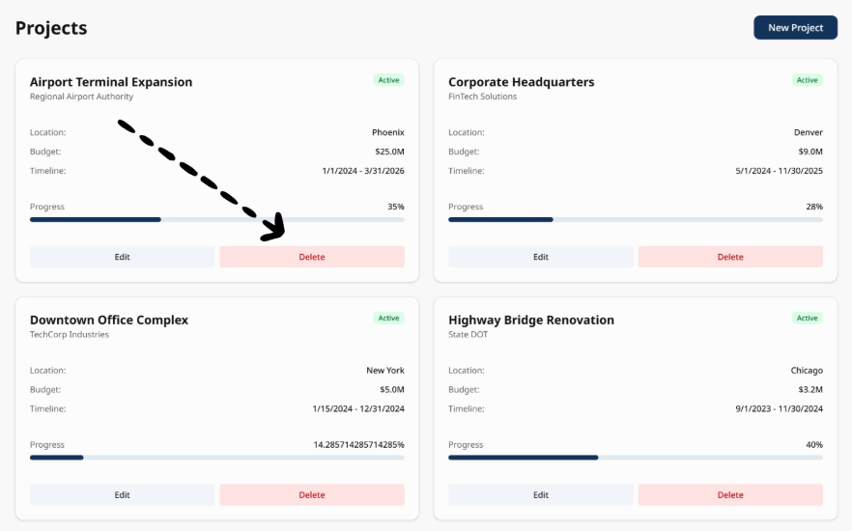
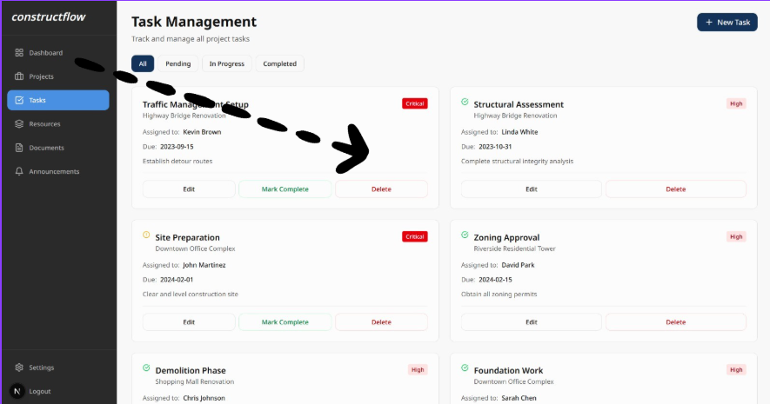

- 2 Update Statements on 2 different tables [with condition].
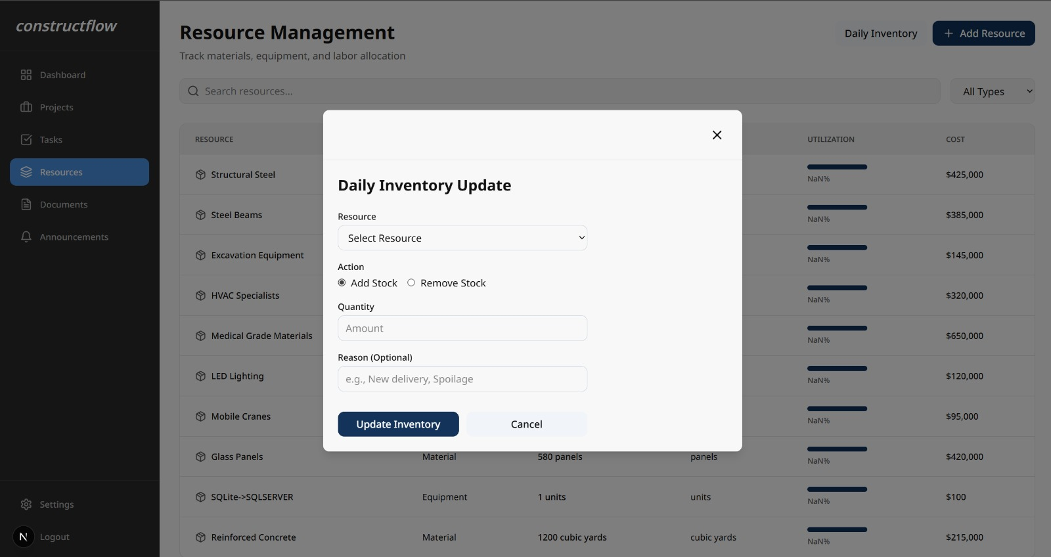
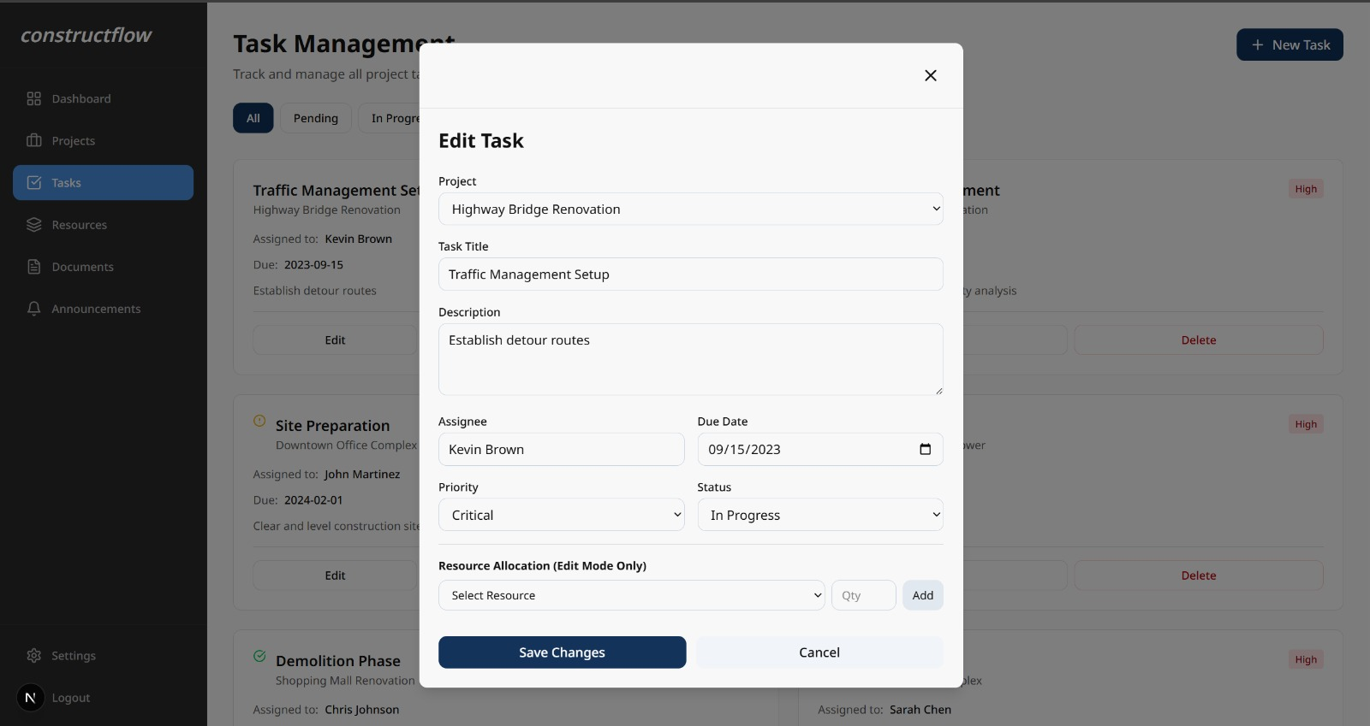
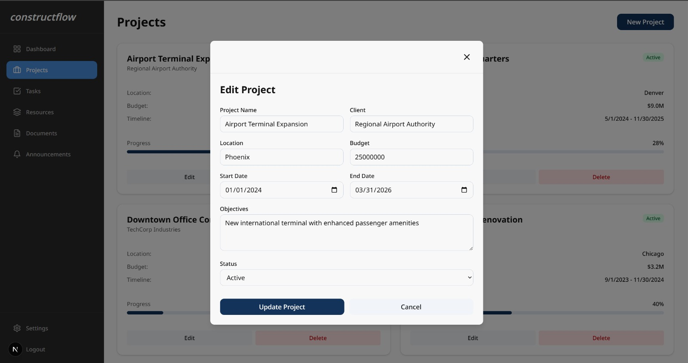
- Select data from any table(s) of the database
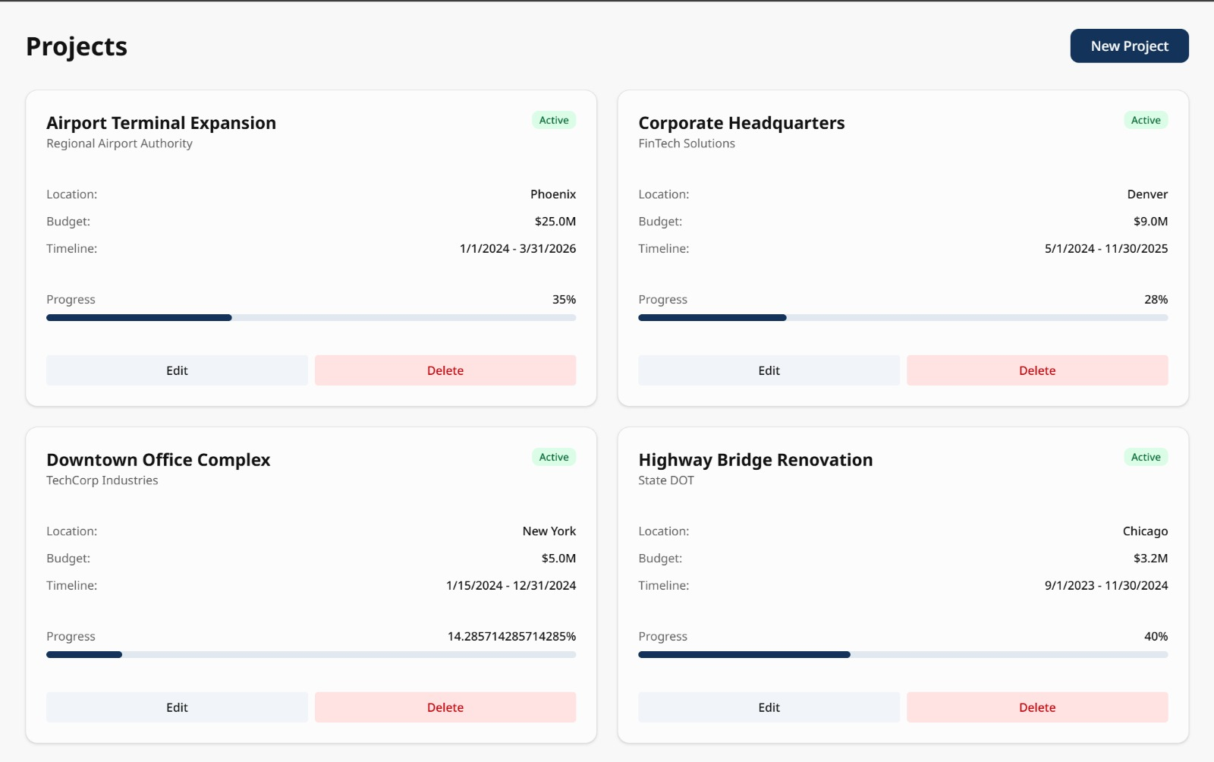
- Select data that involves more than one table of the database- (using joins).
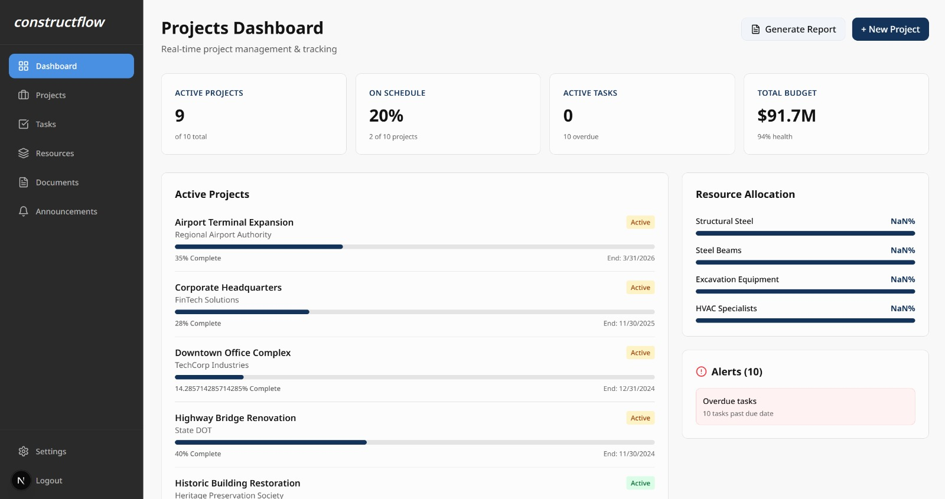
- Generate 1 meaningful report. Bonus
