Contents

1. Executive Summary 4

1.1. Objective 4

1.2. Data Overview 4

1.3. Methodology 4

1.4. Key Findings 5

1.5. Marketing Simulation & Business Impact 5

2. Introduction 5

2.1. Context & Objectives 5

2.2. Importance of Customer Personality Analysis 5

2.3. Predictive Modeling for Wine & Gold Buyers 5

3. Data Overview 6

3.1. Description of Project Dataset (Project_Dataset_X.sav) 6

3.2. Description of Deployment Dataset (Project_Dataset_Base.sav) 6

4. Exploratory Data Analysis (EDA) 7

4.1. Summary Statistics & Data Distribution 7

4.2. Relationship Between Variables & Target Variables (Wine Buyer, Gold Buyer) 8

4.3. Cross-tabulation Analysis 10

5. Model Selection & Training 11

5.1. Introduction to Model Selection 11

5.2. Brief Explanation of Each Model 11

5.3. Training Process 12

6. Evaluation of Model Performance 12

6.1. EvaluationResults 12

6.2. Key Findings 13

6.3. Conclusion 13

7. Calculating Combined Scores for Deployment Base 13

7.1. Overview 13

7.2. Selection of Best Models 14

7.3. Preparing the Deployment Dataset 14

7.4. Feature Scaling: 14

7.5. Probability Predictions**:** 14

7.6. Combining the Scores**:** 14

7.7. Final Output**:** 15

8. Simulating Operational Marketing Action on the Top 20% Customers 15

8.1. Overview 15

8.2. Sorting the Customers by Combined Score**:** 15

8.3. Selecting the Top 20% of Customers**:** 15

8.4. Defining the Threshold for Expected Buyers**:** 15

8.5. Calculating Expected Buyers in the Top 20%**:** 16

8.6. Calculating the Proportion of Expected Buyers: 16

8.7. Output**:** 16

9. Customer Profile Summary for Targeted Clients (Top 20%): 16

9.1. Age Distribution: 17

9.2. Education Level: 17

9.3. Income: 18

9.4. Family Dynamics: 18

9.5. Marital Status: 18

9.6. Recency (Last Purchase Activity): 18

9.7. Web Visits (Customer Engagement): 18

9.8. SW1 Probability (Wine Buyer Probability): 19

9.9. SG1 Probability (Gold Buyer Probability): 19

10. Conclusion: 19

# Executive Summary

## **Objective**

This project focuses on **Customer Personality Analysis** to identify which customers are most likely to buy **wine** and **gold**. By analyzing customer characteristics and purchasing behavior, businesses can optimize marketing strategies by targeting the right customer segments, improving conversion rates, and reducing unnecessary marketing costs.

## **Data Overview**

The analysis is based on **Project_Dataset_X.sav**, which contains **1,250 observations** with customer demographics, purchasing habits, and engagement with previous marketing campaigns. Key variables include:

* **Demographics**: Year of birth, education, marital status, income.
* **Household Information**: Number of kids and teenagers in the household.
* **Customer Engagement**: Recency of last purchase, number of web visits per month, responses to past campaigns.
* **Target Variables**: Whether a customer is a **Wine Buyer** or a **Gold Buyer**.

For deployment, the **Project_Dataset_Base.sav** is used, which contains the same features but lacks the target labels (**Wine Buyer, Gold Buyer**).

## **Methodology**

To predict customer likelihood of purchasing wine and gold, multiple machine learning models were used:

1. **Logistic Regression** – Establishes a probability score based on linear relationships.
2. **k-Nearest Neighbors (k-NN)** – Classifies customers based on similarity to others.
3. **Naïve Bayes** – Uses probability distributions for classification.

Model performance was evaluated using **accuracy, precision, recall, F1-score, and AUC** to determine the best-performing model for deployment.

## **Key Findings**

* Certain factors, such as **income, number of web visits, and previous campaign responses**, were strong indicators of wine and gold purchases.
* Logistic Regression showed the best balance of accuracy and interpretability, making it the preferred model for deployment.
* Customers were scored based on their likelihood to purchase wine (SW) and gold (SG).

## **Marketing Simulation & Business Impact**

* A **top 20% scoring segment** was selected for targeted marketing efforts.
* Customers in this segment had **higher income, lower recency values, and active online engagement**.
* Based on this analysis, businesses can implement **personalized campaigns**, such as exclusive promotions or loyalty rewards, to increase sales efficiency.

# Introduction

## **Context & Objectives**

This project aims to identify customers most likely to purchase **wine** and **gold** by analyzing their demographics, behaviors, and engagement with previous marketing campaigns. The goal is to build predictive models that help businesses target the right customer segments and optimize marketing efforts.

## **Importance of Customer Personality Analysis**

Customer Personality Analysis allows businesses to focus marketing on high-potential customers, improving efficiency and reducing costs. By segmenting customers based on their likelihood to purchase specific products, companies can enhance product customization and customer engagement.

## **Predictive Modeling for Wine & Gold Buyers**

Using machine learning models like **Logistic Regression**, **k-NN**, and **Naïve Bayes**, we predict the likelihood of customers purchasing wine (SW) and gold (SG). These models will guide targeted marketing strategies, maximizing sales potential by focusing on the most promising segments.

# Data Overview

## **Description of Project Dataset (Project_Dataset_X.sav)**

The **Project_Dataset_X.sav** contains **1,250 customer observations** with a variety of demographic, household, and behavioral information. This dataset includes two key target variables: **Wine_buyer** and **Gold_buyer**, which indicate whether a customer is likely to purchase wine or gold, respectively.

#### **Key Variables in the Dataset:**

* **ID**: Unique identifier for each customer.
* **Year_Birth**: Year of birth of the customer.
* **Education**: Education level of the customer (e.g., Primary, Secondary, Tertiary).
* **Marital_Status**: Marital status of the customer (e.g., Single, Married).
* **Income**: Annual income of the customer.
* **Kidhome**: Number of children in the household.
* **Teenhome**: Number of teenagers in the household.
* **Dt_Customer**: Date when the customer became a client.
* **Recency**: Number of days since the customer's last purchase.
* **NumWebVisitsMonth**: Number of web visits per month.
* **AcceptedCmp1, AcceptedCmp2, AcceptedCmp3**: Binary variables indicating whether the customer accepted each of three previous campaigns.
* **Complain**: Whether the customer has lodged a complaint (binary).
* **Response**: Whether the customer responded to the last marketing campaign (binary).
* **Wine_buyer**: Target variable indicating if the customer is likely to buy wine.
* **Gold_buyer**: Target variable indicating if the customer is likely to buy gold.

## **Description of Deployment Dataset (Project_Dataset_Base.sav)**

The **Project_Dataset_Base.sav** contains the same set of features as the **Project_Dataset_X.sav**, excluding the target variables (**Wine_buyer** and **Gold_buyer**). This dataset is used for deploying the model and calculating the predicted scores for wine and gold buyers.

#### **Key Variables**

* The dataset includes **demographics, household information, and customer engagement features**, which can be used to predict customer behavior.
* **No target variables** (Wine_buyer, Gold_buyer) are present in this dataset, as these are to be predicted based on the features.

# Exploratory Data Analysis (EDA)

## **Summary Statistics & Data Distribution**

In this section, we will provide an overview of the **summary statistics** and **data distribution** of the key variables in the dataset. The summary statistics will give insights into the central tendency, spread, and skewness of the data.

#### **Key Variables Summary**

**Summary of Key Continuous Variables:**

1. **Income**:

Average income is 51,855, with a wide range (1,730 to 162,397), reflecting significant income variability across customers.

1. **Recency** (Days since last purchase):

Average of 48.92 days, with a high spread (standard deviation = 29.26), indicating both recent and more distant customer engagements.

1. **NumWebVisitsMonth**:

On average, customers visit the website 5.30 times per month, suggesting moderate online engagement.

1. **Wine_buyer**:

About 40% of customers buy wine, reflecting a notable segment of wine purchasers.

1. **Gold_buyer**:

Around 37% of customers purchase gold, showing a strong interest in this product category as well.

**Categorical Variables**:

1. **Education:**

The education level of most customers is high, with **Graduation** being the most common category (627 out of 1250 customers).

1. **Marital_Status:**

The majority of customers are **Married** (484 out of 1250), followed by other categories such as **Single** or **Divorced**.

## **Relationship Between Variables & Target Variables (Wine Buyer, Gold Buyer)**

Categorical Variables Encoding

**Education Encoding**: We applied ordinal encoding to the **'Education'** variable, which has an inherent order. The mapping was as follows:

* 'Basic' → 0
* '2n Cycle' → 1
* 'Graduation' → 2
* 'Master' → 3
* 'PhD' → 4

**Marital Status Encoding**: We applied one-hot encoding to the **'Marital_Status'** variable to convert it into numeric format, with separate columns for each marital status category (e.g., 'Marital_Single', 'Marital_Married').

**Reason for Encoding**: Categorical variables need to be encoded before correlation analysis and model training to ensure they are represented numerically, allowing them to be used in statistical analysis and machine learning models.

#### Key Correlation Findings:

1. **Income is a strong predictor of purchases**

It has a **high positive correlation with Wine Buyer (0.67)** and **Gold Buyer (0.40)**, meaning higher-income customers are more likely to buy these products.

1. **Children in the household reduce buying likelihood**

**Kidhome has a strong negative correlation** with both **Wine Buyer (-0.51)** and **Gold Buyer (-0.39)**, suggesting customers with young children are less likely to purchase.

1. **Website visits and online engagement impact buying**

**NumWebVisitsMonth is negatively correlated** with **Wine Buyer (-0.37)** and **Gold Buyer (-0.23)**, indicating that frequent website visits do not necessarily translate into purchases.

1. **Marketing campaign acceptance relates to wine and gold purchases**

Customers who accepted **previous campaigns (AcceptedCmp1: 0.29, AcceptedCmp3: 0.02 for Wine Buyer)** were more likely to be buyers, with **AcceptedCmp1 showing a stronger link** to both wine and gold purchases.

1. **Age plays a role in purchasing behavior**

**Year of Birth is negatively correlated with both Wine Buyer (-0.18) and Gold Buyer (-0.10)**, suggesting older customers are more likely to make purchases.

1. **Longer membership duration shows a slight positive impact**

**Membership Duration correlates positively with both Wine Buyer (0.13) and Gold Buyer (0.17)**, indicating loyalty over time might contribute to purchasing behavior.

#### Correlation Heatmap

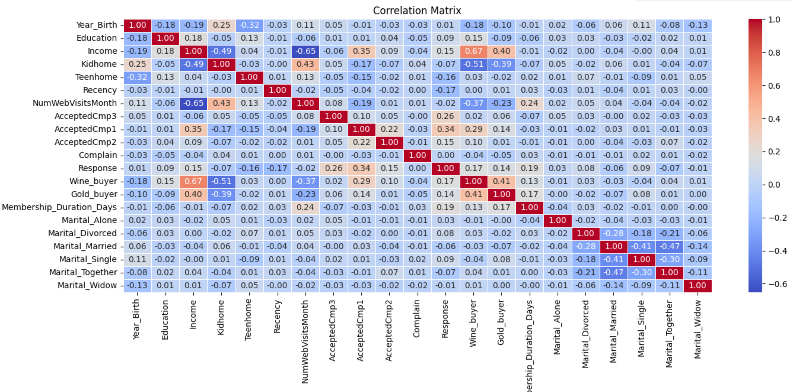

## **Cross-tabulation Analysis**

To further explore the relationships between categorical variables and the target variables, **cross-tabulation analysis** will be used. This analysis shows the frequency distribution of the categories of two variables and provides insights into their joint distributions.

#### Wine Buyer Cross Tabulation

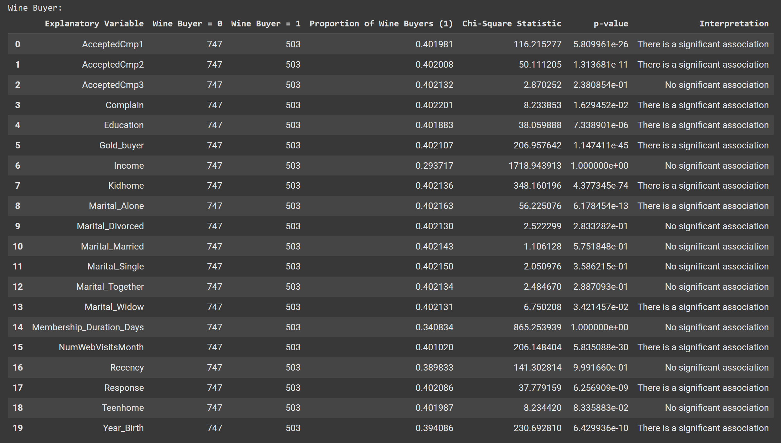

#### Gold Buyer Cross Tabulation

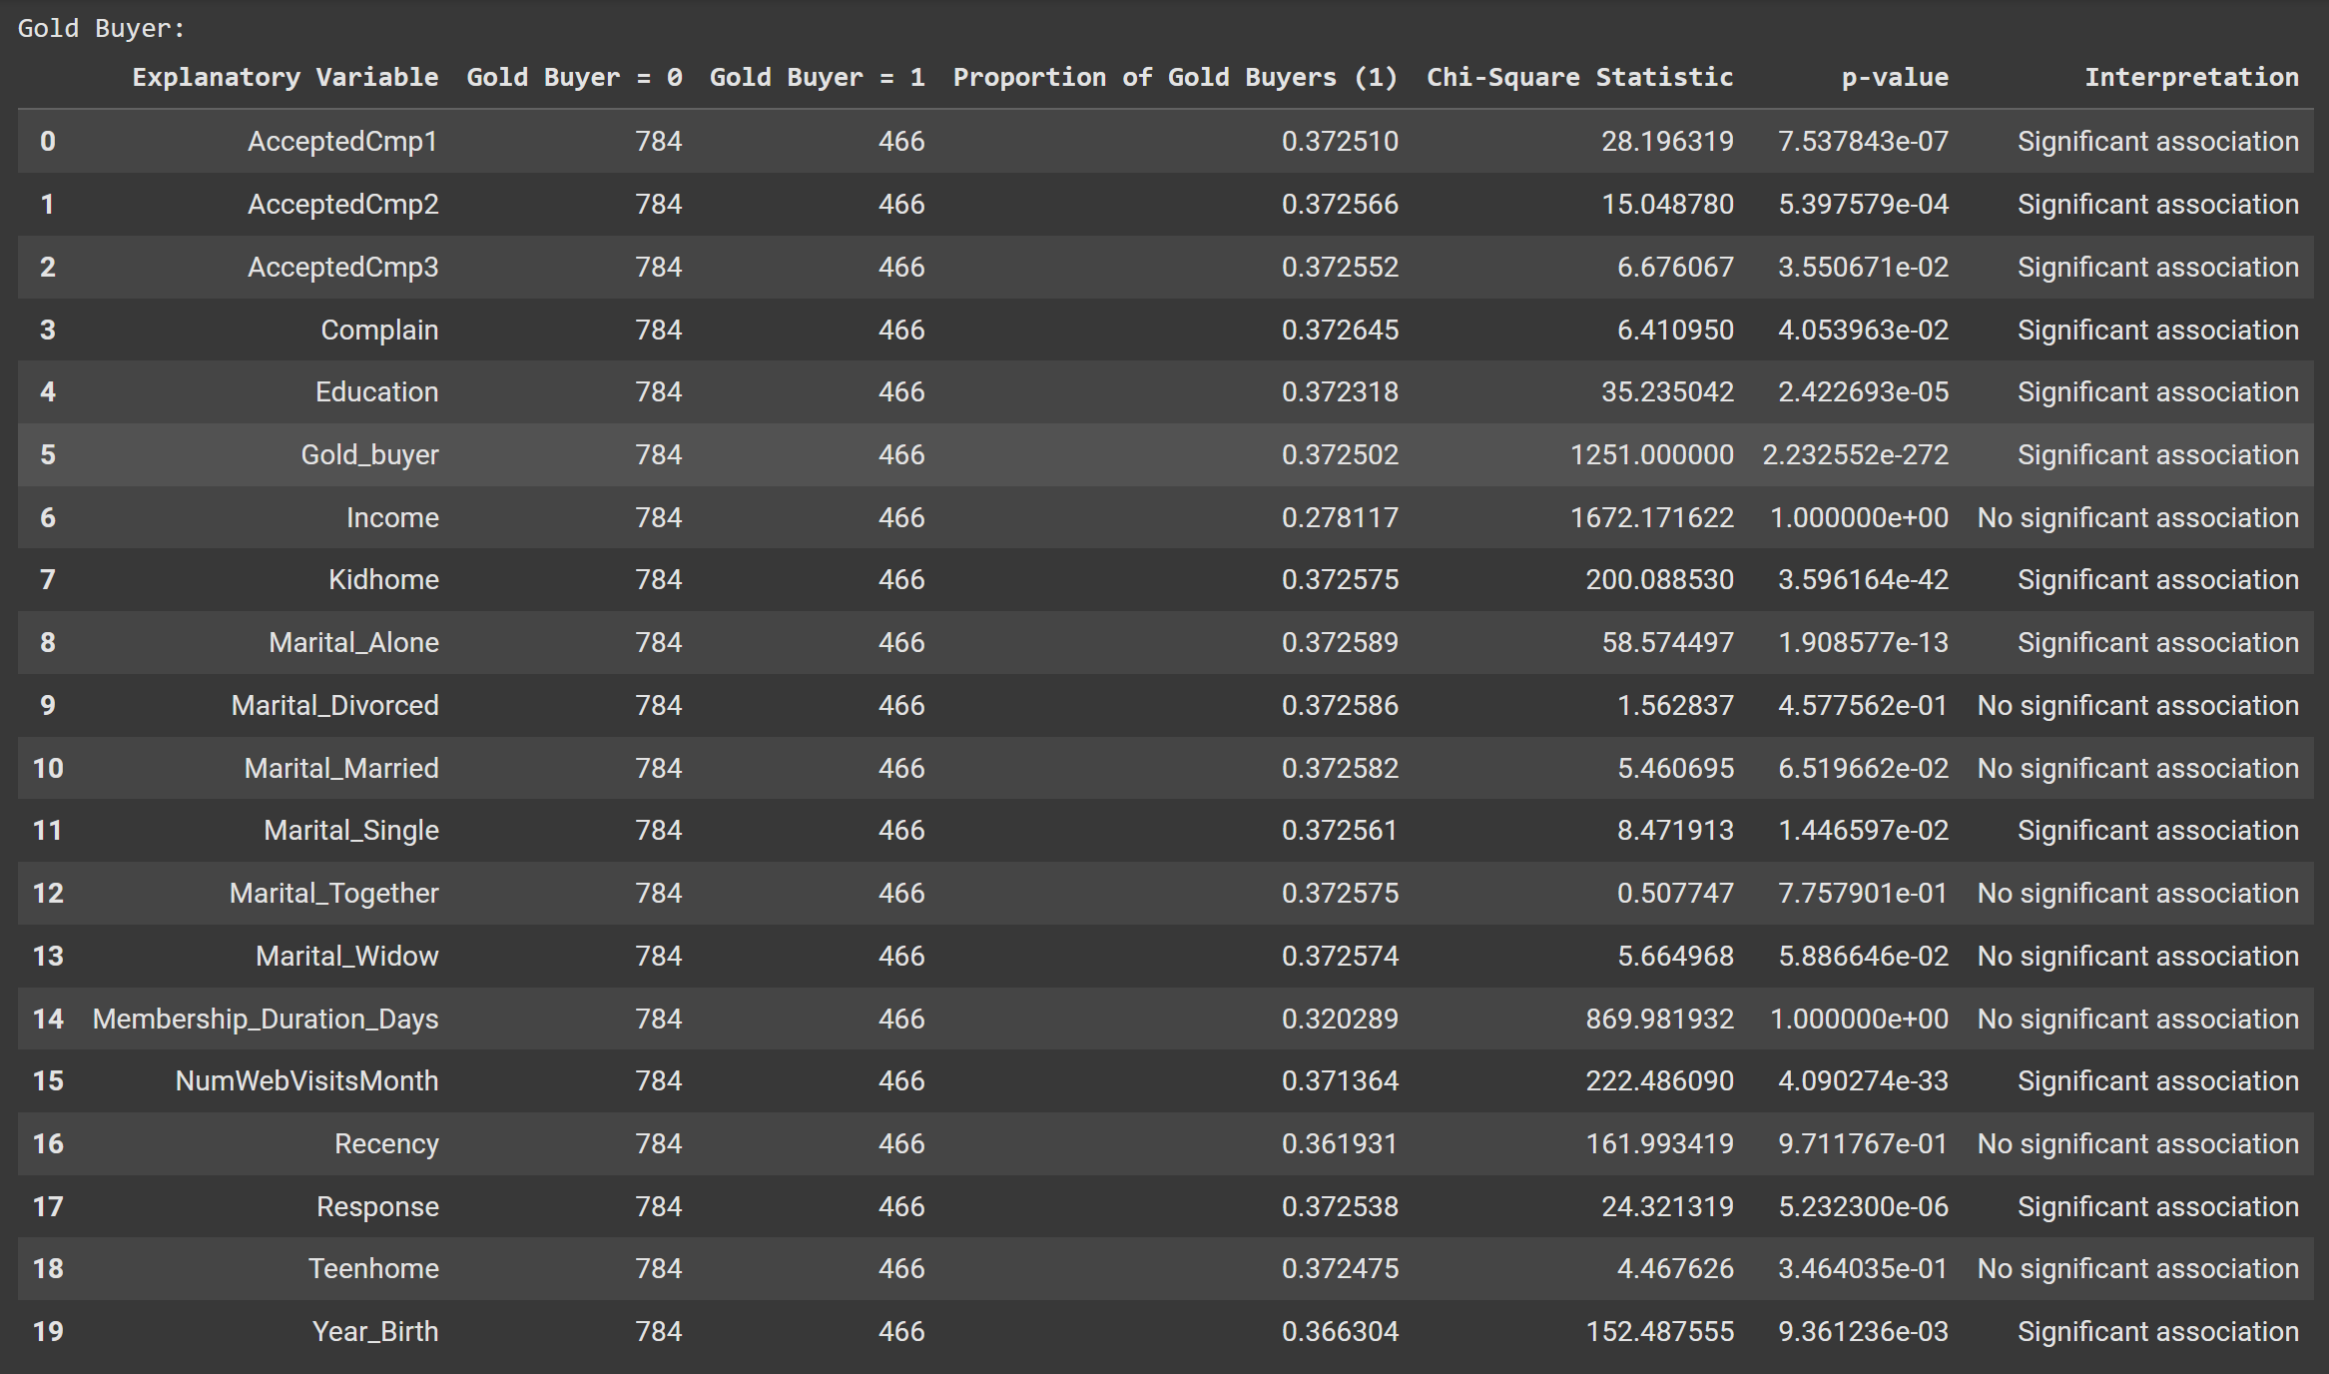

# Model Selection & Training

## **Introduction to Model Selection**

To classify customers as **Wine Buyers (SW1)** and **Gold Buyers (SG1)**, multiple models were tested to compare their performance and determine the most effective algorithm. Since different models have unique advantages, using multiple approaches allows for a more comprehensive evaluation.

* **Logistic Regression**
* **k-Nearest Neighbors (k-NN)**
* **Naïve Bayes**

By applying these models, we aim to determine which one performs best in predicting customer buying behavior.

## **Brief Explanation of Each Model**

* **Logistic Regression** estimates the probability of a binary outcome using the logistic function, assuming a linear relationship between input variables and the log-odds of the target, making it suitable for datasets with clear linear separation.
* **k-Nearest Neighbors (k-NN)** is a non-parametric, instance-based method that classifies data based on the majority class of the nearest **k** neighbors, where a lower **k** captures finer details but may overfit, while a higher **k** generalizes better; it works well with non-linear decision boundaries but requires proper feature scaling.
* **Naïve Bayes** is a probabilistic classifier based on **Bayes' Theorem**, assuming feature independence; despite this assumption being rarely true, it performs well in practice, is highly efficient even with large datasets, and is particularly useful for categorical data classification.

## **Training Process**

#### **Data Splitting**

* The dataset was split into **training (80%)** and **testing (20%)** sets using train_test_split.
* The same training and test sets were used for both target variables (**Wine Buyer** and **Gold Buyer**) to ensure consistency in evaluation.

#### **Feature Scaling**

* Since **Logistic Regression** and **k-NN** are sensitive to feature scales, StandardScaler was applied to normalize the input variables.
* **Naïve Bayes** does not require scaling, but for uniformity, it was trained on the scaled data as well.

#### **Model Training**

* Each model was trained separately on **Wine Buyer (SW1)** and **Gold Buyer (SG1)** labels.
* Hyperparameters were kept at default values initially, with potential tuning for improved performance.

# Evaluation of Model Performance

## **Evaluation Results**

To assess the performance of different classification models for predicting **Wine Buyers (SW1)** and **Gold Buyers (SG1)**, we analyzed their precision, recall, F1-score, and accuracy. The results for each model are summarized in the table below:



## **Key Findings**

#### **Key Observations**:

* **Logistic Regression** performed well on **SW1 (Wine Buyer)** with high **Precision** (0.781) and **Recall** (0.872), achieving an **F1 Score** of 0.824 and **Accuracy** of 0.860. For **SG1 (Gold Buyer)**, the performance was slightly lower but still respectable, with an **Accuracy** of 0.752 and **AUC** of 0.832.
* **K-Nearest Neighbors** (KNN) showed a balanced performance across both targets. It achieved **SW1** accuracy of 0.740 and **SG1** accuracy of 0.740. However, its **Precision** for **SW1** was lower compared to Logistic Regression. The **AUC** scores were 0.784 for **SW1** and 0.789 for **SG1**, indicating reasonable model discrimination.
* **Naive Bayes** demonstrated solid performance for **SW1**, with a high **AUC** (0.864839), but it was less effective for **SG1** with **Precision** and **F1 Score** lower than the other models. Still, its **Accuracy** and **AUC** for both targets were commendable.

## **Conclusion**

* **Logistic Regression** performed the best for **SW1** and **SG1**, with the highest **F1 Score** for both and a strong **AUC** for both target variables.
* **K-Nearest Neighbors** showed competitive **AUC** scores but didn't excel in **Precision** for **SW1** compared to **Logistic Regression**.
* **Naive Bayes** provided the highest **SW1 AUC** but didn't perform as well for **SG1**.

# Calculating Combined Scores for Deployment Base

## **Overview**

In this step, we focused on applying the **best models** for **SW1 (Wine Buyer)** and **SG1 (Gold Buyer)** to the deployment dataset and calculating **combined scores** for each record in the dataset. Here’s a breakdown of the actions taken:

## **Selection of Best Models**

We identified the best-performing models for both **SW1** and **SG1** based on evaluation metrics such as **Precision**, **Recall**, **F1 Score**, and **AUC**. After thorough evaluation, **Logistic Regression** was selected as the best model for both targets.

## **Preparing the Deployment Dataset**

To apply the trained models on the deployment dataset (df_base), we ensured that the dataset had the same features as the training dataset. This is crucial to ensure the models would work properly with the deployment data.

## **Feature Scaling:**

The features in the deployment dataset were scaled using the same **StandardScaler** used during training. This step ensures that the feature values are in the same scale as the training data, which is critical for the model to perform optimally.

## **Probability Predictions:**

For each record in the deployment dataset, we obtained **probability predictions** from the models. Specifically:

* **SW1_Prob**: This represents the probability that the individual is a **Wine Buyer** (target = 1) based on the trained **Logistic Regression** model for **SW1**.
* **SG1_Prob**: This represents the probability that the individual is a **Gold Buyer** (target = 1) based on the trained **Logistic Regression** model for **SG1**.

The predict_proba() function of the **Logistic Regression** model was used to obtain the probabilities. The probabilities for the positive class (class = 1) are extracted from the results, as these represent the likelihood of the individual being a buyer.

## **Combining the Scores:**

To derive a final score that takes into account both the **Wine Buyer** and **Gold Buyer** probabilities, a **combined score** was calculated. This was done by averaging the **SW1_Prob** and **SG1_Prob** for each individual in the dataset:

* **Combined_Score** = (SW1_Prob + SG1_Prob) / 2

This combined score provides a unified measure of the likelihood that an individual is a buyer, considering both wine and gold purchasing behavior.

## **Final Output:**

The final result was added as two new columns to the df_base dataframe:

* **SW1_Prob**: Probability for Wine Buyer
* **SG1_Prob**: Probability for Gold Buyer
* **Combined_Score**: Average of both probabilities

This approach allows us to make more comprehensive predictions by combining insights from both target variables.

# Simulating Operational Marketing Action on the Top 20% Customers

## **Overview**

In this step, we simulated an operational marketing action focused on the top 20% of customers based on their **combined score**. Here's a breakdown of the actions taken and the calculation of the proportion of **expected buyers** within the selected customer base:

## **Sorting the Customers by Combined Score:**

We first sorted the deployment dataset (df_base) based on the **combined score** in **descending order**. This allows us to identify the customers with the highest likelihood of being a buyer, considering both wine and gold purchasing behaviors.

## **Selecting the Top 20% of Customers:**

The next step was to select the **top 20%** of customers from the sorted list. This was done by calculating the top 20% of the total dataset, and then using the .head() function to extract the first 20% of the customers who have the highest combined scores:

* top_20_percent = int(0.2 * len(df_base_sorted))
* df_top_customers = df_base_sorted.head(top_20_percent)

## **Defining the Threshold for Expected Buyers:**

We defined a **threshold** of **0.6** for both the **SW1 (Wine Buyer)** and **SG1 (Gold Buyer)** probabilities. This threshold determines whether a customer is considered an **expected buyer** for either product:

* If a customer's **SW1_Prob** or **SG1_Prob** exceeds 0.6, they are considered an expected buyer.

## **Calculating Expected Buyers in the Top 20%:**

Using the threshold of 0.6, we filtered the **top 20% customers** who meet the criteria of being an expected buyer (having a **probability greater than 0.6** for either SW1 or SG1):

* expected_buyers = df_top_customers[(df_top_customers["SW1_Prob"] > threshold) | (df_top_customers["SG1_Prob"] > threshold)]
* The shape of the resulting subset was used to determine how many customers in the top 20% are expected to buy either wine or gold.

## **Calculating the Proportion of Expected Buyers:**

To quantify the success of our marketing simulation, we calculated the **proportion of expected buyers** within the top 20%:

* proportion_expected = expected_buyers / top_20_percent
* This proportion gives us an indication of the effectiveness of targeting the top 20% of customers, as it shows how many of them are expected to buy based on the model's predictions.

## **Output:**

The final output is the **proportion of expected buyers** within the top 20% of customers. This metric provides a useful insight into the likelihood of success for our operational marketing action based on targeting the top 20% with the highest combined scores.

The printed result gives us the proportion:



# Customer Profile Summary for Targeted Clients (Top 20%):

Based on the analysis of the top 20% of customers (sorted by the combined SW1 and SG1 scores), we have the following insights:

## **Age Distribution:**

* The average age of the targeted customers is **56.4 years**, with a **range from 30 to 82 years**.
* The middle 50% (from the 25th to 75th percentile) are between **47 and 68 years old**.
* This indicates that the targeted customers are primarily older adults, with a large concentration in their late 40s to early 70s.

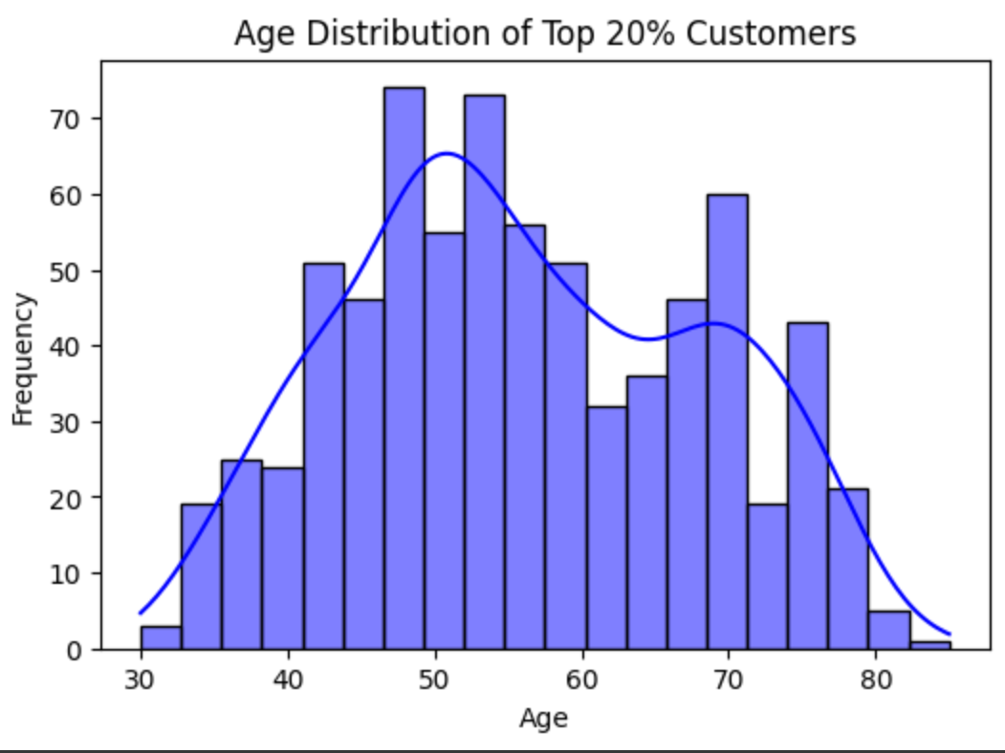

## **Education Level:**

* **Average education level**: 2.19. (2 is Graduation)
* The majority of customers (25th percentile) have **high school** education, while the top 75% also includes customers with a **higher education degree** (up to 3 or 4 on the scale).
* The encoding of education is the following  
  'Basic': 0, '2n Cycle': 1, 'Graduation': 2, 'Master': 3, 'PhD': 4

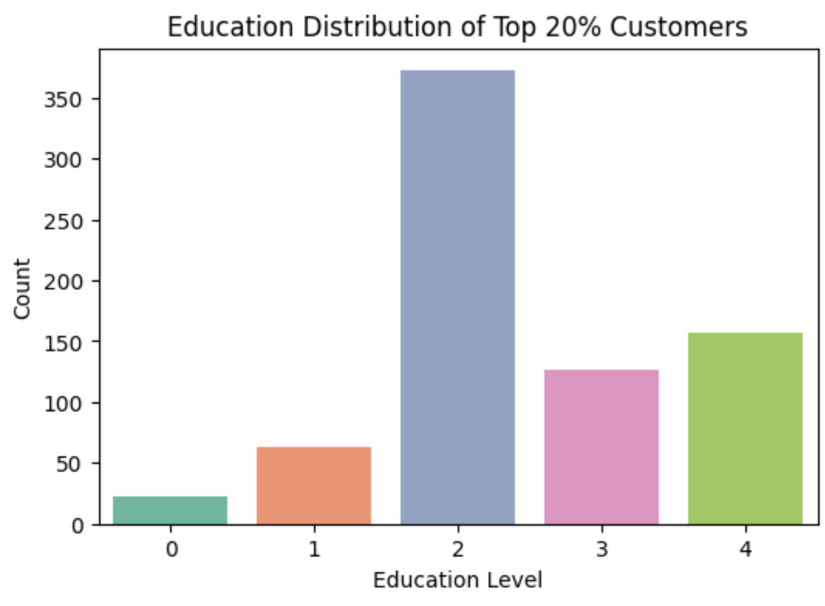

## **Income:**

* The average income of the targeted customers is approximately **76,324** with a large variation in the range.
* **25th percentile**: Customers with an income of **62,698**.
* **50th percentile (median)**: The median income is **72,167**.
* **75th percentile**: Customers with an income of **81,950**.
* A significant portion of customers earns over **62,000**, indicating a relatively high-income group.

## **Family Dynamics:**

* **Kidhome** (Children at home): The average number of children at home is very low, at **0.05** (with the vast majority of customers having no children at home). The range is from **0 to 1** child.
* **Teenhome** (Teenagers at home): The average number of teenagers is **0.47**. However, most customers have either **no teenagers** or just **one teenager at home**.
* This suggests that the customers tend to be in the later stages of life, where children may no longer be living at home.

## **Marital Status:**

* **Marital_Married**: About **34%** of the targeted customers are married, as indicated by the average value of **0.34**. The range goes from **0** (not married) to **1** (married).
* This suggests that the customers may have relatively stable family or relationship statuses.

## **Recency (Last Purchase Activity):**

* The average **Recency** is **54.81** (likely in days), with a large variation of up to **99 days**.
* The 75th percentile of recency is **79 days**, showing that most of these customers have recently engaged in purchasing behavior (likely within the past few months).

## **Web Visits (Customer Engagement):**

* **NumWebVisitsMonth** (number of web visits per month): The average is **4.29** visits per month, with a range from **0 to 9**.
* The customers are fairly active online, with most engaging at least 2 to 6 times a month.

## **SW1 Probability (Wine Buyer Probability):**

* The **SW1_Prob** (probability of being a wine buyer) ranges from **0.52 to 1.00**, with an average of **0.67**.
* The distribution suggests that most customers have a **moderate to high probability** of purchasing wine, with some near-certainty (values approaching 1.0).

## **SG1 Probability (Gold Buyer Probability):**

* Similarly, the **SG1_Prob** (probability of being a gold buyer) has an identical average of **0.67**, with values ranging from **0.52 to 1.00**.
* Like wine buyers, these customers show a moderate to high probability of purchasing gold.

# Conclusion:

The targeted customers for both wine and gold buyers tend to be **middle-aged to older** individuals, with relatively **high income levels** and **moderate to high engagement** online. They have stable family dynamics, with fewer children or teenagers at home, and are generally **active buyers** with strong probabilities for purchasing both wine and gold. Their profiles align with **affluent and established individuals**, with most being **married** and involved in more long-term financial decisions.