The effect of COVID on household savings in the European Union - A social problem.
Omar Zakkouralashy (2889420), Anna Olaru (2881939), Abhigyan Hazarika (2888419), Andrea Tzima or Xhima (2885530), Raluca Naumcef(2888853), Kyle van Emmerik (2897218)
2026-06-22

Set-up your environment

Title Page
The effect of COVID on household savings in the European Union - A social problem.
Omar, Anna, Abhigyan, Raluca, Andrea, Kyle
TG 5 - G 1
Tutorial teacher: Simon Loop

Part 1 - Identify a Social Problem
Aside from being a worldwide health crisis, the Covid-19 pandemic, simultaneously, limited individual spending and generated a sense of financial insecurity among all classes. Through a survey on individuals in eight countries across the world, Deloitte concluded that, while prior to the pandemic a large portion of income surplus went into consumption for most participants, attitudes have now shifted towards dedicating that surplus to savings and investments (Deloitte, 2022). The restrictions imposed by governments during lockdown limited spending opportunities, such as travelling and other non-essentials, which paired with government subsidies in many countries (Deloitte, 2022), increased savings. Additionally, the pandemic brought a sense of economic uncertainty regarding employment and future economic and health stability, makes individuals crave financial security, reflected in their growing savings (Deloitte, 2022). We see this represented quite well in countries like the Netherlands and Germany, experiencing two of the highest household savings even after the lockdown, 24% and 23.4% respectively (Eurostat, n.d), because of great government support causing consumption to fall faster than income. On the other hand, countries like Romania faced a decrease in savings after the pandemic, due to fewer financial resources and rising living costs, also reflected in the country’s economic status . In these countries savings were predominantly used to cope with the post-Covid inflation period (Belbe et al., 2024). Observing household savings prior, during, and after the pandemic, provides insights into the issue of financial vulnerability as a result of the pandemic, as well as inequality between European countries. The issue remains relevant today, because the change in consumption mindsets, due to Covid, seems persistent even well beyond the recovery phase and into present times.
This research is still very much relevant today. In March 2026, De Nederlandsche Bank (DNB) published an analysis of the effects of energy price shocks as a result of the war in the Middle East and Iran’s blockade of the Strait of Hormuz on the Dutch economy (Bank, 2026). Such shocks are particularly relevant for the Netherlands as a trade-dependent country with high exposure to global commodity markets. DNB presented three scenarios:
Source: De Nederlandsche Bank (2026). War in the Middle East: the impact on the Dutch economy.
Scenario | Energy assumption | Effect on Dutch inflation | Effect on Dutch GDP growth
Update | Oil and gas rise, then fall back during 2026 | +0.5 pp in 2026 and 2027 | Slight negative impact
Adverse | Oil and gas rise further, remain elevated Q2/Q3 2026 | Around +1 pp in 2026 and 2027 | Around -0.5 pp in 2026
Severe | Very high energy prices, lasting longer | +1.6 pp in 2026; +2.8 pp in 2027 | Around -0.8 pp in 2026 and 2027
The findings pose an urgent question: what is the impact of large-scale financial instability driven by energy shocks, inflation and eroding household purchasing power on consumer behaviour across Europe? Fortunately, we have a recent crisis of comparable magnitude to draw upon. The COVID-19 pandemic caused a similar sharp macroeconomic shock and its effects on household saving behavior across Europe are well documented. Examining how European households responded – how savings rates changed, how regional disparities developed and how post-crisis inflation subsequently eroded those savings allows us to construct a framework for understanding what crises of this nature mean for European economies, and what we can reasonably expect in the future.

Part 2 - Data Sourcing

2.1 Load in the data

2.2 Provide a short summary of the dataset(s)
Dataset | Source | Indicator | Unit | Level | Years_used | Limitation
nasa_10_ki | Eurostat | Gross household saving rate | % of gross disposable income | Country-year | 2016-2022 | Country-level only, no household-level detail
prc_hicp_ainr | Eurostat | HICP inflation rate | Annual average % change | Country-year | 2016-2022 | National average, not household-specific
Two datasets are used in this analysis, both sourced from Eurostat (the statistical office of the European Union) and downloaded in June 2026.
The HICP – Inflation Rate dataset (code: tec00118, last updated 20/05/2026) has been computed using the Eurostat dataset prc_hicp_ainr. It reports the annual average rate of change in consumer prices across all HICP categories, covering EU averages and individual EU member states. The HICP is a standardized measure of consumer price inflation in Europe ensuring consistency and comparability of data across participating countries. The data runs annually from 2014 to 2025, however for the sake of our research we use data from 2016 to 2022.
The household saving rate dataset (code: tec00131, last updated 04/06/2026) is compiled from annual national accounts data (source: nasa_10_ki) and covers individual EU participating countries as well as EU and euro area aggregates, running annually from 2014 to 2025 however again the data used is from 2016 to 2022. It measures the share of gross disposable income that households set aside rather than spend, expressed as a percentage. The sector includes both households and non-profit institutions serving households.

2.3 Describe the type of variables included
The key numeric variables are the saving rate and inflation rate. Both are numeric variables expressed as percentages, allowing direct comparison across countries and time periods
Country (GEO) is a nominal variable, identifying each EU participating country and averages across Europe. Time is annual in both datasets, ranging from 2014 to 2025, and is treated as an interval variable where the distance between years is equal and meaningful. Later variables created in 3.2 are categorical.
Both variables come from administrative and index-based sources rather than surveys, which limits typical survey sampling error but means values depend on the quality and timeliness of national accounts reporting by each member state.

Part 3 - Quantifying

3.1 Data cleaning
## # A tibble: 1 × 6
## countries first_year last_year observations missing_saving missing_inflation
## <int> <int> <int> <int> <int> <int>
## 1 27 2016 2022 189 0 0

3.2 Generate necessary variables

3.3 Visualize temporal variation
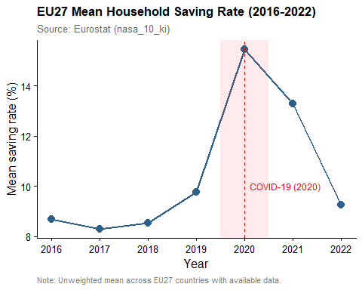
The saving behaviour of households has changed dramatically. In 2020, the average saving rate of the EU27 shot up as the COVID‑19 lockdowns limited consumption possibilities and increased involuntary savings. Restrictions were lifted in 2021 and the saving rate has gradually declined as spending habits have normalised. Then high inflation ate into real disposable incomes, and households accumulated less savings to support consumption.

3.4 Visualize spatial variation
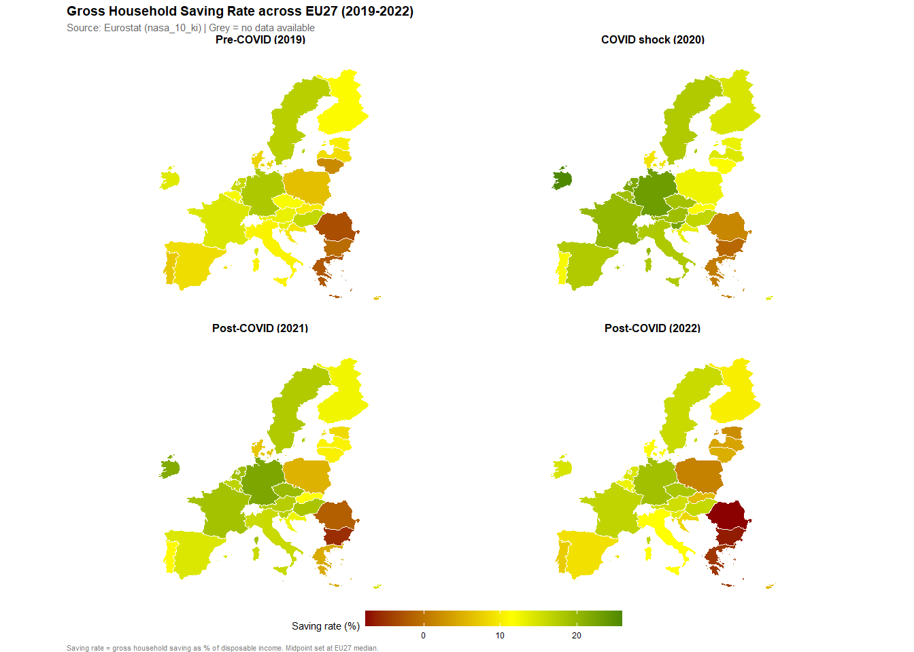
The spatial variation is also quite telling: For most of the EU27 countries, the map is a lot greener in 2020, reflecting the universal rise in saving as lockdowns curtailed consumption everywhere. By 2022 a clear east-west divide appears, with the central and eastern member states turning red. This reflects steeper declines in saving rates as high inflation more sharply eroded household purchasing power in those economies.

3.5 Visualize sub-population variation
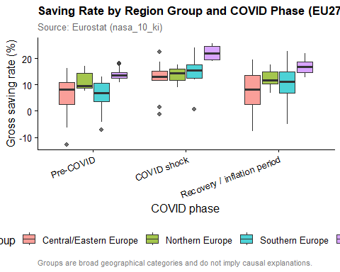
The difference in sub-populations is a structural divide that persists over time with higher saving rates persistently higher in Western and northern Europe and much lower saving rates in southern and central/eastern Europe. The COVID shock of 2020 temporarily closed some of these gaps, with sharp increases in saving rates across all groups while consumption fell sharply. But the post-COVID recovery has been uneven and pre-existing regional differences have re-emerged as countries have been affected by inflation and income pressures to different degrees.

3.6 Event analysis
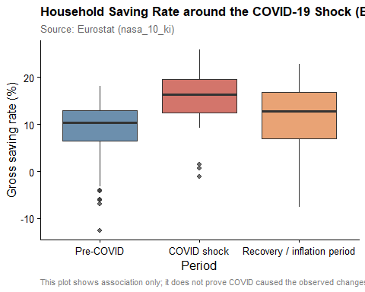
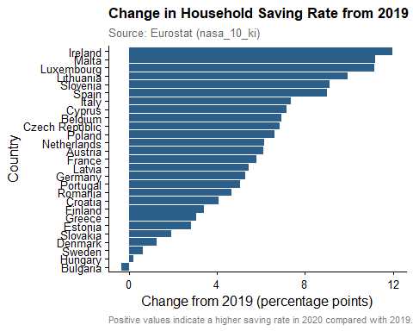
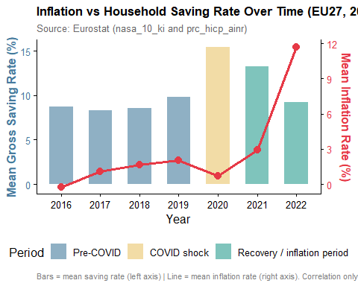
## # A tibble: 3 × 3
## covid_phase correlation n
## <fct> <dbl> <int>
## 1 Pre-COVID 0.12 108
## 2 COVID shock 0.02 27
## 3 Recovery / inflation period -0.33 54
It can be observed from event analysis that there exists a definite three phase dynamics in the relationship between inflation and saving. The first phase is represented by the occurrence of the COVID shock in 2020 where consumption became difficult for households leading to a situation where people were forced to save. This led to an increase in saving rates while in the second phase, savings declined along with real disposable income due to increased inflation in 2022. Here is how it appears in the correlation table. In the COVID shock phase, there is a positive correlation between inflation and saving which implies that both variables are positively correlated in the given phase. In the inflation phase, the relationship between inflation and saving is negative which implies that saving is negatively correlated with inflation.

4.1 Discuss your findings
The mean savings rate from 2016-2022 have not been constant in the slightest. We can dissect this data into three segments for a better analysis; pre-covid, 2016-2019, the savings rate has been relatively constant, reaching a peak of almost 8% during 2017, but having balanced out fluctuations. During covid crisis, 2020, the savings have skyrocketed to approximately 16%. After the covid crisis,2021-2022, we recognize a decrease in the savings rate. This decrease is abrupt and very high compared to any other fluctuation during the pre-covid periods. It is reasonable to conclude that giving the lockdown policies, households have been restricted from consuming and the uncertainty of individuals regarding their career and their income safety has raised the savings rate by an unexpected amount. The impact was not identical across all European countries. The aftermath of post-covid can be also segmented by the economic status of countries, as we know that not every country has the same level of economic development. Germany and the Netherlands have maintained a higher savings rate while eastern European countries like Romania, Bulgaria and Greece show a lower average savings rate, with Romania even going into the negatives. This concluded that not only shocks can influence the economic behaviour of households, but even existing and prolonged economic differences such as income, financial structure, consumption patterns inflation rates and even corruption of political systems. The strength in our analytical approach is our combined savings rate dataset against the inflation. We have chosen this with regards to a clearer and more enunciated data-analysis. The variables inflation and savings rate allow us to assess if periods of higher inflation have occurred alongside periods of higher savings rates. The limitation in the dataset being the measure of inflation as the HICP average, which does not represent exact inflation experienced by households. Economic conditions have changed significantly post-covid, with inflation increasing across the entire Eurozone. The recovery period inflation rate rising from relatively low levels as of 2019 and much higher levels in 2022. (see img.7). Compared against the savings rate, these have begun to skyrocket as of 2020. This suggests that facing an increase in the living costs has influenced households’ financial decisions; e.g., higher prices and reduced purchasing power have made households very uncertain of the future economy hence the higher savings rate. These suggestions are consistent with most research done by the European union suggesting a strong and main factor being involuntary savings and uncertainty in the employment levels. The scatter plot comparing inflation and savings rate provides additional insight into this relationship. The relation is not perfect, meaning that higher inflation did not automatically result in lower or higher savings rate in every country, the effect differs depending on national conditions as mentioned in the previous paragraphs. Additionally, because both datasets are measured at the national level, the analysis cannot show how different household groups reacted. For example, higher-income households may have been able to continue saving, while lower-income households may have reduced savings due to higher living costs. Many datasets only show whether households saved, but our approach considers the wider economic environment in which these decisions were made. By creating variables such as COVID phases and changes from the 2019 baseline, the analysis can identify whether changes were temporary shocks or part of longer-term patterns. In summary we can conclude that the savings rates before COVID have been relatively stable, while during the COVID-19 shock and the additional limitations in consumption and behavior of the households, the average rates have increased significantly, which is consistent with the research so far. Our data also shows a substantial decline in saving rates after COVID, while some of the existing research reports show a continuous rise in savings, the difference in data being due to the use of national total savings in euros versus average saving rates given in percentages.

Part 5 - Reproducibility

5.1 Github repository link
The link to our public repo is: https://github.com/OmarZakk/nieuw_PFE

5.2 Reference list
- Belbe, Ș., Moldovan, D., Andrieș, A. M., Otto, P., & Mare, C. (2024). Evaluation of the space-time effects of Covid-19 on household loans and savings in Romania - A spatial panel data approach at county level. Emerging Markets Review, 101209.
- De Nederlandsche Bank. (2026, March 24). War in the Middle East: the impact on the Dutch economy. Retrieved from De Nederlandsche Bank: https://www.dnb.nl/en/general-news/news-2026/war-in-the-middle-east-the-impact-on-the-dutch-economy/
- Deloitte. (2022). An impact of COVID-19 on savings: A rising sense of financial insecurity. Retrieved from Deloitte: https://www.deloitte.com/content/dam/assets-shared/legacy/docs/analysis/2022/gx-retirement-and-savings-report-updated.pdf
- Eurostat. (2026, May 5). Harmonised index of consumer prices (HICP) - ECOICOP ver.2 - indices and rates of change, annual data. Retrieved from Eurostat: https://ec.europa.eu/eurostat/databrowser/view/prc_hicp_ainr/default/table?lang=en
- Eurostat. (2026, June 4). Key indicators - annual data. Retrieved from Eurostat: https://ec.europa.eu/eurostat/databrowser/view/NASA_10_KI__custom_21822977/default/table
- Eurostat. (n.d). Evolution of saving- and debt rates. Retrieved from Eurostat: https://ec.europa.eu/eurostat/cache/digpub/european_economy/bloc-2d.html?lang=en
Bank, D. N. (2026). War in the middle east: The impact on the dutch economy. https://www.dnb.nl/en/general-news/news-2026/war-in-the-middle-east-the-impact-on-the-dutch-economy/.
Belbe, Ș., Moldovan, D., Andrieș, A. M., Otto, P., & Mare, C. (2024). Evaluation of the space-time effects of covid-19 on household loans and savings in romania - a spatial panel data approach at county level. Emerging Markets Review, 63, 101209. https://doi.org/https://doi.org/10.1016/j.ememar.2024.101209
Deloitte. (2022). An impact of COVID-19 on savings: A rising sense of financial insecurity. https://www.deloitte.com/content/dam/assets-shared/legacy/docs/analysis/2022/gx-retirement-and-savings-report-updated.pdf.
Eurostat. (n.d). Evolution of saving- and debt rates. https://ec.europa.eu/eurostat/cache/digpub/european_economy/bloc-2d.html?lang=en.

