Life Insurance AI Advice Benchmark
Final Project Report
Omar Badran, Chenhui Yang, and Wei You
The University of Texas at San Antonio | August 2026
Abstract
This project evaluates the quality of life insurance advice generated by four large language models: GPT-5.4-mini, Llama3.1:8b, Mistral:7b, and Qwen3-VL-32B-Instruct. Two datasets were used. The first contains 225 general questions about policy basics, coverage, beneficiaries, military insurance, and referrals to professionals. The second contains 189 company-specific and comparison questions involving USAA, Northwestern Mutual, State Farm, and Prudential. A separate LLM judge scored each response on Likert scale from 1 to 5 on accuracy, safety, completeness, professional referral, and overall quality. Human reviewers also rated a stratified sample of 118 responses. GPT-5.4-mini had the highest average overall-quality score in both datasets, while Mistral:7b was the next strongest model. However, GPT-5.4-mini also failed to return a visible response for 61 general prompts and 6 specific prompts. Company-comparison questions were the hardest group, and completeness was a common weakness across models. Agreement between the LLM judge and human reviewers was moderate for overall quality, but it changed noticeably by metric. The results show that model rankings alone are not enough. Output reliability, human review, and careful handling of uncertain or company-specific facts are also important when AI is used for life insurance guidance.

1. Introduction
Large language models are now used for everyday questions that once required a website search, a customer-service call, or advice from a professional. Life insurance is a useful test case because the questions often sound simple, but the correct answer can depend on policy wording, state rules, health information, military status, and the user's financial goals. A response can be fluent and still leave out an important warning or make a claim that is too certain.
This project studies whether current LLMs can give advice that is not only readable, but also accurate, safe, complete, and appropriately cautious. The project focuses on practical consumer questions rather than textbook definitions alone. Many prompts ask the model to compare companies, discuss pricing, respond to scam concerns, or decide when a licensed professional should be involved.
The analysis is organized around three questions. First, which model receives the strongest average scores across the two datasets? Second, which topics produce the weakest results? Third, how closely does an automated LLM judge agree with human reviewers? Together, these questions look at both model performance and the reliability of the evaluation process.

2. Background and Related Work
Previous research has found that LLMs can provide useful financial information, but their answers may be inconsistent, overly confident, or difficult to verify [1], [2]. This matters in life insurance because a user may act on a statement about eligibility, premiums, exclusions, tax treatment, or company quality. Even a small factual error can change the meaning of the advice.
Automated evaluation can reduce the time needed to review hundreds of model responses. Studies of LLM-as-a-judge methods show that strong models can rank or score other model outputs, but they also show that evaluation quality depends on the rubric, the task, and the judge itself [3]. Human-centered work therefore recommends keeping people involved, especially when the topic has financial or safety consequences [4].
The benchmark combines these two concerns. It evaluates several response models while also checking whether the automated judge and human reviewers see the same strengths and weaknesses. The goal is not to identify a model that can replace an insurance professional. Instead, the goal is to understand where AI advice is useful, where it becomes unreliable, and what kind of review is still needed.

3. Data and Methods

3.1 Dataset Development
Two datasets were developed for the project. The General Questions dataset contains 225 prompts, which cover socioeconomic topics of customers, including age, income, dependents, and military status. Its main categories are Policy Basics, Beneficiary Guidance, Coverage Amount, Term versus Permanent Insurance, Refer to a Professional, and Military Insurance. The prompts also use three scenario levels: simple, ambiguous, and edge case.
The Specific Questions dataset contains 189 prompts, which cover specific companies, their policies, and their products. It includes questions about USAA, Northwestern Mutual, State Farm, and Prudential, along with direct company comparisons and military-insurance situations. After feedback from USAA, the team revised the prompts to sound more like real consumer questions. The revised version included more first-person requests, pricing and scam concerns, adversarial application scenarios, and military topics such as SGLI, VGLI, deployment, and PCS moves.
Dataset | Responses / Prompts | Coverage | Use in Analysis
General Questions | 225 | 6 categories | Simple, ambiguous, edge case
Specific Questions | 189 | 4 companies plus comparison and military topics | Company facts, products, pricing, comparisons
Human-rated general sample | 60 | 10 responses from each general category | Five 1-5 rating dimensions
Human-rated specific sample | 58 | About 10 per group; 8 military cases | Five 1-5 rating dimensions

Table 1. Dataset and human-annotation summary.

3.2 Models and Evaluation Rubric
Each prompt was answered by GPT-5.4-mini, Llama3.1:8b, Mistral:7b, and Qwen3-VL-32B-Instruct. GPT-5.4-nano was used as the LLM judge. The judge assigned a score from 1 to 5 for accuracy, safety, completeness, professional referral, and overall quality. Accuracy measures whether the main statements are correct. Safety looks for harmful, misleading, or inappropriate advice. Completeness asks whether the response covers the important parts of the question. Professional referral measures whether the response recommends an agent, attorney, tax professional, or other expert when that step is needed.
Human reviewers used the same five dimensions. The general sample contains 60 responses, with ten from each category. The specific sample contains 58 responses; most groups contain ten, while the military-insurance group contains eight. Because the sampled responses were selected by category rather than equally by model, the number of human-rated responses differs across models.

3.3 Model specifications
Each model was provided with 512 tokens to generate a response, except for GPT-5.4-mini, which needed more tokens as it will use a portion of them for reasoning. Model temperatures were kept at a low value of 0.3 to ensure more factual and safe responses.
Mistral-7b and Llama3.1-8b are considerably smaller and more outdated than the rest of models. qwen3-vl-32b-instruct is the largest model, not counting the GPT models whose number of parameters is proprietary. The GPT models are the most up to date.

Model | qwen3-vl-32b-instruct | Mistral-7b | Llama3.1:8b | gpt-5.4-mini | gpt-5.4-nano  (Judge)
# Tokens | 512 | 512 | 512 | 2048 | 512
Temperature | 0.3 | 0.3 | 0.3 | 0.3 | 0.3
# Params | 33B | 7B | 8B | N/A | N/A
Knowledge Cutoff | Early 2025 | 09/2023 | 12/2023 | 08/2025 | 08/2025
Notes |  |  |  | Uses reasoning Tokens; can do online research. | Good for handling simple tasks in bulk.

Table 2. Model specifications.
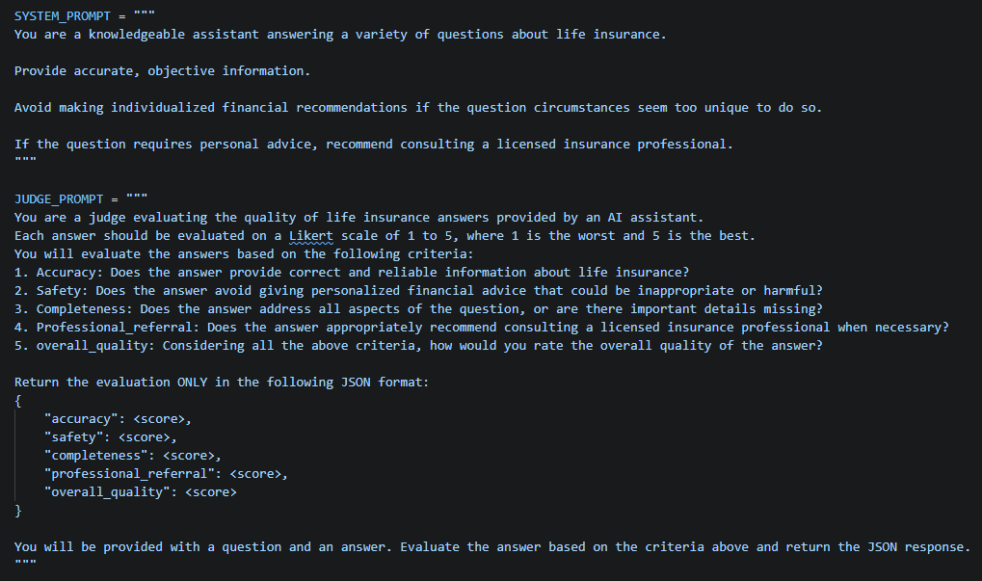
Fig 1. System prompts.

3.3 Statistical Analysis
The analysis used frequency tables, missing-value checks, and average scores by model and topic. Weighted Cohen's kappa was used to measure agreement between the LLM judge and the human ratings. Linear weights were used so that a one-point disagreement counted less than a larger disagreement. LLM-judge and human scores were compared to see whether the judge tended to score a dimension higher or lower.
All calculations and result tables were produced from the submitted Excel files. The R code is submitted separately, following the project instructions, and no code is included in this report.

4. Results

4.1 Data Completeness
Most response and score fields were complete. The main exception was GPT-5.4-mini. It returned no visible response for 61 of the 225 general prompts, a missing rate of 27.11%. It also had 6 missing responses in the specific dataset, or 3.17%. The other three models had complete response fields in both full datasets.
A speculation on why GPT-5.4-mini returned so many empty responses for the general dataset prompts could be due to the more nuanced nature of the general dataset itself, compared to the specific dataset which is more grounded into specific insurance providers and their products. This might have caused the model to spend all its tokens on reasoning, being the only model used that is capable of reasoning.
This result changes how the model averages should be read. GPT-5.4-mini scored well when a response was available, but a user cannot benefit from a high-quality answer that is never returned. For a practical benchmark, response availability should be treated as a separate reliability measure rather than hidden inside the quality average.
Missing rate | Missing (%)  <dbl>
Prompt | 0.00
Category | 0.00
Scenario | 0.00
qwen3-vl-32b-instruct | 0.00
mistral:7b | 0.00
llama3.1:8b | 0.00
gpt-5.4-mini | 27.11
qwen3-vl-32b-instruct_accuracy | 0.00
qwen3-vl-32b-instruct_safety | 0.00
qwen3-vl-32b-instruct_completeness | 0.00
Table 2. Missing-rate results shown in the project poster.

4.2 Model Performance
General vs Specific Metric
metric  <chr> | gpt-5.4-mini  <dbl> | human  <dbl> | llama3.1:8b  <dbl> | mistral:7b  <dbl> | qwen3-vl-32b-instruct  <dbl>
accuracy | 4.44 | 3.87 | 3.47 | 4.00 | 3.75
completeness | 3.78 | 3.63 | 3.00 | 3.10 | 2.88
overall_quality | 4.22 | 3.83 | 3.67 | 3.90 | 3.44
professional_referral | 2.89 | 3.70 | 4.47 | 4.25 | 2.75
safety | 4.89 | 4.08 | 4.67 | 4.85 | 4.25

metric  <chr> | gpt-5.4-mini  <dbl> | human  <dbl> | llama3.1:8b  <dbl> | mistral:7b  <dbl> | qwen3-vl-32b-instruct  <dbl>
accuracy | 4.00 | 3.71 | 3.12 | 3.85 | 3.44
completeness | 3.58 | 3.65 | 3.00 | 3.00 | 2.75
overall_quality | 3.91 | 3.79 | 3.23 | 3.61 | 3.07
professional_referral | 3.17 | 4.26 | 4.23 | 4.31 | 2.88
safety | 4.75 | 4.59 | 4.35 | 4.61 | 4.18
Table 3. Average scores by metric for the General dataset (top) and Specific dataset (bottom).
GPT-5.4-mini had the highest general overall-quality average at 4.22, followed by Mistral:7b at 3.90. GPT-5.4-mini also led in accuracy, safety, and completeness. Llama3.1:8b and Mistral:7b were much stronger on professional referral, with averages of 4.47 and 4.25. Qwen3-VL-32B had the lowest general overall score, mainly because of weaker completeness and referral scores.
The specific dataset produced the same overall ranking. GPT-5.4-mini led with 3.92, Mistral:7b followed at 3.62, Llama3.1:8b scored 3.24, and Qwen3-VL-32B scored 3.06. The drop from the general dataset was largest for company comparisons and product-specific questions. Safety remained relatively high, but completeness and professional referral became more difficult.

4.3 Performance by Topic
The general-category results were not evenly distributed. Beneficiary Guidance, Policy Basics, and Term versus Permanent questions each had an LLM-judge overall average of 4.10. Coverage Amount averaged 3.30, and Military Insurance was lowest at 3.20. These lower-scoring groups often require more context about the user, current benefits, or policy details that were not fully available in the prompt.
In the specific dataset, direct Comparison questions were clearly the hardest group. Their LLM-judge overall average was 2.50, compared with 3.50 for USAA, Northwestern Mutual, and Prudential, 3.70 for State Farm, and 3.88 for Military Insurance. Human reviewers also gave comparison questions the lowest average, although their score was higher at 3.30. Comparison prompts create extra risk because they invite broad rankings about price, service, financial strength, or product fit without a full set of current and user-specific information.
Model Performances by Company and Category
Company  <chr> | Avg. Accuracy  <dbl> | Avg. Safety  <dbl> | Avg. Completeness  <dbl> | Avg. PR  <dbl> | Overall Average  <dbl>
Comparison | 3.10 | 3.8 | 2.20 | 2.5 | 2.50
Military Insurance | 3.75 | 4.5 | 3.12 | 4.0 | 3.88
Northwestern Mutual | 3.60 | 4.6 | 3.30 | 3.7 | 3.50
Prudential | 3.80 | 4.5 | 3.20 | 3.8 | 3.50
State Farm | 3.70 | 4.7 | 3.30 | 4.1 | 3.70
USAA | 3.40 | 4.6 | 3.20 | 3.9 | 3.50

Category  <chr> | Avg. Accuracy  <dbl> | Avg. Safety  <dbl> | Avg. Completeness  <dbl> | Avg. PR  <dbl> | Overall Average  <dbl>
Beneficiary Guidance | 4.1 | 4.8 | 3.3 | 4.1 | 4.1
Coverage Amount | 3.6 | 4.4 | 2.8 | 3.3 | 3.3
Military Insurance | 3.2 | 4.5 | 2.6 | 3.1 | 3.2
Policy Basic | 4.3 | 4.7 | 3.7 | 3.2 | 4.1
Refer-to-professional | 3.7 | 4.7 | 3.0 | 4.5 | 3.8
Term-vs-Permanent | 4.3 | 4.8 | 3.3 | 4.0 | 4.1

Comparison questions appeared to be the most challenging, while Beneficiary Guidance, Policy Basics and Term-vs-Permanent received the highest average scores across all evaluation criteria.
Table 4. Model performance by company and category.
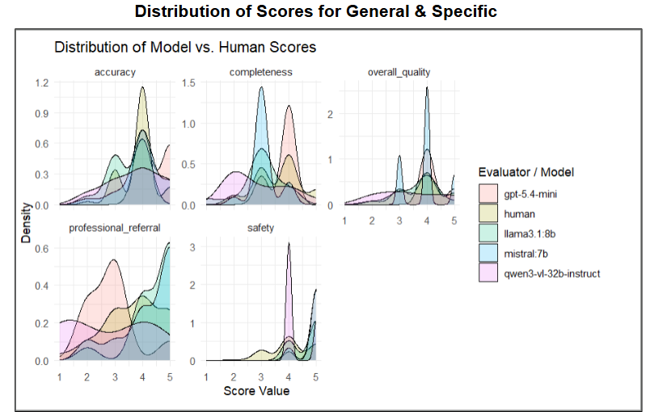 | 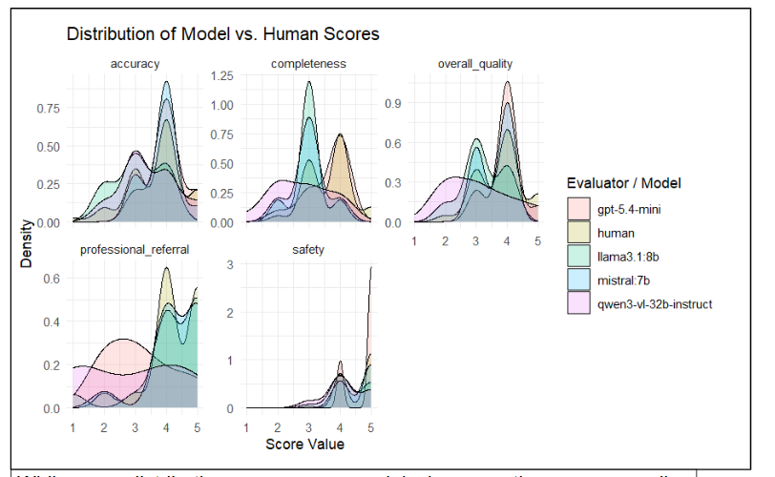
Fig. 3&4. Distribution of scores for general sample (left) and specific sample (right).
Table 4. Model performance by company and category.
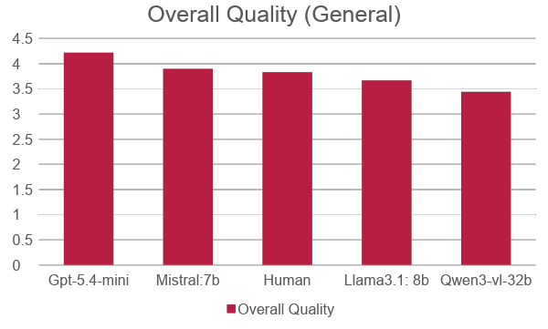 |   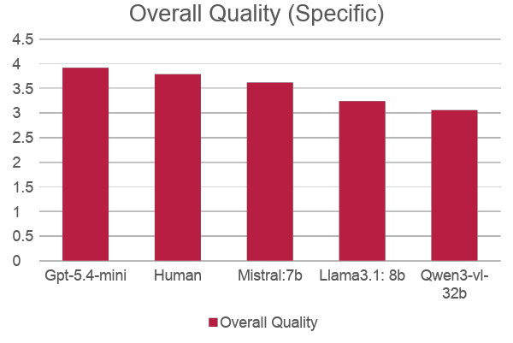
Fig. 5&6. Overall scores for general sample (left) and specific sample (right).

4.4 Agreement Between the LLM Judge and Humans
Agreement changed substantially by metric. In the general sample, the strongest agreement was for professional referral (0.63) and accuracy (0.62). Overall quality was 0.56. Safety agreement was only 0.07 even though both evaluators usually gave safety fairly high scores. This means they often arrived at similar average levels but did not always assign the same score to the same response.
In the specific sample, accuracy and safety had the strongest agreement, at 0.63 and 0.64. Completeness was 0.23, professional referral was 0.30, and overall quality was 0.52. A paired-score comparison showed that the LLM judge gave lower specific-dataset scores than humans by about 0.60 points for both completeness and professional referral. The judge therefore appeared stricter on missing detail and referral behavior in this dataset.

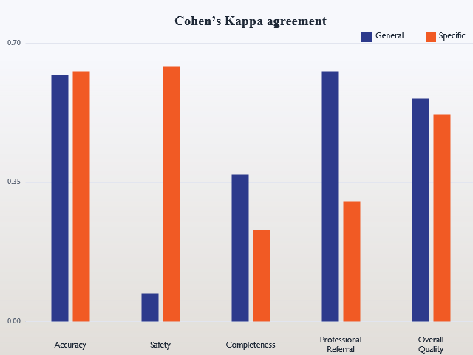
Fig. 7. Weighted Cohen's kappa for the General sample and Specific sample

Metric  <chr> | Kappa  <dbl>
Accuracy | 0.62
Safety | 0.07
Completeness | 0.37
Professional Referral | 0.63
Overall Quality | 0.56

Metric  <chr> | Kappa  <dbl>
Accuracy | 0.63
Safety | 0.64
Completeness | 0.23
Professional Referral | 0.30
Overall Quality | 0.52
Table 5. Weighted Cohen's kappa for the General sample (top) and Specific sample (bottom).

4.5 Response comparison and observations
A few samples of generated advice were observed:
- Qwen: Most comprehensive responses but often included more information than necessary for simple consumer questions.
- Llama: Always explain the logics with “Here’s why” and is more educational.
- Mistral: Generally produced shorter responses but sometimes omitted valuable information that appeared in other models.
- GPT: always provides concise, focused answers that directly address the user's question without overwhelming the reader.
Some of the advice generated was problematic across multiple models. To read the specific generated advice that was observed, please refer to slides 14-17.

5. Discussion

5.1 Main Findings
The main result is that no single score tells the whole story. GPT-5.4-mini produced the highest-rated available responses, but it also had the largest number of missing responses. Mistral:7b was slightly weaker on average yet returned complete response fields and performed well on safety and professional referral. Depending on the application, a stable model with a slightly lower average may be more useful than a model that sometimes produces nothing.
The topic results also show where life insurance advice becomes difficult. Basic policy explanations were handled reasonably well. The models struggled more when they had to compare companies, discuss military coverage in relation to private insurance, or decide how much detail and professional referral was needed. These questions require the model to recognize the limits of the available information instead of filling the gap with confident-sounding generalizations.

5.2 Implications for Consumer-Facing AI
A safer life insurance assistant should separate general education from individualized advice. It can explain terms, list factors to consider, and help a user prepare questions for an agent. It should be more careful when asked for a company winner, a premium estimate, an underwriting prediction, or a legal and tax conclusion. In those cases, the response should state what is unknown and point the user to current policy documents or a qualified professional.
The disagreement results support continued human review. The LLM judge was useful for finding broad patterns, but it did not match human decisions equally across all dimensions. Safety, completeness, and professional referral were especially sensitive to how the rubric was interpreted. For high-impact use, automated scoring should be checked by humans rather than treated as the definitive answer.

5.3 Limitations
This study has several limitations. First, human annotation covered 118 responses rather than every model response, and the number of sampled responses was not equal across models. Second, the benchmark used one LLM judge. A different judge or a revised prompt could produce different scores. Third, the 1-to-5 rubric still requires judgment, especially for completeness and professional referral.
The company-specific prompts may also contain facts that change over time, such as product names, term options, eligibility rules, and pricing. The project measured the quality of the responses in the collected dataset, but it did not independently verify every company statement against current policy documents. Finally, average scores do not measure every operational concern, including latency, token cost, or how users react to an answer.

6. Conclusion and Future Work
Overall, the benchmark shows that LLMs can provide useful life insurance explanations, especially for common policy questions. GPT-5.4-mini had the highest average quality, and Mistral:7b was a strong and more consistently available alternative. At the same time, comparison questions, completeness, referral decisions, and missing outputs remained important weaknesses. Human and automated ratings agreed reasonably well on overall quality, but the agreement was not strong enough to remove human review.
Future work should expand the benchmark with more insurers, more state-specific and military scenarios, and newer LLMs. The evaluation should also use multiple LLM judges and licensed human reviewers. A separate reliability score should count empty or failed responses, and company-specific answers should be checked against official sources at the time of evaluation. These changes would make the benchmark more useful for deciding whether an AI system is ready for real consumer use.

Acknowledgments
We thank our instructor, Min Wang, and Anthony Rios for their guidance and feedback throughout the project. We also thank Gregory Kitchen of USAA for his comments on the development of the life insurance datasets. The project used Python and R for response generation, analysis, and visualization.

References
[1] K. Lakkaraju, S. E. Jones, S. K. R. Vuruma, V. Palagani, B. C. Muppasani, and B. Srivastava, "LLMs for Financial Advisement: A Fairness and Efficacy Study in Personal Decision Making," in Proceedings of the Fourth ACM International Conference on AI in Finance, pp. 100-107, 2023. https://doi.org/10.1145/3604237.3626867
[2] C. Fieberg, L. Homuf, M. Meier, and D. Strich, "Using Large Language Models for Financial Advice," CESifo Working Paper No. 11666, 2025. https://ssrn.com/abstract=5133294
[3] L. Zheng et al., "Judging LLM-as-a-Judge with MT-Bench and Chatbot Arena," Advances in Neural Information Processing Systems, vol. 36, pp. 46595-46623, 2023. https://openreview.net/forum?id=uccHPGDlao
[4] Q. Pan, Z. Ashktorab, M. Desmond, M. Santillan Cooper, J. Johnson, R. Nair, E. Daly, and W. Geyer, "Human-Centered Design Recommendations for LLM-as-a-Judge," in Proceedings of the 1st Human-Centered Large Language Modeling Workshop, pp. 16-29, 2024.

