SKILL_CHECK_3
OMARE_MOKAYA
2026-07-27

1&2 Loading Packages
library(ggplot2)
library(patchwork)
library(dplyr)
##
## Attaching package: 'dplyr'
## The following objects are masked from 'package:stats':
##
## filter, lag
## The following objects are masked from 'package:base':
##
## intersect, setdiff, setequal, union
library(tinytex)

3 Loading Data
gapminder <- read.csv("C:\\Users\\Omare Collins\\Downloads\\gapminder_data.csv")
glimpse(gapminder)
## Rows: 1,704
## Columns: 9
## $ X <int> 1, 2, 3, 4, 5, 6, 7, 8, 9, 10, 11, 12, 13, 14, 15, 16, 17…
## $ country <chr> "Afghanistan", "Afghanistan", "Afghanistan", "Afghanistan…
## $ continent <chr> "Asia", "Asia", "Asia", "Asia", "Asia", "Asia", "Asia", "…
## $ year <int> 1952, 1957, 1962, 1967, 1972, 1977, 1982, 1987, 1992, 199…
## $ lifeExp <dbl> 28.801, 30.332, 31.997, 34.020, 36.088, 38.438, 39.854, 4…
## $ pop <int> 8425333, 9240934, 10267083, 11537966, 13079460, 14880372,…
## $ gdpPercap <dbl> 779.4453, 820.8530, 853.1007, 836.1971, 739.9811, 786.113…
## $ diff_lifeExp <dbl> 0.000, 1.531, 1.665, 2.023, 2.068, 2.350, 1.416, 0.968, 0…
## $ diff_pop <int> 0, 815601, 1026149, 1270883, 1541494, 1800912, -1998556, …

4 Scatter plot of lifeExp vs gdpPercap
ggplot(gapminder,aes(x = gdpPercap, y = lifeExp))+
geom_point()
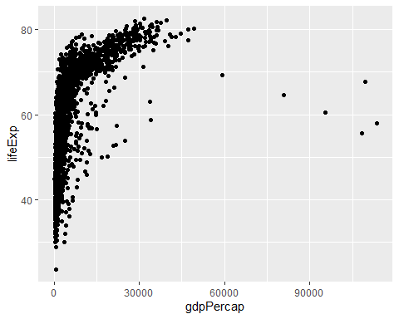

5 Colour by Continent
ggplot(gapminder, aes(x = gdpPercap, y = lifeExp, colour = continent)) +
geom_point()
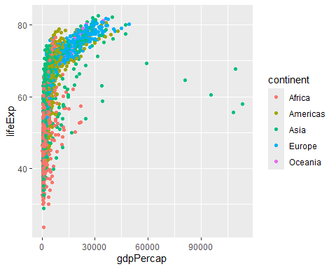

6 Trasforming the Y axis
ggplot(gapminder, aes(x = log10(gdpPercap), y = lifeExp, colour = continent)) +
geom_point()
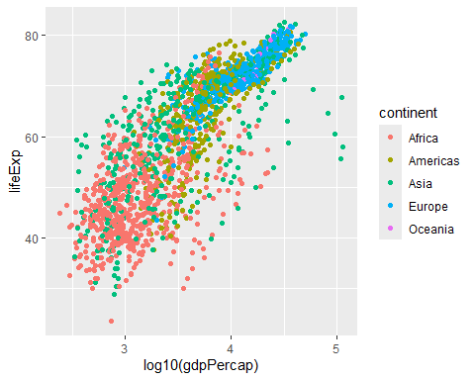

7: Facet by continent
ggplot(gapminder, aes(x = log10(gdpPercap), y = lifeExp, colour = continent)) +
geom_point() +
facet_grid(~continent)
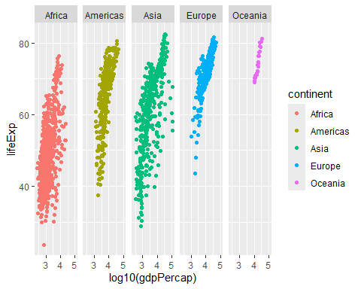

8: Theme as plot1
plot1 <- ggplot(gapminder, aes(x = log10(gdpPercap), y = lifeExp, colour = continent)) +
geom_point() +
facet_grid(~continent) +
theme_bw()
plot1
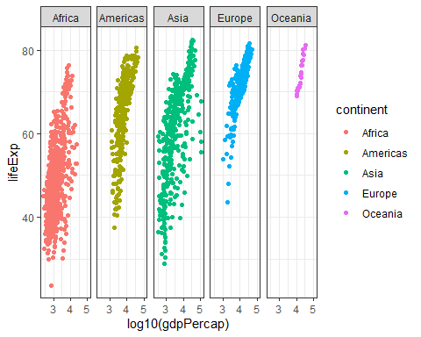

9: Density plot of life expectancy by continent
ggplot(gapminder, aes(x = lifeExp, fill = continent)) +
geom_density(alpha = 0.5)
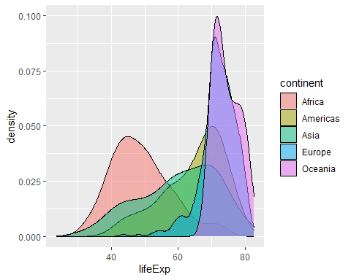

10: Life expectancy vs year, coloured by country, as plot2
plot2 <- ggplot(gapminder, aes(x = year, y = lifeExp, colour = country)) +
geom_line() +
theme(legend.position = "none")
plot2
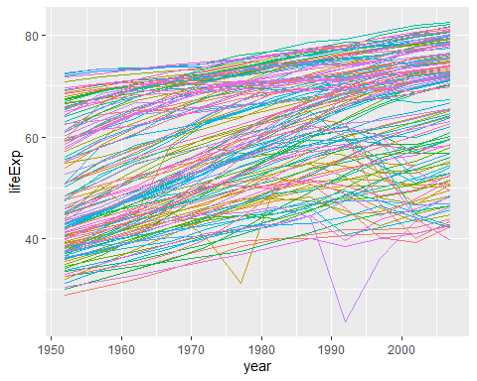

11: gapminder_2007 - mean gdpPercap by continent
gapminder_2007 <- gapminder %>%
filter(year == 2007) %>%
group_by(continent) %>%
summarise(mean_gdpPercap = mean(gdpPercap))
gapminder_2007
## # A tibble: 5 × 2
## continent mean_gdpPercap
## <chr> <dbl>
## 1 Africa 3089.
## 2 Americas 11003.
## 3 Asia 12473.
## 4 Europe 25054.
## 5 Oceania 29810.
# Oceania had the highest mean GDP per capita in 2007 (~$29,810),
# followed by Europe (~$25,054). Africa had the lowest (~$3,089).

12: Point plot of continent vs mean GDP per capita
ggplot(gapminder_2007, aes(x = continent, y = mean_gdpPercap, colour = continent)) +
geom_point()
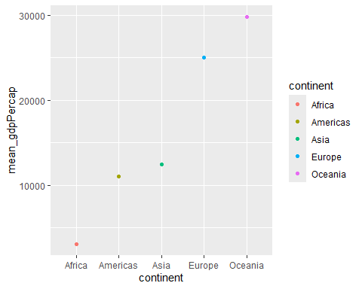

13: Bar plot with labels and theme
ggplot(gapminder_2007, aes(x = continent, y = mean_gdpPercap, colour = continent)) +
geom_col() +
labs(x = "Continent", y = "Mean GDP per Capita (2007)",
title = "Mean GDP per Capita by Continent (2007)") +
theme_minimal()
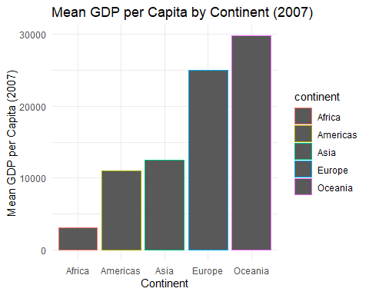

14: gapminder_summary - mean gdpPercap and lifeExp by continent/year
gapminder_summary <- gapminder %>%
group_by(continent, year) %>%
summarise(mean_gdpPercap = mean(gdpPercap),
mean_lifeExp = mean(lifeExp),
.groups = "drop")
gapminder_summary
## # A tibble: 60 × 4
## continent year mean_gdpPercap mean_lifeExp
## <chr> <int> <dbl> <dbl>
## 1 Africa 1952 1253. 39.1
## 2 Africa 1957 1385. 41.3
## 3 Africa 1962 1598. 43.3
## 4 Africa 1967 2050. 45.3
## 5 Africa 1972 2340. 47.5
## 6 Africa 1977 2586. 49.6
## 7 Africa 1982 2482. 51.6
## 8 Africa 1987 2283. 53.3
## 9 Africa 1992 2282. 53.6
## 10 Africa 1997 2379. 53.6
## # ℹ 50 more rows

15: Line + point plot of year vs mean life expectancy
plot3 <- ggplot(gapminder_summary, aes(x = year, y = mean_lifeExp, colour = continent)) +
geom_line() +
geom_point()
plot3
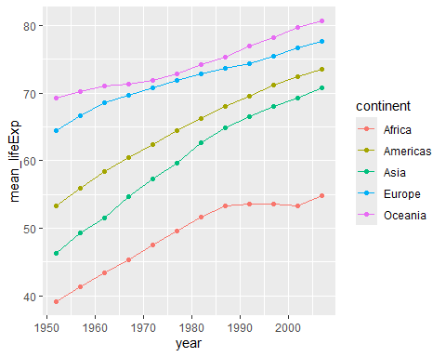

16: kenya_gapminder
kenya_gapminder <- gapminder %>%
filter(country == "Kenya")

17: Year vs GDP per capita for Kenya
ggplot(kenya_gapminder, aes(x = year, y = gdpPercap)) +
geom_line(colour = "blue") +
labs(x = "Year", y = "GDP per Capita",
title = "Kenya: GDP per Capita Over Time") +
theme_bw()
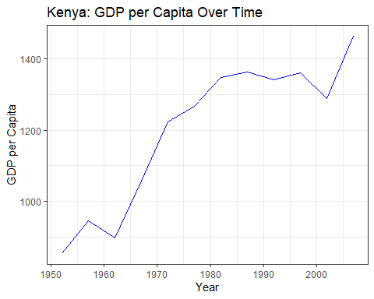

18: gapminder_decline
gapminder_decline <- gapminder %>%
filter(year %in% c(1997, 2002, 2007), diff_lifeExp < 0)

19: Bar plot of decline, faceted by year
ggplot(gapminder_decline, aes(x = country, y = diff_lifeExp)) +
geom_col() +
facet_grid(~year, scales = "free_x") +
theme(axis.text.x = element_text(angle = 90, vjust = 0.5, hjust = 1))
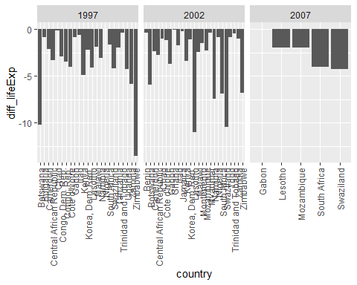
#The countries with the greatest reduction in life expectancy were:
# 1997 - Zimbabwe (-13.57 years)
# 2002 - Lesotho (-10.97 years)
# 2007 - Swaziland (-4.26 years)

20: Colour by country, remove legend, label axes, add theme, saved as plot4
plot4 <- ggplot(gapminder_decline, aes(x = country, y = diff_lifeExp, fill = country)) +
geom_col() +
facet_grid(~year, scales = "free_x") +
labs(x = "Country", y = "Change in Life Expectancy",
title = "Countries with Declining Life Expectancy (1997, 2002, 2007)") +
theme_bw() +
theme(axis.text.x = element_text(angle = 90, vjust = 0.5, hjust = 1),
legend.position = "none")
plot4
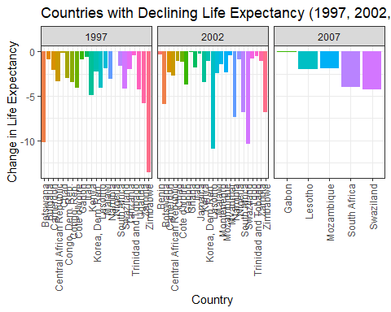

21: Combining plot1-4 with patchwork (2 on top, 2 on bottom)
(plot1 | plot2) / (plot3 | plot4)
