Act report

The analysis on the We rate dogs Data

The source below shows adecrease in early months for the number of tweets and finally there is a rise increase in the trends 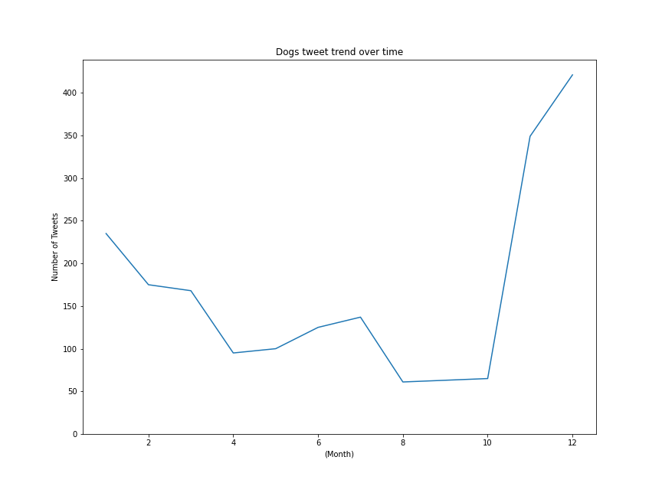

As we can see the month of November shows the highest rate of re tweets with the arrival of the Christmas time as shown in the below figure

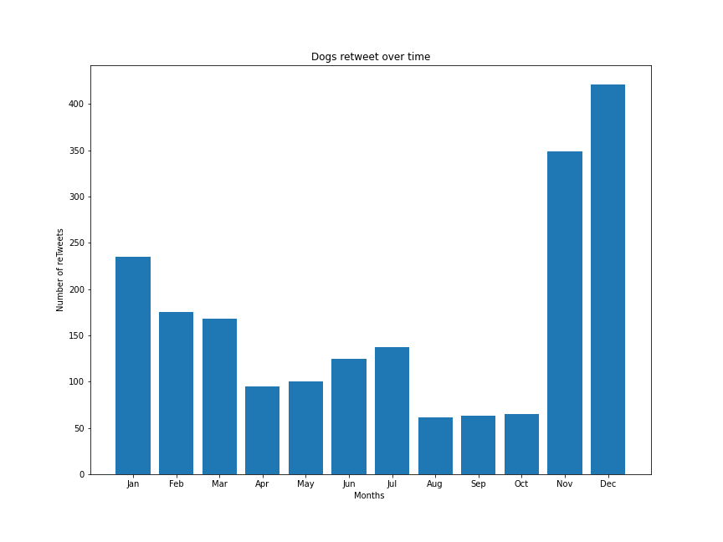

The number pf favoured accounts as well behave in the same manner also , with the approach of Christmas time , there is an increase trend on favouring dog photos. 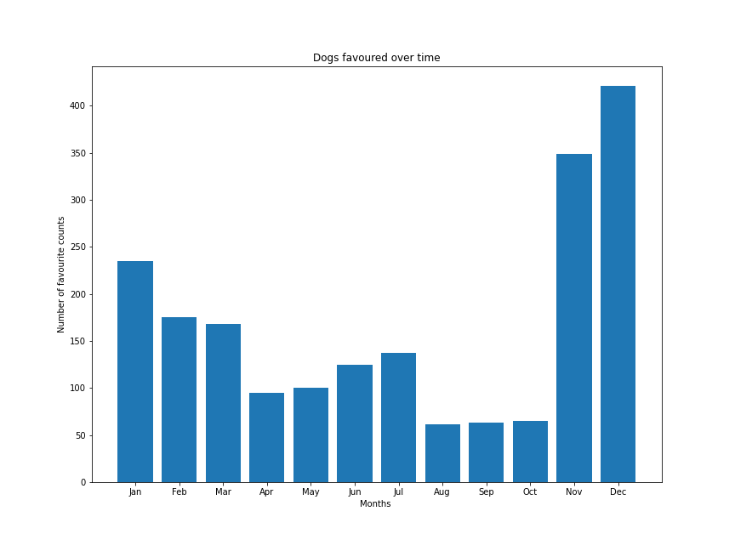

The source usage for the tweets, as clearly indicated below, shows that the most used source for tweeting is the iphone then comes in ascending order the vine, twitter web client , and tweet-deck

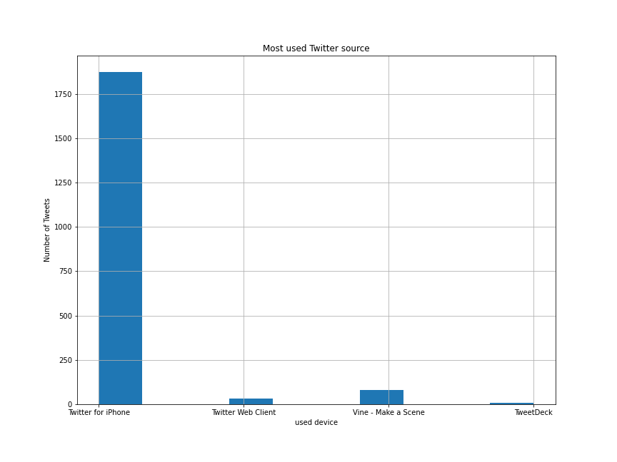

The most common 6 names used for dogs is Phineas , Tilly , Archie , Daria , Franklin , Jax and Finally Zoey , lot of Dogs on the other hand were not tweeted

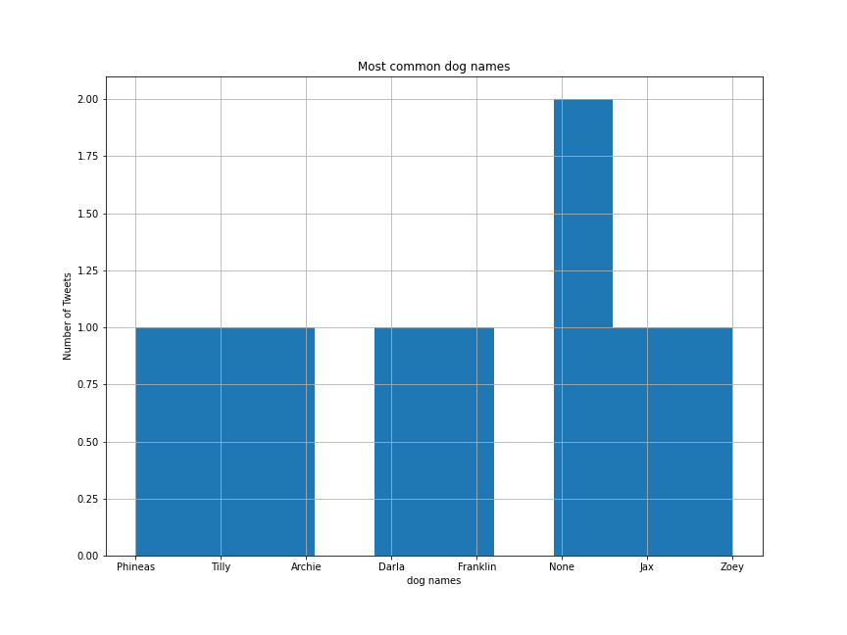

The number of tweets follow the same pattern as the retweets for months , it shows the decrease in early months then the increase in the final months for the tweets.



The dog phases analysis shows that the highest dog phase recordedwas the Doggo, then floofer , then Poopo, Doogo .However some cases were recorded multiple as well.

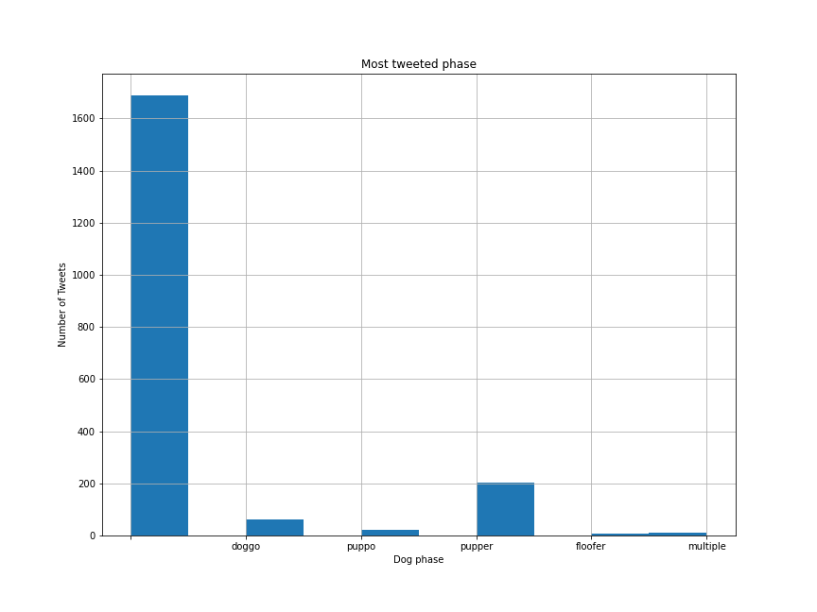

The figure below shows the most common breed, it was proved to be Pug, French bulldog, Chow, Vizsla , basset,m pembrokr, Semoyed, Pug . however there was alot of dogs who were tweeted without name

