**Model and designing**

**External perspective:**

**Context model**

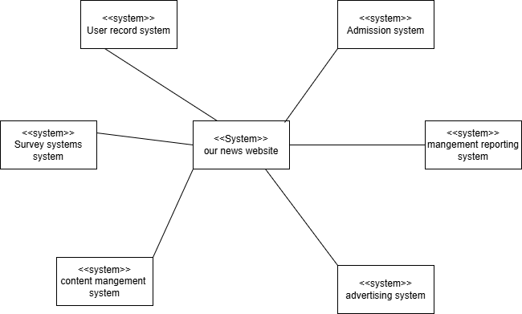

**Interaction perspective:**

**Use case diagram**

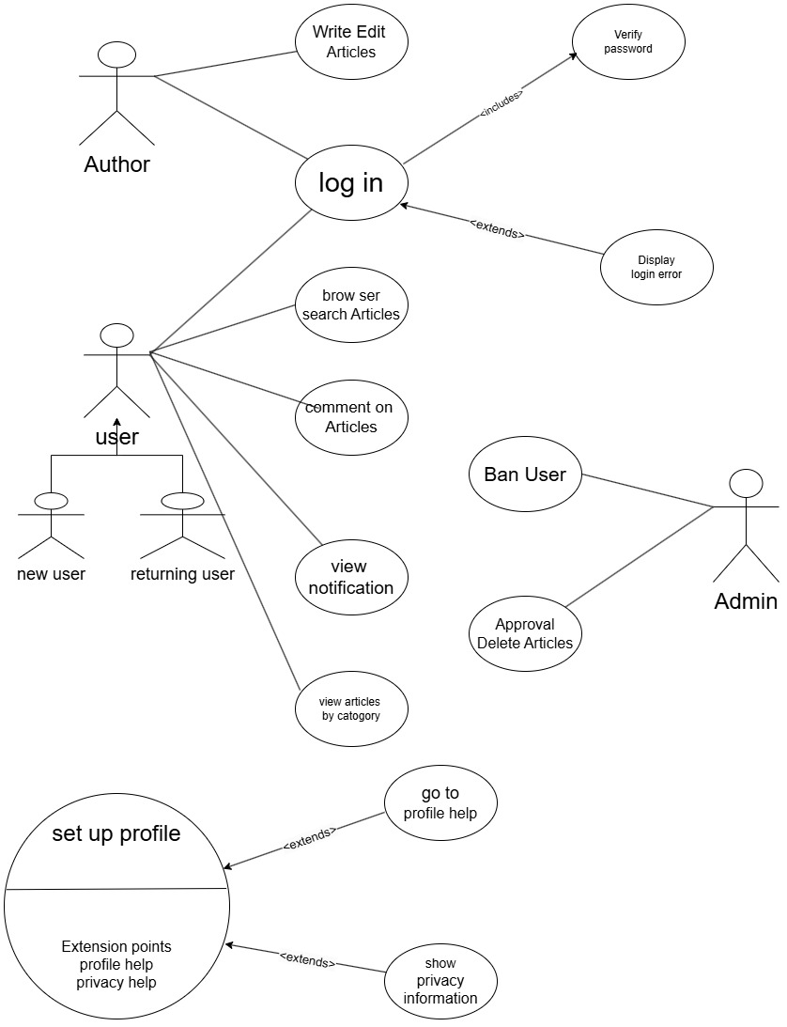

**Sequencing diagram**

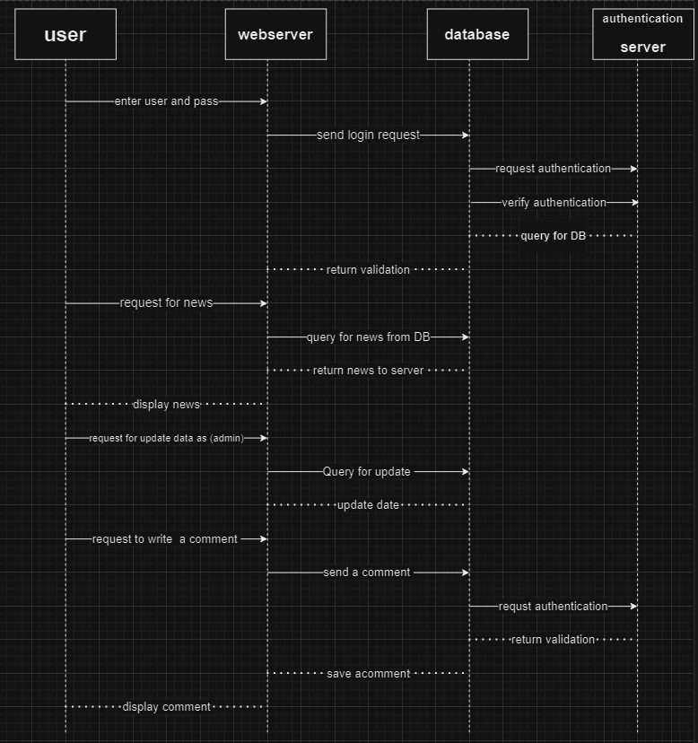

**Structural perspective:**

**Class diagram**

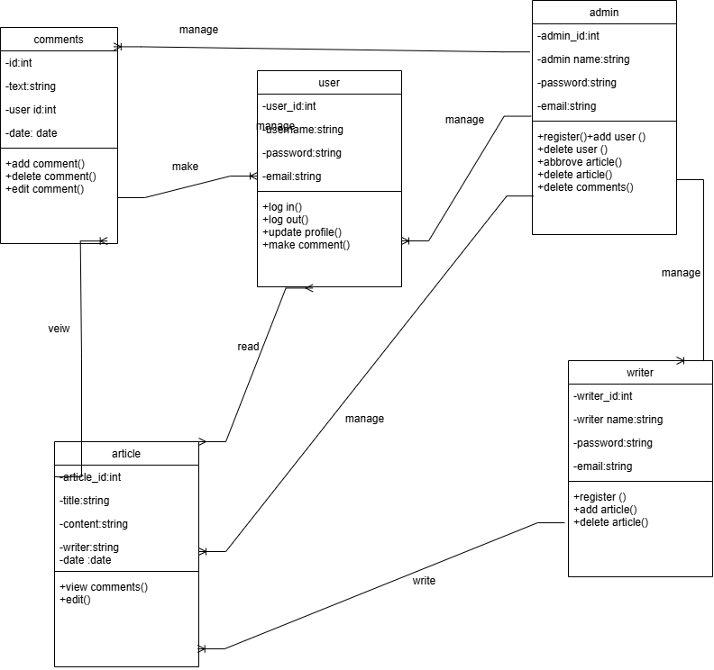

**Behavioral perspective:**

**Activity diagram**

