SRS document

Omar ghobashy 20215024

Phase 1 deliverables

**15 functional requirements :**

1. The system shall allow users to sign up and create accounts.
2. The system shall allow users to log in based on their role.
3. The system shall allow users to edit their personal profile information.
4. Admins shall be able to delete, ban, and unban users or librarians.
5. Admins shall be able to change the password of any account.
6. The system shall allow appropriate users to add new books to the storage.
7. The system shall allow appropriate users to remove books from the storage.
8. Users shall be able to search for books by name or genre.
9. Users shall be able to sort search results by name or rating.
10. Users shall be able to borrow books if available.
11. Users shall be able to request an extension for their borrowing period.
12. Users shall be able to return books, marking them as available.
13. Users shall be able to rate and review books.
14. The system shall calculate and display overdue fines for users.
15. The system shall notify users when a book they are interested in becomes available or is overdue.

**5 non-functional requirements:**

1)The system shall store data in text files to ensure persistence between runs.

2)The system shall be user-friendly, with clear text-based menus.

3)The system shall respond to user inputs within 2 seconds.

4)The system shall support up to 50 concurrent users across different roles.

5)The system shall ensure data security by encrypting stored passwords.

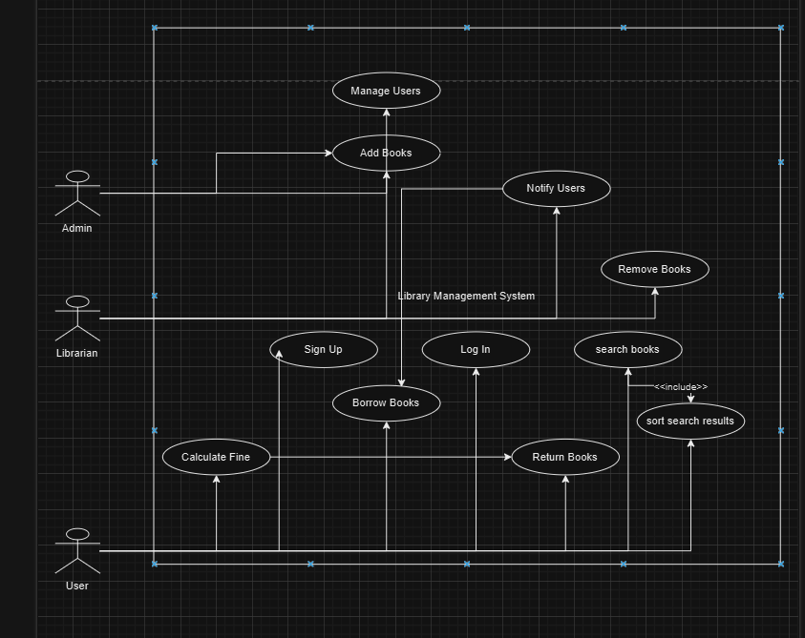

**Use case diagram**

**Formal use case description :**

• **Borrow Book**

* **Actor:** User
* **Precondition:** User is logged in and authenticated.
* **Basic Flow:**
  1. User searches for a book.
  2. System checks if the book is available.
  3. If available, the book is marked as borrowed and removed from the available list.
* **Postcondition:** Book is added to the user’s borrowed list.
* **Alternative Flows:** If unavailable, the user is added to the waiting list.

• **Manage Users (Admin)**

* **Actor:** Admin
* **Precondition:** Admin is logged in.
* **Basic Flow:**
  1. Admin views the list of all users.
  2. Admin selects a user and performs an action (delete/ban/unban/change password).
* **Postcondition:** The user's data is updated as per the action.

• **Request Borrowing Period Extension**

* **Actor:** User
* **Precondition:** User has no overdue books or unpaid fines.
* **Basic Flow:**
  1. User selects the book for which they want an extension.
  2. System checks eligibility and grants an additional week.
* **Postcondition:** Borrowing period is extended.

• **Search and Sort Books**

* **Actor:** User
* **Precondition:** User is logged in.
* **Basic Flow:**
  1. User inputs search criteria (name or genre).
  2. System displays matching books.
  3. User sorts results by name or rating.
* **Postcondition:** Sorted results are displayed.