HydroLoop
GJU Water & Energy Intelligence Program
IEEE Region 8 Sustainable Universities Program (2026)
Institution: German Jordanian University (GJU), Madaba, Jordan
Duration: 3 Months
Funding Requested: $1,400 USD

1. Executive Summary
HydroLoop is a smart sustainability platform designed to transform water and energy usage at GJU into a measurable, data-driven system.
At the center of the university lies a decorative water wheel that consumes electricity and loses water through evaporation without any monitoring. HydroLoop introduces a non-invasive IoT and AI-based system to measure these hidden costs and convert insights into actionable improvements.
The project delivers:
- Real-time measurement of water and energy consumption
- AI-driven analysis and optimization
- A campus-wide water monitoring system
- A data-backed sustainability improvement proposal
The result is a scalable solution that turns an unmonitored system into a flagship sustainability showcase.

2. Problem Statement
2.1 National Context
- Jordan is the world's second most water-stressed country (World Resources Institute, 2023)
- High dependency on imported energy
- Lack of granular monitoring leads to hidden inefficiencies
2.2 GJU-Specific Challenge
- Central water wheel operates daily with:
  - Continuous electricity usage
  - Unmeasured water evaporation
  - Periodic refilling with potable water
- No monitoring or optimization exists
- System runs regardless of actual usage
2.3 Campus-Wide Gap
- No building-level water monitoring
- Leaks and inefficiencies go undetected
- Resource waste is only visible after damage occurs

3. Proposed Solution
HydroLoop consists of two main layers and one institutional output:
3.1 Layer 1 – Smart Water Wheel Monitoring
A non-invasive sensor system to track:
- Energy consumption (motor usage)
- Water loss (evaporation and refill cycles)
- Weather impact
- Human presence in the area
This creates a full understanding of:
- Cost vs. usage
- Waste vs. value

3.2 Layer 2 – Campus Water Intelligence Network
Expansion to multiple buildings with:
- Flow sensors at water entry points
- AI-based anomaly detection
- Centralized monitoring dashboard
This enables:
- Leak detection
- Usage optimization
- Real-time insights across campus

3.3 Institutional Deliverable
A formal report including:
- Measured costs (water and energy)
- Identified inefficiencies
- Recommended improvements such as:
  - Smart operation (only when needed)
  - Evaporation reduction
  - Energy optimization
  - Alternative water sources

3.4 Public Engagement Feature
- QR code linked to live dashboard
- Students can view real-time data
- Turns infrastructure into an educational tool

4. Technical Architecture
System Components
Field Layer:
- Water wheel sensors
- Building flow sensors
- Weather station
- Camera for occupancy tracking
Key hardware: ESP32 microcontrollers, PZEM-004T clamp-on current/voltage sensors, JSN-SR04T waterproof ultrasonic water-level sensors, BME280 weather sensors, and ESP32-CAM modules for occupancy detection.
Data Layer:
- MQTT communication
- Time-series database
Processing Layer:
- AI models for prediction and anomaly detection
Visualization Layer:
- Dashboard (Grafana)
- Public display interface
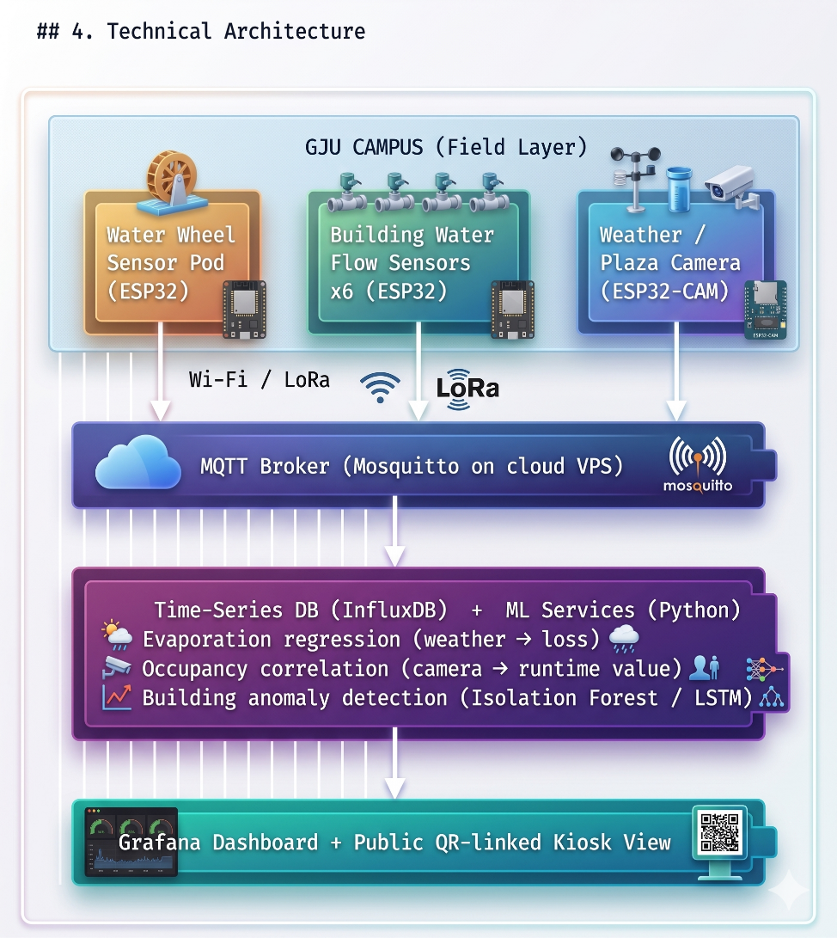

5. Implementation Plan
Phase 1 – Setup (Week 1)
- Stakeholder alignment
- Procurement
Phase 2 – Wheel Monitoring (Weeks 2–3)
- Sensor installation
- Data streaming setup
Phase 3 – Network Deployment (Weeks 3–7)
- Install building sensors
- Validate data collection
Phase 4 – AI & Dashboard (Weeks 6–10)
- Model training
- Dashboard development
Phase 5 – Analysis (Weeks 10–11)
- Data evaluation
- Report preparation
Phase 6 – Final Launch (Week 12)
- Public dashboard release
- Final submission

6. Budget Summary
Total Estimated Cost: $1,400 USD
Item | Qty | Unit Cost (USD) | Total (USD)
PZEM-004T current/voltage sensor (wheel motor) | 1 | $40 | $40
JSN-SR04T waterproof ultrasonic sensor + mount | 1 | $30 | $30
BME280 weather sensor + pole mount + wiring | 1 | $25 | $25
ESP32-CAM + outdoor weatherproof enclosure | 1 | $25 | $25
Weatherproof enclosures, cabling, hardware | — | $100 | $100
Flow sensor + ESP32 + enclosure (x6 buildings) | 6 | $80 | $480
LoRa gateway / central WiFi access point | 1 | $80 | $80
Cloud VPS + domain (3 months) | 1 | $80 | $80
Public kiosk tablet + weatherproof mount | 1 | $200 | $200
Launch signage, QR plaques, infographics | — | $80 | $80
Contingency (shipping, customs, spare parts) | — | $260 | $260
TOTAL |  |  | ~$1,400

7. Key Performance Indicators (KPIs)
- Measured energy consumption of water wheel
- Measured water loss
- Identified reduction opportunities:
  - ≥30% energy savings
  - ≥40% water savings
- Minimum 6 monitored buildings
- Real-time dashboard availability
- Leak/anomaly detection events
- Public engagement via QR dashboard

8. Sustainability Impact
Environmental
- Reduced water waste
- Reduced energy consumption
- Lower carbon footprint
Institutional
- Long-term monitoring capability
- Data-driven decision making
Educational
- Real-time learning platform for students
- Increased awareness of sustainability

9. Scalability & Replication
HydroLoop is designed to be:
- Low-cost
- Easy to deploy
- Fully scalable
The system can be adapted to:
- Other universities
- Different infrastructure (fountains, labs, HVAC systems)
All components are based on:
- Open-source software
- Widely available hardware

10. Risk Assessment & Mitigation
Risk | Likelihood | Impact | Mitigation
Admin restricts sensor access near wheel | Medium | High | Non-invasive design requires zero wheel modification; sensors mount on public poles/lampposts; MoU signed in Week 1 before procurement
Hardware import delays / customs in Jordan | Medium | Medium | $260 contingency included; parallel sourcing from regional and international suppliers; early procurement in Week 1
Sensor measurements inaccurate / not trusted | Low | High | Dual-method validation: ultrasonic level drop + refill-event counting; cross-checked against manual flow measurements
Wi-Fi dead zones between campus buildings | Medium | Low | LoRa fallback included in budget; flexible mesh topology allows re-routing
ML model insufficient with limited training data | Low | Medium | Classical baselines (Isolation Forest, regression) chosen — effective with weeks of data; deep learning left for future phases

