ABSTRACT:

As the energy demand and the environmental problems increase, the natural energy sources have become very important as an alternative to the conventional energy sources. The renewable energy sector is fast gaining ground as a new growth area for numerous countries with the vast potential it presents environmentally and economically. Solar energy plays an important role as a primary source of energy, especially for rural area. This paper aims at the development of process to track the sun and attain maximum efficiency using Arduino uno and LabVIEW for real time monitoring. The project is divided into two stages, which are hardware and software development. In hardware development, four light dependent resistor (LDR) has been used for capturing maximum light source. Two servo motors have been used to move the solar panel at maximum light source location sensing by LDR. The GUI is constructed by using LabVIEW. The performance of the system has been tested and compared with static solar panel. This paper describes the design of a low cost, solar tracking system.

Keywords:

solar tracking, Arduino, LabVIEW

# 1. INTRODUCTION:

The world population is increasing day by day and the demand for energy is increasing accordingly. Oil and coal as the main source of energy nowadays, is expected to end up from the world during the recent century which explores a serious problem in providing the humanity with an affordable and reliable source of energy. Renewable energy is derived from natural processes that are replenished constantly. Renewable energies are inexhaustible and clean. The energy comes from natural resources such as sun, wind, tides, waves, and geothermal heat. Solar energy is quite simply the energy produced directly by the sun. Solar energy is radiant light and heat from the sun harnessed using a range of technologies such as photovoltaic, thermal electricity and etc. A solar cell (also called a photovoltaic cell) is an electrical device that converts the energy of light directly into electricity by the photovoltaic effect. A solar panel is a set of solar photovoltaic modules electrically connected and mounted on a supporting structure. The majority of modules use wafer- based crystalline silicon cells or thin-film cells based on cadmium telluride or silicon. The structural member of a module can either be the top layer or the back layer. Electrical connections are made in series to achieve a desired output voltage and in parallel to provide a desired current capability. Several types of solar cells are available. Monocrystalline Solar Cells, Polycrystalline Solar Cells, Amorphous Silicon (a-Si) Solar Cells, Cadmium Telluride (CdTe) Solar Cells.

LabVIEW (short for Laboratory Virtual Instrument Engineering Workbench) is a system-design platform and development environment for a visual programming language from National Instruments. The software is perhaps the most important component of the system. The main routine, or VI, provides a front panel interface that allows the operator to control and monitor the system. It calls to perform functions that gather analog input, send analog output. The front panel is what allows the operator to control and monitor the process. It includes software controls and indicators that mimic physical controls such as buttons, sliders, LEDs, and charts. The block diagram is a graphical representation of the underlying software program. It consists of icons that represent typical programming elements such as constants, variables, subroutines, and loops. Arduino is a single-board microcontroller, intended to make the application of interactive objects or environments more accessible. It's an open- source physical computing platform and a development environment for writing software for the board. Arduino can be used to develop interactive objects, taking inputs from a variety of switches or sensors, and controlling a variety of lights, motors, and other physical outputs. Arduino has some advantages for educational and interested recreational over other systems like Inexpensive, Open source and extensible software, extensible hardware The LabVIEW Interface for Arduino (LIFA) allows users to control sensors and acquire data through an Arduino microcontroller using the graphical programming environment LabVIEW. Arduino microcontroller acts as an I/O engine that interfaces with LabVIEW Vis through a serial connection. This helps to move information from Arduino pins to LabVIEW without adjusting the communication, synchronization. Using the common Open, Read/Write, Close convention in LabVIEW, we can access the digital, analog, pulse-width- modulated, I2C, and SPI signals of the Arduin microcontroller. The LabVIEW software package from National Instruments is used to develop the custom data acquisition.

# 2. SOLAR TRACKER:

Sunlight has two components, the direct beam that carries about 90% of the solar energy, and the diffuse sunlight that carries the remainder. The diffuse portion is the blue sky on a clear day and increases proportionately on cloudy days. As the majority of the energy is in the direct beam, maximizing collection requires the sun to be visible to the panels as long as possible. A typical solar panel converts only 30 to 40 percent of the incident solar irradiation into electrical energy

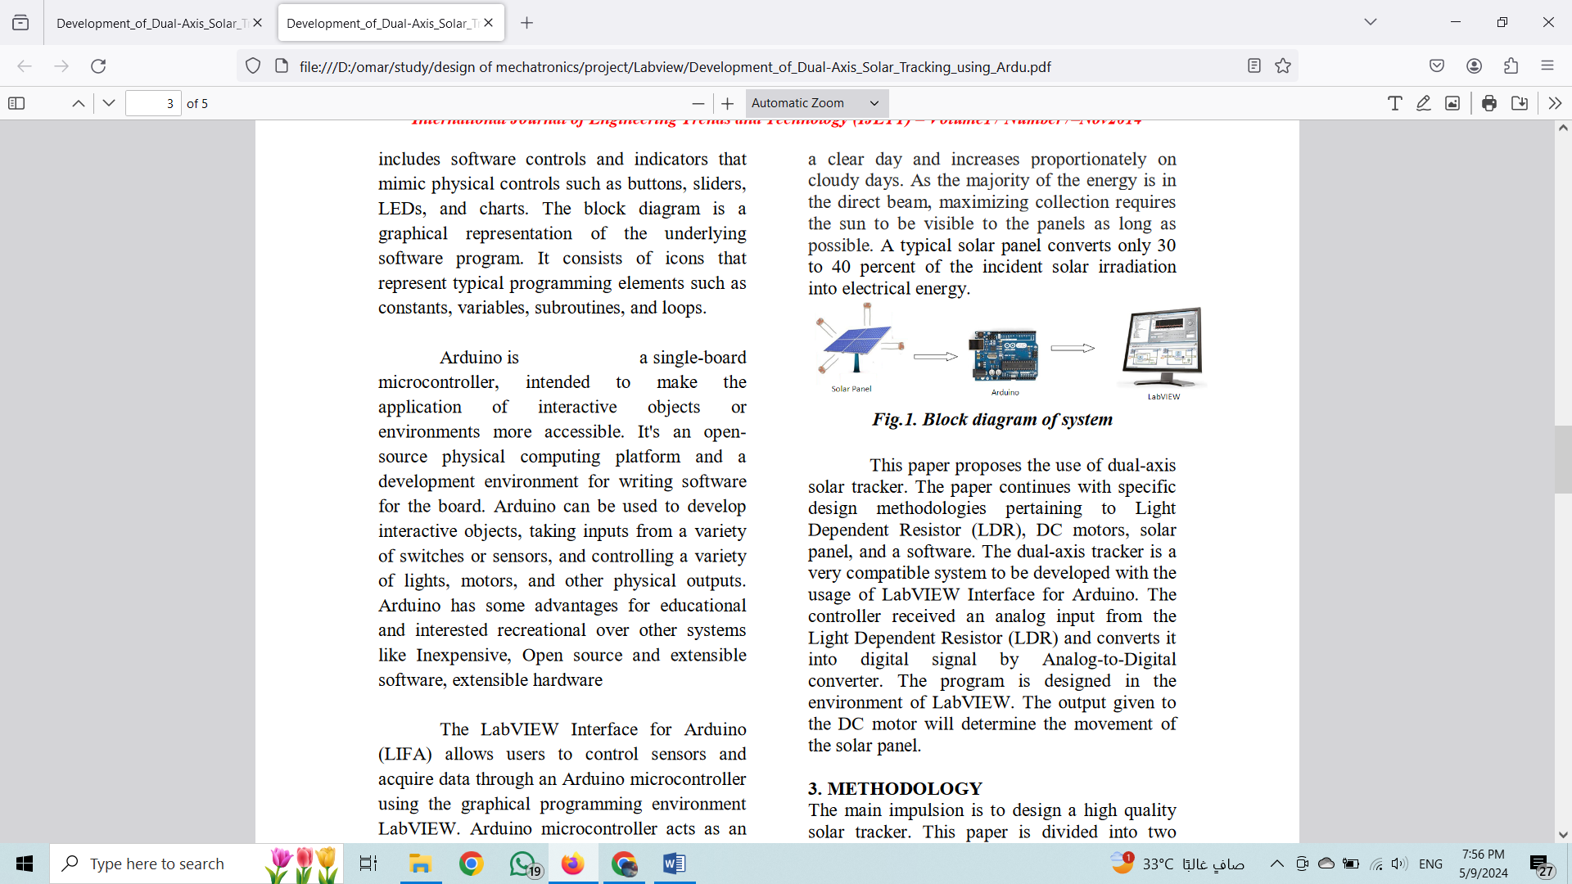

This paper proposes the use of dual-axis solar tracker. The paper continues with specific design methodologies pertaining to Light Dependent Resistor (LDR), servo motors, solar panel, and a software. The dual-axis tracker is a very compatible system to be developed with the usage of LabVIEW Interface for Arduino. The controller received an analog input from the Light Dependent Resistor (LDR) and converts it into digital signal by Analog-to-Digital converter. The program is designed in the environment of LabVIEW. The output given to the servo motor will determine the movement of the solar panel.

# 3. METHODOLOGY:

The main impulsion is to design a high quality solar tracker. This paper is divided into two parts; hardware and software. It consists of three main constituent which are the inputs, controller and the output as shown in Fig 1.A photo resistor or Light-dependent resistor (LDR) or photocell is a light-controlled variable resistor. LDRs or Light Dependent Resistors are very useful especially in light/dark sensor circuits. Normally the resistance of an LDR is very high, sometimes as high as 1000 000 ohms, but when they are illuminated with light resistance drops dramatically. LDR’s have low cost and simple structure. A servo motor relies on the fact that like magnet poles repels and unlike magnetic poles attracts each other.servo motors consist of one setof coils, called armature winding, inside another set of coils or a set of permanent magnets, called the stator. Applying a voltage to the coils produces a torque in the armature, resulting in motion. servo motor with gear arrangement have been selected since they are cheaper than servo and stepper motors.L293D IC having two channels has been used to drive the servo motors with gear arrangement have been used to achieve the desired speed in moving the solar panel .The most important effect of using servo motor with gear mechanism in dual axis tracking system is getting mechanical stability of solar panel without spending much power for servo motors .The servo motors can turn either clockwise or anticlockwise direction depending upon the sequence of the logic signals. The sequence of the logic signals depends on the difference of light intensity of the LDR sensors. The principle of the solar tracking system is done by Light Dependant Resistor (LDR). Four LDR’s are connected to Arduino analog pin AO to A4 that acts as the input for the system. The built-in Analog-to-Digital Converter will convert the analog value of LDR and convert it into digital. The inputs are from analog value of LDR, Arduino as the controller and the servo motor will be the output. LDR1 and LDR2, LDR3 and LDR4 are taken as pair .If one of the LDR in a pair gets more light intensity than the other, a difference will occur on node voltages sent to the respective Arduino channel to take necessary action. The servo motor will move the solar panel to the position of the high intensity LDR that was in the programming. Algorithm had been constructed using LabVIEW programming. The algorithm of the

program is given as steps in the following.

Step 1.Read all analog voltages from analog

channels

Step 2.If all voltages are equal then motor will

be in stop position.

Step 3.If LDR1>LDR2 Then the top motor will

rotate clockwise.

Step 4.If LDR1<LDR2 Then the top motor will

rotate anticlockwise.

Step 5. If LDR3>LDR4 Then the down motor

will rotate clockwise.

Step 6. If LDR3<LDR4 Then the down motor

will rotate anticlockwise.

# 4. RESULT AND DISCUSSION:

Data collected through the monitoring system will be analyzed to identify the features of the effective solar system. The sun position is one of the main factors that caused instability measurement output voltage. The solar panel will not be able to achieve a maximum illumination from the sun from its standard position. As referring to graph, the output voltages for panel are slightly fluctuated. The comparison between static and moving panels shows that the solar panel with tracker produced higher output voltages as it gets optimum absorption. Fig 5. Shows the graph for a period of interval obtained from the experiment.

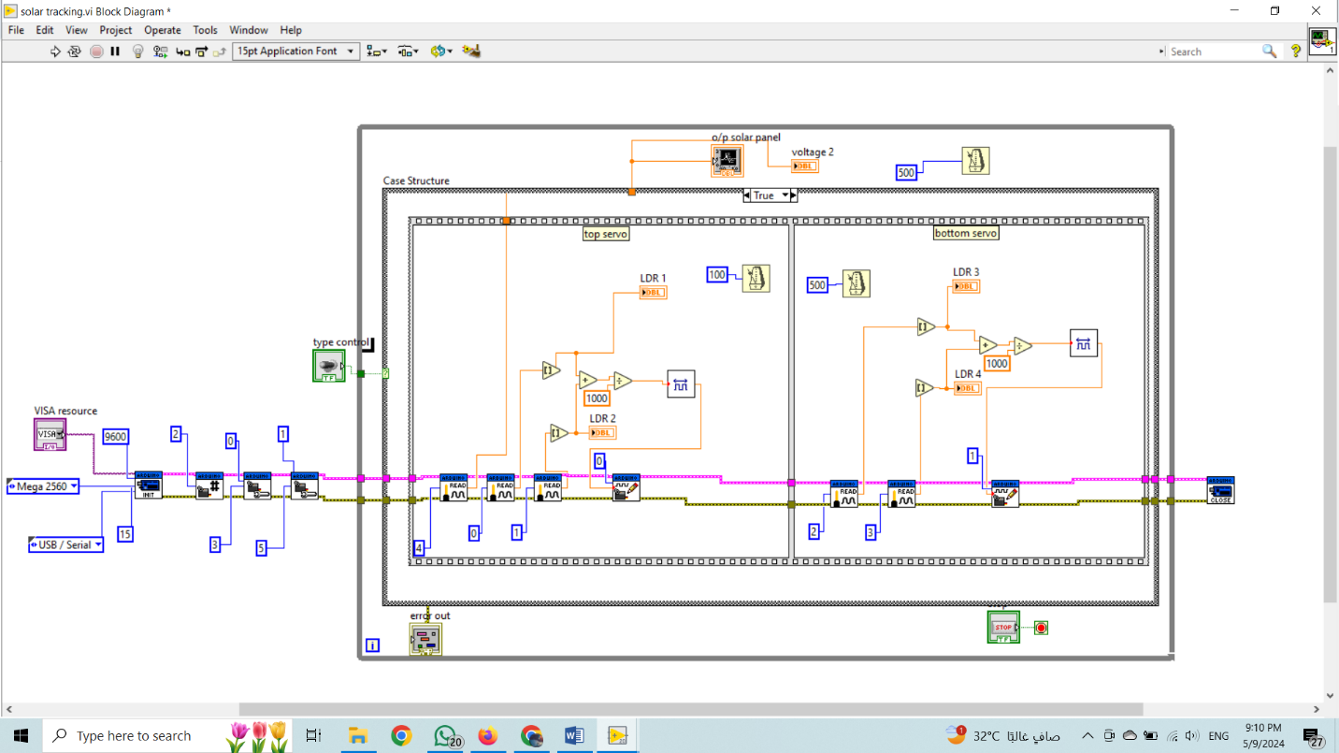

Fig. 2. Block diagram of system in LabVIEW

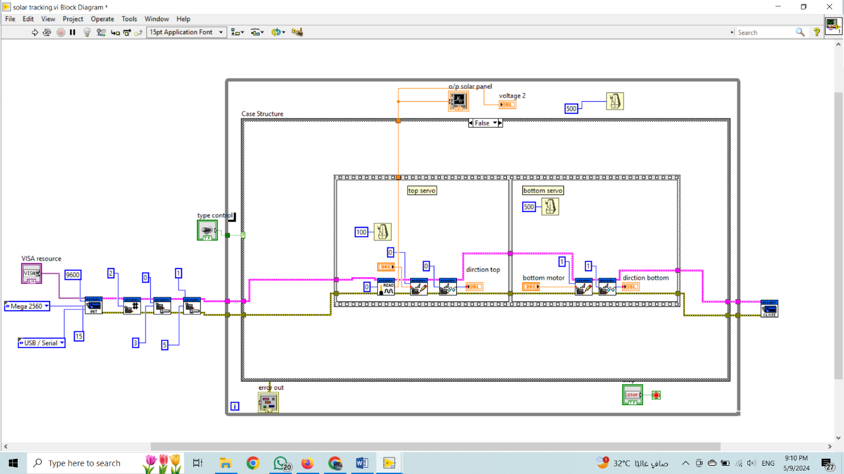

Fig. 3. Block diagram of system in LabVIEW

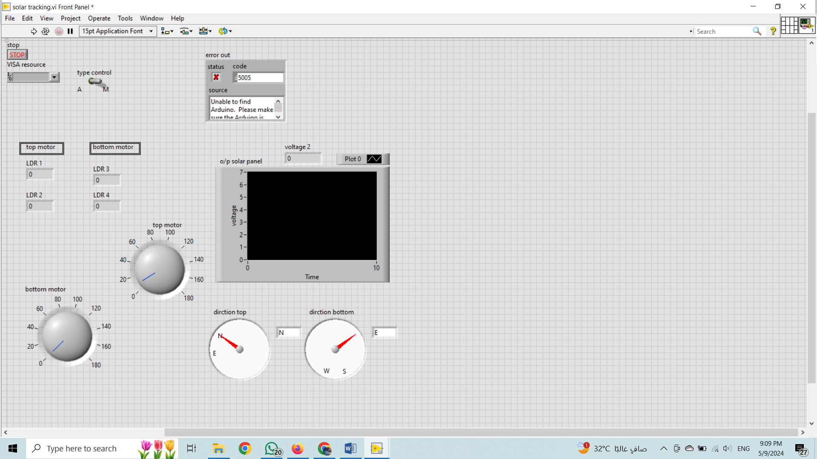

Fig.4.Front panel of the system

# 5.Discribe of blocks

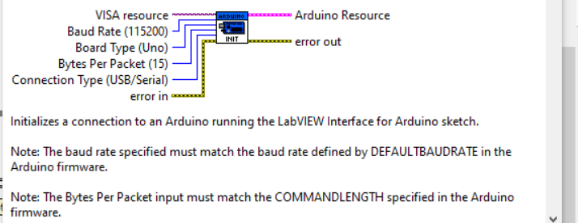

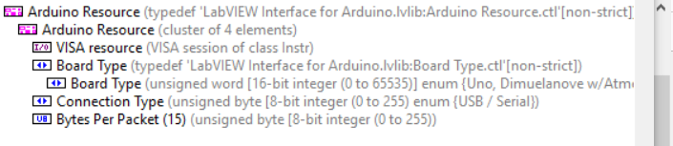

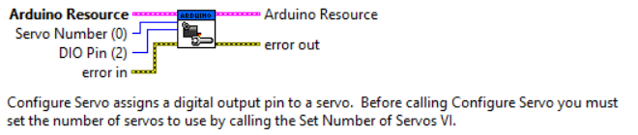

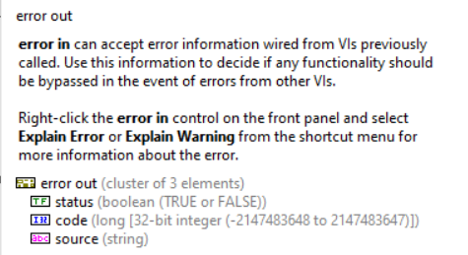

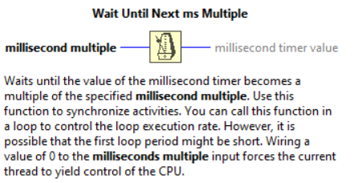

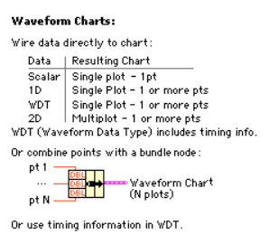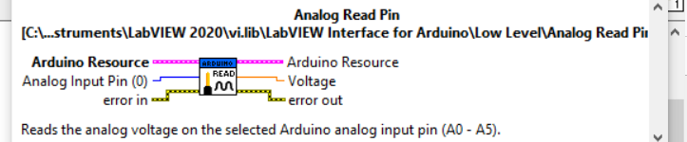

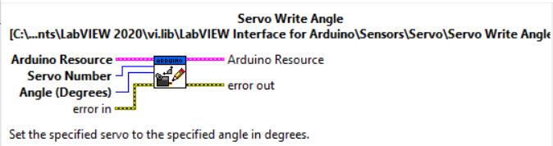

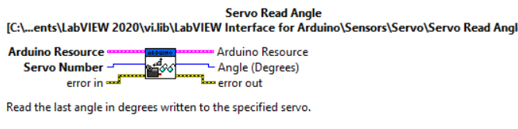

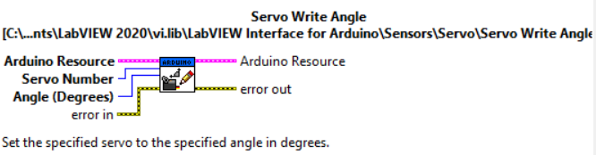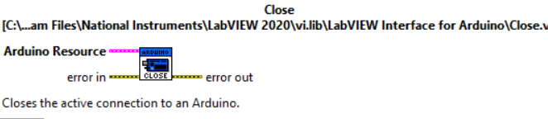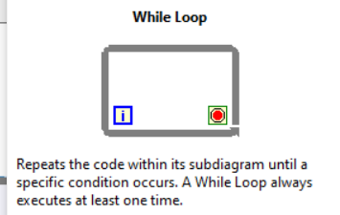

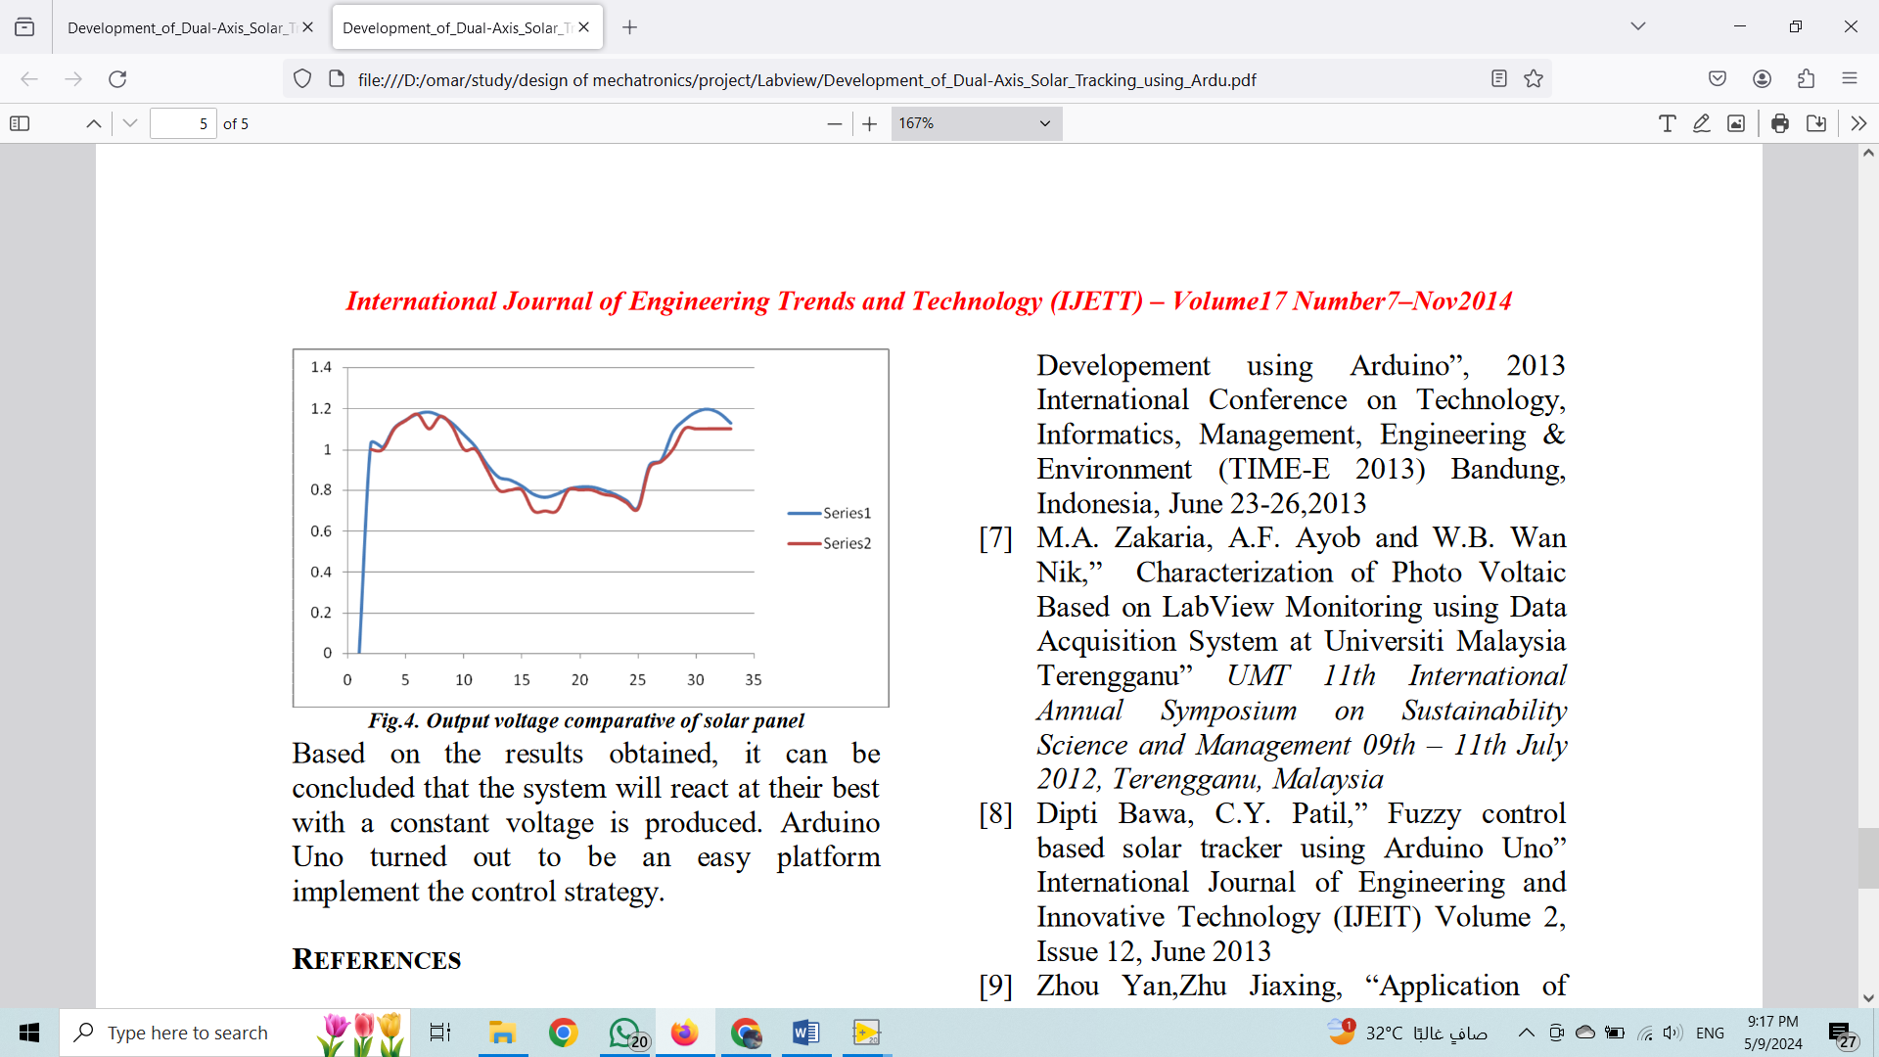

Fig.5. Output voltage comparative of solar panel

Based on the results obtained, it can be concluded that the system will react at their best with a constant voltage is produced. Arduino Uno turned out to be an easy platform implement the control strategy.

# REFERENCES:

[1] www.wikipedia.com

[2] www.ni.com

[3] www. arduino.cc

[4] Gary W. Johnson, Richard Jennings, “LabVIEW Graphical Programming”, 4th ed. McGraw-Hill.

[5] Cor J. Kalkman “LabVIEW : A software system for data acquisition, data analysis and instrument control” Journal of Clinical Monitoring and Computing, 2005, P.51-58

[6] Zolkapli, M,AI-Junid S. A. , Othman Z,Manut, , Mohd Zulkifli M.” High- Efficiency Dual-Axis Solar Tracking Developement using Arduino”, 2013 International Conference on Technology, Informatics, Management, Engineering & Environment (TIME-E 2013) Bandung, Indonesia, June 23-26,2013

[7] M.A. Zakaria, A.F. Ayob and W.B. Wan Nik,” Characterization of Photo Voltaic Based on LabView Monitoring using Data Acquisition System at Universiti Malaysia Terengganu” UMT 11th International Annual Symposium on Sustainability Science and Management 09th – 11th July 2012, Terengganu, Malaysia

[8] Dipti Bawa, C.Y. Patil,” Fuzzy control based solar tracker using Arduino Uno” International Journal of Engineering and Innovative Technology (IJEIT) Volume 2, Issue 12, June 2013

[9] Zhou Yan,Zhu Jiaxing, “Application of Fuzzy Logic Control Approach in A Microcontroller-Based Sun Tracking System” , WASE International Conference on Information Engineering, 2010.

[10] M.K.D.Ulaganathan, C.Saravanan, Olivia Ramya Chitranjan,” Cost-effective Perturb and Observe MPPT Method using Arduino Microcontroller for a Standalone Photo Voltaic System” International Journal of Engineering Trends and Technology (IJETT) – Volume 8 Number 1- Feb 2014