1. Spherical Geometry (November 29, 2021)
2. Space and infinity (January 23, 2022)
3. Geometry and Space (February 14, 2022)
4. Abstraction (March 21, 2022)
5. Drowning in the sea (April 9, 2022)
6. Principia (May 27th, 2022)
7. Zone’s Paradox (June 11,2022)
8. Descartes ( July17, 2022)
9. Infinities ( August 8, 2022)
10. Fibonacci( September 13, 2022) ( not yet uploaded in the google drive)
11. New geometries ( October3, 2022)

Pictures:

1. 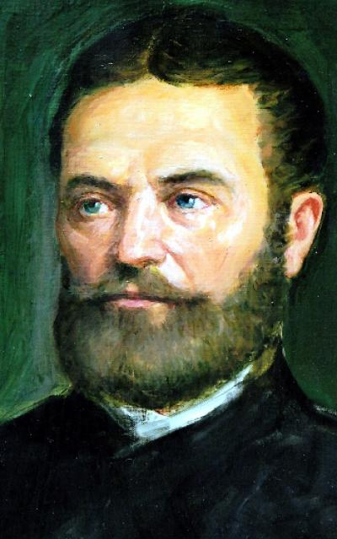Janos Bolyai
2.  Andrew Marvell
3. 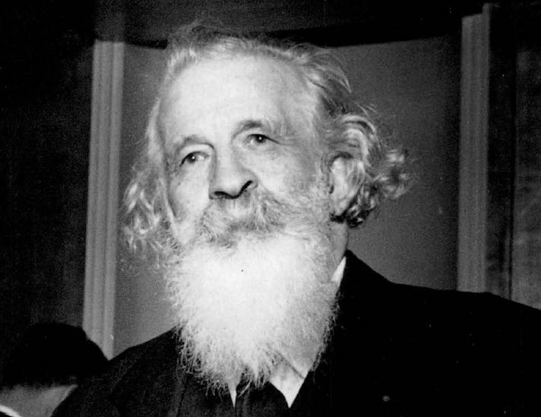

Gaston Bacherlard

1. 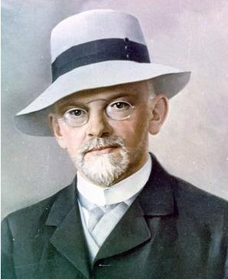

David Hilbert

1. Helmet Hasse

 Arnold Scholz

1. Ermond Halley
2.  Zeno
3. Rene Descartes 
4. 

Johannes Kepler

1.  Fibonacci

Johann Lambert

