IS117 – Exam 1

HTML5 – Boiler Plate Diagram – You can use the image or go to the repository to view the code. <https://github.com/h5bp/html5-boilerplate/blob/master/index.html>

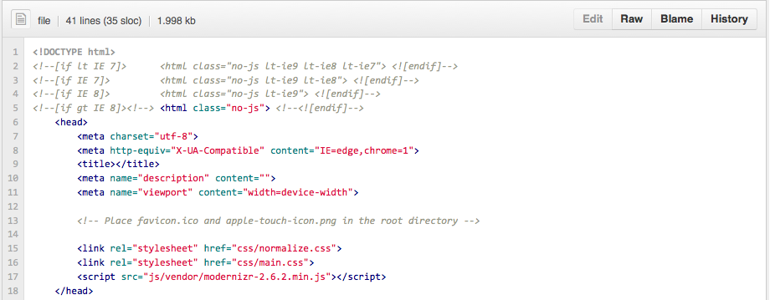

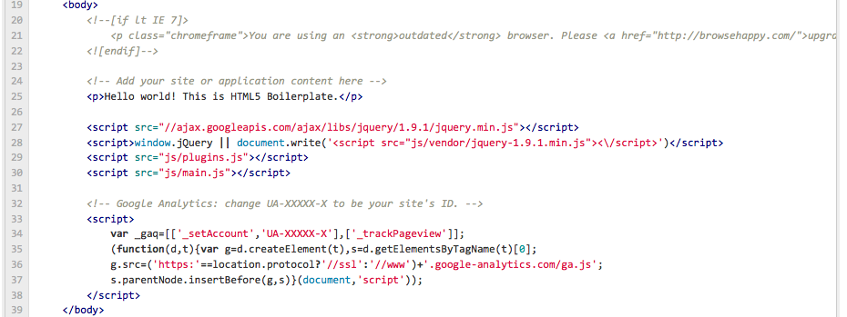

I will ask the question and indicate the line number. Please answer it briefly in only one sentence or less.

**HTML Questions 2 Points Each:**

1. What does line 1 do?
2. What are lines 2-4 for?
3. What is line 7 for?

What is line 9 for?

What is line 15 for?

1. What is line 16 for?
2. What is line 17 for?
3. What happens if the IE 6 browser views this page? What line causes it to happen?
4. Why are many of the JS files loaded at the end of the page?
5. What is a CDN and which line(s) in the page use one?

**HTML Questions 5 Points Each**

1. Identify the proper names for the two parts of this HTML statement:

Part 1

Part 2

<a href=<http://www.google.com>>Google</a>

2. Write 5 HTML tags not in the image above and what they do.

**3 Points Each - CSS Questions**

h2 { *color: #666*; }

1. What is the proper css identification / naming convention for : **“H2”** ?
2. What is the proper css identification / naming convention for: **color: #666; ?**
3. What is the proper css identification / naming convention for: **color:**
4. What is the proper css identification / naming convention for: **#666?**
5. What does the H2 element used for?

**Git Questions 1 Point Each:**

1. What is GIT?
2. How do you think you would use GIT in the future?
3. Why use version control when writing a program?
4. What does the command **gitinit** do?
5. What does the command **git add** do?
6. What does this command do: **git commit –m “my first commit”**
7. What does this command do: **git push origin master**
8. What is **origin** in the previous command?
9. What is **master** in the previous command?
10. Explain what this command is doing:

git remote add origin [git@github.com:h5bp/html5-boilerplate.git](mailto:git@github.com:h5bp/html5-boilerplate.git)

**Layout Creation – 20 Points Total**

Using Adobe Illustrator create a layout for a website using the golden ratio horizontally and vertically. The width of the layout should be 960px and you should use the golden ratio to determine the height of the website. Just use a wire frame that includes the lines associated with the major regions. You do not need to include links or be detailed. I expect to see 3-4 instances of the golden ratio being used within the layout. Export a PNG or GIF file of your layout and paste it into your test.

**Typography Questions – 15 Points (5 Points Each)**

1. Name an example of a Serif and Sans Serif Font?
2. What is the difference between a Sans Serif font and a Serif font?
3. What font is used for New York City street signs?

**Audience Analysis – 10 Points**

Analyze the following website and identify what is being done correctly and indicate what you would change. Think about how this website is and is not being used as a billboard. Identify any layout patterns such as golden ratio or equal spacing. What are the primary links? You should visit the website to fully see how it appears to visitors.

<http://www.simpleremovals.co.uk/home>

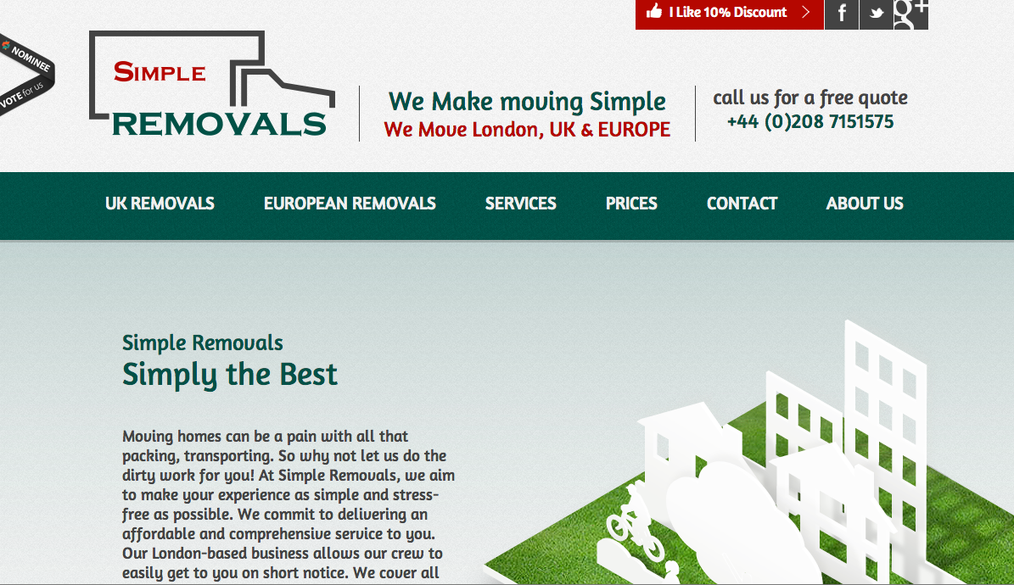

Exam 1 Answer Sheet

You Name: Mohammad O Munir

**HTML Questions - 20 - Points**

1. Specifies the version html

2. Finds whether or not javascript support is enabled.

3. Specifies the location of the cascading style sheet normalize, which contains script

4. Specifies the location of the cascading style sheet main, which contains script

5. Modernizer detects what is not supported, so that an alternative action can be taken.

6. Loads a script library

7. Specifies the character encoding.

8.

9.

10.

**HTML Questions - 10 - Points**

1. Anchor hyperlink reference.

2. H1-heading

P-paragraph

div-creates sections

B- bold

li-primary link

**CSS Questions - 15 - Points**

1. <**h2 id**="h2">Heading 2<**/h2**>

2. style = {color: #666;}

3. style = {color;}

4.

5. H2 is a certain percentage smaller than H1, a 2nd level heading.

**GIT Questions - 10 - Points**

1. GIT allows storing, monitoring and sharing a project as its being worked on.

2. To have all work stored on GIT, I would be able to work anywhere editing and saving without any limitations.

3. To avoid compatibility issues.

4. Initiates a local repository.

5. Adds a file to repository.

6. Saves last changes and specifies the time of commit.

7. Uploads the file to the mater repository.

8. Where the repository sits.

9. Master is the repository.

10. Adds a local repository.

**Layout – 20 – Points**



**Typography Questions – 15 Points**

1. Serif: Andalus San serif: Calibri

2. Serif has small tails at the edges of the letters.

3. Sans Serif

**Audience Analysis – 10 – Points**

The golden ratio is applied for the height at multiple levels and width is adjusted according to the screen size. At the very top the equal spacing is used. It is very easy for a user to identify what the website is selling.

The main content section is like a billboard which fairly quickly gives the user what is being advertised, even though there is some extra text, but serves a purpose in totality.

The typography is also of the right ratio and size that very conformable to read.

**Link to Github with a repository and commit made during the testing period:**

**5 Bonus Points**