Additional file 1: Supplementary Appendix
Blood Lead Exposure, Recent Diarrhea, and Child Undernutrition in Bangladesh: A National Cross-Sectional Analysis of Joint Associations and Interaction Among Children Aged 12–59 Months
Omar Faroque, Mst. Homayra Jannaty, Suman Biswas
Department of Statistics, Islamic University, Kushtia, Bangladesh
――――――――――――――――――――――――――――――――――――――――――――――――――
Table of Contents
• Supplementary Figure S1: STROBE participant selection flow diagram (N = 10,507)
• Supplementary Figure S2: Directed Acyclic Graph (DAG) for environmental lead, diarrhea, and undernutrition
• Supplementary Figure S3: Restricted cubic spline models evaluating continuous BLL with HAZ, WAZ, and WHZ
• Supplementary Table S1: Comparison of unadjusted (crude) and multivariable-adjusted models
• Supplementary Table S2: Survey-weighted multivariable logistic regression evaluating adjusted odds ratios (aORs)
• Supplementary Table S3: Sensitivity analysis restricting to the water quality (E. coli) testing subsample
• Supplementary Table S4: Multicollinearity diagnostic statistics (Variance Inflation Factors - VIF)

Supplementary Figure S1. STROBE participant selection flow diagram.
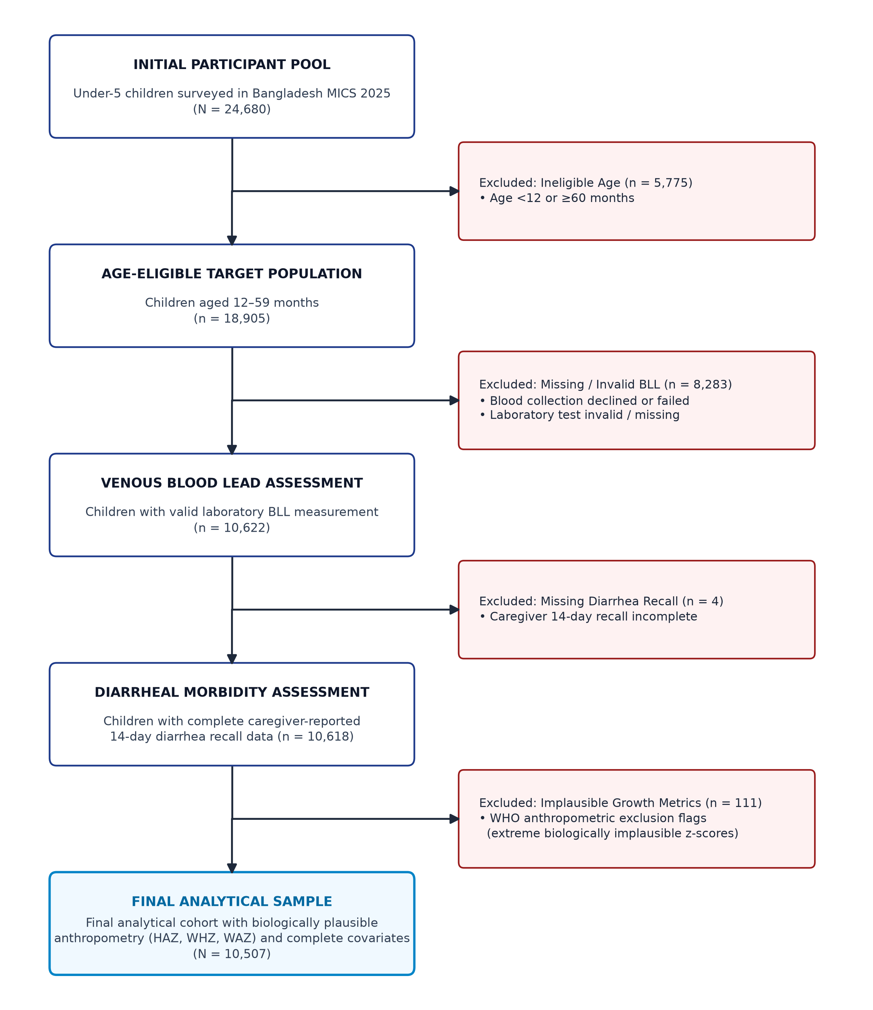
Note: Sequential application of eligibility, laboratory biomarker (LeadCare II), diarrheal illness recall, and anthropometric validity criteria from the Bangladesh Multiple Indicator Cluster Survey (MICS) 2025 to establish the final analytical cohort (N = 10,507).

Supplementary Figure S2. Conceptual Directed Acyclic Graph (DAG).
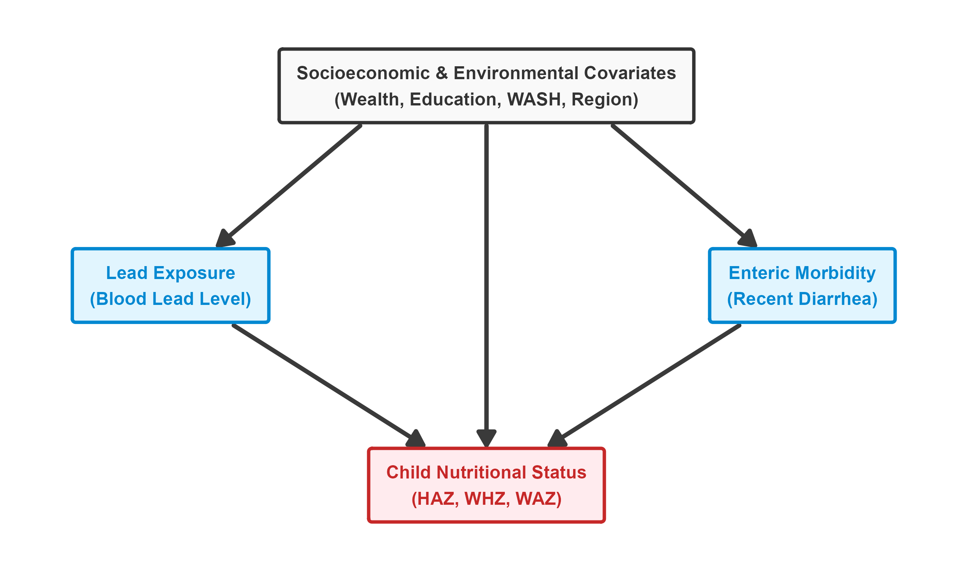
Note: Theoretical causal diagram depicting hypothesized relationships between pediatric blood lead levels, enteric infection (recent diarrhea), nutritional outcomes, and confounding variables identified through prior epidemiological literature.

Supplementary Figure S3. Restricted cubic splines of BLL and child growth Z-scores.
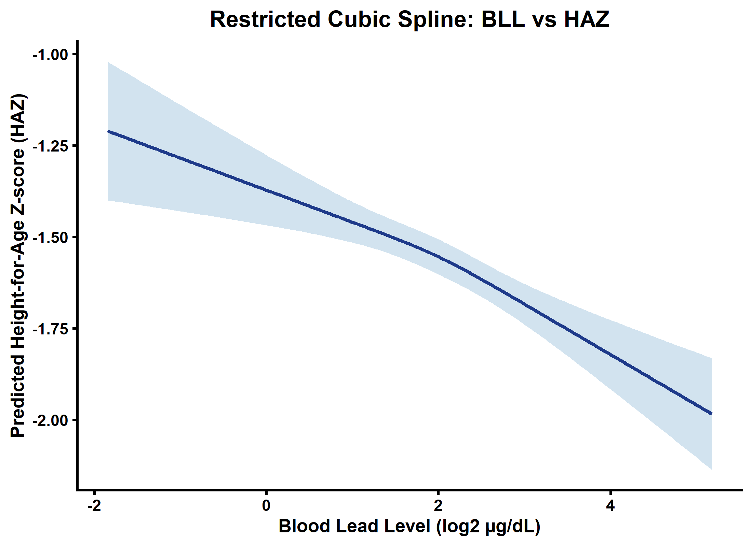
Note: Dose-response restricted cubic spline regressions with 3 knots (10th, 50th, and 90th percentiles) evaluating continuous log2(BLL) with Height-for-Age (HAZ), Weight-for-Age (WAZ), and Weight-for-Height (WHZ) Z-scores, adjusted for all survey-weighted covariates. Reference value set at CDC blood lead reference value (3.5 µg/dL). Shaded bands represent 95% confidence intervals.

Supplementary Table S1: Crude vs. Adjusted Models
Supplementary Table S1. Comparison of unadjusted (crude) and multivariable-adjusted survey-weighted linear regression models evaluating blood lead levels, diarrheal morbidity, and continuous pediatric growth faltering (z-scores) (N = 10,507).

Supplementary Table S2: Logistic Regression (aOR) Sensitivity Check
Supplementary Table S2. Survey-weighted multivariable logistic regression evaluating joint exposure to elevated blood lead levels and diarrheal morbidity on clinical malnutrition outcomes (N = 10,507).

Supplementary Table S3: Water Quality Sensitivity Subsample
Supplementary Table S3. Sensitivity analysis evaluating blood lead levels, diarrheal morbidity, and child growth faltering within the household drinking water quality (E. coli) testing subsample.

Supplementary Table S4: Multicollinearity Diagnostics
Supplementary Table S4. Multicollinearity diagnostic statistics (Variance Inflation Factors) for fully adjusted multivariable regression models.

Outcome | Growth Metric & Parameter Exposure | Crude Beta (95% CI) | Crude p-value | Adjusted Beta (95% CI)* | Adjusted p-value
Height-for-Age (HAZ)
 | Blood lead level (log2 ug/dL) | -0.067 (-0.102, -0.031) | <0.001 | -0.095 (-0.132, -0.059) | <0.001
 | Recent diarrhea (past 2 weeks) | -0.054 (-0.430, 0.323) | 0.780 | -0.089 (-0.457, 0.280) | 0.637
 | Interaction (BLL x Diarrhea) | 0.008 (-0.169, 0.186) | 0.927 | 0.045 (-0.126, 0.216) | 0.609
Weight-for-Height (WHZ)
 | Blood lead level (log2 ug/dL) | 0.031 (0.001, 0.062) | 0.046 | -0.027 (-0.060, 0.007) | 0.119
 | Recent diarrhea (past 2 weeks) | 0.132 (-0.189, 0.453) | 0.421 | 0.104 (-0.222, 0.431) | 0.531
 | Interaction (BLL x Diarrhea) | -0.096 (-0.247, 0.056) | 0.217 | -0.088 (-0.243, 0.067) | 0.263
Weight-for-Age (WAZ)
 | Blood lead level (log2 ug/dL) | -0.014 (-0.044, 0.017) | 0.392 | -0.072 (-0.104, -0.040) | <0.001
 | Recent diarrhea (past 2 weeks) | 0.066 (-0.277, 0.408) | 0.707 | 0.023 (-0.319, 0.364) | 0.897
 | Interaction (BLL x Diarrhea) | -0.058 (-0.219, 0.103) | 0.479 | -0.037 (-0.196, 0.122) | 0.649
Abbreviations: BLL, Blood Lead Level; CI, Confidence Interval; HAZ, Height-for-Age z-score; WAZ, Weight-for-Age z-score; WHZ, Weight-for-Height z-score. Beta coefficients represent the change in anthropometric z-score per two-fold increase in blood lead level (log2-transformed), presence of caregiver-reported diarrhea in the preceding 2 weeks, and their continuous multiplicative interaction term. *Multivariable models adjust for child age (months), child sex, venous hemoglobin (g/dL), maternal education, household head education, wealth index quintile, urban/rural residence, administrative division, peeling wall paint, drinking water source, sanitation facility type, and handwashing facilities. All models account for complex survey strata, primary sampling units, and normalized child blood weights.
Outcome | Joint Exposure Category | Adjusted Odds Ratio (95% CI)* | p-value
Stunting (HAZ < -2 SD)
 | Low BLL (<3.5 ug/dL), No Diarrhea (Reference: 00) | 1.00 (Reference) | —
 | Low BLL (<3.5 ug/dL) + Diarrhea | 1.04 (0.72, 1.50) | 0.848
 | High BLL (>=3.5 ug/dL), No Diarrhea | 1.15 (1.02, 1.30) | 0.019
 | High BLL (>=3.5 ug/dL) + Diarrhea (Joint Exposure) | 1.20 (0.91, 1.59) | 0.205
Wasting (WHZ < -2 SD)
 | Low BLL (<3.5 ug/dL), No Diarrhea (Reference: 00) | 1.00 (Reference) | —
 | Low BLL (<3.5 ug/dL) + Diarrhea | 1.36 (0.89, 2.10) | 0.157
 | High BLL (>=3.5 ug/dL), No Diarrhea | 1.19 (1.02, 1.38) | 0.024
 | High BLL (>=3.5 ug/dL) + Diarrhea (Joint Exposure) | 1.62 (1.17, 2.25) | 0.004
Underweight (WAZ < -2 SD)
 | Low BLL (<3.5 ug/dL), No Diarrhea (Reference: 00) | 1.00 (Reference) | —
 | Low BLL (<3.5 ug/dL) + Diarrhea | 1.12 (0.78, 1.61) | 0.534
 | High BLL (>=3.5 ug/dL), No Diarrhea | 1.12 (0.99, 1.27) | 0.063
 | High BLL (>=3.5 ug/dL) + Diarrhea (Joint Exposure) | 1.46 (1.10, 1.94) | 0.009
Abbreviations: aOR, Adjusted Odds Ratio; BLL, Blood Lead Level; CI, Confidence Interval; HAZ, Height-for-Age z-score; WAZ, Weight-for-Age z-score; WHZ, Weight-for-Height z-score. Elevated blood lead level is defined as >=3.5 ug/dL (US CDC Reference Value). Recent diarrhea is caregiver-reported diarrheal morbidity within the preceding 14 days. *Models adjust for child age (months), child sex, venous hemoglobin (g/dL), maternal education, household head education, wealth index quintile, urban/rural residence, administrative division, peeling wall paint, drinking water source, sanitation facility type, and basic handwashing facilities. All models account for complex survey strata, primary sampling units, and normalized child blood weights.
Outcome | Sample_Size | Parameter | Beta | SE | CI_95 | p_value
HAZ (E. coli Subsample)
 | N = 1112 | Blood lead level (log2 ug/dL) | -0.098 | 0.062 | (-0.220, 0.024) | 0.114
 | N = 1112 | Recent diarrhea (past 2 weeks) | 0.006 | 0.397 | (-0.773, 0.785) | 0.988
 | N = 1112 | Interaction (BLL x Diarrhea) | -0.032 | 0.184 | (-0.392, 0.329) | 0.863
Abbreviations: BLL, Blood Lead Level; CI, Confidence Interval; CFU, Colony Forming Units; HAZ, Height-for-Age z-score; WAZ, Weight-for-Age z-score; WHZ, Weight-for-Height z-score. Household water contamination was assessed via membrane filtration testing of source/stored drinking water (WQ26). Models account for complex survey strata, primary sampling units, and normalized subsample weights, with multivariable adjustment for all baseline demographic and socio-environmental covariates.
Variable | GVIF | Df | GVIF_Adjusted | Conclusion
Blood lead level (log2 ug/dL) | 1.21 | 1.00 | 1.10 | No Collinearity (< 2.5)
Recent diarrhea (past 2 weeks) | 1.02 | 1.00 | 1.01 | No Collinearity (< 2.5)
Child age (months) | 1.13 | 1.00 | 1.06 | No Collinearity (< 2.5)
Child sex | 1.01 | 1.00 | 1.00 | No Collinearity (< 2.5)
Hemoglobin (g/dL) | 1.11 | 1.00 | 1.05 | No Collinearity (< 2.5)
Maternal education | 1.58 | 4.00 | 1.06 | No Collinearity (< 2.5)
Household head education | 1.48 | 3.00 | 1.07 | No Collinearity (< 2.5)
Wealth index quintile | 2.17 | 4.00 | 1.10 | No Collinearity (< 2.5)
Area of residence (Urban/Rural) | 1.13 | 1.00 | 1.06 | No Collinearity (< 2.5)
Administrative division | 1.72 | 7.00 | 1.04 | No Collinearity (< 2.5)
Peeling/chipped wall paint | 1.31 | 1.00 | 1.14 | No Collinearity (< 2.5)
Drinking water source type | 1.42 | 1.00 | 1.19 | No Collinearity (< 2.5)
Sanitation facility type | 1.04 | 1.00 | 1.02 | No Collinearity (< 2.5)
Basic handwashing facility | 1.26 | 1.00 | 1.12 | No Collinearity (< 2.5)
Abbreviations: Df, Degrees of Freedom; GVIF, Generalized Variance Inflation Factor. GVIF^(1/(2*Df)) provides a metric comparable to standard single-degree-of-freedom VIFs. Values of GVIF^(1/(2*Df)) < 2.0 (equivalent to VIF < 4.0) demonstrate an absence of severe collinearity among exposure, socio-demographic, and built-environment covariates.

