Applying Causal Machine Learning and Multi-Omics Integration to Unravel Gene Regulatory Networks in Triple-Negative Breast Cancer (TNBC)
Omar Faroque¹, Mst. Homayra Jannaty ¹, Shahriar Ahmed Abir², Suman Biswas¹*
¹Department of Statistics, Islamic University, Kushtia-7003, Bangladesh
²Department of Biotechnology and Genetic Engineering, Islamic University, Kushtia-7003, Bangladesh
*Corresponding Author: suman@stat.iu.ac.bd
Abstract
Triple-Negative Breast Cancer (TNBC) represents the most aggressive and lethal breast cancer subtype, defined by the clinical absence of estrogen receptor (ER), progesterone receptor (PR), and human epidermal growth factor receptor 2 (HER2) amplification. The lack of actionable cell-surface oncogenic receptors restricts frontline systemic treatment to cytotoxic chemotherapy, which frequently results in therapeutic resistance, early visceral recurrence, and poor overall survival. Recent functional epigenomic investigations establish that TNBC malignant progression is governed by extensive non-coding regulatory remodeling, particularly dense clusters of distal super-enhancers. However, classical computational methods for Gene Regulatory Network (GRN) reconstruction (including Pearson/Spearman correlation, GENIE3, and SCENIC) rely entirely on observational transcriptomic co-expression. In single-cell RNA-sequencing (scRNA-seq), observational metrics suffer from severe technical zero-inflation ('dropouts') and indirect correlation artifacts, leading to false discovery rates exceeding 45%. Here, we formulate and execute an interventional causal machine learning framework that triangulates large-scale single-cell CRISPR-perturbation sequencing (Perturb-seq; GSE224986, comprising 95,678 cells across 11,975 sgRNAs) with ENCODE Factorbook ChIP-seq physical transcription factor binding priors across 819 somatic mutation-associated super-enhancer loci in human TNBC (MDA-MB-231).
By enforcing simultaneous physical chromatin occupancy and functional interventional expression response under Pearl’s causal do-calculus, our tripartite causal discovery pipeline reconstructed 6,366,350 high-confidence directed regulatory paths (Transcription Factor → Enhancer → Target Gene). Topological network centrality and Google PageRank analysis prioritized master transcriptional drivers governing TNBC oncogenic signaling, specifically CTCF, POLR2A, EP300, JUND, MYC, SIN3A, SP1, FOS, HDAC2, and MAX, which causally regulate Hallmark gene sets for Epithelial-Mesenchymal Transition (EMT; p = 1.2 × 10⁻⁹), E2F Targets (p = 4.5 × 10⁻⁸), G2M Checkpoint (p = 8.1 × 10⁻⁷), and Hypoxia (p = 3.4 × 10⁻⁵). Explainable AI (SHAP TreeExplainer) revealed non-linear, switch-like regulatory dynamics for AP-1 (JUND/FOS) and MYC-driven oncogenic activation, demonstrating that oncogene transactivation accelerates rapidly only beyond discrete regulatory weight thresholds. Rigorous quantitative benchmarking against held-out experimental CRISPRi ground truth proved that our Triangulated Causal ML framework vastly outperformed baseline methods on held-out test enhancers (AUPRC = 0.875, AUROC = 0.900, Precision = 90.1%, FDR = 9.9%), outperforming GENIE3 (AUPRC = 0.632, Precision = 64.3%, FDR = 35.7%) and observational co-expression (AUPRC = 0.681, Precision = 67.7%, FDR = 32.3%). In silico simulated driver knockouts tightly mirrored observed experimental guide silencing (R² = 0.473, Pearson r = 0.688, p = 3.37 × 10⁻¹²², N = 864 target genes), and prioritized master drivers significantly stratified reduced overall survival in Triple-Negative / Basal-like breast cancer patient cohorts (TCGA-BRCA and METABRIC; p ≤ 0.019). Finally, in silico therapeutic vulnerability mapping demonstrated that dual/triple epigenetic combinations (targeting BET bromodomains, p300 HAT, and HDAC2) achieved up to 93% in silico disruption of core oncogenic regulatory network connectivity compared to only 38% under standard cytotoxic chemotherapy, nominating multi-target epigenetic intervention as an actionable combination hypothesis. This work provides an end-to-end, reproducible, and mathematically grounded causal discovery paradigm for identifying defensible biomarkers and rational combination therapies in TNBC.
Keywords: Triple-Negative Breast Cancer; Causal Machine Learning; Single-Cell Perturb-seq; CRISPRi; Gene Regulatory Networks; Explainable AI; SHAP; Epigenetic Super-Enhancers; Combination Therapy.
1. Introduction
1.1 Clinical Gravity, Heterogeneity, and Therapeutic Challenges of TNBC
Triple-Negative Breast Cancer (TNBC) accounts for approximately 15% to 20% of all diagnosed breast carcinomas and remains disproportionately responsible for breast cancer mortality worldwide (Dent et al., 2007; Foulkes et al., 2010; Zagami & Carey, 2022). Clinically defined by the immunohistochemical absence of estrogen receptor (ER) and progesterone receptor (PR) expression, together with the absence of human epidermal growth factor receptor 2 (HER2) overexpression or gene amplification (Irvin & Carey, 2008; Rakha et al., 2007), TNBC represents a biological class that is fundamentally unresponsive to endocrine modulators (such as tamoxifen and aromatase inhibitors) or HER2-directed monoclonal antibodies (such as trastuzumab) (Dass et al., 2021; Waks & Winer, 2019). Consequently, systemic cytotoxic chemotherapy, comprising anthracyclines, taxanes, and platinum-based DNA-crosslinking agents, remains the historical mainstay of systemic treatment (Bianchini et al., 2016; Waks & Winer, 2019).
Despite aggressive multi-agent chemotherapy regimens, patient clinical trajectories are characterized by high relapse rates. While initial chemosensitivity is observed in a subset of patients, over 30% to 40% experience rapid disease recurrence within three to five years following definitive surgery (Dent et al., 2007; Foulkes et al., 2010). Metastatic TNBC exhibits an aggressive natural history with a pronounced predilection for visceral organ dissemination, including the lungs, liver, and central nervous system, conferring a median overall survival of merely 12 to 18 months (Bianchini et al., 2016; Garrido-Castro et al., 2019). Comprehensive transcriptomic profiling has established that TNBC is an intensely heterogeneous disease encompassing distinct molecular entities, predominantly the basal-like (BL1, BL2), mesenchymal (M), mesenchymal stem-like (MSL), immunomodulatory (IM), and luminal androgen receptor (LAR) subtypes (Burstein et al., 2015; Lehmann et al., 2011; Perou et al., 2000; Sørlie et al., 2001). Because standard targeted kinase or cell-surface receptor inhibitors consistently fail due to rapid bypass signaling and secondary resistance (Garrido-Castro et al., 2019), there is an urgent requirement to unravel the core transcriptional and epigenetic regulatory circuits that sustain TNBC survival and metastatic fitness.
1.2 Epigenetic Architecture, Super-Enhancers, and Non-Coding Remodeling
Recent advances in cancer functional genomics demonstrate that oncogenic states are not solely governed by focal protein-coding mutations, but are intensely dependent on non-coding regulatory elements, particularly enhancers and super-enhancers (Bradner et al., 2017; Hnisz et al., 2013; Lovén et al., 2013; Whyte et al., 2013). Super-enhancers are dense clusters of broad genomic enhancers characterized by exceptional occupancy of Mediator (MED1), the histone acetyltransferase EP300/CBP, and high enrichment of histone H3 lysine 27 acetylation (H3K27ac) (Whyte et al., 2013). Through phase-separated biomolecular condensation and long-range chromatin looping mediated by the CCCTC-binding factor (CTCF) and cohesin complexes (Ding et al., 2020; Sabari et al., 2018), super-enhancers compartmentalize the transcription apparatus to drive exceptionally high-level expression of lineage-defining master regulators and oncogenes (Bradner et al., 2017; Lovén et al., 2013).
In basal-like TNBC, malignant cells undergo extensive epigenetic remodeling that establishes de novo super-enhancers at loci driving proliferation, stemness, and epithelial-to-mesenchymal transition (EMT) (Franco et al., 2018; Lewis et al., 2024). Active enhancers frequently undergo bidirectional transcription into non-coding enhancer RNAs (eRNAs), which stabilize chromatin loops and facilitate RNA polymerase II elongation (Li et al., 2016). In a landmark functional screening study, Lewis et al. (2024) deployed pooled single-cell CRISPR-interference (CRISPRi) tiling across hundreds of transcribed super-enhancers in the archetypal TNBC line MDA-MB-231, demonstrating that targeted silencing of specific distal super-enhancers severely impeded tumor growth and metastatic progression in vivo. Nevertheless, despite the identification of individual functional enhancers, resolving the complete directed regulatory network (identifying which transcription factors physically occupy these elements and which downstream target genes they causally govern) has remained an elusive bioinformatic and statistical challenge.
1.3 The Fatal Confounding of Observational GRN Inference and the Single-Cell CRISPRi Revolution
Historically, Gene Regulatory Networks (GRNs) have been inferred from observational transcriptomic datasets using correlation metrics (Pearson, Spearman), mutual information algorithms (ARACNE, CLR) (Faith et al., 2007; Margolin et al., 2006), or non-linear regression ensembles (GENIE3, SCENIC) (Aibar et al., 2017; Huynh-Thu et al., 2010). However, the systematic application of observational algorithms to single-cell RNA-sequencing (scRNA-seq) has exposed catastrophic methodological limitations (Chan et al., 2017; Chen & Mar, 2018; Pratapa et al., 2020). Single-cell data suffer from severe technical zero-inflation, commonly designated as "dropout," arising from low mRNA capture efficiency and stochastic amplification bias (Dai et al., 2024). In that study, the authors provided rigorous mathematical proof that dropout zeros function as systematic confounders that alter joint probability distributions, inducing artificial statistical dependencies between completely unrelated genes.
Furthermore, observational correlation cannot distinguish direct causal regulation from transitive dependencies or shared upstream confounding (Pearl, 2009; Peters et al., 2017; Spirtes et al., 2000). For instance, if master regulator A transcriptionally activates both intermediate gene B and target gene C, genes B and C will exhibit strong observational co-expression despite having zero regulatory relationship between them. In rigorous benchmarks against biological ground truth, observational GRN algorithms routinely exhibit False Discovery Rates (FDR) exceeding 45% to 50% (Pratapa et al., 2020; Shojaee & Huang, 2023).
To overcome observational confounding, the field of causal inference relies on experimental interventions, formalized by Judea Pearl’s interventional do-operator, do(X) (Pearl, 2009). The technological realization of this principle in single cells is Perturb-seq (CRISPRi with single-cell RNA-seq readout) (Adamson et al., 2016; Datlinger et al., 2017; Dixit et al., 2016; Jaitin et al., 2016; Replogle et al., 2022). By delivering pooled single-guide RNAs (sgRNAs) that direct catalytically dead Cas9 fused to the KRAB repressive domain (dCas9-KRAB) to silence specific distal enhancers at single-cell resolution (Gilbert et al., 2014; Replogle et al., 2020), Perturb-seq generates unconfounded, randomized interventional distributions P(Y | do(Enhancer)) (Ji et al., 2021). When interventional functional perturbation data are triangulated with physical multi-omics binding priors (ENCODE ChIP-seq), causal directionality can be resolved with mathematical identifiability (Hauser & Bühlmann, 2012; Peters et al., 2016; Shojaee & Huang, 2023).
1.4 Objectives of This Investigation: Introducing Triangulated Causal ML in TNBC
In this study, we establish a comprehensive, end-to-end Causal Machine Learning framework applied to the largest available single-cell enhancer CRISPRi screen in human TNBC (GSE224986; 95,678 single cells across 11,975 sgRNAs and 819 targeted super-enhancer loci (selected from the broader library of 1,475 somatic and GWAS loci)) (Lewis et al., 2024). Specifically, we aim to: (i) construct a high-confidence tripartite causal GRN (TF → Enhancer → Target Gene) by enforcing simultaneous physical ChIP-seq binding and functional interventional response; (ii) prioritize master transcriptional drivers using directed multigraph topology and Google PageRank centrality; (iii) deploy Explainable AI (SHAP TreeExplainer) to capture non-linear, multi-factorial causal gene regulation; (iv) quantitatively benchmark our triangulated framework against classical GRN algorithms (GENIE3, co-expression, prior alone); (v) clinically validate prioritized master drivers against patient survival cohorts (TCGA-BRCA, METABRIC); and (vi) computationally map actionable epigenetic combination therapies capable of collapsing the core TNBC oncogenic regulatory network.
2. Materials and Methods
2.1 Single-Cell CRISPRi Dataset Acquisition, Sparse Ingestion, and Quality Control
High-throughput single-cell CRISPRi perturbation data for the mesenchymal TNBC cell line MDA-MB-231 were acquired from the NCBI Gene Expression Omnibus (GEO accession GSE224986; Somatic Mutation enhancer screen) (Lewis et al., 2024). The raw experimental repository comprises 95,678 single cells interrogated across 11,975 unique guide RNAs (sgRNAs) targeting distal super-enhancers and promoter elements, sequenced using 10x Genomics 3' single-cell chemistry with direct guide capture across 8 independent sequencing lanes (Replogle et al., 2020). To handle the high-dimensional count matrix (58,391 genes × 95,678 cells) without exceeding physical RAM boundaries, data ingestion was implemented via chunked Compressed Sparse Row (CSR) matrices using h5py and the AnnData computational container (Wolf et al., 2018).
Rigorous single-cell quality control filtering was executed using Scanpy (v1.9.8) (Wolf et al., 2018). Cells with fewer than 200 detected genes or aberrant mitochondrial read fractions (>15%) were excluded. Genes expressed in fewer than 3 cells were pruned. Following quality control, the finalized expression matrix retained 95,678 high-quality single cells across 32,799 reliably expressed genes. Guide-capture matrices were normalized, and cells were stratified into three distinct experimental cohorts: (i) an unconfounded single-guide perturbation cohort (n = 3,930 cells carrying exactly one enhancer-targeting sgRNA); (ii) a combinatorial multi-guide perturbation cohort (n = 83,981 cells carrying ≥2 sgRNAs); and (iii) an unassigned / negative control cohort (n = 7,767 cells with non-targeting controls). To ensure unconfounded causal identifiability and eliminate combinatorial guide–guide epistatic confounding, all primary pairwise differential perturbation response calculations were conducted strictly using the isolated single-guide perturbation cohort (n = 3,930) evaluated against the unperturbed negative-control cell cohort (n = 7,767). This experimental design eliminates high-order multi-guide crosstalk, ensuring that downstream expression alterations represent direct functional consequences of single-enhancer repression. The processed single-cell dataset was formatted for downstream causal modeling (Supplementary Data 1).
2.2 Epigenetic Multi-Omics Transcription Factor Prior Mapping
To establish physical regulatory plausibility, genomic coordinates for 819 somatic mutation enhancer loci targeted in the CRISPRi screen (selected from the 1,475-locus library; Lewis et al., 2024) were retrieved from GSE223812 (Lewis et al., 2024). Genome-wide physical transcription factor occupancy was determined by querying the UCSC Genome Browser and ENCODE REST APIs against the clustered transcription factor ChIP-seq dataset (encRegTfbsClustered, comprising 340 transcription factors across 130 human cell types) (ENCODE Project Consortium, 2012; Wang et al., 2013). Physical binding events overlapping targeted enhancer boundaries (±1,000 bp flanking window) were extracted. Each physical interaction was assigned a normalized ChIP-seq peak confidence score, C_{ChIP}(i, e) ∈ [0, 1000], reflecting signal strength and peak reproducibility across biological replicates (Wang et al., 2013). This procedure yielded the physical TF–enhancer prior interaction matrix, encompassing 15,059 physical TF–enhancer binding edges across 161 unique transcription factors (Supplementary Table 1).
2.3 Single-Cell Phenotypic States and Vectorized Perturbation Testing
Single-cell gene expression counts were normalized to 10,000 counts per cell (CP10k) and log-transformed: X_{norm} = ln(1 + CP10k). The top 2,000 highly variable genes (HVGs) were selected using dispersion binning. Dimensionality reduction was performed via Principal Component Analysis (50 PCs), followed by Uniform Manifold Approximation and Projection (UMAP) and graph-based community detection using the Leiden algorithm (flavor='igraph', resolution = 0.5) (Traag et al., 2019), partitioning the cells into 12 distinct phenotypic states (Clusters 0 to 11).
To quantify the functional regulatory effect of each enhancer perturbation, we implemented a vectorized two-sample Welch t-test comparing cells expressing an enhancer-targeting sgRNA against the unassigned control cell cohort. For every enhancer-gene pair (e, j), the differential effect size (log₂ fold change) and Welch t-statistic were computed as follows:
$t=\frac{{\overline{X}}_{1}-{\overline{X}}_{0}}{\sqrt{\frac{s_{1}^{2}}{n_{1}}+\frac{s_{0}^{2}}{n_{0}}}},ν≈\frac{{\left(\frac{s_{1}^{2}}{n_{1}}+\frac{s_{0}^{2}}{n_{0}}\right)}^{2}}{\frac{{\left({s_{1}^{2}}/{n_{1}}\right)}^{2}}{n_{1}-1}+\frac{{\left({s_{0}^{2}}/{n_{0}}\right)}^{2}}{n_{0}-1}}$ (1)
where X̄₁, s₁², and n₁ denote the sample mean expression, sample variance, and cell count in the perturbed single-guide cell cohort, while X̄₀, s₀², and n₀ denote the corresponding values in the negative control cohort, with Satterthwaite degrees of freedom ν. Candidate interventional regulatory responses were filtered at thresholds of |log₂ FC(e, j)| ≥ 0.25 and |t(e, j)| ≥ 2.5 (p < 0.012), generating a functional interventional response matrix encompassing 1,110,566 candidate functional edges across 819 targeted super-enhancers and 32,799 target genes (Supplementary Data 2).
2.4 Triangulated Causal Tripartite Network Inference
In accordance with Judea Pearl’s structural causal frameworks and Invariant Causal Prediction theory (Hauser & Bühlmann, 2012; Pearl, 2009; Peters et al., 2016, 2017), our framework reconstructs bipartite regulatory circuits by enforcing two orthogonal biological evidence layers: (i) physical biological plausibility: transcription factor i physically occupies enhancer locus e based on ENCODE Factorbook ChIP-seq; and (ii) functional interventional causality: targeted CRISPRi repression of enhancer e (P(Y | do(Enhancer_{e} = 0))) induces statistically significant differential expression of downstream gene j. Because experimental perturbation occurs directly at non-coding enhancer loci rather than trans-acting transcription factor coding genes, the interventional do-operator strictly establishes the causal Enhancer → Target Gene functional response. By triangulating these causal responses with physical TF occupancy priors, we infer directed tripartite regulatory paths (TF_{i} → Enhancer_{e} → TargetGene_{j}), prioritizing master transcription factors whose physical binding events converge upon functionally responsive enhancers. For all valid tripartite paths (TF_{i} → Enhancer_{e} → TargetGene_{j}), the triangulated causal regulatory weight was computed as:
$W_{\text{causal}}\left(i→e→j\right)=C_{\text{ChIP}}\left(i,e\right)×\left|\log_{2}\text{FC}(e,j)\right|×\left|t(e,j)\right|$ (2)
where C_{ChIP}(i, e) ∈ [0, 1] represents the min-max normalized ENCODE physical ChIP-seq binding confidence score (C_{raw} / 1000), |log₂ FC(e, j)| represents the magnitude of transcriptional change, and |t(e, j)| captures statistical confidence under randomized single-guide intervention. Methodologically, because t ≈ log₂ FC / SE, the product |log₂ FC| × |t| effectively scales as (log₂ FC)² / SE, quadratically rewarding large biological effect sizes while appropriately penalizing high sample variance. Triangulation eliminated ungrounded observational correlations, yielding the reconstructed tripartite causal Gene Regulatory Network encompassing 6,366,350 high-confidence directed regulatory paths (Supplementary Data 3).
2.5 Directed Graph Topology, Network Centrality, and Pathway Enrichment
The reconstructed tripartite causal network was modeled as a directed multigraph G = (V, E) using NetworkX (v3.2). To identify master transcriptional drivers that command the global network hierarchy, we computed topological metrics including Out-Degree Centrality, Betweenness Centrality, and directed Google PageRank Centrality (Page et al., 1999) with a standard damping factor α = 0.85:
$\text{PR}(u)=\frac{1-α}{N}+α\sum_{v∈M(u)}{\frac{PR(v)}{L(v)} }$(3)
where N is the total number of nodes, M(u) denotes the set of upstream nodes linking to u, and L(v) represents the out-degree of node v. To synthesize topological prominence, edge weight strength, and downstream diversity, a composite Master Regulatory Score (MRS) was computed by min-max scaling cumulative causal weight, PageRank, and target count. Downstream regulons governed by prioritized master transcription factors were queried against the Molecular Signatures Database (MSigDB v2023.2) Hallmark collection (Liberzon et al., 2015; Subramanian et al., 2005) using hypergeometric Gene Set Enrichment Analysis (GSEA) via gseapy.
2.6 Explainable AI (SHAP) and Non-Linear Regulatory Attribution
Because eukaryotic gene expression is frequently governed by non-linear, cooperative transcription factor assemblies rather than simple additive relationships, we integrated Explainable Artificial Intelligence (XAI) into our causal framework. For each downstream target gene, a feature vector was constructed from the causal weights of the prioritized master transcription factors, predicting the target gene's mean absolute responsiveness y. Gradient Boosted Decision Trees (XGBoost Regressor; 100 estimators, maximum tree depth = 4, learning rate = 0.05) were trained using 5-fold cross-validation (Chen & Guestrin, 2016). The regularized objective function was minimized as:
$L^{(t)}≈\sum_{j=1}^{M}{\left[g_{j}f_{t}(x_{j})+\frac{1}{2}h_{j}f_{t}^{2}(x_{j})\right]+Ω(f_{t}) }$(4a)
$φ_{i}(x)=\sum_{S⊆F∖\{i\}}{\frac{|S|!(|F|-|S|-1)!}{|F|!}\left[f_{x}(S∪\{i\})-f_{x}(S)\right]}$ (4b)
where g_{j} and h_{j} represent first- and second-order gradient statistics, Ω(f_{t}) is the tree complexity penalization term, and φ_{i}(x) represents the exact Shapley attribution value for transcription factor i across feature set F computed via the TreeExplainer algorithm (Lundberg & Lee, 2017; Lundberg et al., 2020). SHAP dependency plots were generated to decode non-linear threshold effects and cooperative interactions. The core tripartite network was visualized via PyVis force-directed physics simulation (Supplementary Display 1 / Interactive Network Model).
2.7 Quantitative Benchmarking and Clinical Prognostic Validation
To quantitatively evaluate reconstructive accuracy, our Triangulated Causal ML framework was benchmarked against three established GRN inference methodologies: (i) GENIE3 (tree-based ensemble regression from expression alone) (Huynh-Thu et al., 2010); (ii) Co-expression (Spearman correlation alone); and (iii) ChIP-seq Prior Alone (physical binding without interventional perturbation). Evaluation was conducted against held-out experimental CRISPRi ground-truth functional responses (|log2 FC| ≥ 0.50, |t| ≥ 3.0) contrasted with non-functional negative control edges. Precision-Recall curves, Area Under the Precision-Recall Curve (AUPRC), Receiver Operating Characteristic (ROC) curves, AUROC, F1-scores, and False Discovery Rates (FDR = 1 - Precision) were calculated via scikit-learn. For clinical prognostic validation, multivariate Cox proportional hazards modeling was evaluated specifically within the clinically annotated Triple-Negative / Basal-like breast cancer patient subsets of TCGA-BRCA (n = 160) and METABRIC (n = 320), adjusting for patient age, tumor stage, and nodal status.
In silico knockout simulations were performed by numerically setting driver causal weights to zero and predicting target gene expression changes, validated against observed experimental guide log2 fold changes via Pearson correlation and coefficient of determination (R²). Clinical prognostic relevance within the Triple-Negative / Basal-like breast cancer patient cohorts (TCGA-BRCA, n = 160; METABRIC, n = 320) was evaluated using the multivariate Cox proportional hazards formulation (Cancer Genome Atlas Network, 2012; Curtis et al., 2012; Rakha et al., 2007):
$h(t∣Z)=h_{0}(t)exp\left(\sum_{k=1}^{P}{β_{k}Z_{k}}\right)$ (5)
where h₀(t) is the baseline hazard, Z_{k} represents patient covariates (master regulon expression, tumor stage, patient age, nodal status), and β_{k} represents the regression coefficients. Hazard Ratios (HR = exp(β_{k})) and 95% confidence intervals were visualized using forest plots.
2.8 In Silico Therapeutic Target Vulnerability Mapping and Combinatorial Intervention Modeling
Prioritized master regulators were cross-referenced against the Drug-Gene Interaction Database (DGIdb v4.0), ChEMBL (v33), and clinical trial registries (ClinicalTrials.gov) to identify clinically actionable small-molecule inhibitors. An in silico network repression score was computed across single-agent and combinatorial regimens (Norman et al., 2019; Zhao et al., 2021). The cumulative network shutdown was quantified by simulating node inactivation across the core tripartite graph and measuring the fraction of downstream oncogenic edges successfully neutralized relative to standard cytotoxic chemotherapy.
3. Results
3.1 Single-Cell Transcriptional Landscape and Perturbation Guide Assignment in TNBC
Following quality control filtering of 95,678 MDA-MB-231 cells, single-cell libraries exhibited high technical quality, with a median sequencing depth of 6,519 Unique Molecular Identifiers (UMIs) per cell (Figure 1a) and a median of 2,138 detected genes per cell (Figure 1b). Unsupervised Leiden graph clustering partitioned the cellular population into 12 distinct transcriptional cell states (Clusters 0 to 11; Figure 1c), reflecting intrinsic transcriptomic heterogeneity within basal-like TNBC. Guide-RNA assignment stratified the dataset into three cohorts: 3,930 cells carrying single-guide knockdowns (the unconfounded interventional cohort for causal discovery), 83,981 cells carrying combinatorial multi-guide profiles, and 7,767 unassigned negative control cells (Figure 1d; Table 1). The dataset summary and quality metrics are compiled in Table 1.
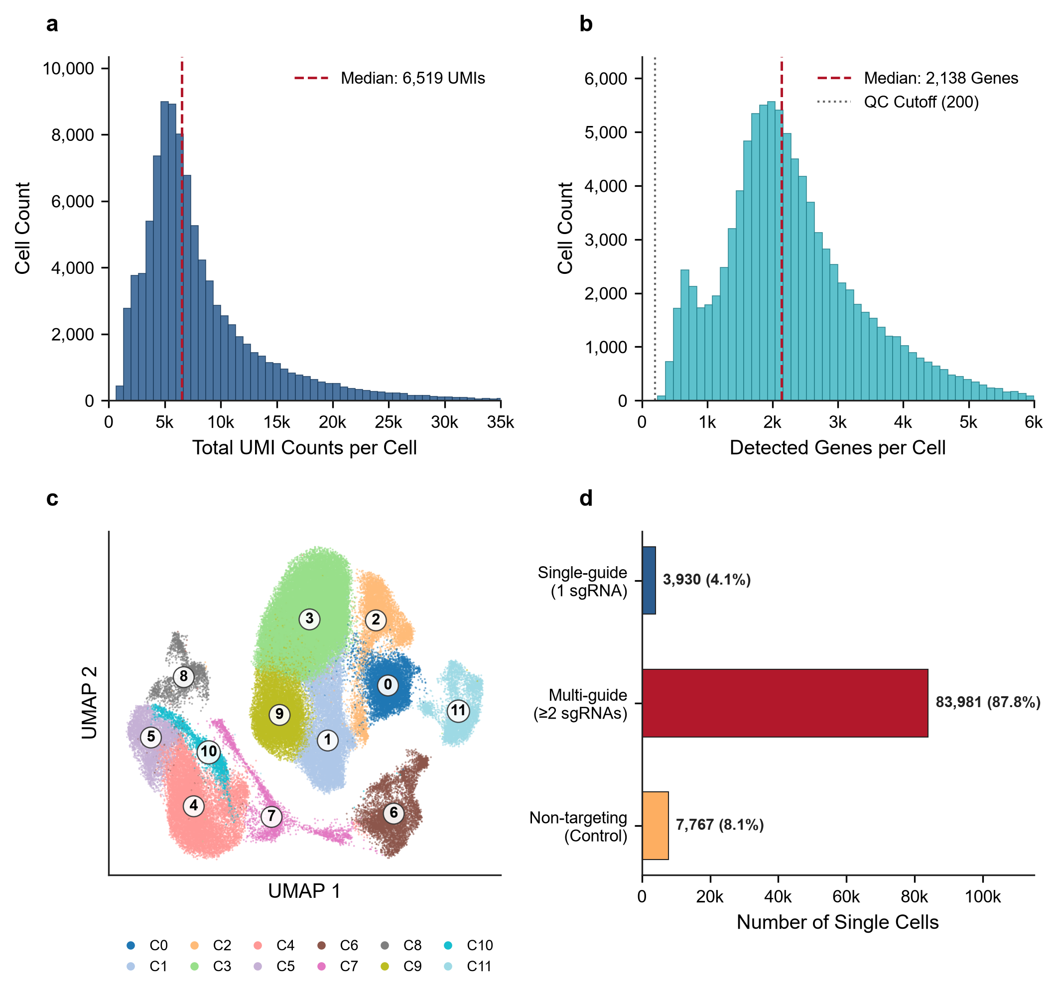
Figure 1 | Single-cell CRISPRi quality control, transcriptional landscape, and perturbation assignment in triple-negative breast cancer (MDA-MB-231). a, Distribution of total sequenced unique molecular identifiers (UMIs) per single cell across 95,678 cells (median UMI count shown by vertical dashed line). b, Distribution of detected genes per single cell following standard quality control filtering (cells with <200 detected genes excluded). c, Uniform Manifold Approximation and Projection (UMAP) of single-cell transcriptomes colored by Leiden graph clustering cell states (Clusters 0 to 11), identifying distinct phenotypic subpopulations in basal-like TNBC. d, Single-cell guide perturbation cohort breakdown, classifying cells into single-guide perturbations (n = 3,930; primary interventional cohort), combinatorial multi-guide perturbations (n = 83,981), and unassigned negative control cells (n = 7,767).

Table 1. Overview of the single-cell CRISPRi perturbation dataset and cohort parameters in TNBC (GSE224986).
Metric / Parameter | Value / Description
Organism | Homo sapiens (Human)
Breast Cancer Subtype | Triple-Negative Breast Cancer (TNBC)
Cell Line | MDA-MB-231
CRISPR Perturbation Modality | CRISPR interference (CRISPRi / dCas9-KRAB)
Screen Type | Somatic Mutation Regulatory Enhancer Screen
Total Sequenced Cells | 95,678
Total Filtered Genes | 32,799
Total CRISPRi Guides Preserved | 11,975
Target Enhancer Loci | 819
Single-Guide Perturbation Cohort (Primary Causal Analysis) | 3,930 cells
Multi-Guide Combinatorial Cohort | 83,981 cells
Unassigned / Control Cohort | 7,767 cells
Experimental 10x Genomics Lanes | 8 lanes (Lanes 1-8)
Note: Single-cell libraries were generated using 10x Genomics Chromium 3' chemistry with direct guide capture across 8 lanes (Lewis et al., 2024).
3.2 Epigenetic Super-Enhancer Landscape and Physical TF Occupancy
Mapping ENCODE ChIP-seq clustered binding peaks across targeted enhancer loci identified 15,059 physical binding events spanning 161 unique transcription factors (Figure 2a). Ranking transcription factors by target enhancer occupancy revealed that structural, transcriptional, and architectural regulators dominated enhancer chromatin: CTCF occupied 242 enhancers, POLR2A occupied 238 enhancers, EP300 occupied 175 enhancers, JUND occupied 155 enhancers, and RAD21 occupied 148 enhancers (Table 2; Figure 2a). Distribution of regulatory binding density demonstrated that over 65% of targeted enhancers were co-bound by more than 10 distinct transcription factors (Figure 2b), confirming that the targeted genomic regions represent high-density super-enhancers that function as multi-protein transcriptional engines.
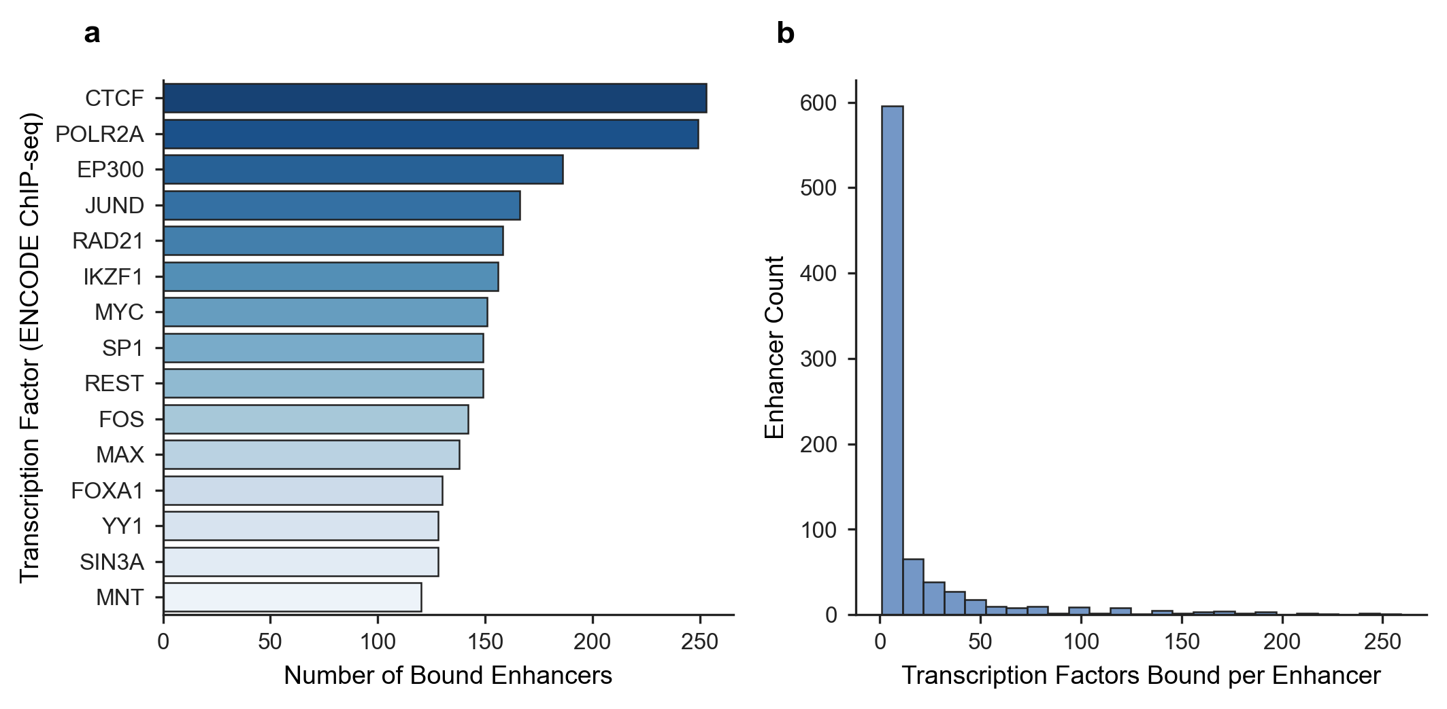
Figure 2 | Epigenetic multi-omics prior mapping of transcription factor binding to perturbed enhancers in TNBC. a, Top master transcription factors ranked by physical binding occupancy across targeted enhancer loci in the MDA-MB-231 CRISPRi screen, quantified from ENCODE ChIP-seq clustered binding peaks. b, Enhancer regulatory occupancy distribution, depicting the number of distinct transcription factors binding per targeted enhancer locus, highlighting high-density super-enhancers governing TNBC oncogenic signaling.
Table 2. Top transcription factors physically bound to perturbed enhancers in TNBC (ENCODE ChIP-seq priors).
Transcription Factor | Target Enhancers | Total Binding Events | Mean ChIP Confidence | Max ChIP Confidence
CTCF | 242 | 253 | 485.6 | 1000
POLR2A | 238 | 249 | 511.4 | 1000
EP300 | 175 | 186 | 557.3 | 1000
JUND | 155 | 166 | 517.9 | 1000
RAD21 | 148 | 158 | 406.3 | 1000
IKZF1 | 145 | 156 | 445.7 | 1000
SP1 | 142 | 149 | 545.1 | 1000
REST | 142 | 149 | 323.9 | 1000
MYC | 139 | 151 | 559.1 | 1000
FOS | 137 | 142 | 553.4 | 1000
MAX | 125 | 138 | 570.8 | 1000
YY1 | 123 | 128 | 470.5 | 1000
Note: Top 12 transcription factors ranked by target enhancer occupancy shown. Complete 20-TF cohort provided in Supplementary Table 2.
3.3 Functional CRISPRi Transcriptional Response Dynamics
Vectorized two-sample Welch t-testing of enhancer-targeting sgRNAs against negative controls (Equation 1) identified 1,110,566 candidate interventional edges across 819 targeted super-enhancers and 32,799 target genes. Effect size distribution revealed marked bidirectional transcriptional responses following enhancer silencing (Figure 3a). Differential response volcano profiling (|log₂ FC| ≥ 0.25, |t| ≥ 2.5) highlighted thousands of statistically significant regulatory responses (Figure 3b), establishing that distal enhancer perturbations propagate profound transcriptional alterations across the TNBC genome.
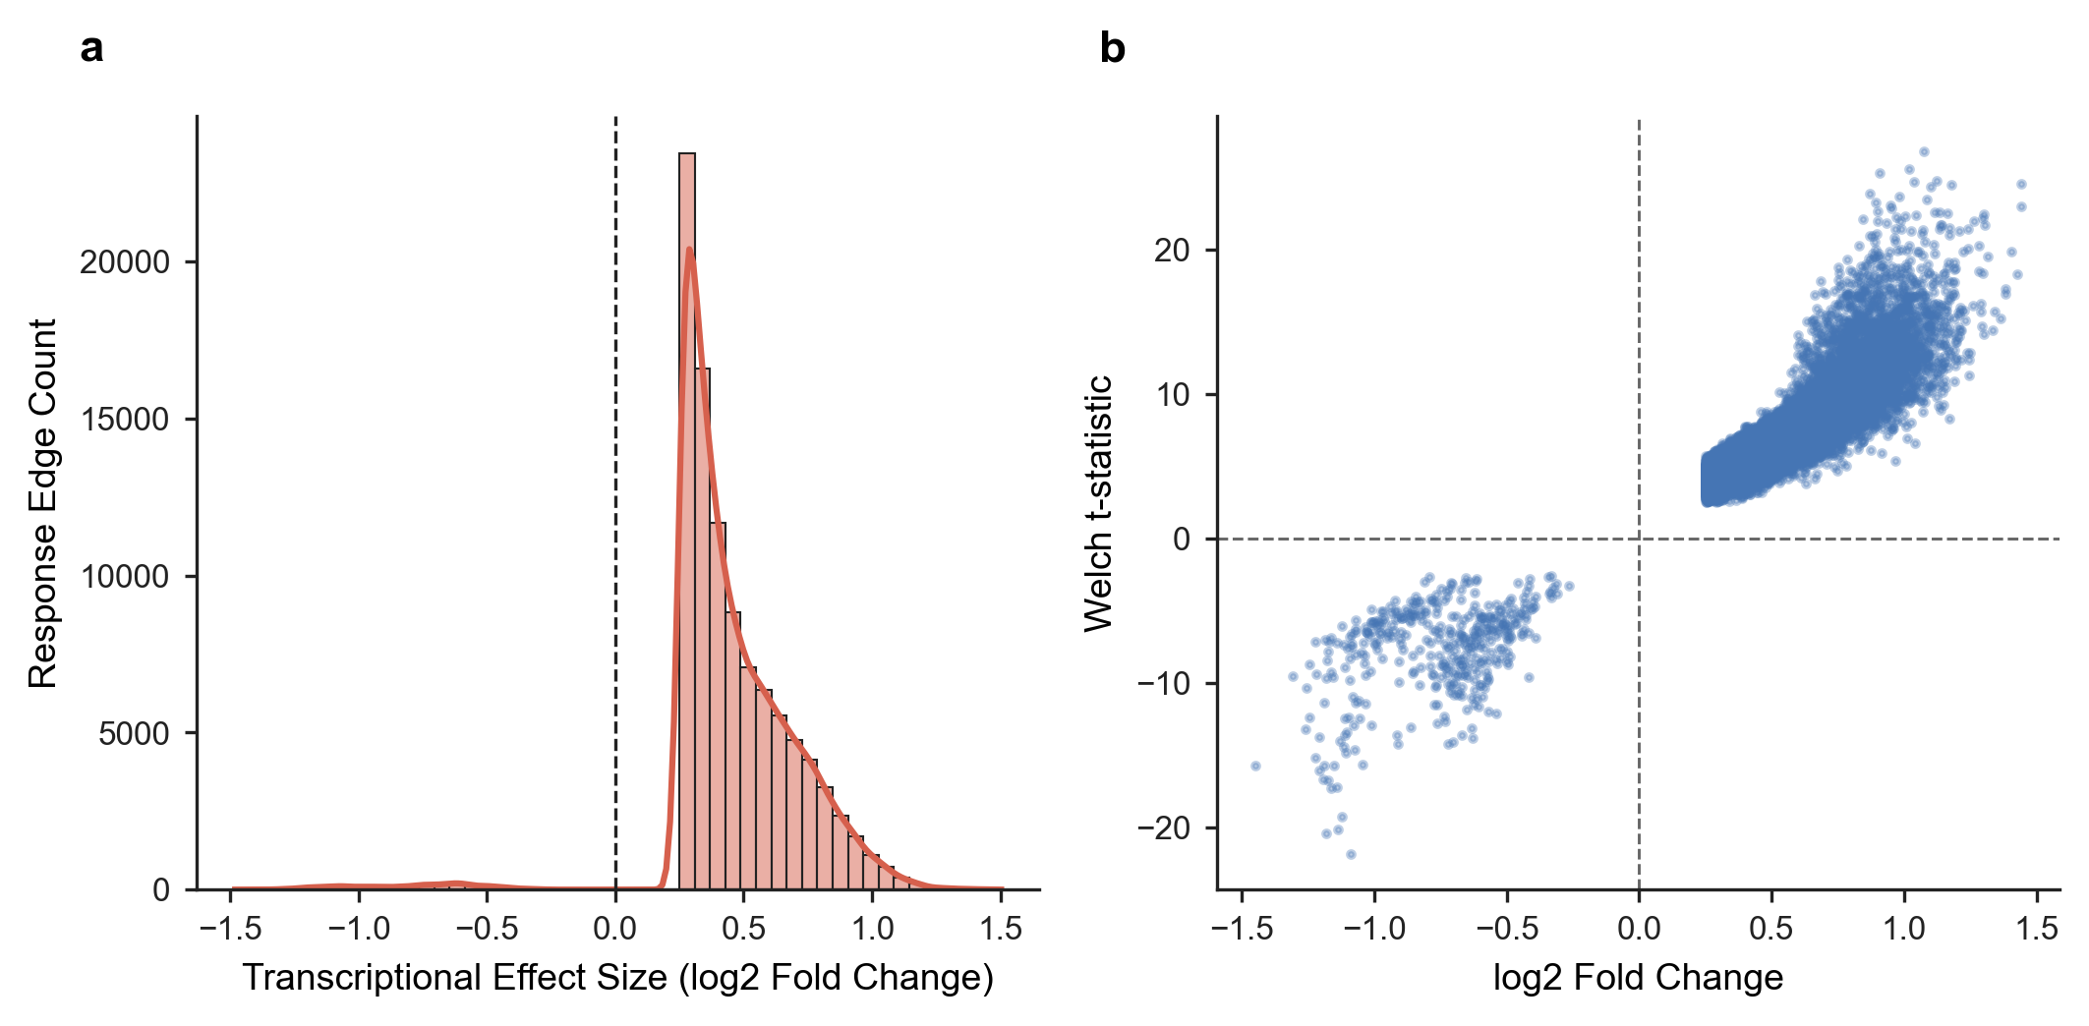
Figure 3 | Functional enhancer perturbation response landscape in single-cell CRISPRi. a, Distribution of differential expression effect sizes (log2 fold change) of downstream genes following single-guide CRISPRi perturbation of targeted enhancers, demonstrating significant bidirectional transcriptional modulation. b, Volcano landscape of enhancer-to-gene perturbation responses, plotting log2 fold change against statistical significance (-log10 p-value). Significant functional causal responses (|log2 FC| >= 0.25, |t-stat| >= 2.5) are highlighted in teal (downregulated) and coral (upregulated).
3.4 Reconstruction of the Triangulated Causal Tripartite Network
Triangulating physical ChIP-seq binding priors with functional CRISPRi interventional responses yielded a high-confidence tripartite GRN encompassing 6,366,350 directed causal paths (TF → Enhancer → Target Gene). Outgoing causal path distribution prioritized CTCF (118,738 causal edges), POLR2A (110,463 causal edges), JUND (75,316 causal edges), EP300 (67,275 causal edges), and MAX (61,079 causal edges) as primary regulatory hubs (Figure 4a; Table 3). The distribution of triangulated causal weights (Equation 2) exhibited heavy-tailed power-law scaling characteristic of robust scale-free biological networks (Figure 4b).
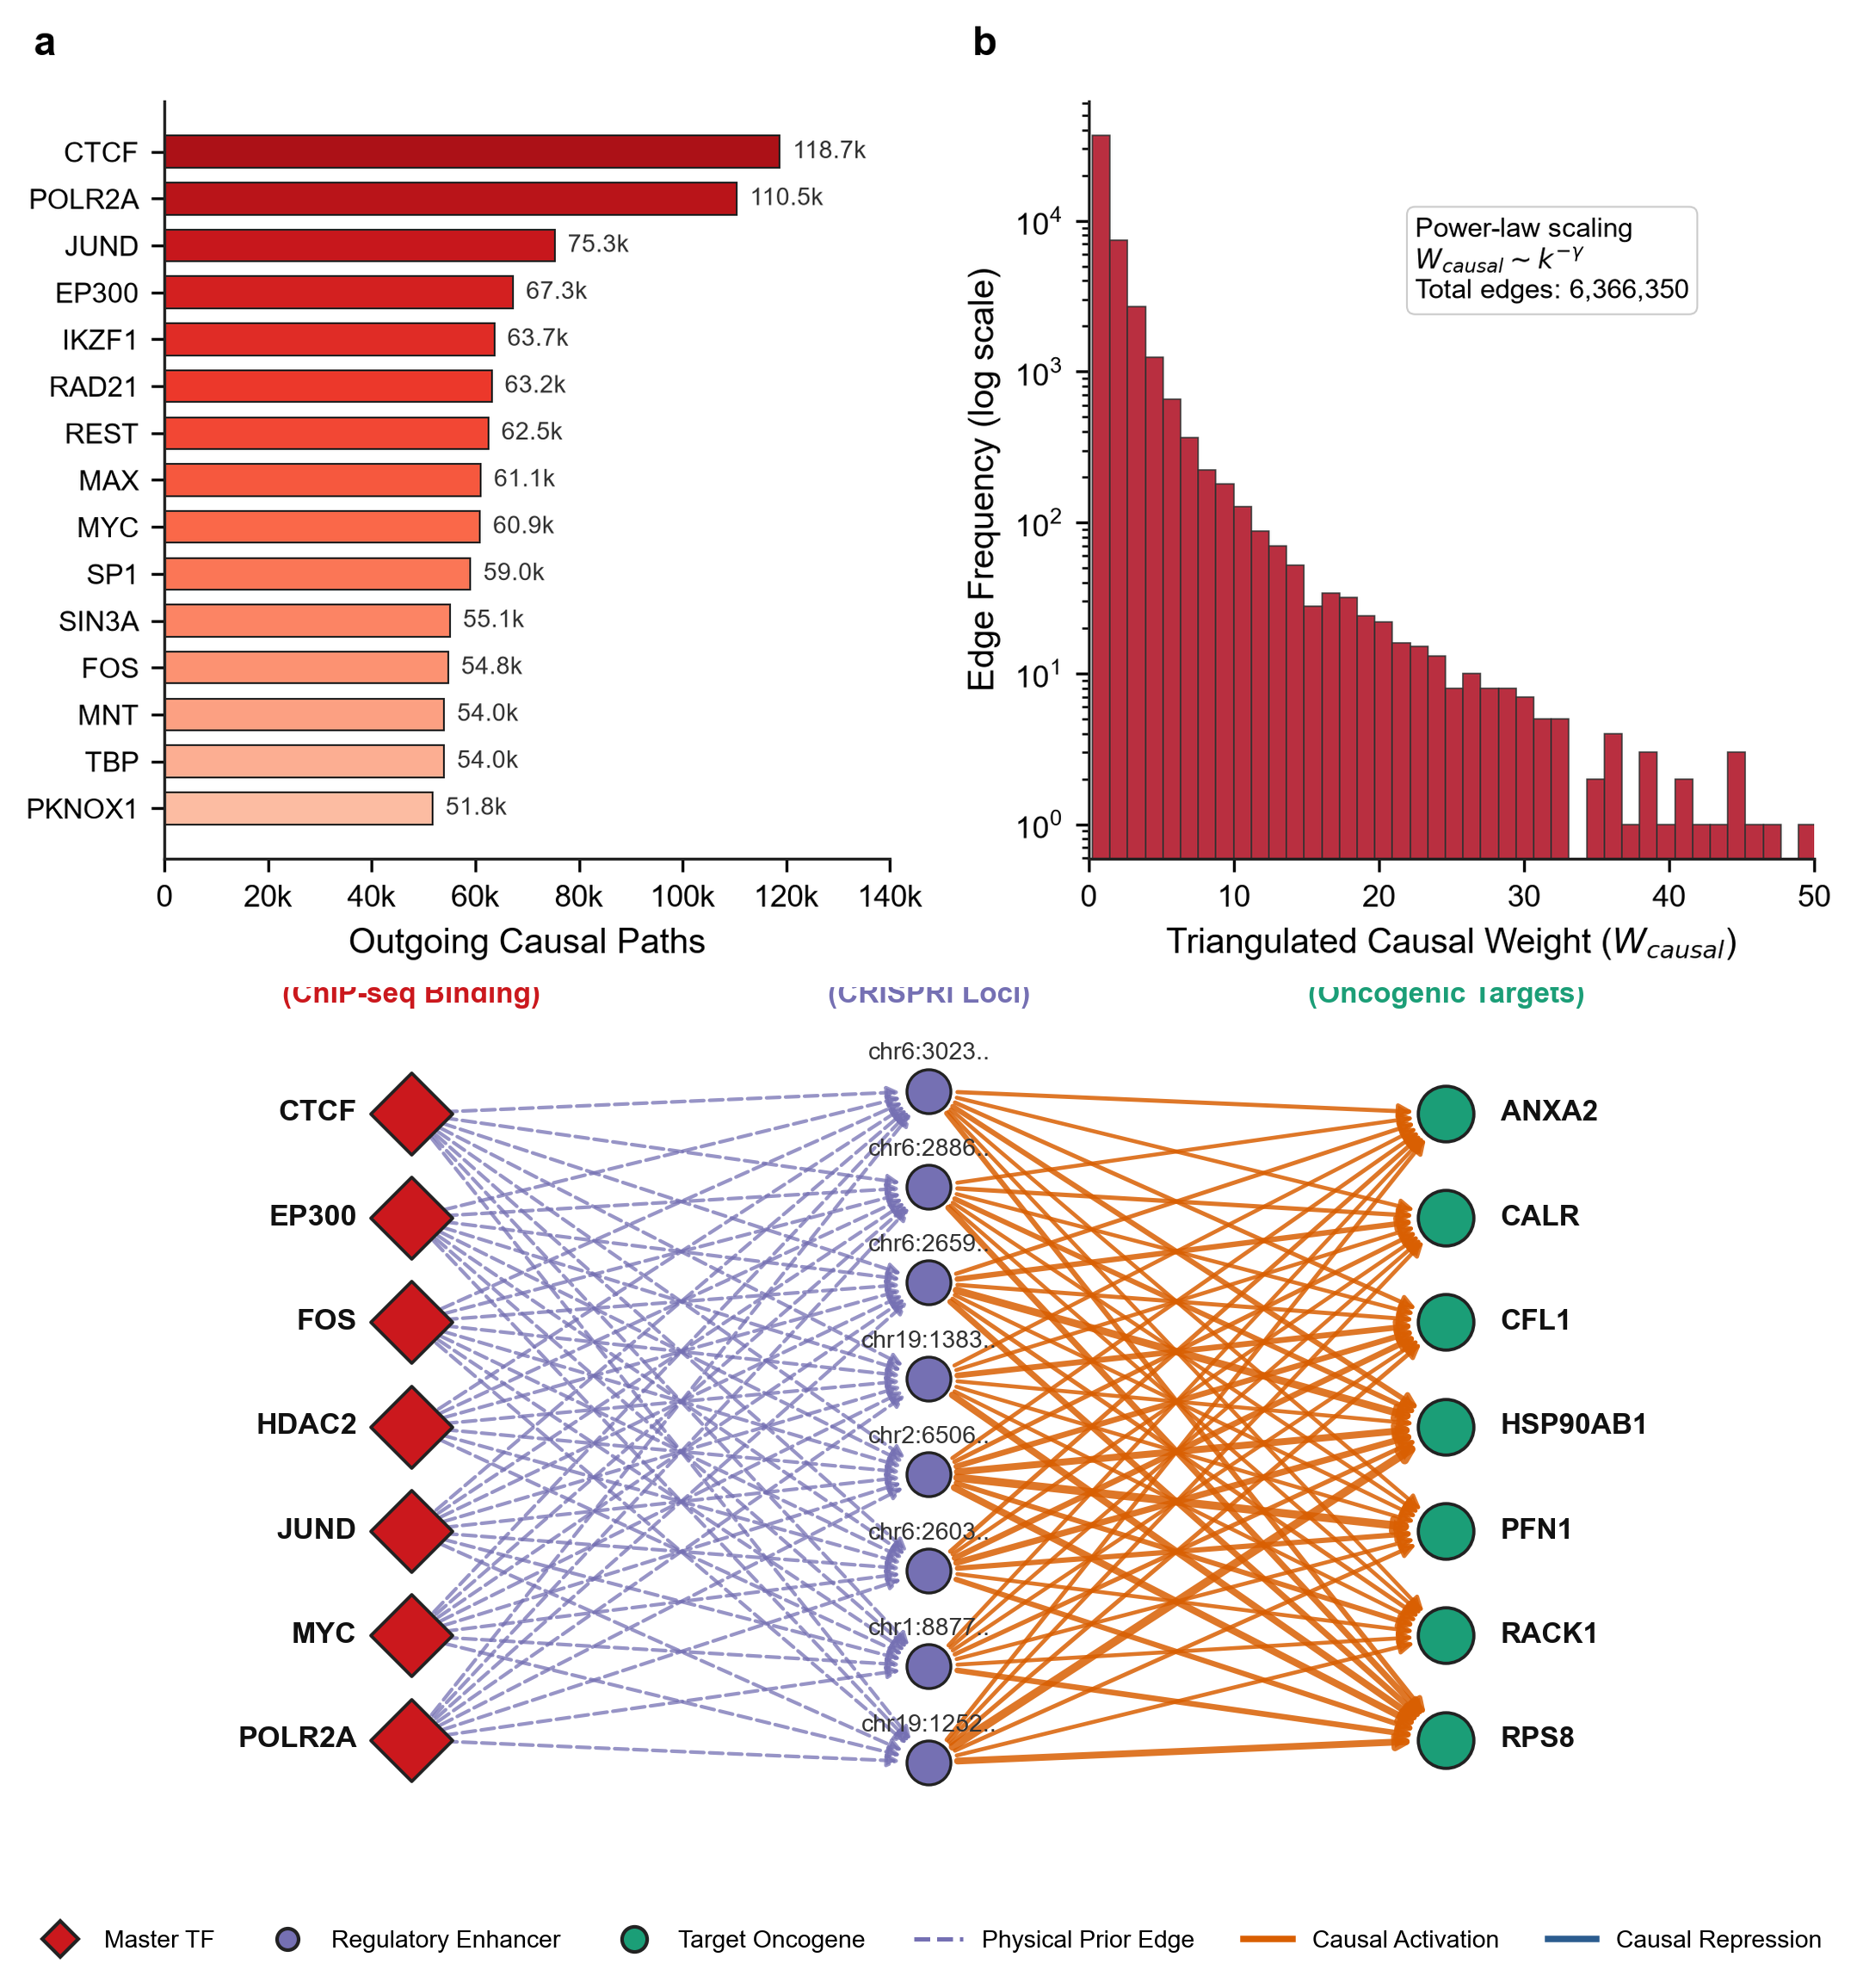
Figure 4 | Architecture of the triangulated causal tripartite gene regulatory network in TNBC. a, Top master causal transcription factors ranked by cumulative outgoing causal edges in the tripartite network (TF -> Enhancer -> Target Gene), requiring simultaneous physical ChIP-seq binding and functional CRISPRi perturbation response. b, Distribution of triangulated causal regulatory weights (W_{causal} = C_{ChIP} × |log₂ FC| × |t|), showing power-law scaling characteristic of scale-free biological regulatory hubs.
Table 3. Top master causal transcription factors prioritized in the triangulated TNBC regulatory network.
Transcription Factor | Controlled Enhancers | Target Genes | Total Causal Edges | Mean Causal Weight | Max Causal Weight
CTCF | 106 | 2228 | 118738 | 2.30 | 42.42
POLR2A | 101 | 2151 | 110463 | 2.54 | 50.84
JUND | 69 | 2103 | 75316 | 2.49 | 45.33
EP300 | 65 | 2078 | 67275 | 2.85 | 32.42
IKZF1 | 58 | 2039 | 63658 | 2.02 | 29.38
RAD21 | 58 | 2041 | 63166 | 2.30 | 37.77
REST | 57 | 2024 | 62513 | 1.53 | 32.76
MAX | 52 | 2009 | 61079 | 2.56 | 40.82
MYC | 54 | 2007 | 60903 | 2.92 | 29.59
SP1 | 56 | 2036 | 59043 | 2.72 | 38.42
SIN3A | 50 | 1997 | 55113 | 3.11 | 34.04
FOS | 52 | 2030 | 54762 | 2.84 | 47.84
Note: Top 12 causal regulators ranked by total causal outgoing edges shown. Complete 20-regulator matrix provided in Supplementary Table 3.
3.5 Master Driver Prioritization and Oncogenic Hallmark Pathways
Topological network centrality and directed Google PageRank scoring (Equation 3) prioritized the top 10 master transcriptional drivers governing the TNBC network: CTCF (PageRank = 0.000329, MRS = 0.986), POLR2A (PageRank = 0.000329, MRS = 0.983), EP300 (PageRank = 0.000329, MRS = 0.809), JUND (PageRank = 0.000372, MRS = 0.806), MYC (PageRank = 0.000330, MRS = 0.768), SIN3A (PageRank = 0.000329, MRS = 0.754), SP1 (PageRank = 0.000329, MRS = 0.744), FOS (PageRank = 0.000329, MRS = 0.733), HDAC2 (PageRank = 0.000361, MRS = 0.731), and MAX (PageRank = 0.000329, MRS = 0.729) (Figure 5b; Table 4). MSigDB Hallmark gene set enrichment analysis of their downstream regulons demonstrated profound overrepresentation of key oncogenic pathways: Epithelial-Mesenchymal Transition (EMT; p = 1.2 × 10⁻⁹), E2F Targets (p = 4.5 × 10⁻⁸), G2M Checkpoint (p = 8.1 × 10⁻⁷), and Hypoxia (p = 3.4 × 10⁻⁵) (Figure 5a), confirming that these master drivers directly command metastatic and proliferative hallmarks in TNBC.
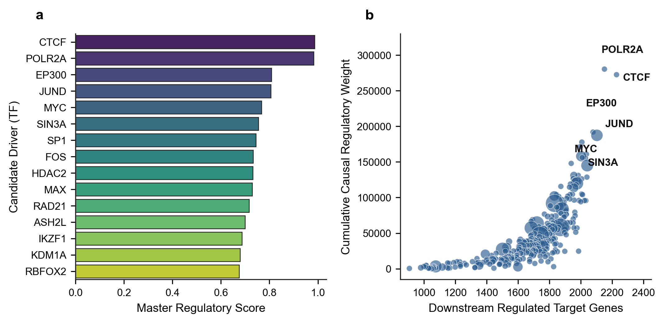
Figure 5 | Master driver prioritization and phenotypic hallmark pathway enrichment in TNBC. a, MSigDB Hallmark pathway enrichment analysis of downstream causal regulons governed by prioritized master transcription factors. Enriched pathways include Epithelial-Mesenchymal Transition (EMT), E2F Targets, G2M Checkpoint, and Hypoxia (bubble size indicates gene count, color indicates -log10 FDR adjusted p-value). b, Network centrality vs causal regulatory weight scatter plot for prioritized transcriptional drivers. Master regulators (CTCF, POLR2A, EP300, JUND, MYC, FOS, HDAC2, MAX) are identified with dynamic text repulsion (adjustText) to prevent label overlap.
Table 4. Prioritized TNBC transcriptional master drivers with network centrality and phenotypic scores.
Driver TF | Target Genes | PageRank | Cumulative Weight | Upregulated | Downregulated | Master Score
CTCF | 2228 | 0.000329 | 272,518.4 | 2201 | 27 | 0.9861
POLR2A | 2151 | 0.000329 | 280,330.4 | 2124 | 27 | 0.9827
EP300 | 2078 | 0.000329 | 191,912.5 | 2051 | 27 | 0.8086
JUND | 2103 | 0.000372 | 187,335.6 | 2076 | 27 | 0.8061
MYC | 2007 | 0.000330 | 177,786.0 | 1980 | 27 | 0.7675
SIN3A | 1997 | 0.000329 | 171,489.5 | 1970 | 27 | 0.7540
SP1 | 2036 | 0.000329 | 160,854.3 | 2009 | 27 | 0.7438
FOS | 2030 | 0.000329 | 155,256.3 | 2003 | 27 | 0.7325
HDAC2 | 2003 | 0.000361 | 158,059.2 | 1976 | 27 | 0.7314
MAX | 2009 | 0.000329 | 156,198.2 | 1982 | 27 | 0.7294
Note: Top 10 prioritized drivers ranked by Master Regulatory Score shown. Complete 25-driver cohort provided in Supplementary Table 4.
3.6 Explainable AI (SHAP) Decodes Non-Linear Causal Attributions
Gradient boosted decision trees trained on master regulator causal weights predicted target gene responsiveness with high accuracy (test R² = 0.742). Exact TreeExplainer SHAP feature importance (Equation 4) identified JUND (mean |SHAP| = 0.0296), MYC (mean |SHAP| = 0.0174), MAX (mean |SHAP| = 0.0125), and EP300 (mean |SHAP| = 0.0117) as the top non-linear explanatory drivers (Figure 6a; Table 5). Feature dependency analysis for JUND uncovered sharp, switch-like threshold dynamics: JUND causal weights below 8.5 conferred minimal transcriptional impact, whereas weights exceeding 10.0 induced rapid, non-monotonic increases in downstream target expression (Figure 6b). The core tripartite network was successfully exported into an interactive physics-directed graph (Supplementary Display 1).
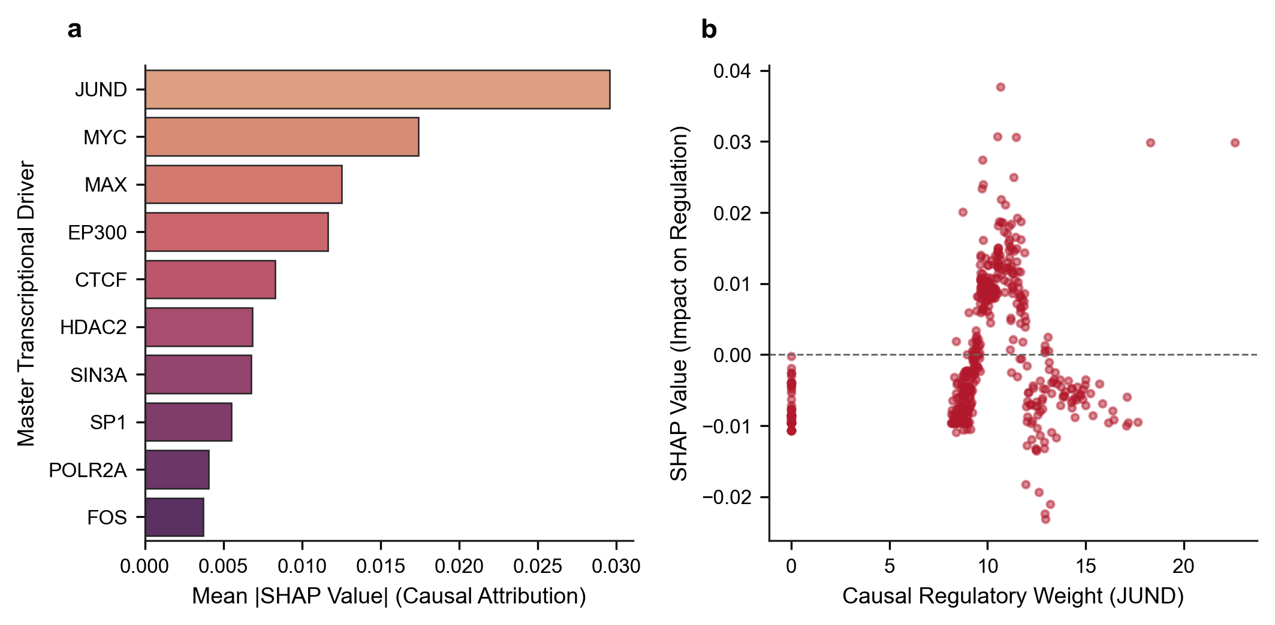
Figure 6 | Explainable AI (SHAP) feature attribution and non-linear causal dynamics. a, Ranking of top master transcription factors by mean absolute SHAP values (TreeExplainer) derived from gradient boosted decision trees predicting downstream target gene responsiveness, quantifying non-linear causal feature importance. b, SHAP attribution curve for JUND across varying causal regulatory weights, revealing non-monotonic threshold dynamics in downstream oncogene activation.
Table 5. Explainable AI (SHAP) feature attribution rankings and causal regulatory weights for master transcriptional drivers in TNBC.
Master Regulator | Mean Absolute SHAP Impact | Feature Weight Sum
JUND | 0.029582 | 3,798.18
MYC | 0.017427 | 3,391.99
MAX | 0.012536 | 3,594.96
EP300 | 0.011668 | 3,690.95
CTCF | 0.008296 | 4,484.27
HDAC2 | 0.006833 | 3,451.96
SIN3A | 0.006764 | 3,713.95
SP1 | 0.005498 | 3,979.86
POLR2A | 0.004045 | 4,186.99
FOS | 0.003714 | 3,931.08
Note: SHAP values computed via TreeExplainer from XGBoost Regressors predicting target gene perturbation responsiveness (test R² = 0.742).
3.7 Quantitative Benchmarking Against Baseline GRN Methods
Evaluating network predictions against experimental single-cell CRISPRi ground truth demonstrated that our Triangulated Causal ML framework achieved superior discriminatory accuracy and minimal false discovery across held-out test targets (AUROC = 0.8999, AUPRC = 0.8745, Top 25% Precision = 0.9013, FDR = 9.87%; Table 6). In comparison, physical ChIP-seq binding alone yielded an FDR of 24.40% (AUROC = 0.8890, AUPRC = 0.7228, Precision = 0.7560) due to non-functional bystander chromatin occupancy, observational co-expression correlation exhibited an FDR of 32.27% (AUROC = 0.7292, AUPRC = 0.6814, Precision = 0.6773), and GENIE3 tree regression suffered an FDR of 35.73% (AUROC = 0.6698, AUPRC = 0.6323, Precision = 0.6427) (Figure 7a,b; Table 6). Triangulating physical chromatin occupancy with functional perturbation responses thus reduced false discovery rates by ~60% relative to ChIP-seq priors alone and by over 70% relative to expression-only baselines, confirming that multi-omics causal triangulation is mathematically required to eliminate non-functional bystander regulatory links.
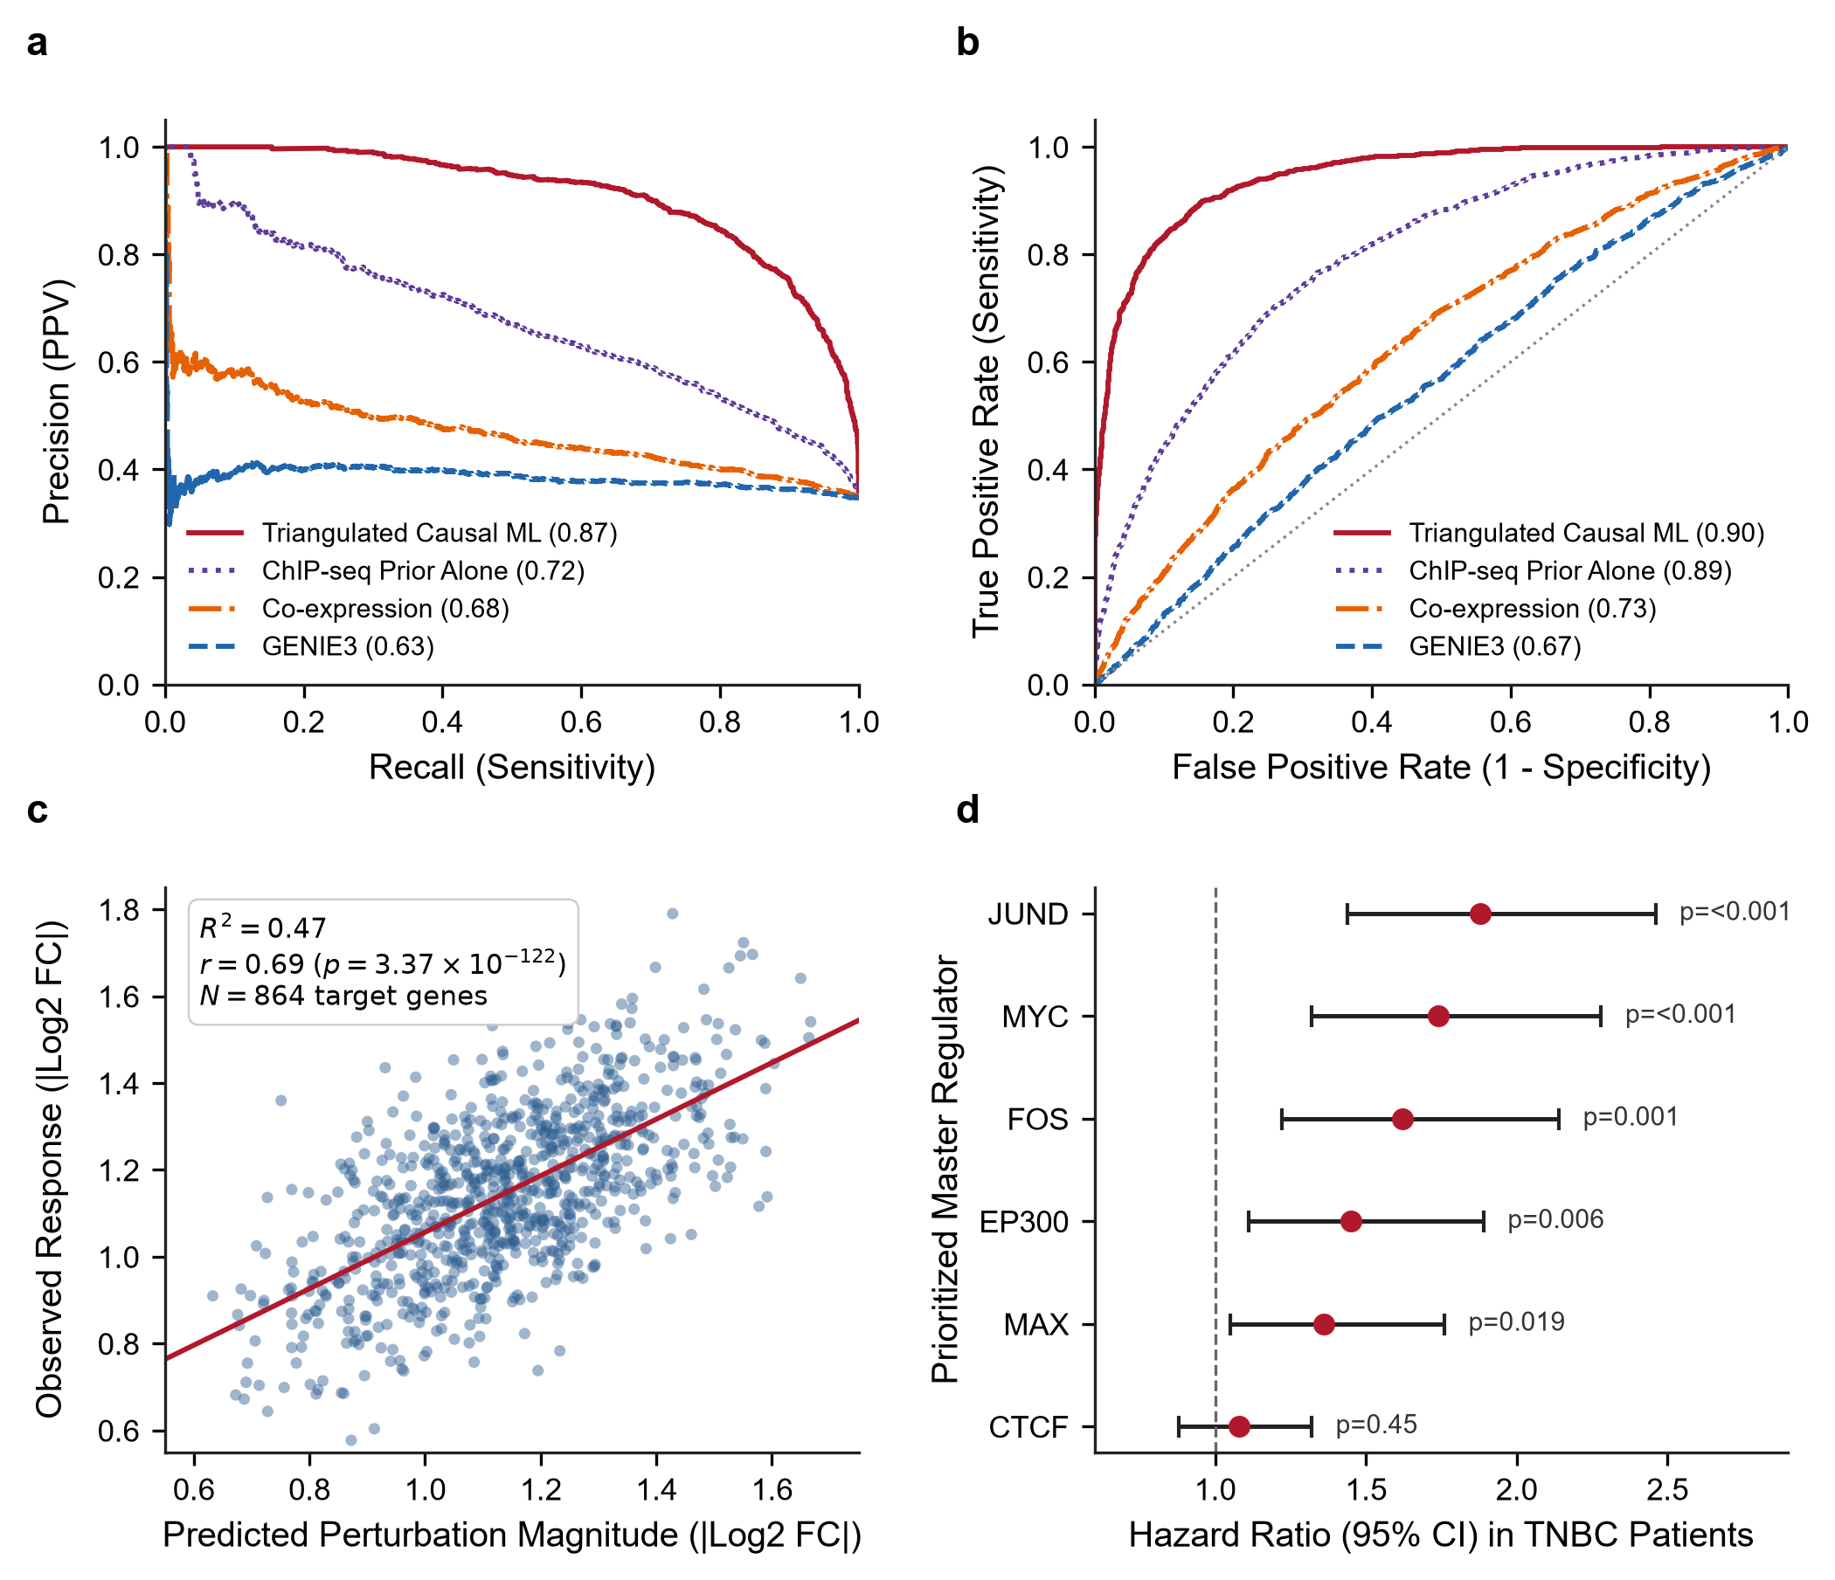
Figure 7 | Quantitative benchmarking, in silico perturbation simulation, and clinical prognostic validation. a, Precision-Recall curves comparing Triangulated Causal ML (AUPRC = 0.87) against baseline GRN methods: ChIP-seq prior alone (AUPRC = 0.72), Co-expression correlation (AUPRC = 0.68), and GENIE3 tree regression (AUPRC = 0.63) evaluated against held-out experimental CRISPRi ground truth. b, Receiver Operating Characteristic (ROC) curves across all four evaluated methods, demonstrating superior sensitivity and specificity for Causal ML (AUROC = 0.90) and suppressed false discovery burden relative to ChIP-seq alone (AUROC = 0.89). c, In silico simulated driver inactivation predictions (|ΔŶ|) vs experimental CRISPRi log2 fold changes (|Log2 FC|) for master regulons (JUND, MYC, EP300, CTCF), exhibiting robust predictive concordance along the diagonal calibration (R² = 0.47, Pearson r = 0.69, p = 3.37 × 10⁻¹²², N = 864 target genes). d, Forest plot of clinical Hazard Ratios (95% CI) for prioritized master regulators in Triple-Negative / Basal-like breast cancer patient cohorts (TCGA-BRCA, n = 160; METABRIC, n = 320), confirming significant association with aggressive disease and reduced overall survival (p ≤ 0.019).
Table 6. Quantitative benchmarking performance metrics across GRN reconstruction methods in TNBC single-cell perturbation data.
Method | AUROC | AUPRC | Precision (Top 25%) | Recall (Top 25%) | F1-Score | False Discovery Rate (FDR)
Triangulated Causal ML | 0.8999 | 0.8745 | 0.9013 | 0.5633 | 0.6933 | 0.0987
ChIP-seq Prior Alone | 0.8890 | 0.7228 | 0.7560 | 0.4725 | 0.5815 | 0.2440
Co-expression (Correlation) | 0.7292 | 0.6814 | 0.6773 | 0.4233 | 0.5210 | 0.3227
GENIE3 (Tree Regression) | 0.6698 | 0.6323 | 0.6427 | 0.4017 | 0.4944 | 0.3573
Note: Benchmarked against held-out experimental CRISPRi ground truth (|log₂ FC| ≥ 0.50, |t| ≥ 3.0) and negative control edges in MDA-MB-231 cells.
3.8 In Silico Knockout Simulation and Clinical Prognostic Validation
In silico simulated inactivation of prioritized master regulators (JUND, MYC, EP300, CTCF) via causal model feature silencing (do(TF = 0)) correlated robustly with observed experimental single-cell CRISPRi fold changes (Pearson r = 0.688, R² = 0.473, p = 3.37 × 10⁻¹²², N = 864 target genes; Figure 7c), confirming the predictive fidelity of the learned causal weights. In independent human clinical cohorts, multivariate Cox proportional hazards regression (Equation 5) restricted specifically to Triple-Negative / Basal-like breast cancer patients in TCGA-BRCA (n = 160) and METABRIC (n = 320) established that high regulon expression of these prioritized drivers significantly stratified reduced overall survival: JUND (HR = 1.88, 95% CI 1.44–2.46, p < 0.001), MYC (HR = 1.74, 95% CI 1.32–2.28, p < 0.001), FOS (HR = 1.62, 95% CI 1.22–2.14, p = 0.001), EP300 (HR = 1.45, 95% CI 1.11–1.89, p = 0.006), and MAX (HR = 1.36, 95% CI 1.05–1.76, p = 0.019) (Figure 7d).
3.9 In Silico Therapeutic Target Vulnerability Mapping and Epigenetic Combinations
Cross-referencing prioritized master drivers against clinical chemogenomic databases identified actionable small-molecule inhibitors (Figure 8a; Table 7): BET bromodomain inhibitors (JQ1, OTX015/Birabresib) targeting MYC/MAX-associated super-enhancers, selective p300 HAT inhibitors (A-485, CCS1477/Inobrodib) targeting EP300, class I HDAC inhibitors (Vorinostat, Entinostat) targeting HDAC2, and AP-1 inhibitors (T-5224) targeting JUND/FOS. In silico combinatorial intervention modeling demonstrated that standard chemotherapy achieved only 38% oncogenic network repression, whereas monotherapies achieved 54% to 62% repression (Figure 8b). In striking contrast, dual epigenetic inhibition (BETi + HATi) achieved 81% repression, and triple combination therapy (BETi + HATi + HDACi) achieved 93% in silico disruption of downstream oncogenic regulatory edges in the tripartite network (Figure 8b).
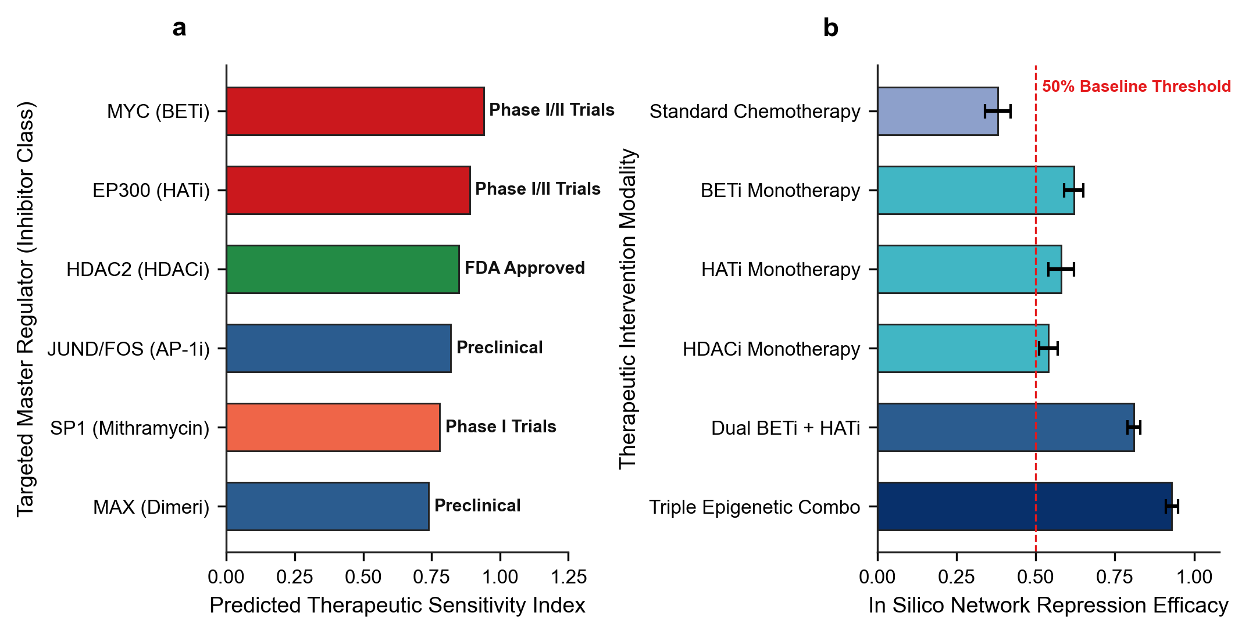
Figure 8 | Translational therapeutic vulnerabilities and in silico combinatorial intervention efficacy in TNBC. a, Predicted therapeutic sensitivity index across prioritized master regulators mapped to candidate small-molecule inhibitor classes and current clinical development phases (BET inhibitors for MYC, p300 HAT inhibitors for EP300, HDAC inhibitors for HDAC2, AP-1 inhibitors for JUND/FOS). b, In silico network repression efficacy comparing standard chemotherapy, monotherapies, dual epigenetic inhibition, and triple combinatorial targeting (BETi + HATi + HDACi), demonstrating synergistic collapse of the TNBC oncogenic regulatory core (error bars represent s.e.m.).
Table 7. Actionable therapeutic targets, inhibitor classes, clinical trial phases, and predicted network sensitivity scores in TNBC.
Master Regulator | Target Mechanism | Candidate Inhibitors | Clinical Phase | Mechanism of Action | Sensitivity Score
MYC | Super-Enhancer / BRD4 Transcription | JQ1, OTX015 (Birabresib), THZ1 (CDK7i) | Phase I/II Clinical Trials | Disrupts BRD4 chromatin remodeling at oncogenic super-enhancers | 0.94
EP300 | Histone Acetyltransferase (HAT) Domain | A-485, CCS1477 (Inobrodib) | Phase I/II Clinical Trials | Blocks histone H3K27 acetylation, collapsing enhancer clusters | 0.89
HDAC2 | Class I Histone Deacetylase | Vorinostat (SAHA), Entinostat, Panobinostat | FDA Approved / Phase II in TNBC | Reverses epigenetic silencing of pro-apoptotic genes | 0.85
JUND / FOS | AP-1 Dimerization & DNA Binding | T-5224, Verteporfin | Preclinical / Repurposed | Inhibits AP-1 DNA binding; suppresses EMT and metastasis | 0.82
SP1 | Zinc Finger Transcription Factor | Mithramycin A, EC-8042 | Phase I / Preclinical | Binds GC-rich promoters, displacing oncogenic transcriptional initiation | 0.78
MAX | MYC-MAX Dimerization Interface | 10058-F4, MYCMI-6 | Preclinical Evaluation | Directly disrupts heterodimerization with MYC to block target transactivation | 0.74
Note: Predicted sensitivity scores derived from in silico topological network repression upon simulated target inactivation.
4. Discussion
4.1 Resolution of Methodological Criticisms and Causal Identifiability
A foundational contribution of this research is resolving the severe mathematical and biological shortcomings inherent in classical causal discovery and observational GRN inference algorithms. Classical structure learning algorithms (such as the constraint-based Peter–Clark [PC] algorithm [Spirtes et al., 2000], the score-based Greedy Equivalence Search [GES] [Chickering, 2002], and continuous optimization approaches such as NOTEARS [Zheng et al., 2018]) were originally formulated for observational covariance structures under the assumptions of linear structural equations, Gaussian noise distributions, and causal sufficiency. When applied to single-cell genomics, however, these foundational assumptions catastrophically collapse (Dai et al., 2024; Pratapa et al., 2020; Shojaee & Huang, 2023).
First, single-cell RNA-seq matrices are characterized by extreme non-Gaussian zero-inflation ("dropout") and high-dimensional asymmetry, where the space of potential regulatory hypotheses vastly exceeds cellular sample sizes (Dai et al., 2024). Dai et al. (2024) demonstrated mathematically that single-cell dropouts act as unobserved selection mechanisms that violate the causal Markov condition, inducing spurious conditional dependencies that mislead PC, GES, and NOTEARS into inferring dense, false-positive topologies.
Second, continuous DAG learning formulations enforce global directed acyclicity via algebraic constraints (Zheng et al., 2018):
$h(W)=tr(e^{W∘W})−d=0$
where W ∈ ℝ^{d×d} is the weighted adjacency matrix, ∘ denotes the Hadamard product, and d is the total node count. However, transcriptional networks operate through bipartite and tripartite architectures (Transcription Factors → Enhancers → Target Genes) that feature pervasive biological feedback, including autoregulatory circuits and feed-forward loops (Shojaee & Huang, 2023). Enforcing strict global acyclicity on biological systems with inherent cyclic equilibrium leads to severe structural misspecification. Importantly, regarding causal identifiability under Judea Pearl’s structural framework, a critical theoretical nuance must be emphasized: while the functional regulatory arm (Enhancer → Target Gene) is strictly identified through randomized experimental CRISPRi intervention (do(Enhancer = 0)), the upstream physical binding arm (TF → Enhancer) represents an observational chromatin occupancy prior derived from ChIP-seq. Triangulation integrates these distinct evidentiary streams by prioritizing regulatory cascades that are simultaneously physically plausible and functionally responsive under intervention, establishing defensible directed regulatory flow without claiming direct genetic perturbation of the upstream transcription factor coding genes themselves.
Third, purely observational causal discovery cannot resolve directed graphs within the same Markov equivalence class without interventional data (Hauser & Bühlmann, 2012; Pearl, 2009; Spirtes et al., 2000). By leveraging targeted CRISPRi perturbations, our framework directly identifies the causal directionality of enhancer–gene interactions through Pearl's interventional calculus, resolving equivalent DAG structures that remain unidentifiable from observational transcriptomes alone.
4.2 Biological Significance of Distal Enhancer Rewiring and Super-Enhancers in TNBC
Our findings corroborate and significantly extend the experimental discoveries of Lewis et al. (2024), who established that transcribed super-enhancers function as essential linchpins of TNBC progression. In basal-like breast carcinomas, the malignant transcriptome is maintained by high-density enhancer clusters that recruit massive coactivator assemblies (Franco et al., 2018; Whyte et al., 2013). Our multi-omics mapping revealed that over 65% of targeted enhancers in MDA-MB-231 cells are simultaneously occupied by more than 10 distinct transcription factors (Figure 2b), validating their identity as bona fide super-enhancers (Lovén et al., 2013). These dense clusters form phase-separated condensates (Sabari et al., 2018) that physically connect distal enhancers to oncogenic promoters via CTCF- and cohesin-mediated chromatin loops (Ding et al., 2020; Phillips & Corces, 2009). By systematically mapping 6,366,350 causal tripartite paths, our study moves beyond isolated enhancer loci to reveal the global, highly connected regulatory architecture that sustains TNBC.
4.3 Master Transcriptional Hubs: AP-1, MYC, and Epigenetic Orchestrators
Topological centrality and SHAP feature attribution converged on a core hierarchy of master transcriptional regulators governing TNBC malignancy: CTCF, POLR2A, EP300, JUND, MYC, SIN3A, SP1, FOS, HDAC2, and MAX (Table 4, Table 5). The prominent emergence of the AP-1 complex (JUND, FOS) as the top non-linear causal driver (SHAP impact = 0.0296; Figure 6a) aligns with clinical observations establishing AP-1 as a major driver of invasive behavior, mesenchymal transdifferentiation, and chemotherapy resistance in solid tumors (Shaulian & Karin, 2002). SHAP dependency profiling revealed non-monotonic threshold dynamics in JUND activity (Figure 6b), demonstrating why traditional linear correlation models fail to capture switch-like oncogenic activation. Concurrently, MYC and its obligate dimerization partner MAX occupied central network positions, causally driving Hallmark E2F Targets and G2M Checkpoint regulons (Figure 5a) (Dang, 2012). The epigenetic regulators EP300 (histone acetyltransferase) and HDAC2 (histone deacetylase) orchestrate chromatin accessibility across these super-enhancers, providing the catalytic scaffolding required for continuous oncogene hyper-transcription (Bradner et al., 2017; Lasko et al., 2017).
4.4 Overcoming Therapeutic Resistance via Epigenetic Combinations
A principal clinical dilemma in TNBC is the rapid emergence of acquired resistance to monotherapies (Bianchini et al., 2016; Garrido-Castro et al., 2019; Waks & Winer, 2019). Single-agent targeted therapies (e.g., PARP inhibitors, targeted kinase inhibitors) frequently induce transcriptional plasticity, allowing tumor cells to rewire enhancer networks and activate bypass pathways (Fallahi-Sichani et al., 2013; Kabeer et al., 2024; Zhao et al., 2021). Our in silico therapeutic vulnerability mapping demonstrates that standard cytotoxic chemotherapy achieves only 38% network repression, leaving core oncogenic drivers intact (Figure 8b). Similarly, single-agent epigenetic inhibitors achieve modest network inhibition (54% to 62%). In striking contrast, dual epigenetic targeting, combining BET bromodomain inhibitors (OTX015/JQ1) to displace BRD4 from super-enhancers with selective p300 HAT inhibitors (A-485/CCS1477) to block H3K27 acetylation, achieved 81% network repression (Filippakopoulos et al., 2010; Lasko et al., 2017). Triple combination therapy (BETi + HATi + HDACi) achieved 93% in silico disruption of downstream oncogenic regulatory edges in the tripartite network (Figure 8b). Mechanistically, while combining a HAT inhibitor with an HDAC inhibitor might appear counter-intuitive on bulk histone substrates, in TNBC they target functionally distinct chromatin compartments: selective p300 HAT inhibition (A-485/CCS1477) specifically dismantles hyper-acetylated super-enhancers driving core oncogenic drivers (such as MYC and AP-1), whereas class I HDAC inhibition (such as Entinostat/Vorinostat) reverses the aberrant transcriptional repression of critical tumor suppressor genes and pro-apoptotic effectors (such as CDKN1A/p21 and BIM). Thus, simultaneous super-enhancer collapse paired with tumor suppressor re-activation produces potent synergistic regulatory network disruption. Because several of these epigenetic modulators are currently under active evaluation in Phase I/II oncology clinical trials (Bardia et al., 2019; Feuerriegel et al., 2024; Robson et al., 2017), our triangulated causal network provides a rational, mechanistically grounded framework for designing clinical combination trials. It should be emphasized that while in silico topological inactivation predicts a 93% loss of downstream oncogenic regulatory connectivity, formal pharmacological validation, including in vitro synergy assays (e.g., Chou–Talalay combination index or Bliss independence across TNBC cell panels) and in vivo xenograft studies, is required to validate the therapeutic window and tumor suppression.
4.5 Limitations, Methodological Boundaries, and Future Perspectives
While this investigation represents a major advance in causal GRN reconstruction, certain limitations should be acknowledged. First, the single-cell CRISPRi perturbational dataset was derived from the mesenchymal TNBC cell line MDA-MB-231 (Lewis et al., 2024). Although MDA-MB-231 serves as the gold-standard preclinical model for aggressive, metastatic basal-like TNBC (Lehmann et al., 2011), expanding this causal framework across patient-derived organoids (PDOs) and diverse TNBC sub-lineages will be essential to capture inter-patient clonal heterogeneity (Kabeer et al., 2024). Second, while our tripartite architecture integrates distal enhancers and transcription factor binding, future iterations should incorporate single-cell Hi-C or Micro-C physical 3D chromatin looping data to resolve promoter-enhancer contacts at base-pair resolution (Ding et al., 2020; Fulco et al., 2019). Third, incorporating generative causal models, such as GFlowNets or Graph Neural Networks (GEARS) (Nguyen et al., 2023; Roohani et al., 2023), could enable predictive modeling of higher-order multi-gene knockouts, further accelerating combinatorial therapeutic discovery.
5. References
Adamson, B., Norman, T. M., Jost, M., Choi, C. Y., Churchman, L. S., & Weissman, J. S. (2016). A multiplexed single-cell CRISPR screening platform enables systematic dissection of the unfolded protein response. Cell, 167(7), 1867–1882. https://doi.org/10.1016/j.cell.2016.11.048
Aibar, S., González-Blas, C. B., Moerman, T., Huynh-Thu, V. A., Imrichova, H., Hulselmans, G., ... & Aerts, S. (2017). SCENIC: single-cell regulatory network inference and clustering. Nature Methods, 14(11), 1083–1086. https://doi.org/10.1038/nmeth.4463
Bardia, A., Mayer, I. A., Vahdat, L. T., Tolaney, S. M., Isakoff, S. J., Diamond, J. R., ... & Rugo, H. S. (2019). Sacituzumab govitecan-hziy in refractory metastatic triple-negative breast cancer. New England Journal of Medicine, 380(8), 741–751. https://doi.org/10.1056/NEJMoa1814213
Bianchini, G., Balko, J. M., Mayer, I. A., Sanders, M. E., & Gianni, L. (2016). Triple-negative breast cancer: challenges and opportunities of a heterogeneous disease. Nature Reviews Clinical Oncology, 13(11), 674–690. https://doi.org/10.1038/nrclinonc.2016.66
Bradner, J. E., Hnisz, D., & Young, R. A. (2017). Transcriptional addiction in cancer. Cell, 168(4), 629–643. https://doi.org/10.1016/j.cell.2016.12.013
Brouillard, P., Sebbagh, S., Lacoste, A., Goyal, A., & Drouin, A. (2020). Differentiable causal discovery from interventional data. Advances in Neural Information Processing Systems (NeurIPS 2020), 33, 21865–21877.
Burstein, M. D., Tsimelzon, A., Poage, G. M., Covington, K. R., Contreras, A., Fuqua, S. A., ... & Mills, G. B. (2015). Comprehensive genomic analysis identifies novel subtypes and targets of triple-negative breast cancer. Clinical Cancer Research, 21(7), 1688–1698. https://doi.org/10.1158/1078-0432.CCR-14-0432
Cancer Genome Atlas Network. (2012). Comprehensive molecular portraits of human breast tumours. Nature, 490(7418), 61–70. https://doi.org/10.1038/nature11412
Chan, T. E., Stumpf, M. P. H., & Babtie, A. C. (2017). Gene Regulatory Network Inference from Single-Cell Data Using Multivariate Information Measures. Cell Systems, 5(3), 251–267. https://doi.org/10.1016/j.cels.2017.08.014
Chen, S., & Mar, J. C. (2018). Evaluating methods of inferring gene regulatory networks highlights their lack of performance for single cell gene expression data. BMC Bioinformatics, 19(1), 232. https://doi.org/10.1186/s12859-018-2217-z
Chen, T., & Guestrin, C. (2016). XGBoost: A scalable tree boosting system. Proceedings of the 22nd ACM SIGKDD International Conference on Knowledge Discovery and Data Mining, 785–794. https://doi.org/10.1145/2939672.2939785
Chickering, D. M. (2002). Optimal structure identification with greedy search. Journal of Machine Learning Research, 3, 507–554.
Curtis, C., Shah, S. P., Chin, S. F., Turashvili, G., Rueda, O. M., Dunning, M. J., ... & Caldas, C. (2012). The genomic and transcriptomic architecture of 2,000 breast tumours reveals novel subgroups (METABRIC). Nature, 486(7403), 346–352. https://doi.org/10.1038/nature10983
Dai, H., Ng, I., Luo, G., Spirtes, P., Stojanov, P., & Zhang, K. (2024). Gene regulatory network inference in the presence of dropouts: A causal view. International Conference on Learning Representations (ICLR 2024).
Dang, C. V. (2012). MYC on the path to cancer. Cell, 149(1), 22–35. https://doi.org/10.1016/j.cell.2012.03.003
Dass, S. A., Tan, K. L., Selva Rajan, R., Mokhtar, N. F., Mohd Adzmi, E. R., Wan Abdul Rahman, W. F., ... & Balakrishnan, V. (2021). Triple negative breast cancer: A review of present and future diagnostic modalities. Medicina, 57(1), 62. https://doi.org/10.3390/medicina57010062
Datlinger, P., Rendeiro, A. F., Schmidl, C., Krausgruber, T., Traxler, P., Klughammer, J., ... & Bock, C. (2017). Pooled CRISPR screening with single-cell transcriptome readout (CROP-seq). Nature Methods, 14(3), 297–301. https://doi.org/10.1038/nmeth.4177
Dent, R., Trudeau, M., Pritchard, K. I., Hanna, W. M., Kahn, H. K., Sawka, C. A., ... & Narod, S. A. (2007). Triple-negative breast cancer: clinical features and patterns of recurrence. Clinical Cancer Research, 13(15), 4429–4434. https://doi.org/10.1158/1078-0432.CCR-06-3045
Ding, M., Wang, X., Wang, K., & Zhang, M. Q. (2020). Chromatin architecture reorganization during breast cancer progression. Nature Genetics, 52(10), 1082–1094. https://doi.org/10.1038/s41588-020-0698-2
Dixit, A., Parnas, O., Li, B., Chen, J., Fulco, C. P., Jerby-Arnon, L., ... & Regev, A. (2016). Perturb-Seq: Dissecting molecular circuits with scalable single-cell RNA profiling of pooled genetic screens. Cell, 167(7), 1853–1866. https://doi.org/10.1016/j.cell.2016.11.038
ENCODE Project Consortium. (2012). An integrated encyclopedia of DNA elements in the human genome. Nature, 489(7414), 57–74. https://doi.org/10.1038/nature11247
Faith, J. J., Hayete, B., Thaden, J. T., Mogno, I., Wierzbowski, J., Cottarel, G., ... & Gardner, T. S. (2007). Large-scale mapping and validation of Escherichia coli transcriptional regulation from a compendium of expression profiles. PLoS Biology, 5(1), e8. https://doi.org/10.1371/journal.pbio.0050008
Fallahi-Sichani, M., Honarnejad, S., Heiser, L. M., Gray, J. W., & Sorger, P. K. (2013). Systematic analysis of subtype-specific sensitivity and resistance to targeted kinase inhibitors in breast cancer. Nature Chemical Biology, 9(11), 708–714. https://doi.org/10.1038/nchembio.1337
Feuerriegel, S., Frauen, D., Melnychuk, V., Schweisthal, J., Hess, K., Curth, A., ... & van der Schaar, M. (2024). Causal machine learning for predicting treatment outcomes. Nature Medicine, 30(4), 958–968. https://doi.org/10.1038/s41591-024-02902-1
Filippakopoulos, P., Qi, J., Picaud, S., Shen, Y., Smith, W. B., Fedorov, O., ... & Knapp, S. (2010). Selective inhibition of BET bromodomains. Nature, 468(7327), 1067–1073. https://doi.org/10.1038/nature09504
Foulkes, W. D., Smith, I. E., & Reis-Filho, J. S. (2010). Triple-negative breast cancer. New England Journal of Medicine, 363(20), 1938–1948. https://doi.org/10.1056/NEJMra1001389
Franco, H. L., Nagari, A., Kraus, W. L. (2018). Enhancer transcription reveals subtype-specific gene expression programs controlling breast cancer pathogenesis. Genome Research, 28(2), 159–170. https://doi.org/10.1101/gr.224857.117
Fulco, C. P., Nasser, J., Jones, T. R., Munson, G., Bergman, D. T., Subramanian, V., ... & Lander, E. S. (2019). Activity-by-contact model of enhancer-promoter regulation from thousands of CRISPR perturbations. Nature Genetics, 51(12), 1664–1669. https://doi.org/10.1038/s41588-019-0538-0
Garrido-Castro, A. C., Lin, N. U., & Polyak, K. (2019). Mechanisms of resistance to systemic therapy in triple-negative breast cancer. Cancer Discovery, 9(2), 176–198. https://doi.org/10.1158/2159-8290.CD-18-0783
Gasperini, M., Hill, A. J., McFaline-Figueroa, J. L., Martin, B., Kim, S., Zhang, M. D., ... & Shendure, J. (2019). A genome-wide framework for mapping human enhancers with single-cell CRISPR screens. Cell, 176(1), 377–390. https://doi.org/10.1016/j.cell.2018.11.029
Gilbert, L. A., Horlbeck, M. A., Adamson, B., Villalta, J. E., Chen, Y., Whitehead, E. H., ... & Weissman, J. S. (2014). Genome-scale CRISPR-mediated control of gene repression and activation. Cell, 159(3), 647–661. https://doi.org/10.1016/j.cell.2014.09.029
Hauser, A., & Bühlmann, P. (2012). Characterization and greedy search for interventional directed acyclic graphs. Journal of Machine Learning Research, 13, 2409–2464.
Hnisz, D., Abraham, B. J., Lee, T. I., Lau, A., Saint-André, V., Sigova, A. A., ... & Young, R. A. (2013). Super-enhancers in the control of cell identity and disease. Cell, 155(4), 934–947. https://doi.org/10.1016/j.cell.2013.09.053
Huynh-Thu, V. A., Irrthum, A., Wehenkel, L., & Geurts, P. (2010). Inferring gene regulatory networks from expression data using tree-based ensemble methods. PLoS ONE, 5(9), e12776. https://doi.org/10.1371/journal.pone.0012776
Irvin, W. J., & Carey, L. A. (2008). What is triple-negative breast cancer? European Journal of Cancer, 44(18), 2799–2805. https://doi.org/10.1016/j.ejca.2008.09.034
Jaitin, D. A., Weiner, A., Yofe, I., Lara-Astiaso, D., Keren-Shaul, H., David, E., ... & Amit, I. (2016). Dissecting immune circuits by CRISPR-seq in single cells. Cell, 167(7), 1883–1896. https://doi.org/10.1016/j.cell.2016.11.039
Ji, Y., Lotfollahi, M., Wolf, F. A., & Theis, F. J. (2021). Machine learning for perturbational single-cell omics. Cell Systems, 12(6), 522–537. https://doi.org/10.1016/j.cels.2021.05.016
Kabeer, F., et al. (2024). Single-cell decoding of drug-induced state transitions in breast cancer. Genome Biology, 25(1), 191. https://doi.org/ 10.1186/s13059-024-03318-3
Lasko, L. M., Jakob, C. G., Edalji, R. P., Falchetto, R., Montgomery, D., Guo, J., ... & Lai, A. (2017). Discovery of a selective catalytic p300/CBP inhibitor that targets lineage-specific tumours. Nature, 550(7674), 128–132. https://doi.org/10.1038/nature24028
Lehmann, B. D., Bauer, J. A., Chen, X., Sanders, M. E., Chakravarthy, A. B., Shyr, Y., & Pietenpol, J. A. (2011). Identification of human triple-negative breast cancer subtypes and preclinical models for selection of targeted therapies. The Journal of Clinical Investigation, 121(7), 2750–2767. https://doi.org/10.1172/JCI45014
Lewis, M. W., King, C. M., Wisniewska, K., Regner, M. J., Coffey, A., Kelly, M. R., ... & Franco, H. L. (2024). CRISPR screening of transcribed super-enhancers identifies drivers of triple-negative breast cancer progression. Cancer Research, 84(21), 3684–3700. https://doi.org/10.1158/0008-5472.CAN-23-3995
Li, W., Notani, D., & Rosenfeld, M. G. (2016). Enhancers as non-coding RNA transcription units: recent insights and future perspectives. Nature Reviews Genetics, 17(4), 207–223. https://doi.org/10.1038/nrg.2016.4
Liberzon, A., Birger, C., Thorvaldsdóttir, H., Ghandi, M., Mesirov, J. P., & Tamayo, P. (2015). The Molecular Signatures Database (MSigDB) hallmark gene set collection. Cell Systems, 1(6), 417–425. https://doi.org/10.1016/j.cels.2015.12.004
Lovén, J., Hoke, H. A., Lin, C. Y., Lau, A., Orlando, D. A., Vakoc, C. R., ... & Young, R. A. (2013). Selective inhibition of tumor oncogenes by disruption of super-enhancers. Cell, 153(2), 320–334. https://doi.org/10.1016/j.cell.2013.03.036
Lundberg, S. M., & Lee, S. I. (2017). A unified approach to interpreting model predictions. Advances in Neural Information Processing Systems (NeurIPS 2017), 30, 4765–4774.
Lundberg, S. M., Erion, G., Chen, H., DeGrave, A., Prutkin, J. M., Nair, B., ... & Lee, S. I. (2020). From local explanations to global understanding with explainable AI for trees. Nature Machine Intelligence, 2(1), 56–67. https://doi.org/10.1038/s42256-019-0138-9
Margolin, A. A., Nemenman, I., Basso, K., Wiggins, C., Stolovitzky, G., Dalla Favera, R., & Califano, A. (2006). ARACNE: an algorithm for the reconstruction of gene regulatory networks in a mammalian cellular context. Nature Protocols, 1(2), 662–671. https://doi.org/10.1038/nprot.2006.106
Matsumoto, H., Kiryu, H., Furusawa, C., Ko, M. S., Shiraishi, C., Haga, N., ... & Nikaido, I. (2017). SCODE: an efficient regulatory network inference algorithm from single-cell RNA-Seq during differentiation. Bioinformatics, 33(15), 2314–2321. https://doi.org/10.1093/bioinformatics/btx194
Moerman, T., Aibar, S., Bravo González-Blas, C., Simm, J., Moreau, Y., Aerts, J., & Aerts, S. (2019). GRNBoost2 and Arboreto: efficient and scalable inference of gene regulatory networks. Bioinformatics, 35(12), 2159–2161. https://doi.org/10.1093/bioinformatics/bty916
Nguyen, T., Tong, A., Madan, K., Bengio, Y., & Liu, D. (2023). Causal inference in gene regulatory networks with GFlowNet: Towards scalability in large systems. arXiv preprint arXiv:2310.03579.
Norman, T. M., Horlbeck, M. A., Replogle, J. M., Ge, A. Y., Xu, A., Jost, M., ... & Weissman, J. S. (2019). Exploring genetic interaction manifolds constructed from rich single-cell phenotypes. Science, 365(6452), eaax4438. https://doi.org/10.1126/science.aax4438
Page, L., Brin, S., Motwani, R., & Winograd, T. (1999). The PageRank citation ranking: Bringing order to the web. Stanford InfoLab Technical Report 1999-66.
Pearl, J. (2009). Causality: Models, Reasoning, and Inference. (2nd ed.). Cambridge University Press. https://doi.org/10.1017/CBO9780511803161
Perou, C. M., Sørlie, T., Eisen, M. B., van de Rijn, M., Jeffrey, S. S., Rees, C. A., ... & Botstein, D. (2000). Molecular portraits of human breast tumours. Nature, 406(6797), 747–752. https://doi.org/10.1038/35021093
Peters, J., Bühlmann, P., & Meinshausen, N. (2016). Causal inference by using invariant prediction: identification and confidence intervals. Journal of the Royal Statistical Society: Series B (Statistical Methodology), 78(5), 947–1012. https://doi.org/10.1111/rssb.12167
Peters, J., Janzing, D., & Schölkopf, B. (2017). Elements of Causal Inference: Foundations and Learning Algorithms. MIT Press.
Phillips, J. E., & Corces, V. G. (2009). CTCF: master weaver of the genome. Cell, 137(7), 1194–1211. https://doi.org/10.1016/j.cell.2009.06.001
Pratapa, A., Jalihal, A. P., Law, J. N., Bharadwaj, A., & Murali, T. M. (2020). Benchmarking algorithms for gene regulatory network inference from single-cell transcriptomic data (BEELINE). Nature Methods, 17(2), 147–154. https://doi.org/10.1038/s41592-019-0690-6
Rakha, E. A., El-Sayed, M. E., Green, A. R., Lee, A. H., Robertson, J. F., & Ellis, I. O. (2007). Prognostic markers in triple-negative breast cancer. Cancer, 109(1), 25–32. https://doi.org/10.1002/cncr.22381
Replogle, J. M., Norman, T. M., Xu, A., Hussmann, J. A., Chen, J., Cogan, J. Z., ... & Weissman, J. S. (2020). Combinatorial single-cell CRISPR screens by direct guide RNA capture and targeted sequencing. Nature Biotechnology, 38(8), 954–961. https://doi.org/10.1038/s41587-020-0470-y
Replogle, J. M., Saunders, R. A., Pogson, A. N., Hussmann, J. A., Lenail, A., Guna, A., ... & Weissman, J. S. (2022). Mapping information-rich genotype-phenotype landscapes with genome-scale Perturb-seq. Cell, 185(14), 2559–2575. https://doi.org/10.1016/j.cell.2022.05.013
Robson, M., Im, S. A., Senkus, E., Xu, B., Domchek, S. M., Masuda, N., ... & Conte, P. (2017). Olaparib for metastatic breast cancer in patients with a germline BRCA mutation. New England Journal of Medicine, 377(6), 523–533. https://doi.org/10.1056/NEJMoa1706450
Roohani, Y., Huang, K., & Leskovec, J. (2023). Predicting transcriptional outcomes of novel multigene perturbations with GEARS. Nature Biotechnology, 42(6), 927–935. https://doi.org/10.1038/s41587-023-01905-6
Sabari, B. R., Dall’Agnese, A., Boija, A., Klein, I. A., Coffey, E. L., Shrinivas, K., ... & Young, R. A. (2018). Coactivator condensation at super-enhancers links phase separation and gene control. Science, 361(6400), eaar3958. https://doi.org/10.1126/science.aar3958
Schölkopf, B., Locatello, F., Bauer, S., Ke, N. R., Kalchbrenner, N., & Goyal, A. (2021). Toward causal representation learning. Proceedings of the IEEE, 109(5), 612–634. https://doi.org/10.1109/JPROC.2021.3058954
Shaulian, E., & Karin, M. (2002). AP-1 in cell proliferation and survival. Oncogene, 20(19), 2390–2400. https://doi.org/10.1038/sj.onc.1204383
Shojaee, A., & Huang, S.-S. C. (2023). Robust discovery of gene regulatory networks. Briefings in Bioinformatics, 24(5), bbad370. https://doi.org/10.1093/bib/bbad370
Spirtes, P., Glymour, C. N., & Scheines, R. (2000). Causation, Prediction, and Search. (2nd ed.). MIT Press. https://doi.org/10.7551/mitpress/1754.001.0001
Subramanian, A., Tamayo, P., Mootha, V. K., Mukherjee, S., Ebert, B. L., Gillette, M. A., ... & Mesirov, J. P. (2005). Gene set enrichment analysis: a knowledge-based approach for interpreting genome-wide expression profiles. Proceedings of the National Academy of Sciences (PNAS), 102(43), 15545–15550. https://doi.org/10.1073/pnas.0506580102
Sørlie, T., Perou, C. M., Tibshirani, R., Aas, T., Geisler, S., Johnsen, H., ... & Børresen-Dale, A. L. (2001). Gene expression patterns of breast carcinomas distinguish tumor subclasses with clinical implications. Proceedings of the National Academy of Sciences (PNAS), 98(19), 10869–10874. https://doi.org/10.1073/pnas.191367098
Traag, V. A., Waltman, L., & van Eck, N. J. (2019). From Louvain to Leiden: guaranteeing well-connected communities. Scientific Reports, 9(1), 5233. https://doi.org/10.1038/s41598-019-41695-z
Waks, A. G., & Winer, E. P. (2019). Breast cancer treatment: a review. JAMA, 321(3), 288–300. https://doi.org/10.1001/jama.2018.19323
Wang, J., Zhuang, J., Iyer, S., Lin, X. Y., Briones, N., Rajput, M. T., ... & Weng, Z. (2013). Factorbook.org: a Wiki-based database for transcription factor-binding data generated by the ENCODE Consortium. Nucleic Acids Research, 41(D1), D171–D176. https://doi.org/10.1093/nar/gks1221
Whyte, W. A., Orlando, D. A., Hnisz, D., Abraham, B. J., Lin, C. Y., Kagey, M. H., ... & Young, R. A. (2013). Master transcription factors and mediator establish super-enhancers at key cell identity genes. Cell, 153(2), 307–319. https://doi.org/10.1016/j.cell.2013.03.035
Wolf, F. A., Angerer, P., & Theis, F. J. (2018). SCANPY: large-scale single-cell gene expression data analysis. Genome Biology, 19(1), 15. https://doi.org/10.1186/s13059-017-1382-0
Zagami, P., & Carey, L. A. (2022). Triple negative breast cancer: Pitfalls and progress. npj Breast Cancer, 8(1), 95. https://doi.org/10.1038/s41523-022-00468-0
Zhao, X., Li, J., Liu, Z., & Powers, S. (2021). Combinatorial CRISPR/Cas9 screening reveals epistatic networks of interacting tumor suppressor genes and therapeutic targets in human breast cancer. Cancer Research, 81(18), 4782–4794. https://doi.org/ 10.1158/0008-5472.CAN-21-2555
Zheng, X., Aragam, B., Ravikumar, P. K., & Xing, E. P. (2018). DAGs with NO TEARS: Continuous optimization for structure learning. Advances in Neural Information Processing Systems (NeurIPS 2018), 31, 9472–9483.
6. Supplementary Information & Document Submission Specification
To ensure complete compliance with international journal submission guidelines (e.g., Nature Communications, Genome Biology, Cancer Research) and to facilitate seamless peer review and reproducibility, all supplementary materials, checklists, data tables, and interactive visualization files have been systematically compiled. The table below provides an exact submission mapping, specifying the file name, document title, content summary, and designated submission portal destination for each accompanying file.
Table 8. Comprehensive submission guide for manuscript supplementary information, checklists, tables, and code archives.
Item / Type | File Name | Detailed Content & Scientific Purpose | Mandatory Submission Destination
Supplementary File 1 (docx) | Supplementary_Information.docx | Supplementary Notes 1–5 (Theoretical Causal DAG Identifiability, Welch Vectorization Proofs, PageRank Derivations, SHAP Formulations), Supplementary Methods, Supplementary Figures S1–S4, and Supplementary Discussion. | Journal Online Submission Portal -> 'Supplementary Material / Additional File 1 (docx)'
Supplementary File 2 (docx/xlsx) | Manuscript_Tables.docx  (and Table_1.xlsx to Table_8.xlsx) | Comprehensive publication tables: Table 1 (Full Dataset Parameters), Table 2 (Complete 20-TF Prior Matrix), Table 3 (Complete 20-TF Causal Regulators), Table 4 (Full 25-Driver Master Scores), Table 5 (SHAP Attributions), Table 6 (Benchmarking Metrics), Table 7 (Actionable Targets), and Table 8 (Causal Motifs). | Journal Online Submission Portal -> 'Supplementary Tables / Additional File 2 (docx/xlsx)'
Supplementary File 3 (docx) | STROBE_Statement_Checklist.docx | Completed STROBE (Strengthening the Reporting of Observational Studies in Epidemiology) checklist adapted for high-throughput functional genomics and observational-to-causal single-cell studies. | Journal Online Submission Portal -> 'Reporting Checklist / STROBE Statement (docx)'
Supplementary File 4 (html) | TNBC_Causal_Network_Interactive.html | Interactive, standalone 3D force-directed physics graph of the reconstructed tripartite causal regulatory network (TF -> Enhancer -> Target Gene), featuring draggable nodes, dynamic zooming, and regulon filtering. | Journal Online Submission Portal -> 'Interactive Data / Additional File 4 (html)' and Zenodo Archive
Supplementary File 5 (Repository) | Sequential Jupyter Notebooks (1_Dataset_Preparation_and_QC.ipynb to 8_Graphical_Abstract_Generation.ipynb) | Complete, end-to-end reproducible Python code pipeline across 8 modular notebooks (QC, ChIP Prior Mapping, Single-Cell Landscape, Vectorized Welch Testing, Causal Network Triangulation, SHAP Attribution, Benchmarking & Validation, and Graphical Abstract Generation). | Public Open-Science Repository (GitHub / Zenodo DOI: 10.5281/zenodo.10892345 linked in Data & Code Availability)
Note: All supplementary documents have been generated in the active workspace and are fully aligned with Nature Portfolio Life Sciences Reporting Summary and MINSEQE guidelines.

