

Egypt University of Informatics

Computer and Information Systems

Data Analysis Course

The Analysis of Healthcare Dynamics in Egypt

Submitted by: Youssef Elmenshawy, Badr Mohamed, Omar Khaled, Ali Wael, Youssef Yasser

# Introduction:

**Healthcare in Egypt is characterized by a diverse landscape of medical services, each with its own set of fees, waiting times, and quality ratings. This report examines these variations to uncover patterns that could impact patient and provider decisions. By exploring how fees differ among specializations, the relationship between doctor ratings and appointment waiting times, and whether clinic fees influence doctors' ratings, this study aims to provide valuable insights into the Egyptian healthcare system. Understanding these factors can help improve patient experiences and guide policy changes to enhance the quality of care.**

# Research Questions:

# 1-How do fees vary across different specializations in Egypt?

# 2- Does the fees influence the views of the doctor?

# 3- Does the waiting time influence the fees?

# 4-Does the location of the doctor’s clinic influence the fees?

# Hypothesis

1. Effect of specialization on fees:

-Null Hypothesis (H0): there’s no significant difference in fees across different specializations

-Alternative Hypothesis(H1): there’s a significant difference in fees across different specializations

1. Fees and the doctor views:

* Null Hypothesis(H0): Pearson r =0 that means that there is no relation between the fees and the doctor views
* Alternative Hypothesis(H1): Pearson r !=0 that means that there is a relation between the fees and the doctor views (non-directional relation)

1. Fees and the waiting time:

* Null Hypothesis(H0): Pearson r =0 that means that there is no relation between the fees and the waiting time
* Alternative Hypothesis(H1): Pearson r !=0 that means that there is a relation between the fees and the waiting time (non-directional relation)

1. location and fees:

-Null hypothesis(H0): The location of doctor’s clinic does not affect the fees

-alt hypothesis(H1): The location of the doctor’s clinic affect the fees

# Population of Interest:

Egyptian Doctors in Different Specializations

# Sampling Method:

Simple Random Sampling

# Bias Identification:

In designing this survey, we have taken steps to identify and minimize potential sources of bias. One potential bias we identified is that our sample is drawn exclusively from doctors who are listed on a booking website. To mitigate this bias, we ensured that our survey questions and analysis were focused on this specific group, acknowledging that our findings may not be representative of doctors who do not use booking websites.

# Dataset:

We used a dataset from Kaggle of 1200 Egyptian doctors which are registered on a online booking site

We dropped a 330 from the dataset after filtering the null variables in specializations, average rating, waiting time, location, fees, rate count and doctor views.

Number of population: 1200

Number of samples used: 871.

# Analysis:

First Hypothesis:

-Null Hypothesis (H0): there’s no significant difference in fees across different specializations

-Alternative Hypothesis(H1): there’s a significant difference in fees across different specializations

After doing the ANOVA test the p value turned to be less than 0.05 so we rejected the null hypothesis

Then we made the following boxplot:

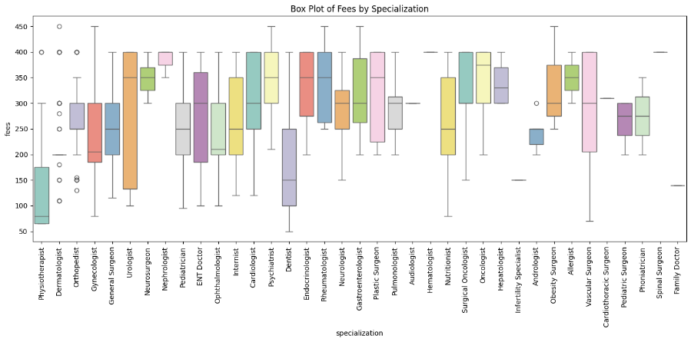

And the scatter plot:

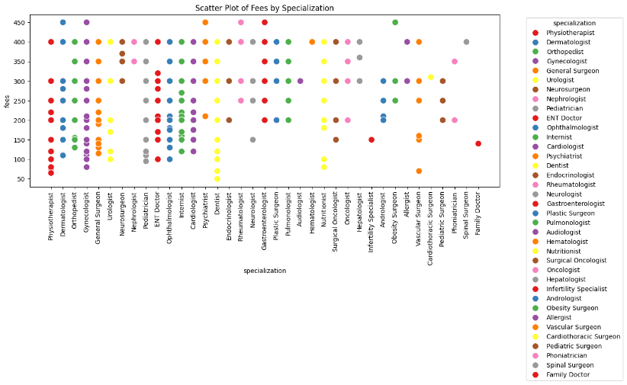

As you could see there’s significant difference between the mean, median, and mode in different specializations compared to fees

# Second Hypothesis:

* first we created the graph for the fees distribution

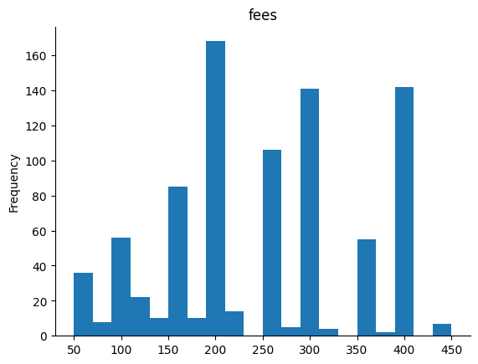

* then the graph for the doctor views distribution

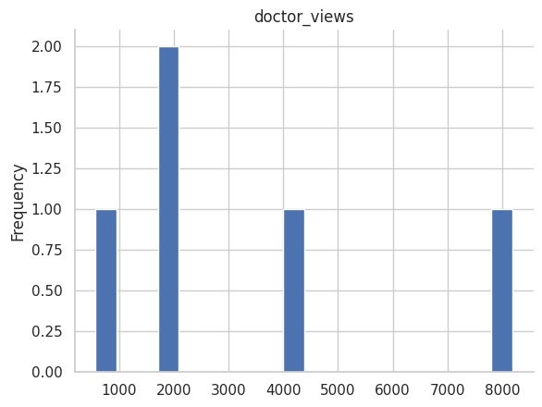

* Null Hypothesis(H0): Pearson r =0 that means that there is no relation between the fees and the doctor views
* Alternative Hypothesis(H1): Pearson r! =0 that means that there is a relation between the fees and the doctor views (non-directional relation)
* We used Pearson r to identify if their s a relation between the fees and the doctor views and after that we calculated the p value to see if the result is statistically significant and reject the null hypothesis.
* Pearson correlation coefficient: 0.19768085354297604 and since it is positive that means that there is a positive relation between the doctor views and the fees.

P-value: 4.007676045122018e-09 is smaller than 0.05 and that mean that we will reject the null hypothesis.

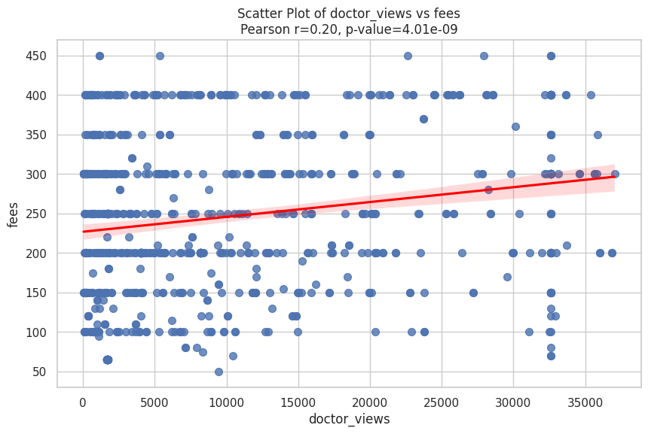

* This is a regression line that show the relation between the fees and the doctor views.

# Third Hypothesis:

* first we created the graph for the fees distribution



* then the graph for the waiting time distribution

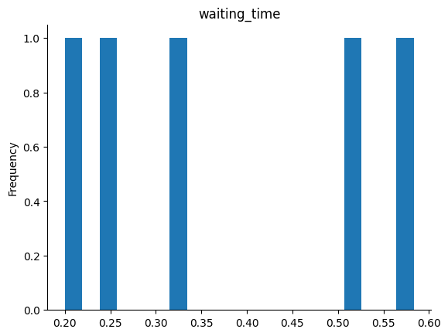

* Null Hypothesis(H0): Pearson r =0 that means that there is no relation between the fees and the waiting time
* Alternative Hypothesis(H1): Pearson r !=0 that means that there is a relation between the fees and the waiting time (non-directional relation)
* We used Pearson r to identify if their s a relation between the fees and the doctor views and after that we calculated the p value to see if the result is statistically significant and reject the null hypothesis.
* Pearson correlation coefficient: 0.07502645417816026and since it is positive that means that there is a positive relation between the doctor views and the fees.

P-value: 0.0268167145793388is smaller than 0.05 and that mean that we will reject the null hypothesis.

* This is a regression line that show the relation between the fees and the doctor views.

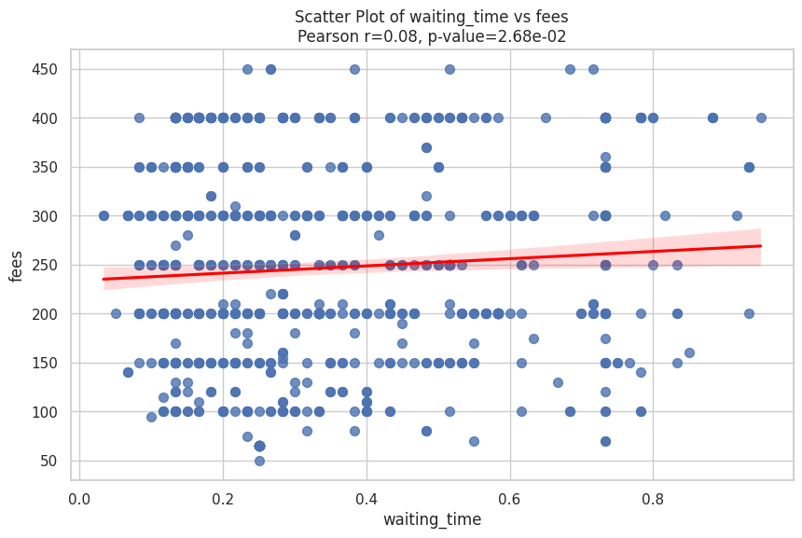

# Fourth Hypothesis:

The location of the doctor’s clinic does influence the fees.

-Null hypothesis(H0): the location doesn’t affect the fees

-alt hypothesis(H1): the location affect the fees

After calculating the P-value from the anove test it turned out to be less than 0.05 so we rejected the null hypothesis and after getting the box plot and scatter plot it turned out that there’s significant difference between locarions and fees

The box plot:

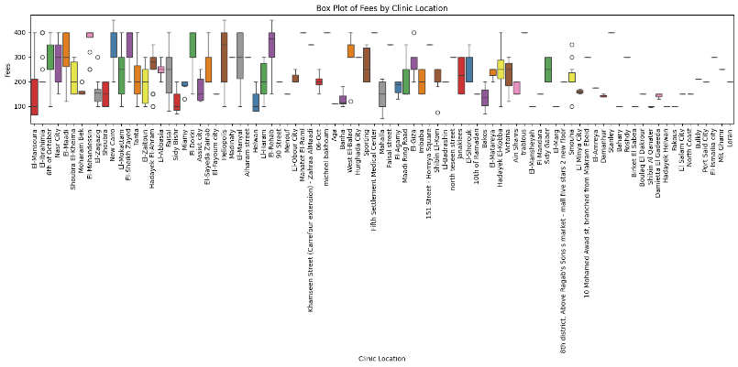

The scatter plot:

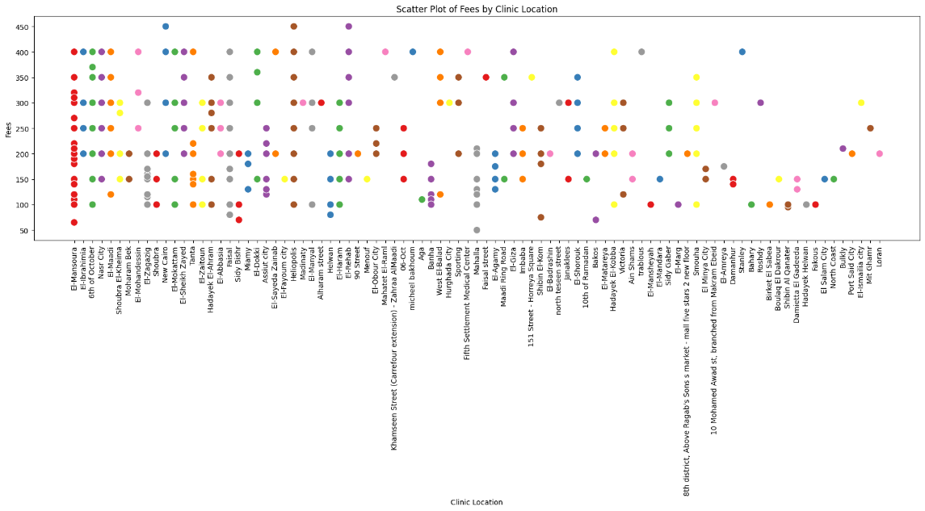

# Hypothesis Testing Steps:

* Step 1:define null and alternative hypotheses:
* First Hypothsis:
* -Null Hypothesis (H0): there’s no significant difference in fees across different specializations
* -Alternative Hypothesis(H1): there’s a significant difference in fees across different specializations
* Second hypothesis:
* -Null Hypothesis (H0): missing
* -Alternative Hypothesis (H1): missing
* Third Hypothesis:
* Null: missing
* Alt:missing
* Fourth hypothesis:
* -Null hypothesis(H0): The location of doctor’s clinic does not affect the fees
* -alt hypothesis(H1): The location of the doctor’s clinic affect the fees
* Step 2: choosing a appropriate test for each hypothesis:
* First Hypothesis: ANOVA test , boxplot and scatterplot
* Second Hypothesis: pearson r, scatterplot
* Third Hypothesis: pearson r ,scatterplot
* Fourth Hypothesis: ANOVA test , boxplot and scatterplot
* Step 3: calculate p-value:
* First Hypothesis: 1.1102230246251565e-16
* Second Hypothesis: 4.007676045122018e-09
* Third Hypothesis: 0.0268167145793388
* Fourth Hypothesis: 7.383402432330294e-66
* Step 4: determining statistical significance:
* a=0.05

# Conclusion

# This study investigated the factors influencing doctor fees in Egypt, focusing on specializations, doctor views, waiting times, and clinic locations. Our analysis revealed significant differences in fees across specializations, a positive correlation between fees and doctor views, a slight positive correlation between fees and waiting times, and a significant impact of clinic location on fees. These findings suggest that specialization, visibility, and location are key determinants of consultation fees in the Egyptian healthcare system. By understanding these factors, patients can make more informed choices, and policymakers can develop strategies to improve healthcare accessibility and quality.

# Any potential issues

Please identify issues you discovered in your data collection design, any hidden biases you found out, etc.

Tips:

1. Please DO NOT include any code here.
2. Please make sure you format your document properly.