**Omar Al Zoghbi**

**Hasan Itani**

**ERD Diagram Presentation**

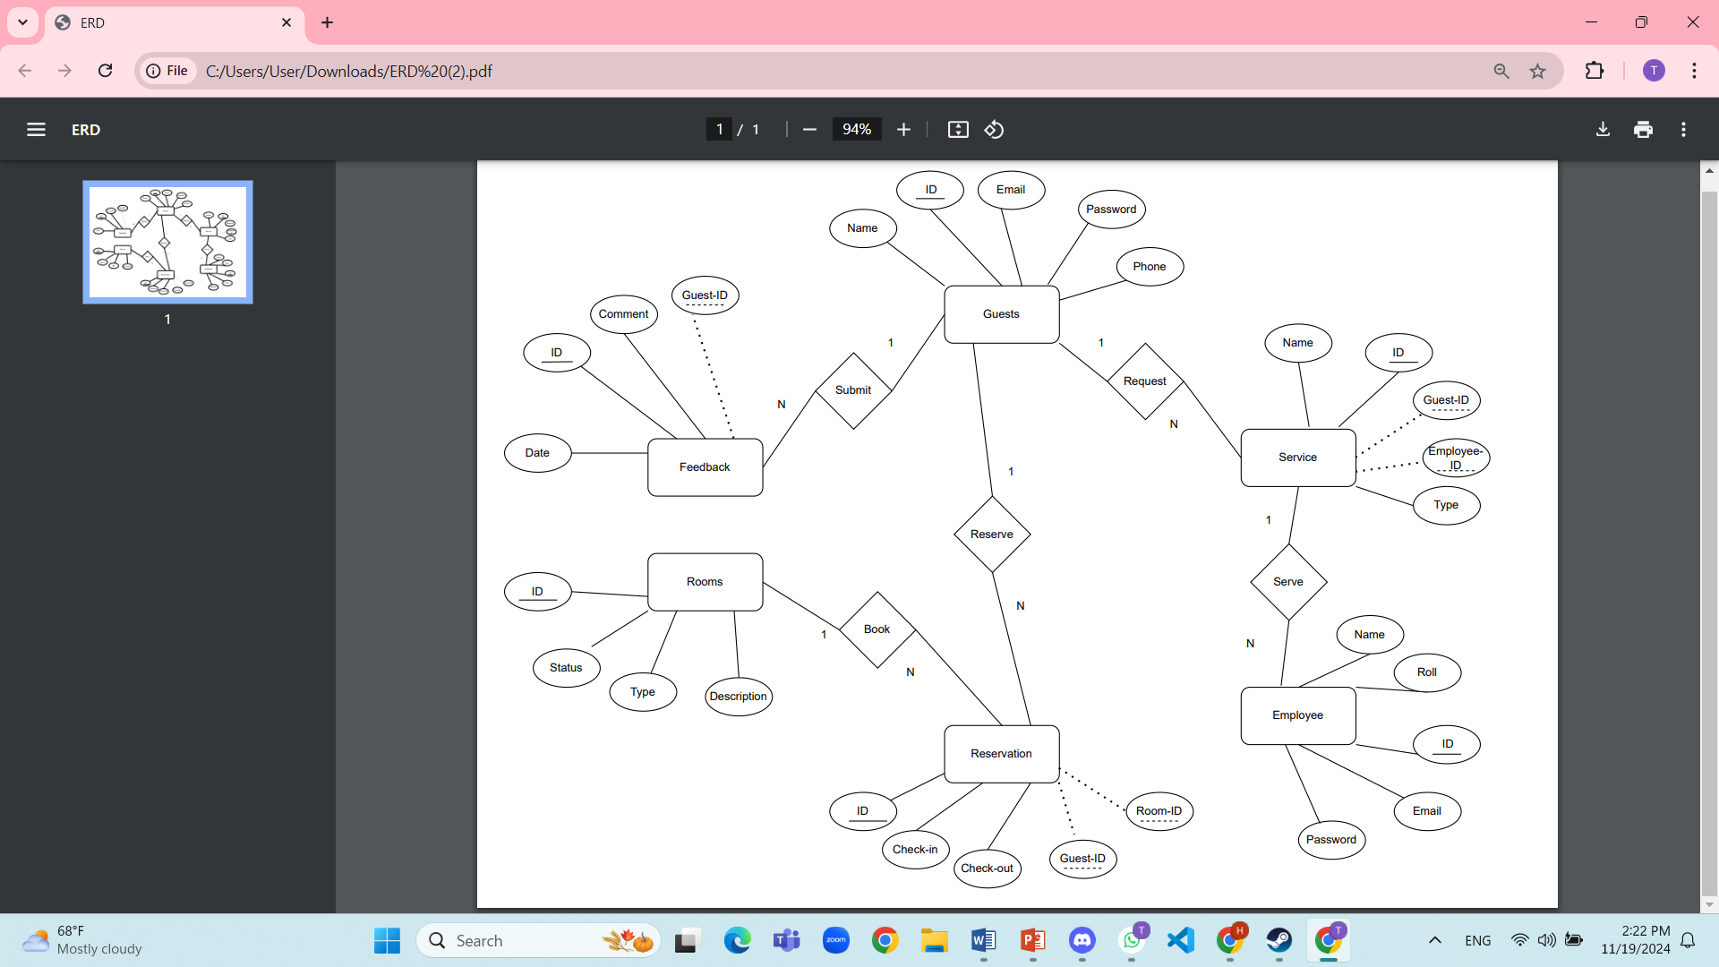

**Guests**

* **ID**: A unique identifier for each guest.
* **Name**: The guest’s full name.
* **Phone**: Contact number of the guest.
* **Email**: The guest’s email address for communication.
* **Password**: Password for the guest's account.

**Rooms**

* **ID**: A unique identifier for each room.
* **Type**: Type of room (e.g., single, double, suite).
* **Status**: The current status of the room (e.g., available, occupied).
* **Description**: A brief description of the room.

**Reservation**

* **ID**: A unique identifier for each reservation.
* **Check-in**: The check-in date for the reservation.
* **Check-out**: The check-out date for the reservation.
* **Guest-ID (FK)**: Foreign key linking to the guest who made the reservation.
* **Room-ID (FK)**: Foreign key linking to the reserved room.

**Employee**

* **ID**: A unique identifier for each employee.
* **Name**: Full name of the employee.
* **Role**: The role or position of the employee (e.g., receptionist, manager).
* **Email**: The employee’s work email address.
* **Password**: Login password for the employee.

**Service**

* **ID**: A unique identifier for each service.
* **Name**: The name of the service.
* **Type**: Type of service (e.g., room service, cleaning).
* **Employee-ID (FK)**: Foreign key linking to the employee responsible for the service.
* **Guest-ID (FK)**: Foreign key linking to the guest requesting the service.

**Feedback**

* **ID**: A unique identifier for each feedback entry.
* **Date**: The date the feedback was submitted.
* **Comment**: The actual feedback provided by the guest.
* **Guest-ID (FK)**: Foreign key linking to the guest who submitted the feedback.
* **Reservation-ID (FK)**: Foreign key linking to the related reservation.