AI in Mental Health Care
A Research Summary Using Consensus.app
Student: Omar Saeed Mohamed Kamel | ID: AI8 – G3 – 0543 | Program: سفراء الذكاء الاصطناعي

Research Question
Research Question:
Can AI effectively treat or support mental health disorders?

Consensus Answer
Consensus Answer: While AI can meaningfully support mental health, it works best as a complement — not a replacement — for human care.
Based on 2.9 million peer-reviewed research papers | Results: Highly Cited Systematic Reviews

Screenshots from Consensus.app
Screenshot 1 — Main Answer & Search Results
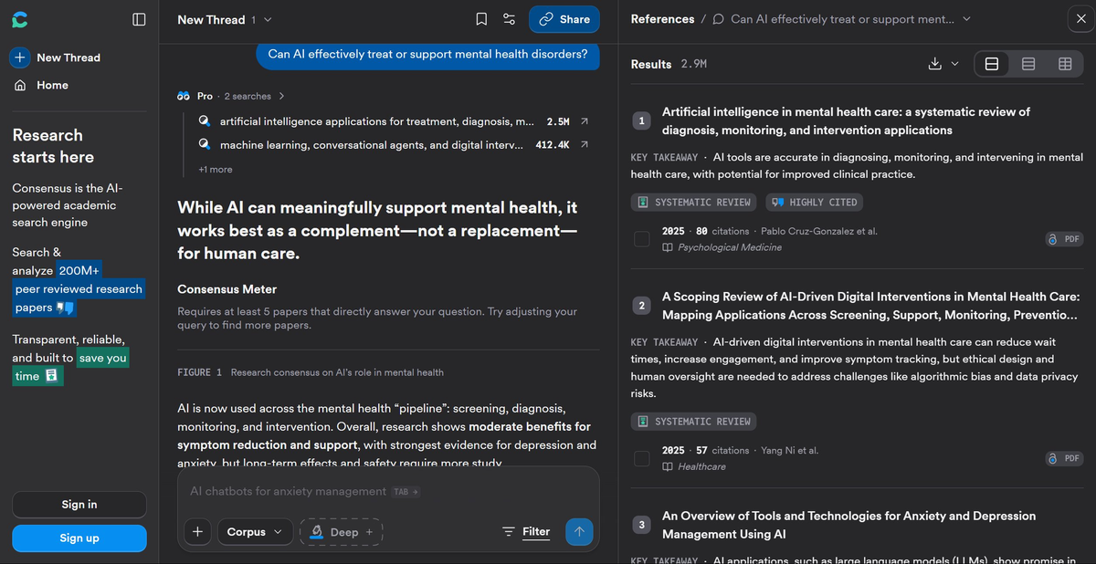

Screenshot 2 — Types of AI Uses in Mental Health Care
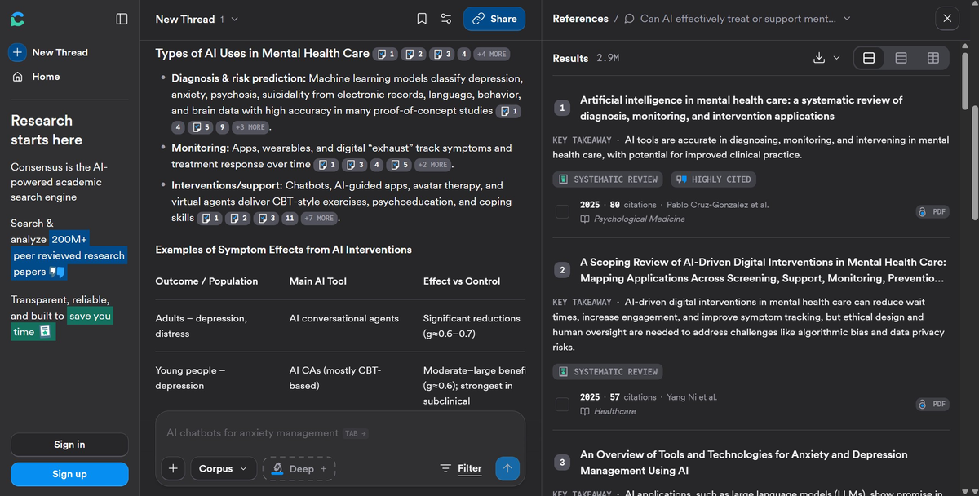

Screenshot 3 — How Effective Is AI as Treatment or Support?
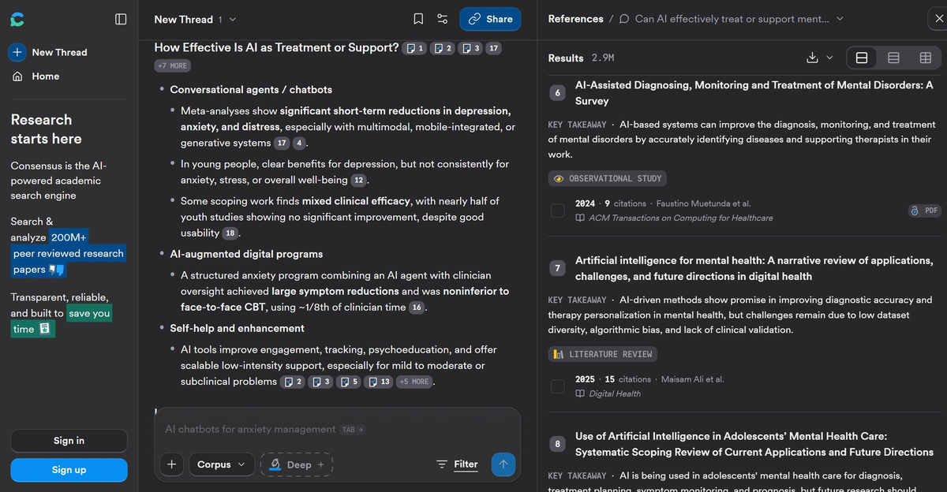

Screenshot 4 — Limitations, Risks & Summary
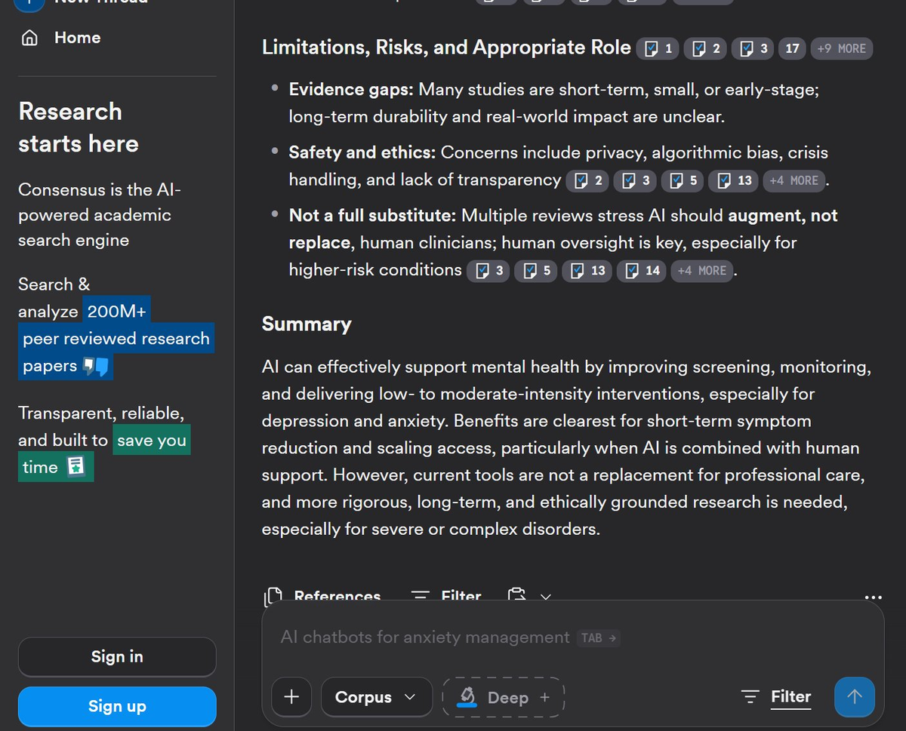

Selected Research Sources (3 from Consensus Results)
# | Research Title | Year | Key Idea
1 | Artificial Intelligence in Mental Health Care: A Systematic Review of Diagnosis, Monitoring, and Intervention Applications | 2025 | AI tools are accurate in diagnosing, monitoring, and intervening in mental health care. Reviewed 85 studies — AI chatbots were the top intervention tool, with strong performance across depression, anxiety, and risk prediction.
2 | A Scoping Review of AI-Driven Digital Interventions in Mental Health Care: Mapping Applications Across Screening, Support, Monitoring, and Prevention | 2025 | AI-driven digital interventions can reduce wait times, increase patient engagement, and improve symptom tracking. However, ethical design and human oversight are essential to address algorithmic bias and data privacy risks.
3 | An Overview of Tools and Technologies for Anxiety and Depression Management Using AI | 2024 | AI applications — including large language models (LLMs) and conversational agents — show significant promise in anxiety and depression management through personalized, scalable, and accessible interventions.

Final Conclusion
Based on over 2.9 million research papers analyzed by Consensus, AI demonstrates clear and consistent effectiveness in supporting mental health care, particularly for mild-to-moderate depression and anxiety. Conversational agents and chatbots show significant short-term symptom reductions (effect size g ≈ 0.6–0.7), and AI-augmented programs using CBT-style exercises prove noninferior to face-to-face therapy while using only one-eighth of clinician time. AI excels at screening, monitoring, psychoeducation, and scalable low-intensity support — especially in regions with limited access to mental health professionals. However, AI is not a replacement for human clinicians: multiple reviews stress that human oversight remains essential, particularly for high-risk or complex conditions, and long-term safety, ethical governance, and data privacy must be addressed before large-scale deployment.

