PC-Parts-Shop:
Omar Yammine & Mohammed Kadri
IDs: 22330394 & 22231021
Course: CSCI426
Instructor: Haissam Al Awaar

Description:
About Computer parts shop, which design is easy to work with and give the customer a comfortable experience while finding the parts that fits his needs.
This Project is done by Omar Yammine and Mohammed Kadri

System Design:

Main Page:
- App.js

Other Pages:
- Home.js
- Cart.js
- CPUs.js
- GPUs.js
- Storage.js
- PowerSupplies.js
- RAM.js

Context:
- CartContext.js

Components:
- Navbar.js

Styles:
- Home.css
- Cart.css
- Navbar.css
- RAM.css
- CPUs.css
- GPUs.css
- Storage.css
- PowerSupplies.css

Technologies Used:
- ReactJS

Pictures Of the website:
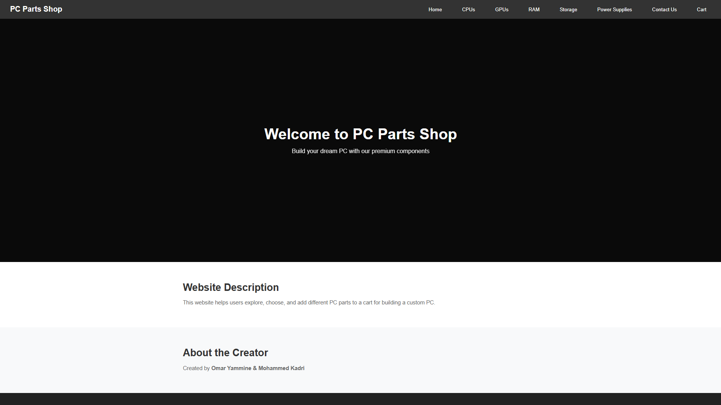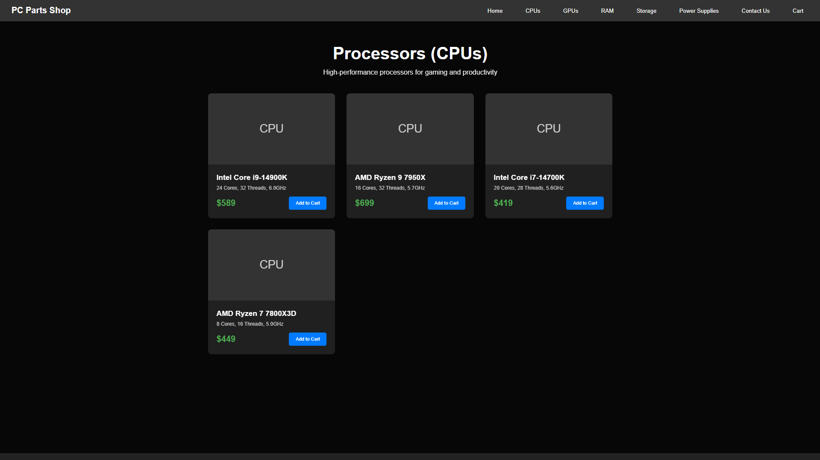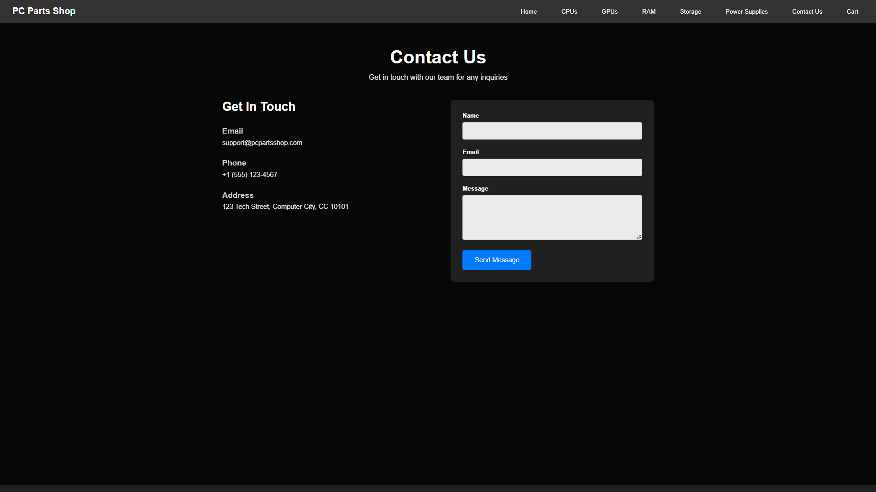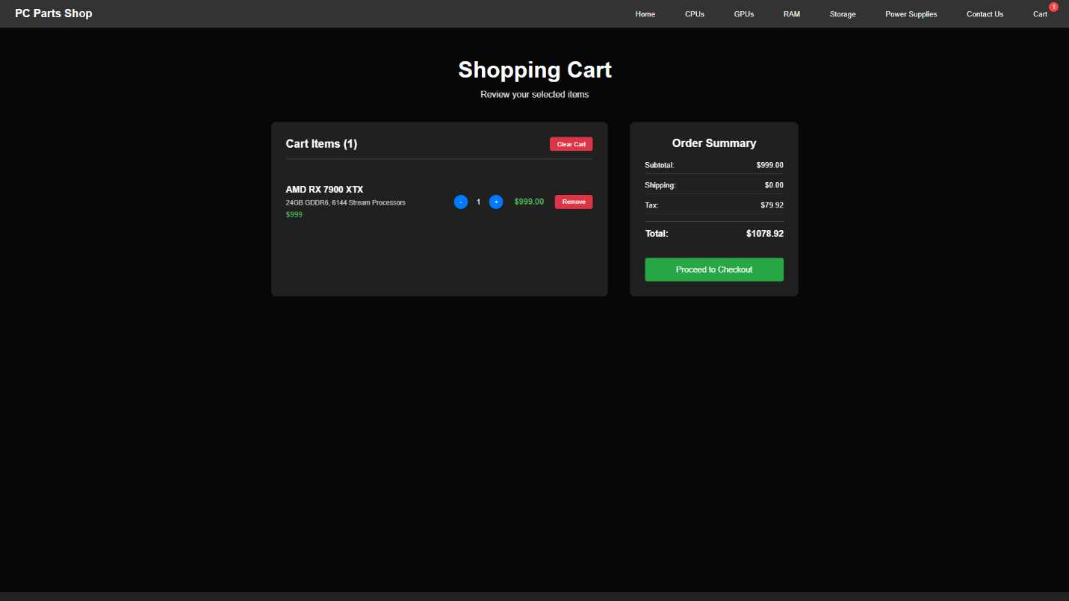

GitHub Link
- https://github.com/Omarya-21/Project/tree/main

