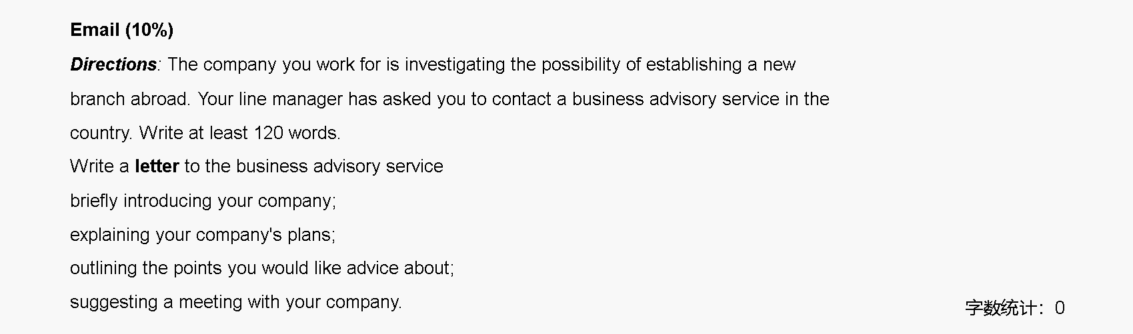
Dear Mr.Li,
I am writing to you on behalf of AI Solutions Ltd., a company specializing in artificial intelligence and machine learning technologies. We are currently planning to establish a new branch in your country as part of our global expansion strategy.

Our goal is to introduce our innovative AI solutions to local businesses and explore new opportunities in the foreign market. We are particularly interested in your professional advice regarding several key aspects. First, we would like to understand the local demand for AI-related services and products, as this will help us tailor our offerings to the market. Additionally, we seek guidance on the legal requirements for establishing a technology company in your country, which is crucial for ensuring compliance. Finally, we would appreciate your insights on potential challenges we may face when entering the local market and strategies to effectively address them.

We would greatly appreciate the opportunity to discuss these matters in detail. Please let us know your availability for a meeting.

Thank you for your time and assistance. We are looking forward to your reply.

Best regards,
Zhou

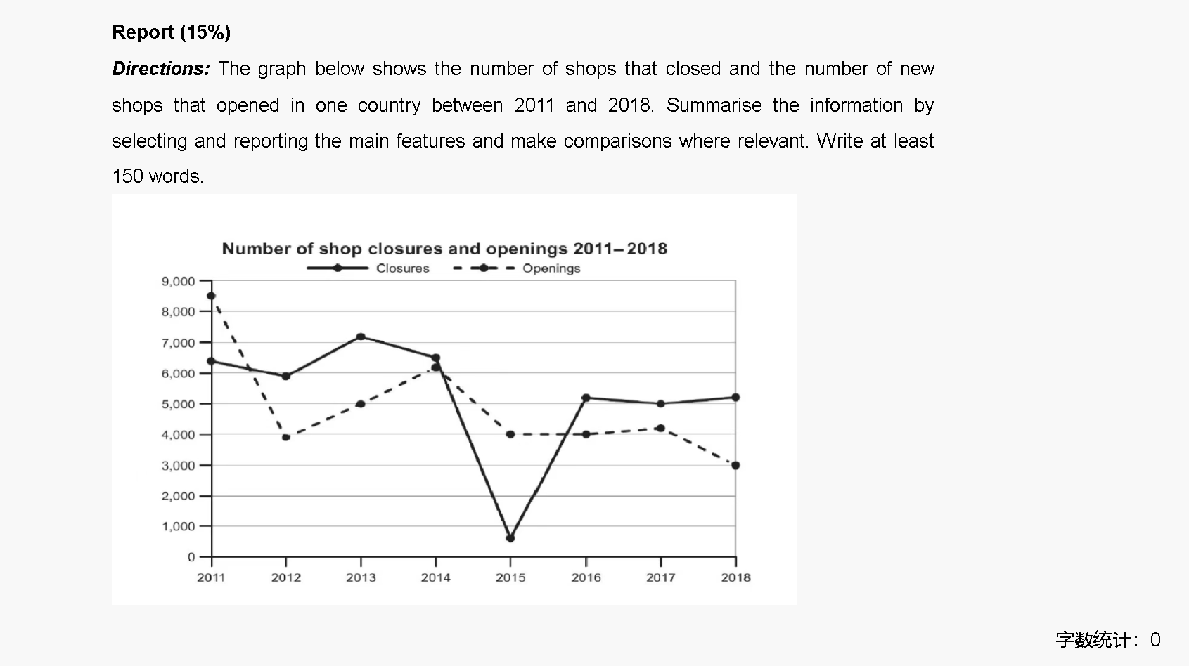
The graph illustrates the number of shop closures and openings in one country from 2011 to 2018. Overall, the trends for both closures and openings fluctuated over the period, with closures generally remaining higher than openings.

In 2011, the number of shop closures was around 6,000, slightly more than the 8,500 shop openings. However, shop openings decreased significantly to about 4,000 in 2012, while closures stayed relatively stable at 6,000. By 2013, shop closures rose sharply to a peak of approximately 7,200, surpassing the openings, which increased slightly to around 5,000.

From 2014 onwards, the number of closures and openings experienced notable changes. In 2015, closures reached a low of about 600, while openings declined to around 4,000. The number of closures rebounded in 2016, reaching approximately 5,000, while openings remained steady at the same level. Between 2017 and 2018, both figures showed a gradual decline, with closures ending at 5,000 and openings at about 4,000.

In conclusion, the number of shop closures remained higher than openings for most of the period, with significant fluctuations observed in both trends.

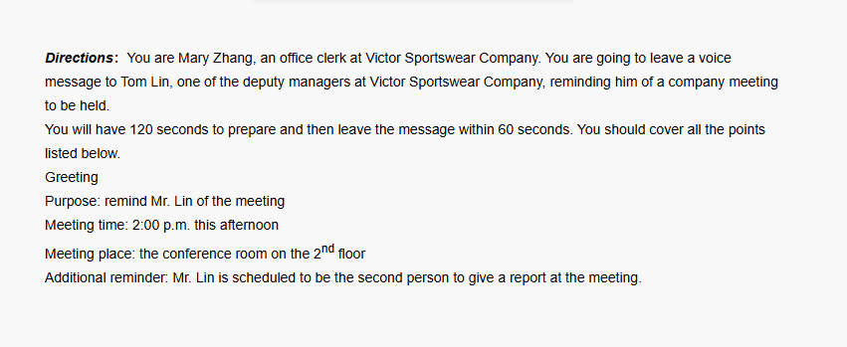
Good morning, Mr. Lin. This is Mary Zhang from Victor Sportswear Company.
I’m calling to remind you about the company meeting scheduled for 2:00 p.m. this afternoon.
The meeting will be held in the conference room on the second floor.
Also, please remember that you are the second person to give a report at the meeting. If you have any questions, feel free to contact me.
Thank you!


Good morning, everyone! My name is Peter Wang from the Overseas Students Affairs Office.
I’m excited to invite you to join our free Chinese kung fu course.
Kung fu is a great way to improve both your physical and mental health.
It also gives you a wonderful chance to experience traditional Chinese culture.
Moreover, this course is a perfect opportunity to meet new friends and have fun together.
I hope to see you there. Thank you!

