**MULTI AGENT SYSTEM FOR MARKET RESEARCH**

**Executive summary**

This project is a **multi-agent system** designed to automate market research and analysis using AI and ML technologies. The goal is to provide businesses with insights into their industry, company, and relevant AI/ML applications. The system consists of several specialized agents, each with a unique function. The **Research Agent** gathers and summarizes information related to the company or industry, offering insights that can aid decision-making. The **Market Analysis Agent** focuses on industry trends, particularly in AI, ML, and automation, helping users understand the current market dynamics. The **Use Case Generation Agent** identifies real-world applications of AI/ML in the industry and specific companies, providing valuable case studies. The **Dataset Agent** searches for relevant datasets from platforms like Kaggle, Hugging Face, and GitHub, offering users direct links to datasets they can use for research or development.

By using this multi-agent system, companies can automate the process of obtaining key business intelligence and stay informed about the latest trends, technology applications, and available resources in their industry. The system is designed to be highly efficient, saving time and enabling better decision-making. It is developed using **Gradio**, which makes it easy for users to input their queries and receive comprehensive, well-organized reports. The results include clickable links to datasets and other resources, providing immediate access to the information needed. The project offers a flexible, scalable solution, which could be further enhanced by integrating additional data sources or business tools in the future.

**Introduction**

A **multi-agent system** is a setup where multiple independent "agents" (software programs or virtual entities) work together to perform tasks or solve problems. Each agent in this system has its own specific role or job, and they communicate with each other to achieve a common goal.

This project is designed to help businesses and researchers perform market research using artificial intelligence (AI) and advanced dataset search tools. The system is built around multiple agents, each responsible for handling a specific task that collectively provides valuable insights about a company's industry, market trends, use cases, and relevant datasets.

The first component, the **Research Agent**, gathers information about the company and its industry. It searches for articles and company overviews to give users a quick understanding of the company’s position and its market. This helps users gain important information about the company and its operations.

The **Market Analysis Agent** focuses on understanding the broader market trends. It looks for information on the latest industry developments, particularly those related to AI, machine learning (ML), and automation, which are becoming increasingly important in various sectors. By analysing these trends, the agent helps users stay updated on the changes shaping their industry.

Next, the **Use Case Generation Agent** looks for real-world examples and case studies where AI and ML have been applied successfully. This agent also suggests potential use cases for the company, helping it think of ways to implement AI and ML technologies in its operations. These suggestions are valuable for businesses looking to adopt new technologies to improve their products or services.

The **Dataset Search Agent** connects to popular platforms like Kaggle, Hugging Face, and GitHub, where it searches for datasets that can be used in machine learning and AI research. This feature simplifies the process of finding relevant data for training AI models or conducting further research, saving users a lot of time.

The entire system is user-friendly, thanks to the integration with **Gradio**, a web interface that allows users to interact with the agents easily. The interface displays all the collected information in a clear and organized format, making it simple for users to access and analyse the data. The project aims to automate the research process, making it easier for businesses to stay competitive by quickly gathering insights, understanding market trends, and finding useful datasets for their projects. This system offers an efficient way to gather and analyse data, providing a valuable resource for decision-making, research, and development.

**Methodology**

The methodology of this project involves using a multi-agent system to gather and analyze market data in a structured way.

1. **Setting Up API Integration**: The project starts by setting up an API key for SerpAPI, which allows access to search results from the web. This API key is used to query various search engines for relevant data, ensuring the gathered information is up-to-date and accurate.
2. **Data Collection Through Agents**: The project uses multiple agents, each tasked with specific research:

* The Research Agent focuses on gathering general information about a company or its industry.
* The Market Analysis Agent looks for trends and insights, especially related to technology such as AI and machine learning in the industry.
* The Use Case Generation Agent searches for real-world examples of AI and machine learning applications, providing valuable use cases for businesses.
* The Dataset Agent searches for available datasets from online platforms like Kaggle, Hugging Face, and GitHub. This is particularly useful for AI projects, where high-quality datasets are needed for training machine learning models.

1. **Data Compilation and Report Generation**: Once the agents collect the data, the project compiles all the information into a comprehensive report. This report is automatically generated in markdown format, including details such as:
   * An overview of the company or industry
   * Trends and market analysis
   * Industry-specific and company-specific use cases for AI and machine learning
   * Links to relevant datasets for further research or project development
2. **Saving and Sharing the Report**: After the report is generated, it is saved in a markdown file. This format makes it easy to read and share, and it can be used by business analysts, researchers, or other stakeholders.

**Flowchart**

Start

Enter Company Name

Determine Industry

Company Research

Market Analysis

Use Cases

Dataset Search

Collect all result

Generate Final Report

Save as Markdown File

End

Run Four Research Agent

**Result**

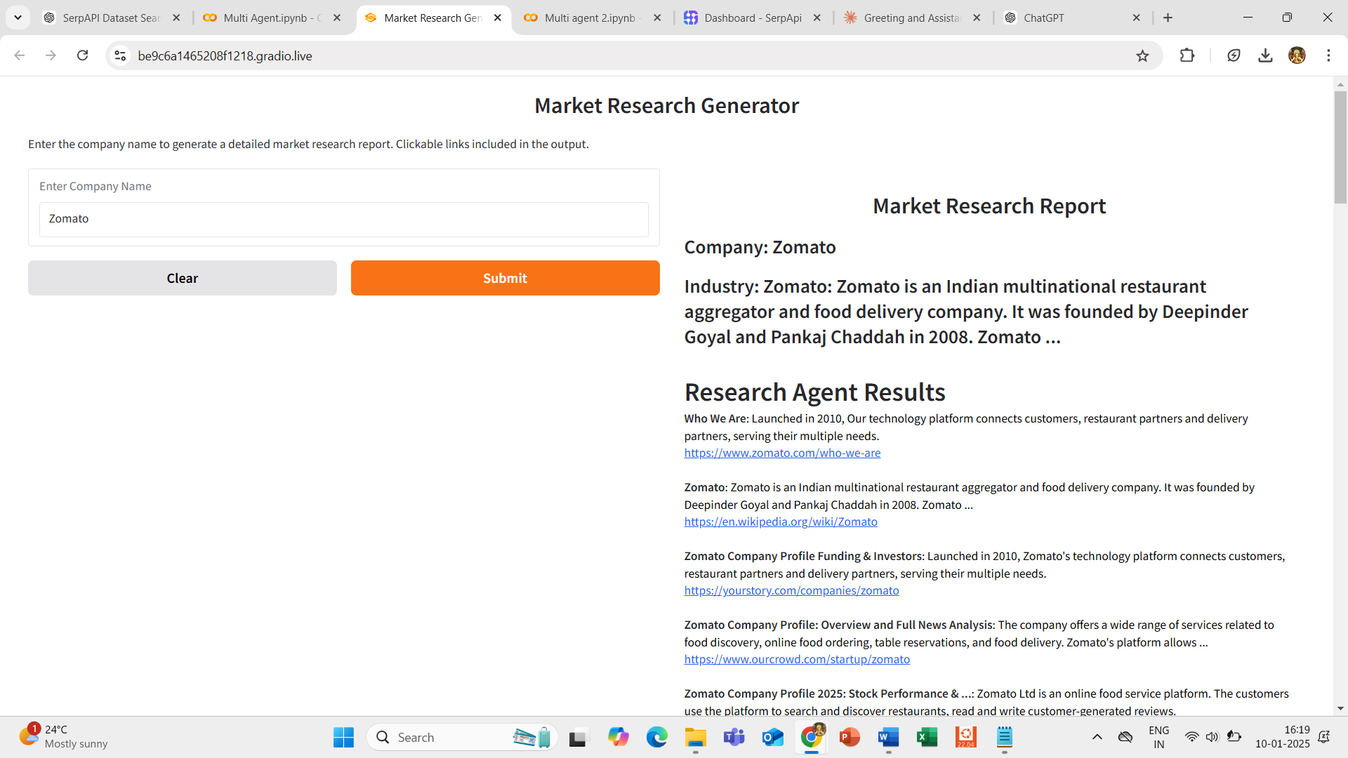

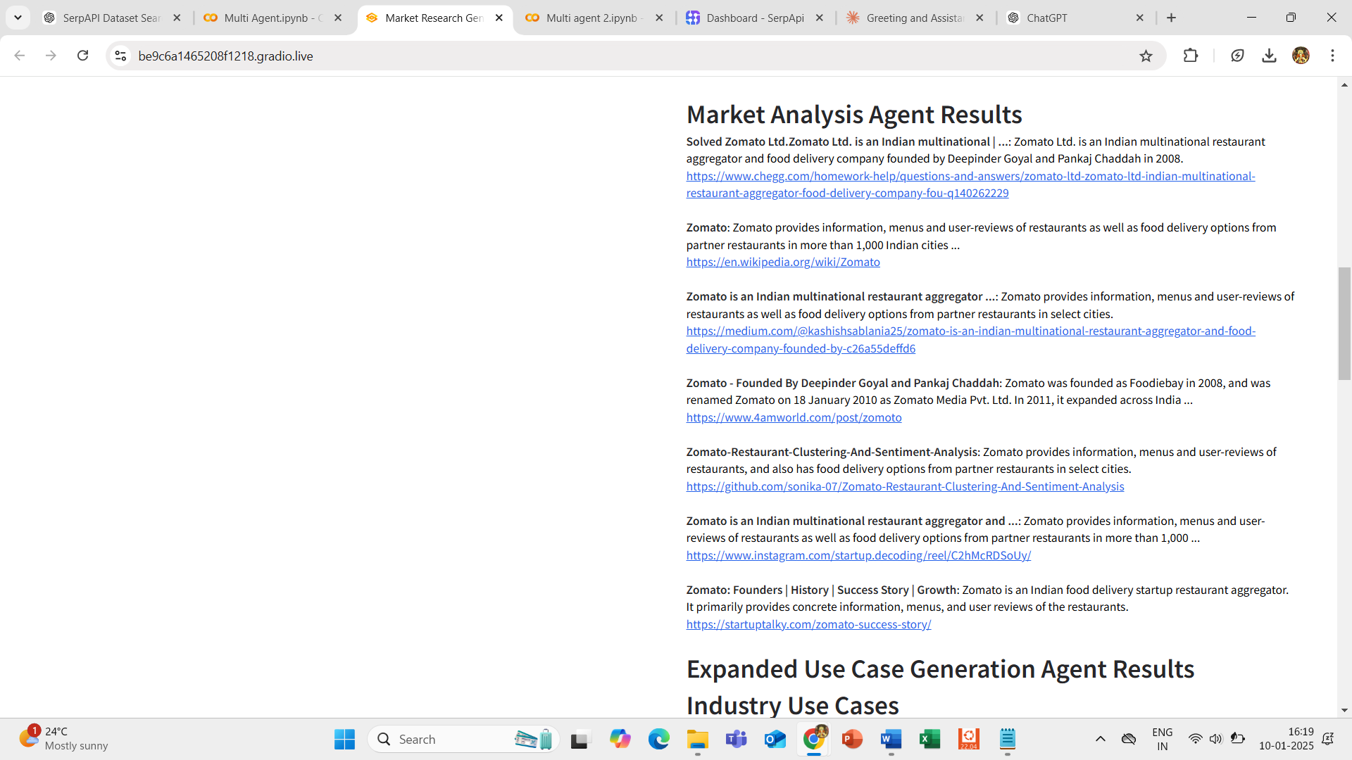

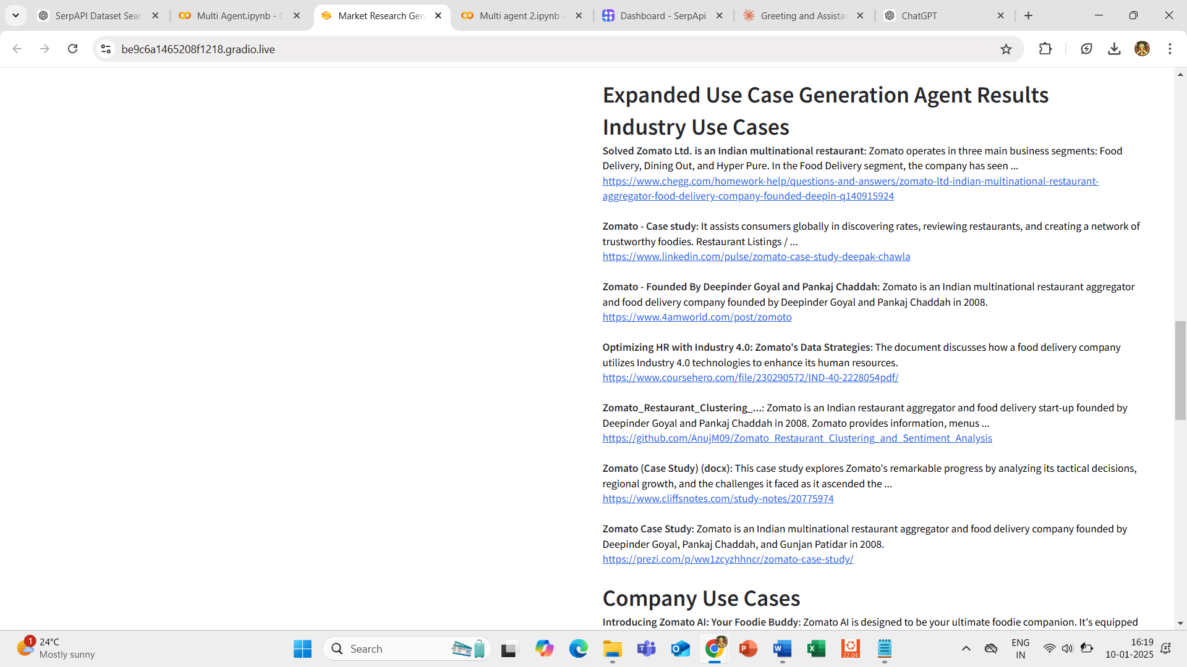

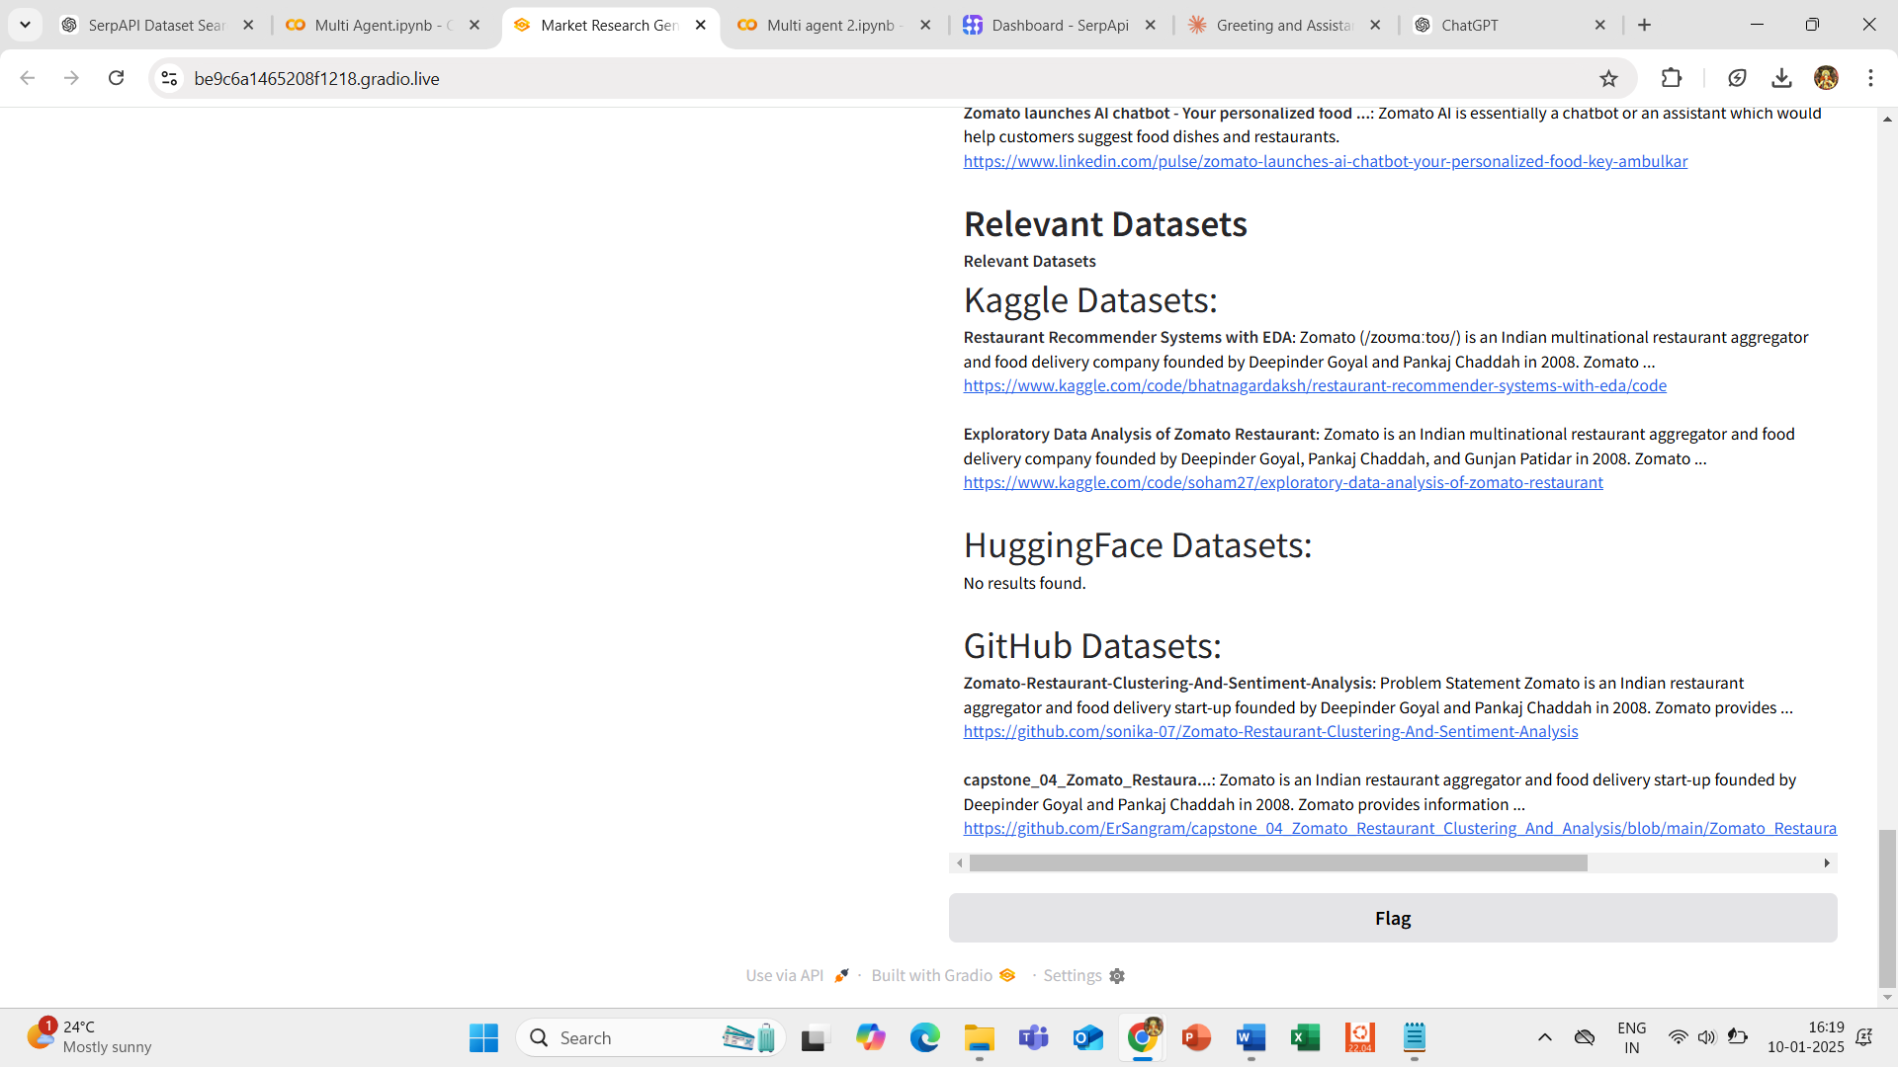

**Conclusion**

In conclusion, this project effectively utilizes a multi-agent system to automate the process of gathering and analyzing market data. By leveraging APIs and search engines, it provides valuable insights into industries and companies, helping businesses stay updated with the latest trends, use cases, and available datasets for AI and machine learning applications. The generated reports offer a comprehensive overview that can guide decision-making and strategy development. Overall, this system streamlines market research, saving time and effort, and ensures that businesses have access to accurate and relevant information in a format that is easy to understand and share.

**Reference**

1. <https://www.Chatgpt.com>
2. <https://github.com/>
3. <https://www.wikipidia.com>
4. <https://claude.ai/>