**APT 2022 INTRODUCTION TO ASSEMBLY LANGUAGE PROGRAMMING**

**ASSEMBLY LANGUAGE LAB5**

**TITLE:**

**CONTROL OF TRAFFIC LIGHTS USING ASSEMBLY LANGUAGE PROGRAM**

**INSTRUCTIONS**

1. Work in groups of three students each to do these tasks.
2. Write a lab report using the standard template discussed in class already.
3. Prepare a presentatation on the same

**OBJECTIVES**

1. To write an assembly language program for controlling traffic lights using 8086 microprocessor
2. To demonstrate control of traffic lights using above program in an 8086 microprocessor emulator environment
3. To excute the traffics light control assembly language program in 8086 emulator and provideits view in the following: stack, variables, memory, 8086 machine code listing, registers and the ALU contents
4. To investigate on the effect of delay on performance of traffic lights
5. To appreciate the use of 8086 microprocessor to control external devices.

**REQUIRED**

1. **8086 Emulator**
2. **8086 instruction set**

**METHODOLGY**

Write and excute a traffic lights assembly languge program of your own, based on the the following sample traffic lights control assembly language program.

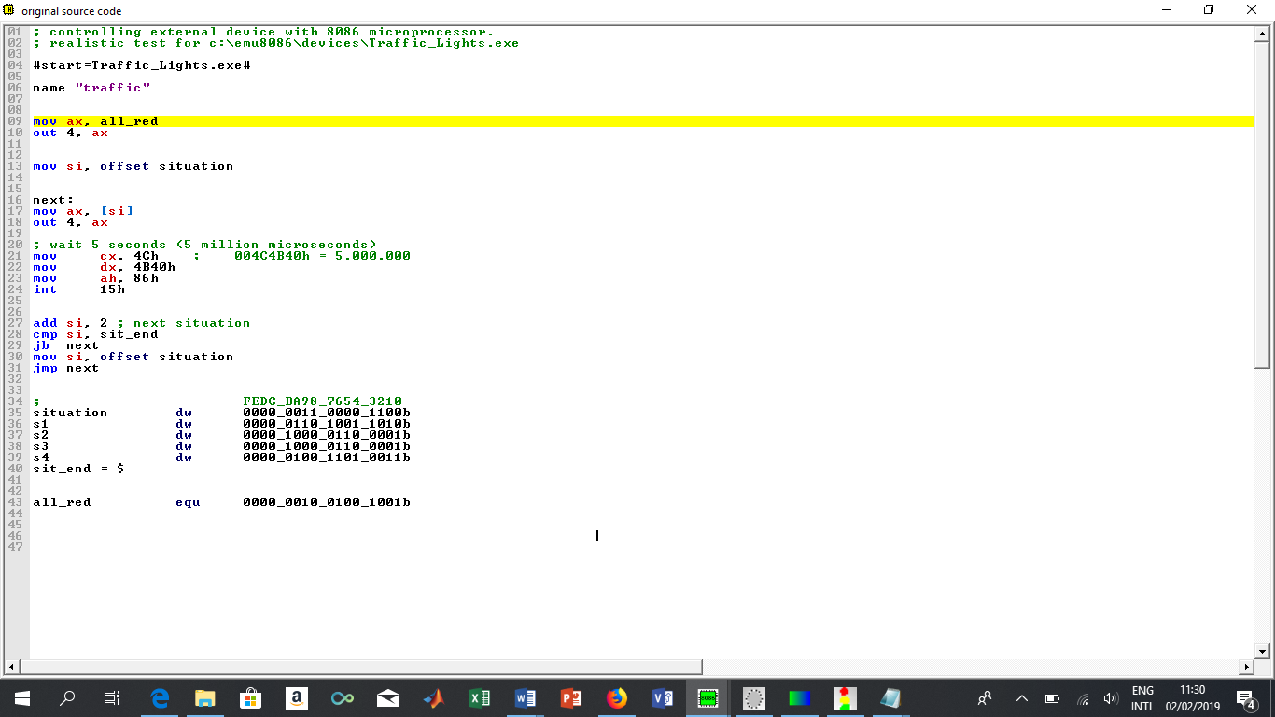

Repeat the program with various values of delay or waiting times such as 10seconds, 15seconds and 20seconds.

**RESULTS AND DISCUSSION**

1. Show your assembly language program as well as the machine code.
2. Discuss the role of assembler, compiler and interpreter in assembly language programming.
3. After excuting the traffics light control assembly language program in 8086 emulator, provide and explain its view in the following: stack, variables, memory, 8086 machine code listing, registers and the ALU contents
4. What is the effect of delay time on the performance of traffic lights control system with 8086 microprocesssor?
5. How can you improve on this project?

**END**