CS 410 OS

Prudhvi Balusu

Lab 03-01

LAB REPORT

The task was to create a program Lab 03-01.c such that after the handler is invoked, Hello world and Turing is back is looped infinitely. This is achieved by a while loop as illustrated bellow

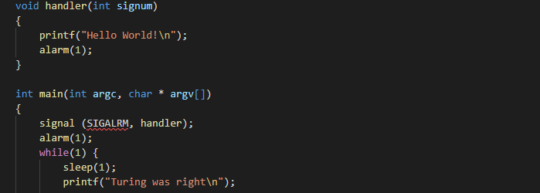

An alarm is set to 1 second to time the loop to output:

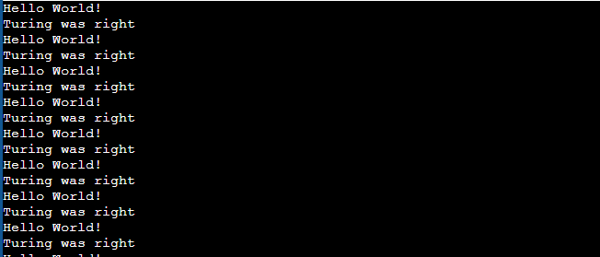

Process can be terminated with the CTRL-C command

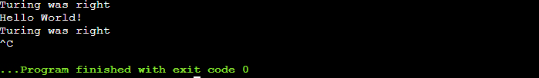

The impr0ovement uses a signal interrupt to stop the infinite loop and output the runtime in seconds. This is achieved by a SIGINT handler.

The sigint_handler function captures an interrupt signal “SIGINT”, from when CTRL-C is pressed. The program exits and outputs the run time

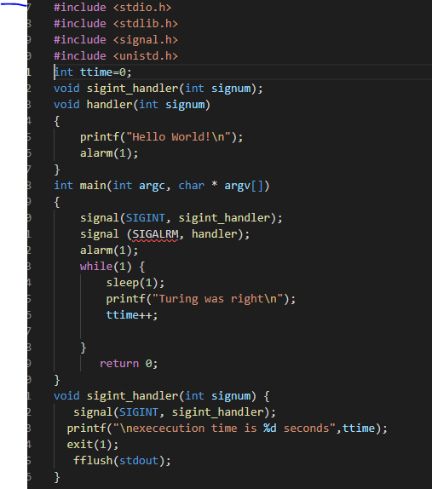

OUTPUT

The time is counted from the variable ttime which increases with the number of signal loops.

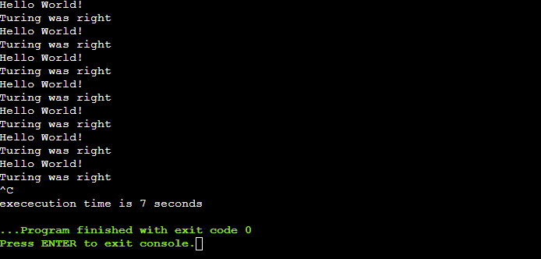

CONCLUSION

The alarm function uses a signal that typically indicates expiration of a timer that measures real or clock time.

Signals are the interrupts that force an OS to stop its ongoing task and attend the task for which the interrupt has been sent. These interrupts can pause service in any program of an OS.

When a signal the handler executes, the parameter passed to it is the number of the signal. A programmer can use the same signal handler function to handle several signals. In this case the handler would need to check the parameter to see which signal was sent. On the other hand, if a signal handler function only handles one signal.