Name- Om Deep Regn No- 12002017 Course- CAP283 (ASSIGNMENT 1) Roll No- 05

Topic- Biography Website

**Page 1 Login Page:**

Code:

<HTML>

<head>

<style>

#header{

background-color:blue;

color:white;

text-align:center;

padding:24px

}

</style>

</head>

<body>

<div id="header">

BIOGRAPHY PORTAL

</div>

<center><img src="C:\Users\omdee\Desktop\website\depositphotos_84014296-stock-photo-biography-written-in-search-bar.jpg" width=300 height=200>

</center>

<p>

<center>User Name<input type="text"></center><br>

<center>Password <input type="password"></center><br>

<h3><center><a href="home.html">Login</a></center></h3>

<p>

<p>

<h3>

</center>

<hr>

<b><center>© OM DEEP 2002</center></b>

<hr>

</BODY>

</HTML>

**Screenshot:**

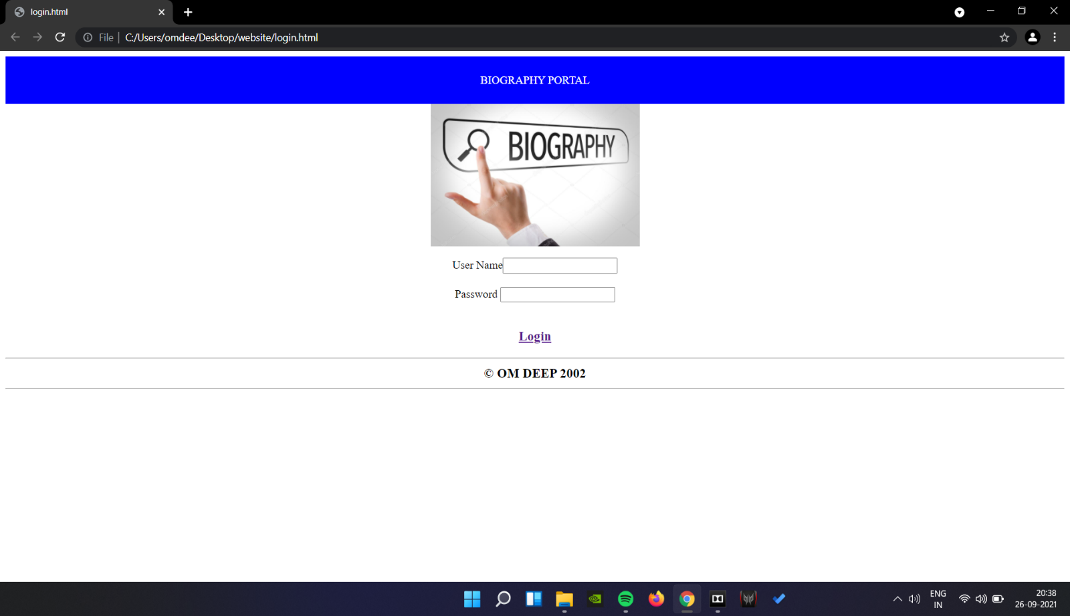

**Page 2 Home Page:**

**Code:**

<html lang="en-ca">

<head>

<style>

#header{

background-color:blue;

color:white;

text-align:center;

padding:6px;

}

</style>

</head>

<body background="C:\Users\omdee\Desktop\website\white-elegant-texture-wallpaper_23-2148417584.jpg">

<div id="header">

<h1><center>BIOGRAPHY PORTAL HOME PAGE</center></p>

</div>

<center><h3> CONTENTS</H3>

<NAV>

<ul CLASS="NAV">

<a href="elonmusk.html">ELON MUSK</a>

<P>

<a href="mark.html">MARK ZUCKERBERG</a>

<P>

<a href="ratan.html">RATAN TATA</a>

<P>

<a href="steve.html">STEVE JOBS</a>

</UL>

</nav>

<p>

<hr>

<b><center>© OM DEEP 2002</center></b>

<hr>

</body>

</html>

**Screenshot:**

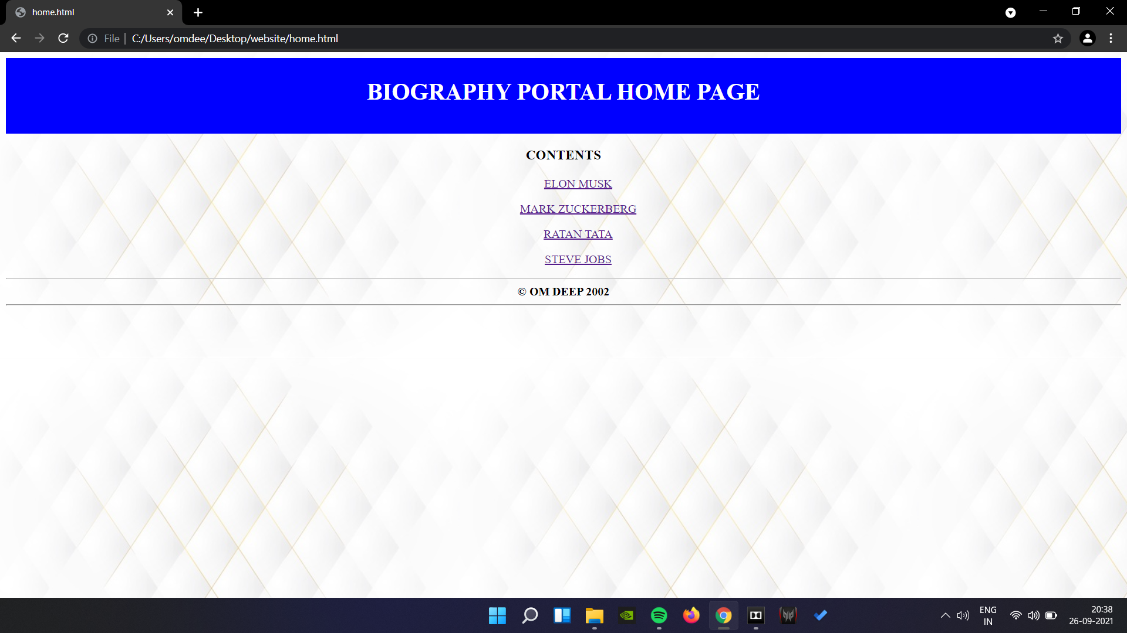

**Page 3 Content Page:**

**a) Elon Musk:**

**Code:**

<HTML>

<HEAD>

<STYLE>

#header{

background-color:red;

color:white;

text-align:center;

padding:20px;

}

</STYLE>

</HEAD>

<body>

<div id="header">

ELON MUSK

</div>

<center><IMG SRC="C:\Users\omdee\Desktop\website\biography\gettyimages-1229892983-square.jpg" width=300 height=300><BR>

<p>

Elon Musk is a South African-born American entrepreneur and businessman who founded X.com in 1999 (which later became PayPal), SpaceX in 2002 and Tesla Motors in 2003. Musk became a multimillionaire in his late 20s when he sold his start-up company, Zip2, to a division of Compaq Computers.

Musk made headlines in May 2012, when SpaceX launched a rocket that would send the first commercial vehicle to the International Space Station. He bolstered his portfolio with the purchase of SolarCity in 2016 and cemented his standing as a leader of industry by taking on an advisory role in the early days of President Donald Trump's administration.

In January 2021, Musk reportedly surpassed Jeff Bezos as the wealthiest man in the world.

<p>

Musk was born on June 28, 1971, in Pretoria, South Africa. As a child, Musk was so lost in his daydreams about inventions that his parents and doctors ordered a test to check his hearing.

At about the time of his parents’ divorce, when he was 10, Musk developed an interest in computers. He taught himself how to program, and when he was 12 he sold his first software: a game he created called Blastar.

In grade school, Musk was short, introverted and bookish. He was bullied until he was 15 and went through a growth spurt and learned how to defend himself with karate and wrestling.

<p>

At age 17, in 1989, Musk moved to Canada to attend Queen’s University and avoid mandatory service in the South African military. Musk obtained his Canadian citizenship that year, in part because he felt it would be easier to obtain American citizenship via that path.

In 1992, Musk left Canada to study business and physics at the University of Pennsylvania. He graduated with an undergraduate degree in economics and stayed for a second bachelor’s degree in physics.

After leaving Penn, Musk headed to Stanford University in California to pursue a PhD in energy physics. However, his move was timed perfectly with the Internet boom, and he dropped out of Stanford after just two days to become a part of it, launching his first company, Zip2 Corporation in 1995. Musk became a U.S. citizen in 2002.

<p>

</ul>

<p>

<hr>

<b><center>© OM DEEP 2002</center></b>

<hr>

</BODY>

</HTML>

**Screenshot:**

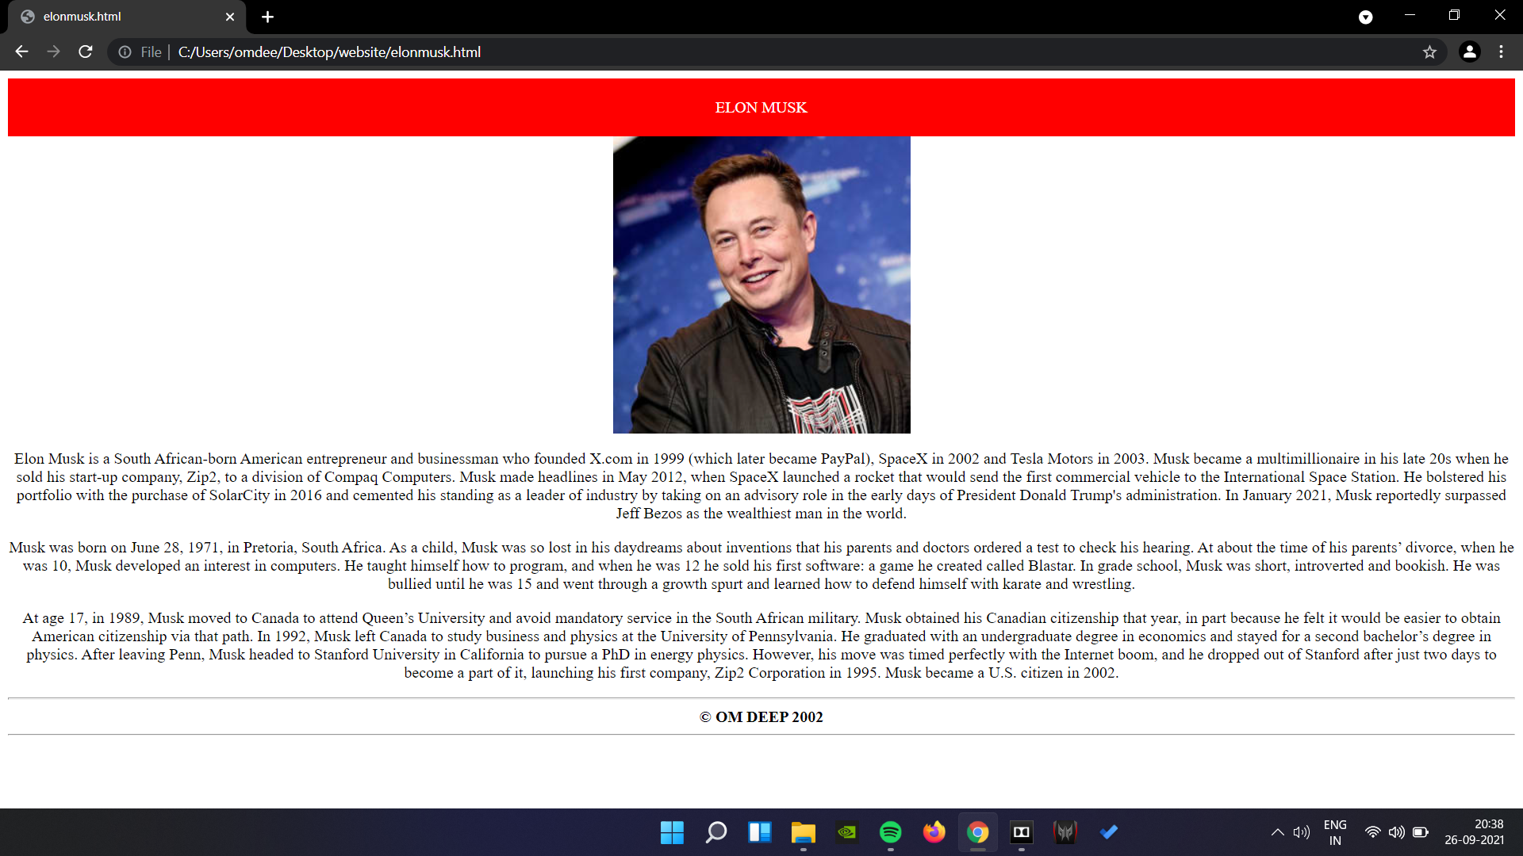

**b) Mark Zuckerberg**

**Code:**

<html>

<head>

<Style>

#header{

background-color:red;

color:white;

text-align:center;

padding:20px;

}

</style>

</head>

<body>

<div id="header">

Mark Zuckerberg

</div>

<center><img src="C:\Users\omdee\Desktop\website\biography\https _specials-images.forbesimg.com_imageserve_60ede06c39d1b0ed3859d7ab_0x0.jpg cropX1=0&cropX2=2155&cropY1=0&cropY2=1437.jpg" width=300 height=200>

<p>

Mark Zuckerberg co-founded the social-networking website Facebook out of his college dorm room at Harvard University. Zuckerberg left college after his sophomore year to concentrate on the site, the user base of which has grown to more than two billion people, making Zuckerberg a billionaire many times over. The birth of Facebook was portrayed in the 2010 film The Social Network.

<p>

Zuckerberg was born on May 14, 1984, in White Plains, New York, into a comfortable, well-educated family. He was raised in the nearby village of Dobbs Ferry.

Zuckerberg’s father, Edward Zuckerberg, ran a dental practice attached to the family's home. His mother, Karen, worked as a psychiatrist before the birth of the couple's four children — Mark, Randi, Donna and Arielle.

Zuckerberg developed an interest in computers at an early age; when he was about 12, he used Atari BASIC to create a messaging program he named "Zucknet." His father used the program in his dental office, so that the receptionist could inform him of a new patient without yelling across the room. The family also used Zucknet to communicate within the house.

Together with his friends, he also created computer games just for fun. "I had a bunch of friends who were artists," he said. "They'd come over, draw stuff, and I'd build a game out of it."

<p>

To keep up with Zuckerberg's burgeoning interest in computers, his parents hired private computer tutor David Newman to come to the house once a week and work with Zuckerberg. Newman later told reporters that it was hard to stay ahead of the prodigy, who began taking graduate courses at nearby Mercy College around this same time.

Zuckerberg later studied at Phillips Exeter Academy, an exclusive preparatory school in New Hampshire. There he showed talent in fencing, becoming the captain of the school's team. He also excelled in literature, earning a diploma in classics.

Yet Zuckerberg remained fascinated by computers and continued to work on developing new programs. While still in high school, he created an early version of the music software Pandora, which he called Synapse.

Several companies—including AOL and Microsoft—expressed an interest in buying the software, and hiring the teenager before graduation. He declined the offers.

<p>

Zuckerberg and his friends Dustin Moskovitz, Chris Hughes and Eduardo Saverin created The Facebook, a site that allowed users to create their own profiles, upload photos, and communicate with other users. The group ran the site out of a dorm room at Harvard University until June 2004.

That year Zuckerberg dropped out of college and moved the company to Palo Alto, California. By the end of 2004, Facebook had 1 million users.

In 2005, Zuckerberg's enterprise received a huge boost from the venture capital firm Accel Partners. Accel invested $12.7 million into the network, which at the time was open only to Ivy League students.

Zuckerberg's company then granted access to other colleges, high school and international schools, pushing the site's membership to more than 5.5 million users by December 2005. The site began attracting the interest of other companies that wanted to advertise with the popular social hub.

Not wanting to sell out, Zuckerberg turned down offers from companies such as Yahoo! and MTV Networks. Instead, he focused on expanding the site, opening up his project to outside developers and adding more features.

<p>

<hr>

<b><center>© OM DEEP 2002</center></b>

<hr>

</body>

</html>

**Screenshot:**

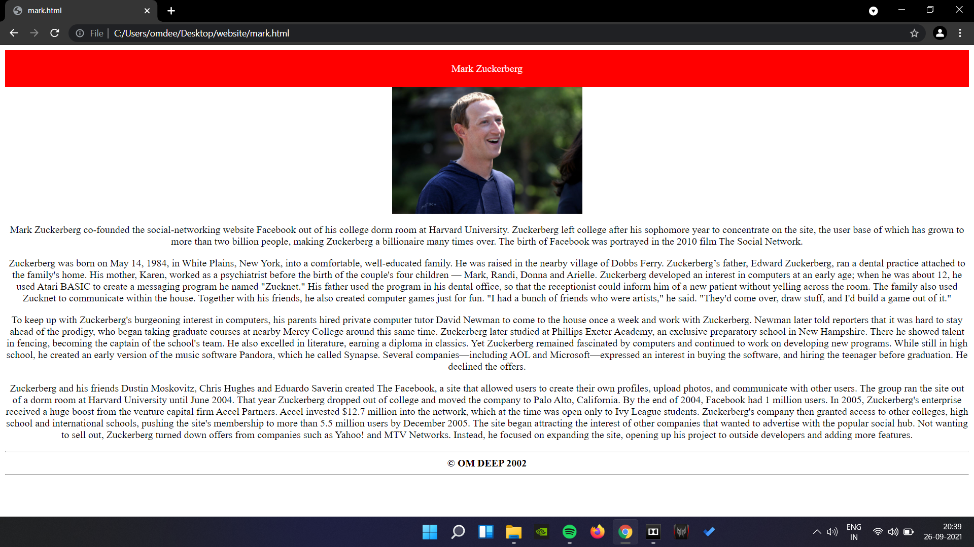

**c) Ratan Tata:**

**Code:**

<html>

<head>

<style>

#header{

background-color:red;

color:white;

text-align:center;

padding:20px;

}

</style>

<head>

<body>

<div id="header">

RATAN TATA

</div>

<center><img src="C:\Users\omdee\Desktop\website\biography\ratan-tata-reuters1-big.jpg" width=300 height=200>

<p>

Ratan Tata, in full Ratan Naval Tata, (born December 28, 1937, Bombay [now Mumbai], India), Indian businessman who became chairman (1991–2012 and 2016–17) of the Tata Group, a Mumbai-based conglomerate

<p>

A member of a prominent family of Indian industrialists and philanthropists (see Tata family), he was educated at Cornell University, Ithaca, New York, where he earned a B.S. (1962) in architecture before returning to work in India. He gained experience in a number of Tata Group businesses and was named director in charge (1971) of one of them, the National Radio and Electronics Co. He became chairman of Tata Industries a decade later and in 1991 succeeded his uncle, J.R.D. Tata, as chairman of the Tata Group.

<p>

Upon assuming leadership of the conglomerate, Tata aggressively sought to expand it, and increasingly he focused on globalizing its businesses. In 2000 the group acquired London-based Tetley Tea for $431.3 million, and in 2004 it purchased the truck-manufacturing operations of South Korea’s Daewoo Motors for $102 million. In 2007 Tata Steel completed the biggest corporate takeover by an Indian company when it acquired the giant Anglo-Dutch steel manufacturer Corus Group for $11.3 billion.

<p>

In 2008 Tata oversaw Tata Motors’ purchase of the elite British car brands Jaguar and Land Rover from the Ford Motor Company. The $2.3 billion deal marked the largest-ever acquisition by an Indian automotive firm. The following year the company launched the Tata Nano, a tiny rear-engined, pod-shaped vehicle with a starting price of approximately 100,000 Indian rupees, or about $2,000. Although only slightly more than 10 feet (3 metres) long and about 5 feet (1.5 metres) wide, the highly touted “People’s Car” could seat up to five adults and, in Tata’s words, would provide a “safe, affordable, all-weather form of transport” to millions of middle- and lower-income consumers both in India and abroad. In December 2012 Tata retired as chairman of the Tata Group. He briefly served as interim chairman beginning in October 2016 following the ouster of his successor, Cyrus Mistry. Tata returned to retirement in January 2017 when Natarajan Chandrasekaran was appointed chairman of the Tata Group.

</ul>

<p>

<hr>

<b><center>© OM DEEP</center></b>

<hr>

</body>

</html>

**Screenshot:**

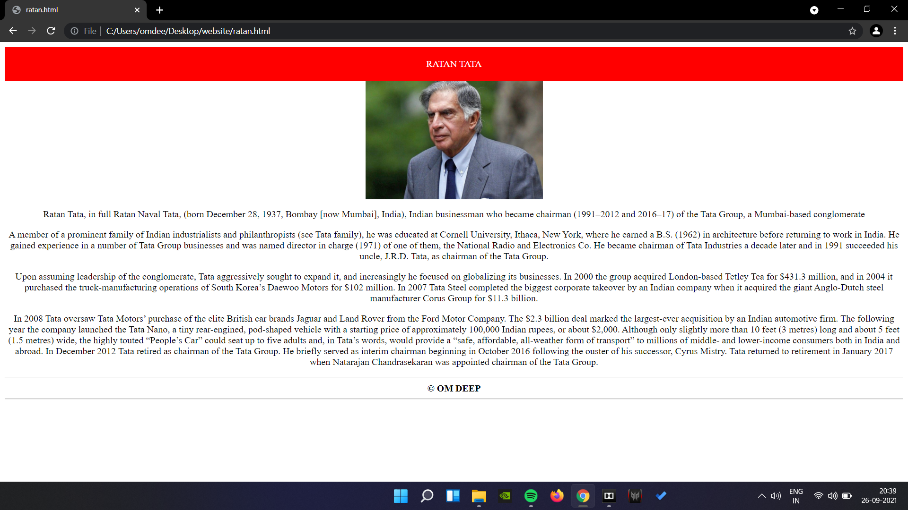

**d) Steve Jobs:**

**Code:**

<html>

<head>

<style>

#header{

background-color:red;

color:white;

text-align:center;

padding:20px;

}

</style>

</head>

<body>

<div id="header">

STEVE JOBS

</div>

<center><img src="C:\Users\omdee\Desktop\website\biography\steve-jobs--david-paul-morrisbloomberg-via-getty-images.jpg" widht=300 height=200>

<p>

Steven Paul Jobs was an American inventor, designer and entrepreneur who was the co-founder, chief executive and chairman of Apple Computer. Apple's revolutionary products, which include the iPod, iPhone and iPad, are now seen as dictating the evolution of modern technology.

Born in 1955 to two University of Wisconsin graduate students who gave him up for adoption, Jobs was smart but directionless, dropping out of college and experimenting with different pursuits before co-founding Apple with Steve Wozniak in 1976. Jobs left the company in 1985, launching Pixar Animation Studios, then returned to Apple more than a decade later. Jobs died in 2011 following a long battle with pancreatic cancer.

<P>

Jobs was born on February 24, 1955, in San Francisco, California. He lived with his adoptive family in Mountain View, California, within the area that would later become known as Silicon Valley.

As a boy, Jobs and his father worked on electronics in the family garage. Paul showed his son how to take apart and reconstruct electronics, a hobby that instilled confidence, tenacity and mechanical prowess in young Jobs.

<p>

While Jobs was always an intelligent and innovative thinker, his youth was riddled with frustrations over formal schooling. Jobs was a prankster in elementary school due to boredom, and his fourth-grade teacher needed to bribe him to study. Jobs tested so well, however, that administrators wanted to skip him ahead to high school — a proposal that his parents declined.

After high school, Jobs enrolled at Reed College in Portland, Oregon. Lacking direction, he dropped out of college after six months and spent the next 18 months dropping in on creative classes at the school. Jobs later recounted how one course in calligraphy developed his love of typography.

In 1974, Jobs took a position as a video game designer with Atari. Several months later he left the company to find spiritual enlightenment in India, traveling further and experimenting with psychedelic drugs.

<p>

In 1976, when Jobs was just 21, he and Wozniak started Apple Computer in the Jobs’ family garage. They funded their entrepreneurial venture by Jobs selling his Volkswagen bus and Wozniak selling his beloved scientific calculator. Jobs and Wozniak are credited with revolutionizing the computer industry with Apple by democratizing the technology and making machines smaller, cheaper, intuitive and accessible to everyday consumers.

Wozniak conceived of a series of user-friendly personal computers, and — with Jobs in charge of marketing — Apple initially marketed the computers for $666.66 each. The Apple I earned the corporation around $774,000. Three years after the release of Apple's second model, the Apple II, the company's sales increased by 700 percent to $139 million.

In 1980, Apple Computer became a publicly-traded company, with a market value of $1.2 billion by the end of its very first day of trading. Jobs looked to marketing expert John Sculley of Pepsi-Cola to take over the role of CEO for Apple.

The next several products from Apple suffered significant design flaws, however, resulting in recalls and consumer disappointment. IBM suddenly surpassed Apple in sales, and Apple had to compete with an IBM/PC-dominated business world.

In 1984, Apple released the Macintosh, marketing the computer as a piece of a counterculture lifestyle: romantic, youthful, creative. But despite positive sales and performance superior to IBM's PCs, the Macintosh was still not IBM-compatible.

Sculley believed Jobs was hurting Apple, and the company's executives began to phase him out. Not actually having had an official title with the company he co-founded, Jobs was pushed into a more marginalized position and thus left Apple in 1985

<p>

In 1986, Jobs purchased an animation company from George Lucas, which later became Pixar Animation Studios. Believing in Pixar's potential, Jobs initially invested $50 million of his own money in the company.

The studio went on to produce wildly popular movies such as Toy Story, Finding Nemo and The Incredibles; Pixar's films have collectively netted $4 billion. The studio merged with Walt Disney in 2006, making Jobs Disney's largest shareholder.

In 2011, Forbes estimated the majority of Jobs’ net worth at around $6.5 billion to $7 billion from his sale of Pixar to the Walt Disney Company in 2006. However if Jobs had not sold his Apple shares in 1985, when he left the company he founded and helmed for over a decade, his net worth would have been a staggering $36 billion.

<p>

In 2003, Jobs discovered that he had a neuroendocrine tumor, a rare but operable form of pancreatic cancer. Instead of immediately opting for surgery, Jobs chose to alter his pesco-vegetarian diet while weighing Eastern treatment options.

For nine months, Jobs postponed surgery, making Apple's board of directors nervous. Executives feared that shareholders would pull their stock if word got out that their CEO was ill. But in the end, Jobs' confidentiality took precedence over shareholder disclosure.

In 2004, Jobs had successful surgery to remove the pancreatic tumor. True to form, in subsequent years Jobs disclosed little about his health.

Early in 2009, reports circulated about Jobs' weight loss, some predicting his health issues had returned, which included a liver transplant. Jobs responded to these concerns by stating he was dealing with a hormone imbalance. Days later, he went on a six-month leave of absence.

In an email message to employees, Jobs said his "health-related issues are more complex" than he thought, then named Tim Cook, Apple’s chief operating officer, as “responsible for Apple's day-today operations."

After nearly a year out of the spotlight, Jobs delivered a keynote address at an invite-only Apple event on September 9, 2009. He continued to serve as master of ceremonies, which included the unveiling of the iPad, throughout much of 2010.

In January 2011, Jobs announced he was going on medical leave. In August, he resigned as CEO of Apple, handing the reins to Cook.

</ul>

<p>

<hr>

<b><center>© OM DEEP 2002</center></b>

<hr>

</body>

</html>

**Screenshot:**

