IN THE CIRCUIT COURT OF THE [Judicial Circuit] JUDICIAL CIRCUIT, IN AND FOR [County] COUNTY, [State]  
Case No.: 403315  
Division: Family

3034 Gonzalez Spur Apt. 442, Andersonmouth, CO 33716  
Court telephone No.: 288-419-9001x405

**Husband: Anthony Salazar and Wife: Sierra Norman**

PETITION FOR SIMPLIFIED DISSOLUTION OF MARRIAGE

We, Anthony Salazar, Husband, and Sierra Norman, Wife, being sworn, certify that the following information is true:

1. We are both asking the Court for a dissolution of our marriage.

2. Husband lives at 4515 Gordon Streets Apt. 052, Kiddmouth, ME 10820. Wife lives at 76320 Melissa Station Suite 617, Jasonburgh, ME 41918.

3. We were married on April 16, 2016 in the city of East Andrew, Louisiana.

4. Our marriage is irretrievably broken.

5. We do not have any minor or dependent children together, and the wife is not pregnant.

6. We have divided our assets and liabilities by agreement, and we are satisfied with the division.

[Check one only]

- ( ) Our marital settlement agreement is attached and was signed freely by both parties.  
- ( ) We prefer to keep our financial agreements private.

Filed on: October 15, 2024

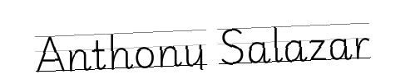

Husband's Signature: __________________________



Wife's Signature: __________________________