IN THE CIRCUIT COURT OF THE [Judicial Circuit] JUDICIAL CIRCUIT, IN AND FOR [County] COUNTY, [State]  
Case No.: 887222  
Division: Family

9215 Murphy Viaduct Suite 299, South Robertchester, WV 08813  
Court telephone No.: 001-534-743-5586

**Husband: Cole Robinson and Wife: Morgan Carson**

PETITION FOR SIMPLIFIED DISSOLUTION OF MARRIAGE

We, Cole Robinson, Husband, and Morgan Carson, Wife, being sworn, certify that the following information is true:

1. We are both asking the Court for a dissolution of our marriage.

2. Husband lives at 220 Sullivan Squares, Hansenmouth, CT 39093. Wife lives at 09680 Martin Meadow Apt. 622, South Brianshire, KY 38663.

3. We were married on December 03, 2015 in the city of North Kathleen, North Dakota.

4. Our marriage is irretrievably broken.

5. We do not have any minor or dependent children together, and the wife is not pregnant.

6. We have divided our assets and liabilities by agreement, and we are satisfied with the division.

[Check one only]

- ( ) Our marital settlement agreement is attached and was signed freely by both parties.  
- ( ) We prefer to keep our financial agreements private.

Filed on: May 17, 2024



Husband's Signature: __________________________

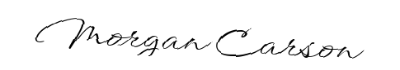

Wife's Signature: __________________________