IN THE CIRCUIT COURT OF THE [Judicial Circuit] JUDICIAL CIRCUIT, IN AND FOR [County] COUNTY, [State]  
Case No.: 356796  
Division: Family

PSC 8950, Box 0793, APO AE 28326  
Court telephone No.: 365.555.0205

**Husband: Cory Morrow and Wife: Ashley Scott**

PETITION FOR SIMPLIFIED DISSOLUTION OF MARRIAGE

We, Cory Morrow, Husband, and Ashley Scott, Wife, being sworn, certify that the following information is true:

1. We are both asking the Court for a dissolution of our marriage.

2. Husband lives at 9299 Reyes Views Suite 904, Richardsonton, LA 22751. Wife lives at 186 White Curve, West Bradleyshire, KY 48623.

3. We were married on December 06, 2017 in the city of Stephenmouth, Connecticut.

4. Our marriage is irretrievably broken.

5. We do not have any minor or dependent children together, and the wife is not pregnant.

6. We have divided our assets and liabilities by agreement, and we are satisfied with the division.

[Check one only]

- ( ) Our marital settlement agreement is attached and was signed freely by both parties.  
- ( ) We prefer to keep our financial agreements private.

Filed on: September 14, 2024

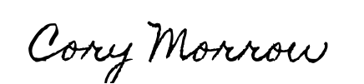

Husband's Signature: __________________________

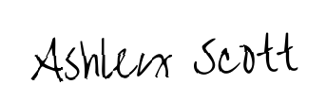

Wife's Signature: __________________________