IN THE CIRCUIT COURT OF THE [Judicial Circuit] JUDICIAL CIRCUIT, IN AND FOR [County] COUNTY, [State]  
Case No.: 549222  
Division: Family

07670 Antonio Extension Apt. 470, Lake Logan, MN 63744  
Court telephone No.: 6367565890

**Husband: David Aguirre MD and Wife: Alexandra Hurley**

PETITION FOR SIMPLIFIED DISSOLUTION OF MARRIAGE

We, David Aguirre MD, Husband, and Alexandra Hurley, Wife, being sworn, certify that the following information is true:

1. We are both asking the Court for a dissolution of our marriage.

2. Husband lives at 542 Brooks Viaduct Suite 028, Johnsonstad, VI 64658. Wife lives at 298 Elizabeth Mission Apt. 571, Joshuamouth, SC 78608.

3. We were married on December 13, 2019 in the city of Brownland, Colorado.

4. Our marriage is irretrievably broken.

5. We do not have any minor or dependent children together, and the wife is not pregnant.

6. We have divided our assets and liabilities by agreement, and we are satisfied with the division.

[Check one only]

- ( ) Our marital settlement agreement is attached and was signed freely by both parties.  
- ( ) We prefer to keep our financial agreements private.

Filed on: April 23, 2024

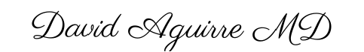

Husband's Signature: __________________________

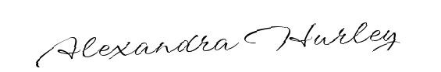

Wife's Signature: __________________________