IN THE CIRCUIT COURT OF THE [Judicial Circuit] JUDICIAL CIRCUIT, IN AND FOR [County] COUNTY, [State]  
Case No.: 461930  
Division: Family

8913 Brian Trafficway, Brucemouth, KY 41514  
Court telephone No.: 730-400-9236

**Husband: Douglas Clark and Wife: Suzanne Jones**

PETITION FOR SIMPLIFIED DISSOLUTION OF MARRIAGE

We, Douglas Clark, Husband, and Suzanne Jones, Wife, being sworn, certify that the following information is true:

1. We are both asking the Court for a dissolution of our marriage.

2. Husband lives at Unit 0073 Box 0074, DPO AE 22798. Wife lives at 87714 Davis Street Suite 983, New Amberbury, AL 46305.

3. We were married on August 14, 2016 in the city of Gonzalezside, Maine.

4. Our marriage is irretrievably broken.

5. We do not have any minor or dependent children together, and the wife is not pregnant.

6. We have divided our assets and liabilities by agreement, and we are satisfied with the division.

[Check one only]

- ( ) Our marital settlement agreement is attached and was signed freely by both parties.  
- ( ) We prefer to keep our financial agreements private.

Filed on: August 08, 2024

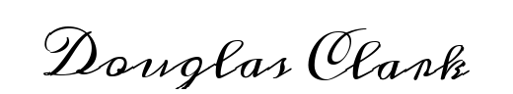

Husband's Signature: __________________________



Wife's Signature: __________________________