IN THE CIRCUIT COURT OF THE [Judicial Circuit] JUDICIAL CIRCUIT, IN AND FOR [County] COUNTY, [State]  
Case No.: 626254  
Division: Family

83627 Munoz Ridge Suite 130, East Sethmouth, NY 60234  
Court telephone No.: 548-480-6928x6113

**Husband: Frank Boyd and Wife: Chelsea Franco**

PETITION FOR SIMPLIFIED DISSOLUTION OF MARRIAGE

We, Frank Boyd, Husband, and Chelsea Franco, Wife, being sworn, certify that the following information is true:

1. We are both asking the Court for a dissolution of our marriage.

2. Husband lives at 371 Johnson Glen Suite 885, Johnsonfort, DE 80534. Wife lives at 92213 Carter Rapids, Gaineschester, VI 26793.

3. We were married on November 20, 2017 in the city of Michaelshire, Nevada.

4. Our marriage is irretrievably broken.

5. We do not have any minor or dependent children together, and the wife is not pregnant.

6. We have divided our assets and liabilities by agreement, and we are satisfied with the division.

[Check one only]

- ( ) Our marital settlement agreement is attached and was signed freely by both parties.  
- ( ) We prefer to keep our financial agreements private.

Filed on: April 27, 2024

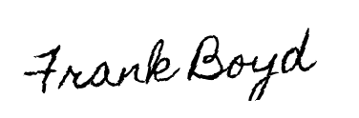

Husband's Signature: __________________________



Wife's Signature: __________________________