IN THE CIRCUIT COURT OF THE [Judicial Circuit] JUDICIAL CIRCUIT, IN AND FOR [County] COUNTY, [State]  
Case No.: 252149  
Division: Family

161 Johnson Branch, Dixontown, CA 14887  
Court telephone No.: 001-955-835-2677x3563

**Husband: George Daniels and Wife: Lisa Cummings**

PETITION FOR SIMPLIFIED DISSOLUTION OF MARRIAGE

We, George Daniels, Husband, and Lisa Cummings, Wife, being sworn, certify that the following information is true:

1. We are both asking the Court for a dissolution of our marriage.

2. Husband lives at 43890 Jose Groves, North Dawn, MA 02312. Wife lives at Unit 3290 Box 6272, DPO AP 38395.

3. We were married on June 18, 2015 in the city of Tonyachester, Delaware.

4. Our marriage is irretrievably broken.

5. We do not have any minor or dependent children together, and the wife is not pregnant.

6. We have divided our assets and liabilities by agreement, and we are satisfied with the division.

[Check one only]

- ( ) Our marital settlement agreement is attached and was signed freely by both parties.  
- ( ) We prefer to keep our financial agreements private.

Filed on: September 15, 2024

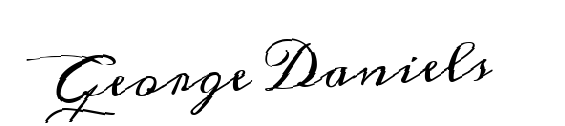

Husband's Signature: __________________________

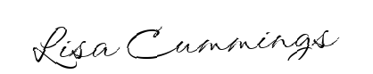

Wife's Signature: __________________________