IN THE CIRCUIT COURT OF THE [Judicial Circuit] JUDICIAL CIRCUIT, IN AND FOR [County] COUNTY, [State]  
Case No.: 865956  
Division: Family

101 Jacobson Points, Lake Sethstad, PW 17039  
Court telephone No.: +1-788-851-7316x078

**Husband: Jesse Allen and Wife: Samantha Mccarthy**

PETITION FOR SIMPLIFIED DISSOLUTION OF MARRIAGE

We, Jesse Allen, Husband, and Samantha Mccarthy, Wife, being sworn, certify that the following information is true:

1. We are both asking the Court for a dissolution of our marriage.

2. Husband lives at 14500 Garcia Route Suite 321, Kellishire, KS 61889. Wife lives at USNV Brewer, FPO AA 36157.

3. We were married on April 20, 2016 in the city of Jodiland, Louisiana.

4. Our marriage is irretrievably broken.

5. We do not have any minor or dependent children together, and the wife is not pregnant.

6. We have divided our assets and liabilities by agreement, and we are satisfied with the division.

[Check one only]

- ( ) Our marital settlement agreement is attached and was signed freely by both parties.  
- ( ) We prefer to keep our financial agreements private.

Filed on: July 21, 2024



Husband's Signature: __________________________

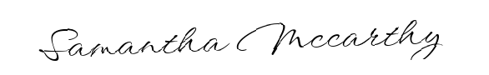

Wife's Signature: __________________________