IN THE CIRCUIT COURT OF THE [Judicial Circuit] JUDICIAL CIRCUIT, IN AND FOR [County] COUNTY, [State]  
Case No.: 896999  
Division: Family

39837 Frank Junctions, East Felicia, CA 43530  
Court telephone No.: 001-300-656-2527x476

**Husband: Joshua Adams Jr. and Wife: Jamie Nunez**

PETITION FOR SIMPLIFIED DISSOLUTION OF MARRIAGE

We, Joshua Adams Jr., Husband, and Jamie Nunez, Wife, being sworn, certify that the following information is true:

1. We are both asking the Court for a dissolution of our marriage.

2. Husband lives at 0752 Richard Row, New Jill, IL 11614. Wife lives at 8155 Sarah Street, Johnsonmouth, NE 80956.

3. We were married on July 04, 2018 in the city of New Christine, Virginia.

4. Our marriage is irretrievably broken.

5. We do not have any minor or dependent children together, and the wife is not pregnant.

6. We have divided our assets and liabilities by agreement, and we are satisfied with the division.

[Check one only]

- ( ) Our marital settlement agreement is attached and was signed freely by both parties.  
- ( ) We prefer to keep our financial agreements private.

Filed on: September 07, 2024

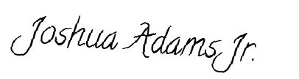

Husband's Signature: __________________________



Wife's Signature: __________________________