IN THE CIRCUIT COURT OF THE [Judicial Circuit] JUDICIAL CIRCUIT, IN AND FOR [County] COUNTY, [State]  
Case No.: 676379  
Division: Family

88261 Fuller Spur, West Thomas, NM 41711  
Court telephone No.: 2638708672

**Husband: Justin Ramos and Wife: Tina Bailey**

PETITION FOR SIMPLIFIED DISSOLUTION OF MARRIAGE

We, Justin Ramos, Husband, and Tina Bailey, Wife, being sworn, certify that the following information is true:

1. We are both asking the Court for a dissolution of our marriage.

2. Husband lives at 3961 Warren Stream, Port Timothy, NY 45489. Wife lives at 349 Joseph Pine, Anthonystad, NJ 55311.

3. We were married on October 12, 2018 in the city of Port Colleen, New Jersey.

4. Our marriage is irretrievably broken.

5. We do not have any minor or dependent children together, and the wife is not pregnant.

6. We have divided our assets and liabilities by agreement, and we are satisfied with the division.

[Check one only]

- ( ) Our marital settlement agreement is attached and was signed freely by both parties.  
- ( ) We prefer to keep our financial agreements private.

Filed on: January 10, 2025

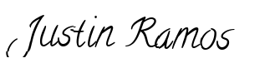

Husband's Signature: __________________________

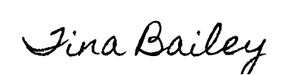

Wife's Signature: __________________________