IN THE CIRCUIT COURT OF THE [Judicial Circuit] JUDICIAL CIRCUIT, IN AND FOR [County] COUNTY, [State]  
Case No.: 624137  
Division: Family

23958 Macdonald Key, East George, MT 50050  
Court telephone No.: 001-936-778-2118x15343

**Husband: Justin Wilson and Wife: Peggy Bradley**

PETITION FOR SIMPLIFIED DISSOLUTION OF MARRIAGE

We, Justin Wilson, Husband, and Peggy Bradley, Wife, being sworn, certify that the following information is true:

1. We are both asking the Court for a dissolution of our marriage.

2. Husband lives at 2774 Kim Glen Apt. 637, Snowberg, AK 53926. Wife lives at 2546 Amanda Meadow Apt. 886, New Johntown, MH 36047.

3. We were married on June 09, 2015 in the city of North Andrea, New Hampshire.

4. Our marriage is irretrievably broken.

5. We do not have any minor or dependent children together, and the wife is not pregnant.

6. We have divided our assets and liabilities by agreement, and we are satisfied with the division.

[Check one only]

- ( ) Our marital settlement agreement is attached and was signed freely by both parties.  
- ( ) We prefer to keep our financial agreements private.

Filed on: December 23, 2024

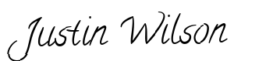

Husband's Signature: __________________________

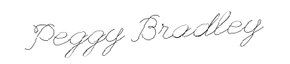

Wife's Signature: __________________________