IN THE CIRCUIT COURT OF THE [Judicial Circuit] JUDICIAL CIRCUIT, IN AND FOR [County] COUNTY, [State]  
Case No.: 880229  
Division: Family

5593 Brian Fields Apt. 163, Lake Joshua, NJ 31902  
Court telephone No.: 3206764437

**Husband: Matthew Martinez and Wife: Shelby Lewis**

PETITION FOR SIMPLIFIED DISSOLUTION OF MARRIAGE

We, Matthew Martinez, Husband, and Shelby Lewis, Wife, being sworn, certify that the following information is true:

1. We are both asking the Court for a dissolution of our marriage.

2. Husband lives at 338 Monica Port Suite 909, Simmonsberg, IL 12217. Wife lives at 48668 Sandra Creek Apt. 144, New Douglas, AL 02664.

3. We were married on December 14, 2017 in the city of West Jasonhaven, Arizona.

4. Our marriage is irretrievably broken.

5. We do not have any minor or dependent children together, and the wife is not pregnant.

6. We have divided our assets and liabilities by agreement, and we are satisfied with the division.

[Check one only]

- ( ) Our marital settlement agreement is attached and was signed freely by both parties.  
- ( ) We prefer to keep our financial agreements private.

Filed on: October 08, 2024

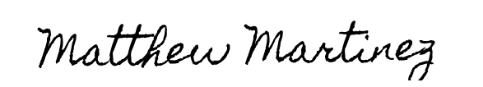

Husband's Signature: __________________________

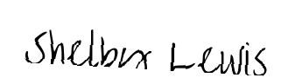

Wife's Signature: __________________________