RESIDENTIAL LEASE AGREEMENT

1. THE PARTIES. This Residential Lease Agreement (“Agreement”) is made on February 01, 2025 by and between:

Landlord  
Name: Lawrence Williams  
Mailing Address: 29067 Thomas Brooks, East Samuelview, OR 46252

Tenant  
Name: Ashley Bender  
Mailing Address: 15513 Nielsen Falls, Carrillotown, IA 38605

2. PROPERTY  
Property Address: Unit 4046 Box 2198, DPO AE 96423  
Residence Type: Townhouse  
Bedroom(s): 4 Bathroom(s): 1

3. TERM  
Start Date: March 04, 2025  
End Date: April 30, 2026

4. RENT  
Monthly Rent: $1796  
Due Date: 1st day of each month.

5. SECURITY DEPOSIT  
Amount: $1841

IN WITNESS WHEREOF, the Parties have executed this Agreement as of the date first above written.



Landlord's Signature: __________________________

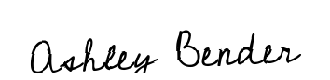

Tenant's Signature: __________________________