RESIDENTIAL LEASE AGREEMENT

1. THE PARTIES. This Residential Lease Agreement (“Agreement”) is made on February 04, 2025 by and between:

Landlord  
Name: Kristin Steele  
Mailing Address: 9472 Roberts Crossing Suite 075, Stephensonfurt, AS 47346

Tenant  
Name: Cody Bernard  
Mailing Address: 800 Anderson View Apt. 184, West Phillip, SC 23438

2. PROPERTY  
Property Address: 417 Tucker Corner Suite 035, Nicoleton, MH 62647  
Residence Type: Townhouse  
Bedroom(s): 2 Bathroom(s): 1

3. TERM  
Start Date: February 26, 2025  
End Date: September 09, 2026

4. RENT  
Monthly Rent: $2504  
Due Date: 1st day of each month.

5. SECURITY DEPOSIT  
Amount: $2289

IN WITNESS WHEREOF, the Parties have executed this Agreement as of the date first above written.

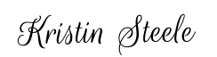

Landlord's Signature: __________________________

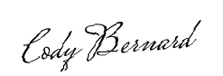

Tenant's Signature: __________________________