RESIDENTIAL LEASE AGREEMENT

1. THE PARTIES. This Residential Lease Agreement (“Agreement”) is made on February 01, 2025 by and between:

Landlord  
Name: Patrick Ferguson  
Mailing Address: 4909 Ashley Pass Apt. 647, Harrisborough, AL 07701

Tenant  
Name: Dalton Tran  
Mailing Address: 33403 Macdonald Fords Apt. 434, New Rebecca, PW 34314

2. PROPERTY  
Property Address: 652 Mcguire Square Apt. 354, New Vanessa, FM 16300  
Residence Type: Townhouse  
Bedroom(s): 5 Bathroom(s): 1

3. TERM  
Start Date: February 12, 2025  
End Date: January 13, 2027

4. RENT  
Monthly Rent: $1624  
Due Date: 1st day of each month.

5. SECURITY DEPOSIT  
Amount: $3580

IN WITNESS WHEREOF, the Parties have executed this Agreement as of the date first above written.

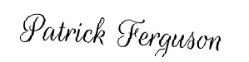

Landlord's Signature: __________________________

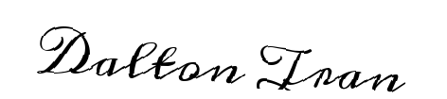

Tenant's Signature: __________________________