RESIDENTIAL LEASE AGREEMENT

1. THE PARTIES. This Residential Lease Agreement (“Agreement”) is made on February 01, 2025 by and between:

Landlord  
Name: Ashley Rodriguez  
Mailing Address: PSC 0178, Box 6654, APO AA 36830

Tenant  
Name: Daniel Davis  
Mailing Address: 33198 Kimberly Landing Suite 481, Port Allison, MP 41050

2. PROPERTY  
Property Address: 4137 Ryan Meadows, Vargasmouth, GU 66896  
Residence Type: Apartment  
Bedroom(s): 5 Bathroom(s): 3

3. TERM  
Start Date: February 20, 2025  
End Date: January 11, 2027

4. RENT  
Monthly Rent: $2207  
Due Date: 1st day of each month.

5. SECURITY DEPOSIT  
Amount: $1780

IN WITNESS WHEREOF, the Parties have executed this Agreement as of the date first above written.

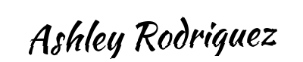

Landlord's Signature: __________________________

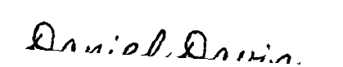

Tenant's Signature: __________________________