RESIDENTIAL LEASE AGREEMENT

1. THE PARTIES. This Residential Lease Agreement (“Agreement”) is made on February 02, 2025 by and between:

Landlord  
Name: Brianna Patrick  
Mailing Address: 8538 Rachel Lake Apt. 602, East Jeffrey, DE 12311

Tenant  
Name: Jason Allen  
Mailing Address: 232 Rebecca Lane Suite 847, East Jonathan, MO 49273

2. PROPERTY  
Property Address: 1479 Bradley Mission Suite 498, New Bryanton, WV 95357  
Residence Type: House  
Bedroom(s): 1 Bathroom(s): 1

3. TERM  
Start Date: February 24, 2025  
End Date: July 18, 2026

4. RENT  
Monthly Rent: $1912  
Due Date: 1st day of each month.

5. SECURITY DEPOSIT  
Amount: $2479

IN WITNESS WHEREOF, the Parties have executed this Agreement as of the date first above written.

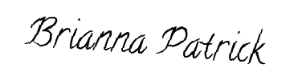

Landlord's Signature: __________________________



Tenant's Signature: __________________________