RESIDENTIAL LEASE AGREEMENT

1. THE PARTIES. This Residential Lease Agreement (“Agreement”) is made on February 04, 2025 by and between:

Landlord  
Name: Eric Santos  
Mailing Address: Unit 9434 Box 4278, DPO AE 10362

Tenant  
Name: Jeffrey Brown  
Mailing Address: 3124 Mark Landing Suite 057, West Chaseland, SD 78660

2. PROPERTY  
Property Address: 2703 Jessica Mountains Suite 152, East Kennethport, KS 93317  
Residence Type: House  
Bedroom(s): 2 Bathroom(s): 3

3. TERM  
Start Date: February 08, 2025  
End Date: July 13, 2026

4. RENT  
Monthly Rent: $2616  
Due Date: 1st day of each month.

5. SECURITY DEPOSIT  
Amount: $3781

IN WITNESS WHEREOF, the Parties have executed this Agreement as of the date first above written.

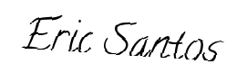

Landlord's Signature: __________________________

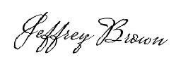

Tenant's Signature: __________________________