RESIDENTIAL LEASE AGREEMENT

1. THE PARTIES. This Residential Lease Agreement (“Agreement”) is made on February 01, 2025 by and between:

Landlord  
Name: Thomas Campbell  
Mailing Address: Unit 4064 Box 3237, DPO AE 99622

Tenant  
Name: Jennifer Williams  
Mailing Address: 693 Velasquez Spring Suite 028, Mcdanielmouth, SD 14430

2. PROPERTY  
Property Address: 020 Tracy Course Suite 526, Collinsfurt, PA 28534  
Residence Type: Condo  
Bedroom(s): 1 Bathroom(s): 3

3. TERM  
Start Date: February 26, 2025  
End Date: December 10, 2026

4. RENT  
Monthly Rent: $1076  
Due Date: 1st day of each month.

5. SECURITY DEPOSIT  
Amount: $3601

IN WITNESS WHEREOF, the Parties have executed this Agreement as of the date first above written.

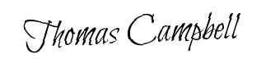

Landlord's Signature: __________________________

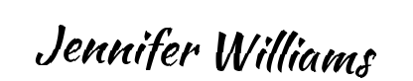

Tenant's Signature: __________________________