RESIDENTIAL LEASE AGREEMENT

1. THE PARTIES. This Residential Lease Agreement (“Agreement”) is made on February 02, 2025 by and between:

Landlord  
Name: Bradley Brown  
Mailing Address: 12676 Conrad Fork, Port Jennifer, ID 98057

Tenant  
Name: Jessica Walker  
Mailing Address: 350 Richardson Wall Apt. 228, Gillton, NY 87108

2. PROPERTY  
Property Address: 371 Young Point Suite 006, South Donna, OK 28441  
Residence Type: Condo  
Bedroom(s): 2 Bathroom(s): 1

3. TERM  
Start Date: February 17, 2025  
End Date: April 30, 2026

4. RENT  
Monthly Rent: $1690  
Due Date: 1st day of each month.

5. SECURITY DEPOSIT  
Amount: $3522

IN WITNESS WHEREOF, the Parties have executed this Agreement as of the date first above written.

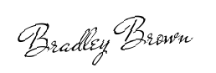

Landlord's Signature: __________________________

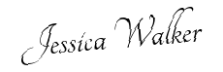

Tenant's Signature: __________________________